Information for the CDS

Temporary dataset title:

**CMIP5 three hourly data on single levels**

Issued by: Ruth Petrie/ CEDA-STFC

Date: 17/05/2019

Official reference number service contract: C3S_34a_Lot1/SC3

( Please note that Abstract, Additional variables, Picture, Licence and Documentation can be filled later on, as well the explanation of the variables. Mandatory from the start are: Manifests, conventions and names and units for the variables.

Please see <https://confluence.ecmwf.int/display/COPSRV/How+to+integrate+data+in+the+CDS+Catalogue> to have more specific information on how to provide the required information)

This is important since there are always some small changes in the way the information should be provided due to lessons learned with the provider.

## ACCESSING DATA:

## File name and path convention used to create the addresses to access the files with data

## **Very Important: This should describe the whole dataset to be delivered and not just a part. Not just what already exists, but also what is expected to exist.**

The dataset is made accessible to the CDS via HTTP and OpenDAP protocols.

The URL addresses for the data records are structured as follows:

%(root)s

/%(product)s

/%(institute)s

/%(model)s

/%(experiment)s

/%(time_frequency)s

/%(realm)s

/%( table)s

/%(ensemble)s

/%(variable)s

/%(version)s

/%(variable)s_%(table)s_%(model)s_%(experiment)s_%(ensemble)s_%(timeperiod)s.nc

|  |  |  |
| --- | --- | --- |
| **Identifier** | **All possible values** | **Explanation** |
| root | <http://data.mips.copernicus-climate.eu/thredds/fileServer/esg_c3s-cmip5>  http://data.mips.copernicus-climate.eu/thredds/dodsC/esg_c3s-cmip5 | Download method, HTTP or OpenDAP |
| product | output1 | CMIP5 product |
| institute | BCC  BNU  CCCma  CMCC  CNRM-CERFACS  CSIRO-BOM  ICHEC  MOHC  NASA-GISS | CMIP5 institution id |
| model | ACCESS1-0  ACCESS1-3  bcc-csm1-1  bcc-csm1-1-m  BNU-ESM  CanAM4  CMCC-CM  CNRM-CM5  EC-EARTH  GISS-E2-H  GISS-E2-R  HadGEM2-A  HadGEM2-ES | CMIP5 model name |
| experiment | amip  historical  piControl  rcp26  rcp45  rcp60  rcp85 | CMIP5 experiment name |
| time_frequency | 3hr | CMIP5 time frequency |
| realm | atmos | CMIP5 modelling realm |
| table | 3hr  cf3hr | CMIP5 MIP (CMOR) table id |
| ensemble | r13i1p1  r14i1p1  r1i1p1  r1i2p1  r2i1p1  r2i3p1  r3i1p1  r3i2p1  r4i1p1  r4i3p1  r5i3p1  r6i1p1  r6i1p2  r6i1p3  r7i1p1  r8i1p1 | CMIP5 ensemble identifier |
| variable | psl  uas  vas | CMIP5 variable id |
| version | v1  v20110323  v20110701  v20110708  v20110802  v20110819  v20111006  v20120203  v20120207  v20120229  v20120330  v20120503  v20120504  v20120514  v20120518  v20120612  v20120617  v20120709  v20120726  v20120802  v20120925  v20130419  v20131120  v20181201 | ESGF version number |
| timeperiod | 037101010300 - […]  […] - 228101010000 | Temporal period of data in file |

**Examples:**

<http://data.mips.copernicus-climate.eu/thredds/fileServer/esg_c3s-cmip5/output1/CMCC/CMCC-CM/amip/3hr/atmos/3hr/r2i1p1/uas/v20120925/uas_3hr_CMCC-CM_amip_r2i1p1_198001010000-198012312100.nc>

This URL provides an HTTP download link to CMIP5 three hourly zonal winds at the surface computed by the CMCC-CM model for the amip experiment by ensemble member r2i1p1 over the time period 19800-01-01 00:00 – 1980-31-12 21:00.

## Address for Manifest File for data

HTTP URLs:

<https://drive.google.com/file/d/1AjLJQTBZkXlkM9sktaSZk8mzvciyy8gv/view?usp=sharing>

OpenDAP URLs:

<https://drive.google.com/file/d/1j8BHqfkP-G3OjGtN3JAC2GFpnJHSBzXc/view?usp=sharing>

## Mapping between files and variables

The CMIP5 subset provided to the CDS follows the CF conventions where there is only variable per file. It is however possible to require multiple files to construct a timeseries of a given variable.

The mapping is as follows:

* psl_*.nc files contain the variable: Sea-level pressure
* uas_*.nc files contain the variable: Near-surface zonal component of wind
* vas_*.nc files contain the variable: Near-surface meridional component of wind

## Download options

* HTTP URLs:
  + https://data.mips.copernicus-climate.eu/thredds/fileServer/esg_c3s-cmip5
* OpenDAP URLs:
  + https://data.mips.copernicus-climate.eu/thredds/dodsC/esg_c3s-cmip5

## ACCESSING DOCUMENTATION:

## 

## Address for Manifest File for documents

None

**Documentation to be available in the CDS**

CMIP5 essential information: <https://pcmdi.llnl.gov/mips/cmip5/guide.html>

The link above provides simple and direct information on CMIP5. It also works as an entry point for more in-depth documentation on CMIP5 data and experiments.

## Information that can be provided after the manifest and conventions are accepted and tested:

## -----------------------------------------------------------------------------

# Abstract

This catalogue entry provides three-hourly climate projections on single levels from a large number of experiments, models, members and time periods computed in the framework of fifth phase of the Coupled Model Intercomparison Project (CMIP5). Information on how to access the complete CMIP5 dataset can be found in the Documentation section.

The term "single levels" is used to express that the variables computed at multiple vertical levels are excluded from this catalogue entry. The term "experiments" refers to the four main categories of CMIP5 simulations:

* Pre-industrial control experiments (Pi-control) with prescribed, non-evolving concentrations of atmospheric gases and aerosols as they are supposed to be before the industrial period;
* Historical experiments which cover the period where climate observations do exist;
* Ensemble of experiments from the Atmospheric Model Intercomparison Project (AMIP), which prescrives the oceanic variables for all models and during the all period of the experiment. This configuration removes the added complexity of ocean-atmosphere feedbacks in the climate system;
* Ensemble of climatic projection experiments following the Representative Concentration Pathways (RCP) 2.6, 4.5, 6.0 and 8.5.

Typically, the same experiment was done using different models. In addition, for each model, the same experiment was repeatedly done using slightly different conditions producing in that way an ensemble of experiments closely related. Each member of that ensemble is named after a triad of integers associated to the letters r, i and p. These three letter cover variations in initial conditions and dates as well as in the physical parameters of the models. The associated numbers are typically assigned sequentially. For instance, the member "r1i1p1" and the member "r1i2p2" for the same model and experiment indicate that the corresponding simulations differ since the initial conditions and the physical parameters of the model for the second member were changed relatively to the first member.

CMIP5 data were used extensively in the Intergovernmental Panel on Climate Change 5th Assessment Report (IPCC AR5) which was published in September 2009. The use of these data is often aimed at:

* addressing outstanding scientific questions that arose as part of the IPCC AR4 (the Intergovernmental Panel on Climate Change 4th Assessment Report) process;
* improving the understanding of climate;
* providing estimates of future climate change that will be useful to those considering its possible consequences;
* determining why similarly forced models produce a range of responses;
* assessing the mechanisms responsible for model differences in poorly understood feedbacks associated with the carbon cycle and with clouds;
* examining climate predictability and exploring the ability of models to predict climate on decadal time scales;
* evaluating how realistic the different models are in simulating the recent past.

# Data Description

|  |  |
| --- | --- |
| Horizontal coverage | Global |
| Horizontal resolution | From 0.125°x0.125° to 5°x5° depending on the model |
| Vertical resolution | Variables are provided in one single level (which may differ among variables). |
| Temporal coverage | Dependent on experiment. |
| Temporal resolution | Three hourly |
| File format | NetCDF, Climate and Forecast (CF) Metadata Convention v1.4 |
| Data type | Grid |

# Main Variables

|  |  |  |
| --- | --- | --- |
| **Name** | **Units** | **Explanation** |
| Sea level pressure (psl) | Pa | Pressure of the air pressure at sea level. |
| Near-surface zonal component of wind (uas) | m.s^-1 | Magnitude of the zonal (eastward) component of the two-dimensional horizontal air velocity near the surface. |
| Near-surface meridional component of wind (vas) | m.s^-1 | Magnitude of the meridional (northward) component of the two-dimensional horizontal air velocity near the surface. |

# Additional Variables

None

# Overview Picture

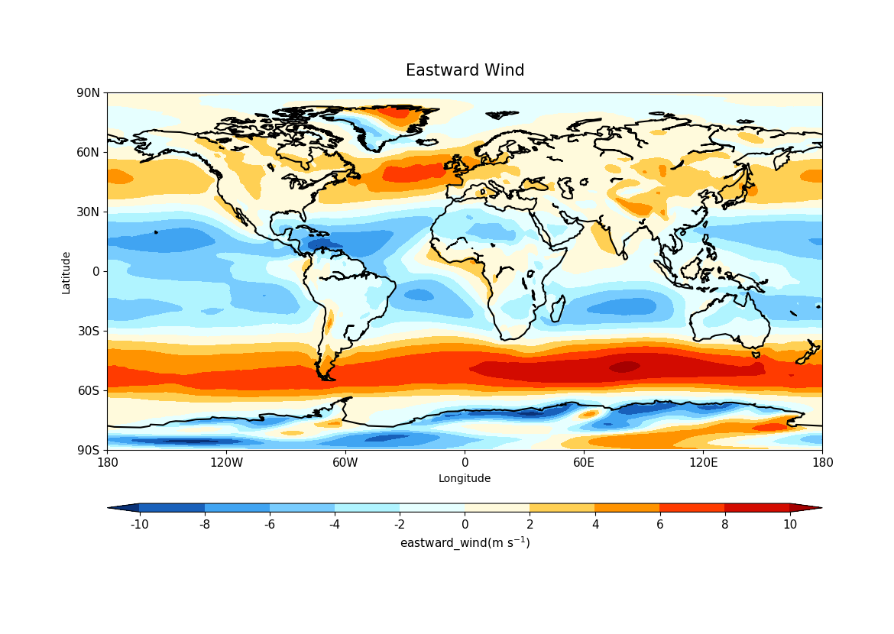

# Licence

PDF Version: <http://licences.ceda.ac.uk/image/data_access_condition/cmip5_open.pdf>

**CMIP5 - Data Access - Terms of Use**

**Terms of use agreement for CMIP5 model output**

*All* model output in the CMIP5 archive is available for "non-commercial research and educational purposes." A *subset (about three-quarters of the models)* of the data has also been released for "unrestricted" use, see table in the document "[Modeling Groups and their Terms of Use](https://pcmdi.llnl.gov/mips/cmip5/docs/CMIP5_modeling_groups.pdf?id=95)". Users registering to access CMIP5 output will be granted access to some or all of the data, depending on which of the following terms of use are agreed to:

**Terms of use for unrestricted data:**

1. I understand that the subset of CMIP5 model output that will be made accessible to this group has been designated for "unrestricted" use.

2. I will hold no individual(s), organization(s), or group(s) responsible for any errors in the models or in their output data.

3. In publications that rely on the CMIP5 model output, I will appropriately credit the data providers by an acknowledgment similar to the following:

"We acknowledge the World Climate Research Programme's Working Group on Coupled Modelling, which is responsible for CMIP, and we thank the climate modeling groups (listed in Table XX of this paper) for producing and making available their model output. For CMIP the U.S. Department of Energy's Program for Climate Model Diagnosis and Intercomparison provides coordinating support and led development of software infrastructure in partnership with the Global Organization for Earth System Science Portals."

where *"Table XX"* in your paper should list the models and modeling groups that provided the data you used.

4. I understand that Digital Object Identifiers (DOI's used, for example, in journal citations) will be assigned to various subsets of the CMIP5 multi-model dataset, and when available and as appropriate, I will cite these references in my publications. I will consult the CMIP5 website (<https://pcmdi.llnl.gov/mips/cmip5/>) to learn how to do this.

5. I acknowledge the potential limitations of the data obtained from this archive. These may include (but are not necessarily limited to) errors in the models, shortcomings in the experiment designs, the conjectural quality of the forcing scenarios used to drive the models, and so on.

6. I understand that although the model output has been subjected to a quality control procedure, unrecognized errors almost certainly remain.

7. To aid participating groups in understanding and improving upon their models' behaviors, I will respond to reasonable requests from the WGCM for feedback about my CMIP5 research results (e.g., reporting model deficiencies, recording CMIP5 publications, etc.).

8. Although I may freely share downloaded CMIP5 data with close collaborators, I understand that I may not redistribute the data more widely without abiding by additional terms of use enumerated below.

Users may share data with close collaborators who have agreed to abide by the above terms of use. A research institution wishing to share CMIP5 data *internally* among its staff may seek permission to do so from PCMDI by submitting to PCMDI this form [permission_to_share_form.docx](https://pcmdi.llnl.gov/mips/cmip5/docs/permission_to_share_form.docx). Others planning to redistribute CMIP5 model output must abide by additional "terms of use" enumerated below.

**\*Additional* terms of use for redistribution of CMIP5 model output:**

For the following reasons, users are discouraged from downloading CMIP5 data for the purpose of redistributing it to others (beyond their close collaborators):

1. The CMIP5 data archive is a dynamic collection of files, and it will be difficult to keep a copy (of even a small subset of the archived data) up to date. (Even if an automated update procedure is implemented, the resources allocated to the official CMIP5 archive could be unduly affected.)

2. The modeling groups have requested that users downloading CMIP5 data be registered and agree to the terms of use, and PCMDI alone is responsible for this.

If despite the above arguments against it, you wish to redistribute CMIP5 data to others, there are specific conditions that must be met. In addition to abiding by the terms of use (see above), anyone redistributing CMIP5 output (beyond their close collaborators) is required to:

1. Seek permission to proceed by contacting PCMDI (taylor13@llnl.gov, williams13@llnl.gov).

2. Record contact information for all users downloading CMIP5 output. These records must be sent to PCMDI quarterly in a format acceptable to PCMDI. These records will be used 1) to inform users when flaws in model output are discovered, and 2) to gauge the impact of CMIP5 results through the collection of usage statistics, as requested by the modeling groups.

3. Continually update data holdings to accurately reflect the CMIP5 archive. This will prevent known flawed data from being distributed.

4. Require users to agree to the "terms of use" and "acknowledgement" statements found at: [http://cmip- pcmdi.llnl.gov/cmip5/terms.html](https://cmip.llnl.gov/cmip5/terms.html).

5. Display a prominent banner showing the source of the data (CMIP5) and indicating that the original CMIP5 data can be accessed through the ESGF data portals (see <https://pcmdi.llnl.gov/mips/cmip5/availability.html>).

6. Display a warning that the modeling groups have not checked or approved of the data being distributed.

In general, the operation of ESGF and its performance in serving other users must not be adversely affected.

Note that commercial use of all but "unrestricted" data is strictly forbidden. In particular, paid advertisements must not appear on websites providing access to data (or derived data products) from CMIP5 models that have been designated as being available only for "non-commercial research and educational purposes".

**Dataset citation**

**Literature citation**