Using Spark from Sql Server to MySql (serial 7 million records)
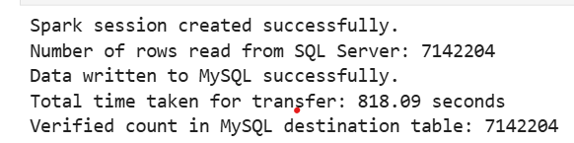

Using spark from Sql Server to MySql (serial 88 million records)
10446.34 seconds (2 hrs, 54 minutes)

