- ETL 1 – Combined Incremental
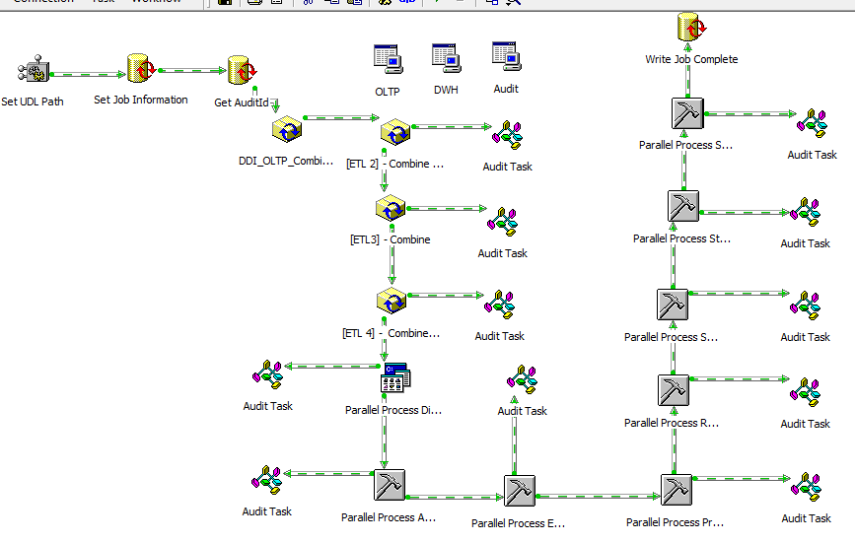
Task / Setting above, come from the left side


There are three connections to the databases, using .udl, stored in G:\DDI Files\UDL
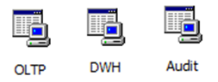
Udl files : OLTP.udl, DWH.udl.Audit.udl. Sample of udl. When OLTP is right clicked, this will be appeared when you choose properties
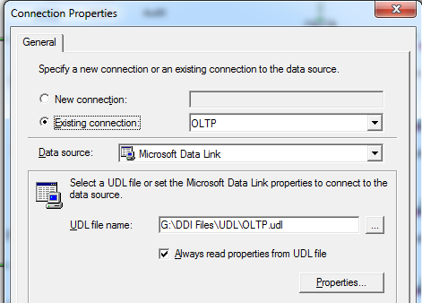

And when you choose properties again, this will be appeared
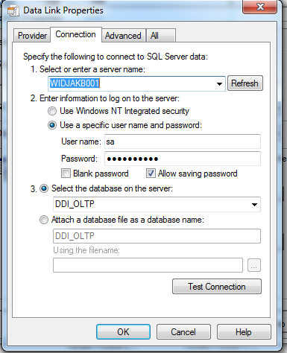
The Job started with set global variable 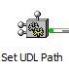, the icon named Dynamic Properties Task.When you right hand click and choose properties, you will see :
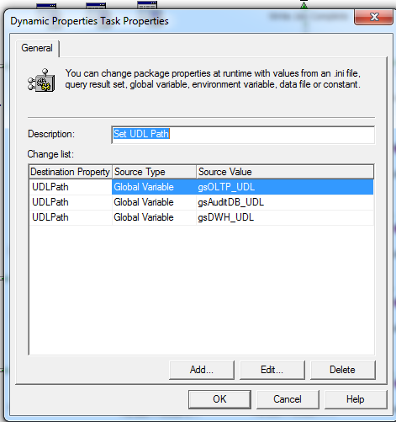
This icon is the information of all Connections, Tasks, Steps, and global variables that already created in a package. Task and Step name will be made automatically by DTS. Your MS Data Link (OLTP, DWH, Audit) will also appear here automatically. For example, your Set UDL Path will have Task name DTSTask_DynamicPropertiesTask_1 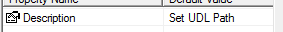, Steps
All element in a package have name, except arrows (on success, etc) and scripts.
To create a global variable, right click in the white space of package, and choose Package Properties and choose Global Variables tab and click add button.
Global Variables :
gv_FileLocation = G:\Distributor Data\Sales\
gv_ArchiveLocation = G:\Distributor Data\BackUp_Sales\
gv_FileFullName = G:\Distributor Data\Sales\ALL_transaction_20100306.csv
gv_FileCheckErrors = <not displayable>
giAuditId = 1
gdtPostStart = 1/1/2010
gsAuditDB_UDL = G:\DDI Files\UDL\Audit.udl
gsOLTP_UDL = G:\DDI Files\UDL\OLTP.udl
gv_ErrorLocation = G:\Distributor Data\Error_Sales\
gv_FileShortName = ALL_transaction_20100306.csv

When you click Edit… it will appear
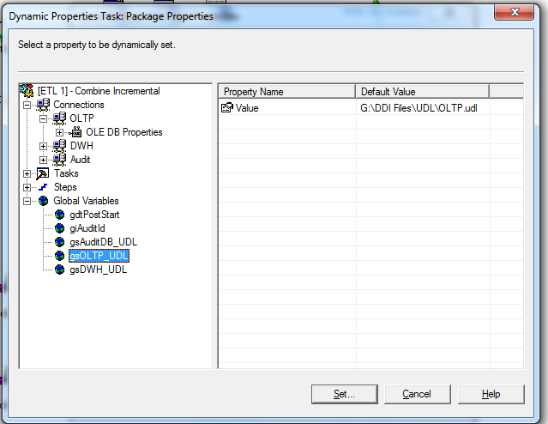

Execute Sql Task icon 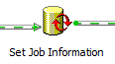will do this sql command
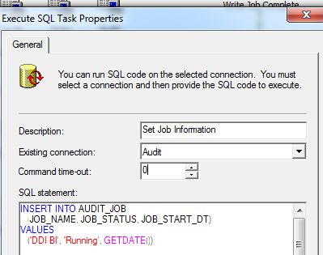

On Success do 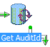
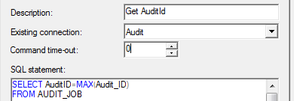
On Succes do Execute Package Task 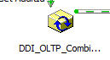
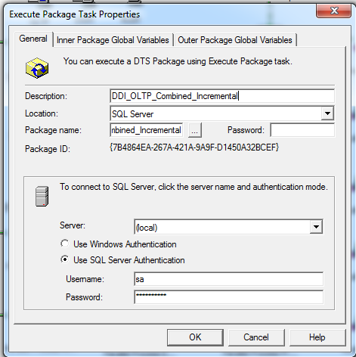
Which consists
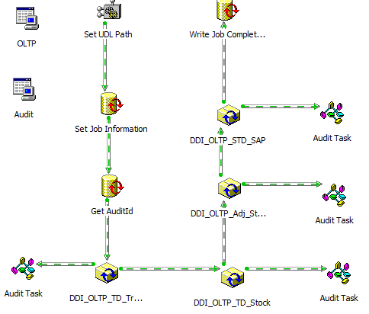
Set Job Information :
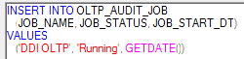
Set Audit Id

On Success do

Start with Dynamic Properties Task
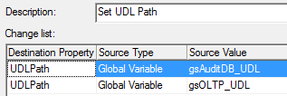 On Success do Execute Sql Task
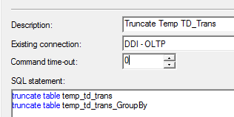

Temp_td_trans table likely a temporary table for .csv s created from Excel files sent from distributors. Temp_td_trans_GroupBy likely a table created after Temp_td_trans with group by to avoid double records. On Success do  Devine The GVs.
SET pkg = DTSGlobalVariables.Parent makes the current package can communicate and work together within a larger SSIS / DTS package execution context. It allows a child package to access and potentially modify properties and variable that initiates its execution.
Main = DTSTaskExecResult_Success at the bottom of a function means the function will be always successful
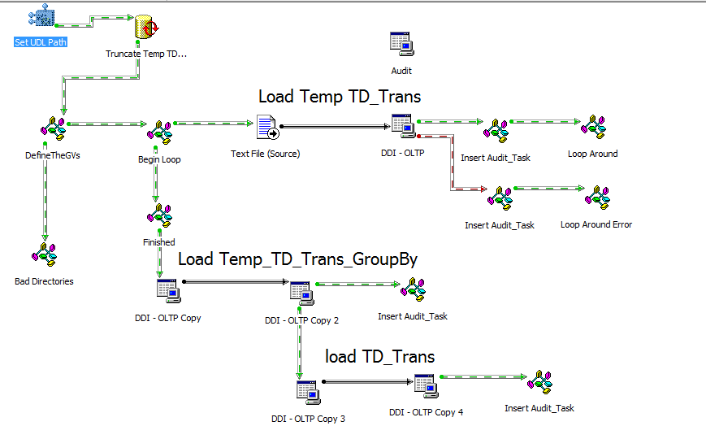
First thing we need to do is to check if our directories are valid. On Success do ActiveX Script Bad Directories and Begin Loop. It seems Bad Directories will display zero if all is Ok. The center of this package is
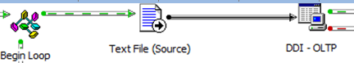 and 

Script Begin Loop there are statements
set pkg = DTSGlobalVariables.Parent ‘set a package object, since Global Variables derived from Package object
set stpEnterLoop = pkg.Steps("DTSStep_DTSDataPumpTask_1") ‘Sales .csv transfer to Temp_Td_Trans
set stpFinished = pkg.Steps("DTSStep_DTSActiveScriptTask_5") ‘Finished
set conTextFile = pkg.Connections("Text File (Source)")

if ShouldILoop = True then
stpEnterLoop.DisableStep = False ‘it means stpEnterLoop will run
stpFinished.DisableStep = True ‘it means ActiveXScript Finished will not run
conTextFile.DataSource = DTSGlobalVariables("gv_FileFullName").Value ‘.csv will be processed
stpEnterLoop.ExecutionStatus = DTSStepExecStat_Waiting ‘it means stpEnterLoop still run
else
stpEnterLoop.DisableStep =True ‘it means stpEnterLoop will not run
stpFinished.DisableStep = False ‘it means ActiveXScript Finished will run
stpFinished.ExecutionStatus = DTSStepExecStat_Waiting ‘it means Finish still run

End if
ShouldILoop is the function consists of
set pkg = DTSGlobalVariables.Parent
set fso = CREATEOBJECT("Scripting.FileSystemObject")
set fold = fso.GetFolder(DTSGlobalVariables("gv_FileLocation").Value)
counter = fold.files.count

'So long as there is more than 1 file carry on

if counter >= 1 then

for each fil in fold.Files
DTSGlobalVariables("gv_FileFullName").Value = fil.path ‘means the last .csv will be processed ?
DTSGlobalVariables("gv_FileShortName").Value = fil.name
ShouldILoop = CBool(True)
Next
else
ShouldILoop = CBool(False)
End if
Loop will still run as long as the folder (g:\distributor data\Sales) consist .csv files. 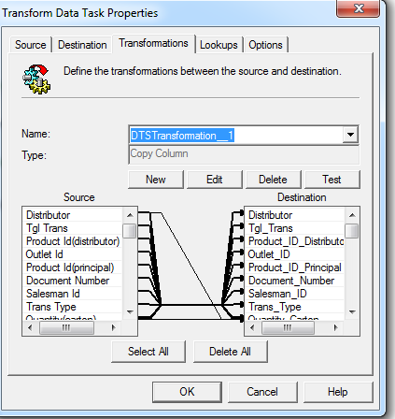
Picture above is DTSTransformation_1 that only copy columns. DTSTransformation_2 consists of its ActiveX Script. Every line from Source to Destination there is VB Scriptn, eg Tax Amount :

' Copy each source column to the destination column
Function Main()
If DTSSource("Tax amount") = "null" Then
DTSDestination("Tax_Amount") = 0
End if
Main = DTSTransformStat_OK
End Function

For additional FileName column which not exists in csv is made special VB Script :
Function Main()
DTSDestination("FileName") = DTSGlobalVariables("gv_FileFullName").Value
Main = DTSTransformStat_OK
End Function

Loop ActiveXScript will move .csvs from Sales to Backup_Sales folder consists of, also will back to Begin Loop ActiveX Script
set pkg = DTSGlobalVariables.Parent
set stpbegin = pkg.Steps("DTSStep_DTSActiveScriptTask_3") ‘Begin ActiveX Script
set fso = CREATEOBJECT("Scripting.FileSystemObject")

'The trick to looping in DTS is to set the step at the start of the loop to an execution status of waiting

stpbegin.ExecutionStatus = DTSStepExecStat_Waiting ‘this will run again Begin Loop ActiveX Script
'This is how we do our archiving. We use the FileSystemObject to move
'the file to another directory
'I extend this even further in my packages and zip the files up as well.
'I do this using the command line zipping tool from PKWare

If fso.FileExists(DTSGlobalVariables("gv_ArchiveLocation").Value & "\" & DTSGlobalVariables("gv_FileShortName").Value) Then
fso.DeleteFile DTSGlobalVariables("gv_ArchiveLocation").Value & "\" & DTSGlobalVariables("gv_FileShortName").Value, TRUE
End If

fso.MoveFile DTSGlobalVariables("gv_FileFullName").Value ,DTSGlobalVariables("gv_ArchiveLocation").Value
Main = DTSTaskExecResult_Success
After Finish then 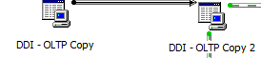 and 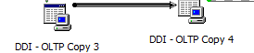 by running spe_TD_Trans_GroupBy_insert
and spe_TD_Trans_insert

Please note, that from .csv to Temp_Td_Trans, the tgl_trans column still in varchar type, and will be converted into datetime by sp : spe_TD_Trans_GroupBy_insert

Not yet

