- How to transfer many csv into one table using For Each Loop container
- Prepare your CSV files:
  - Ensure all CSV files intended for the same table have identical column structures (data types, order, and names).
  - Place all CSV files in a single, dedicated folder.
  - (you can see it already run under package

- Create an SSIS package in Visual Studio:
  - Open SQL Server Data Tools (SSDT) or Visual Studio with SSIS extensions.
  - Create a new Integration Services Project.

- Configure a For Each Loop Container:
  - Drag a "For Each Loop Container" from the SSIS Toolbox onto the Control Flow tab.
  - Double-click the container to open its editor (or you can right click and choose Edit at the top).
  - In the "Collection" tab, set the "Enumerator" to "Foreach File Enumerator".
  - 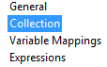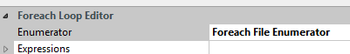
  - Specify the "Folder" where your CSV files are located.
  - Set "Files" to *.csv to include all CSV files in the folder.
  - Set "Retrieve File name" to "Fully qualified".
  - 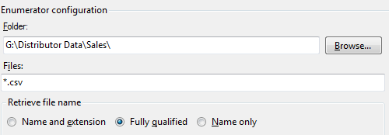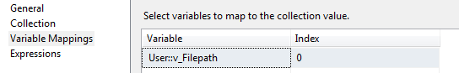
  - In the "Variable Mappings" tab, create a new variable (e.g., User::FileName) and map it to Index 0 to store the full path of each CSV file during iteration. In My version of SSIS, you must create this variable by right click on the Control Flow tab, and click Variables

- Add a Data Flow Task inside the loop:
  - Drag a "Data Flow Task" into the "For Each Loop Container".
  - Double-click the Data Flow Task to open its designer.

- Configure the Flat File Source:
  - Drag a "Flat File Source" from the SSIS Toolbox onto the Data Flow designer.
  - Double-click the Flat File Source to open its editor.
  - Click "New" to create a new Flat File Connection Manager.
  - Browse and select one of your CSV files to define the metadata (columns, delimiters, etc.). This will serve as the template for all other files.
  - Configure the column properties (data types, lengths) to match your SQL Server table.
  - Click "OK" to save the connection manager.

- Make the Flat File Connection Manager Dynamic:
  - Right-click on the Flat File Connection Manager in the Connection Managers pane and select "Properties".
  - In the Properties window, find the "Expressions" property and click the ellipsis (...).
  - Add a new expression for the ConnectionString property. 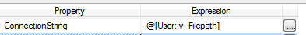
  - Set the expression value to @[User::FileName] (your variable created in step 3). This will dynamically update the file path for each iteration of the loop.

- Configure the OLE DB Destination:
  - Drag an "OLE DB Destination" from the SSIS Toolbox onto the Data Flow designer.
  - Connect the output of the Flat File Source to the OLE DB Destination.
  - Double-click the OLE DB Destination.
  - Configure the OLE DB Connection Manager to connect to your SQL Server database.
  - Select the target SQL Server table where you want to load the data.
  - Go to the "Mappings" tab and ensure the source columns are correctly mapped to the destination table columns.

- Execute the SSIS package:
  - Run the SSIS package. The For Each Loop Container will iterate through each CSV file in the specified folder, and the Data Flow Task within it will load the data from each file into your SQL Server table.

- How to transfer many csv into one table using For Each Loop container, fix the null columns
(you can see it already run under package

Same with No. 1. Just go to the Flat File Source, right click and choose Show Advanced Editor, then Component Properties tab
And change Retain Nulls to True

- How to transfer many csv into one table using For Each Loop container, fix the null columns, and change the default of column width.
(you can see it already run under package

Same with No. 1 and 2. Just go to the Connection Manager of Flat File Source right click and choose Edit, then Advanced option 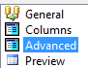, choose column that you want to change
And change to 100 from 50
If you just copy paste from the previous package you have create, you might the result you don’t expected..particularly you insert many times only the first table..don’t hesitate to create it from the beginning for that package.

- How to transfer many csv into one table using For Each Loop container, fix the null columns, and change the default of column width, and add column name for file name
(you can see it already run under package
You need to create derived column here. Below is the additional steps, beside already explained before

Add and Configure Derived Column Transformation:
- Drag a Derived Column transformation from the SSIS Toolbox onto the Data Flow canvas.
- Connect the output of the Flat File Source to the input of the Derived Column transformation.
- Double-click the Derived Column transformation, or you can right click and choose Edit.
- In the "Derived Column Name" column, provide a name for your new column.
- In the "Derived Column" column, select whether to add a new column or replace an existing one.
- In the "Expression" column, build your expression using available columns, variables, functions, and operators to define the logic for your derived column. As usual, variable v_FilePath for Expression must exist first. Length can be adjusted later, or you can cast your expresision like (DT_WSTR, 350) @[User::v_FilePath]

- Click "OK".

To set the width (or length) of a derived column in SSIS, especially for string data types, follow these steps:
- Open the Advanced Editor:
Right-click on the Derived Column transformation in your SSIS Data Flow Task and select "Show Advanced Editor."
- Navigate to Input and Output Properties:
In the Advanced Editor window, go to the "Input and Output Properties" tab.
- Locate the Derived Column:
Expand "Derived Column Output" and then "Output Columns." Find the specific derived column for which you want to adjust the width.
- Modify the Length Property:
Under the "Common Properties" section for your selected derived column, locate the "Length" property. Manually enter the desired maximum length for your derived column.
Alternative Method (Explicit Casting):
You can also explicitly cast the derived column's expression to a specific data type and length within the Derived Column transformation itself. For example, to ensure a string derived column has a length of 50 characters, you could use an expression similar to:
Code
(DT_WSTR, 50) YourExpression
This method can be useful when you want to enforce the length directly within the expression, but using the Advanced Editor offers a cleaner separation of configuration.

To get filename only, you can change your expression :
RIGHT(@[User::v_FilePath], FINDSTRING(REVERSE(@[User::v_FilePath]), "\\", 1) - 1)
Or SUBSTRING(@[User::v_FilePath],27,100)

