Internet of Things – AP Web Server

Grad Project

Team: Return To_Sleep

Members:

Eric Simmons

Chirag Padsala

Palak Lodha

Komal Musale

Jason Ligon

CPSC 440-01 13325

Fall 2016

Professor: Dr. Ning Chen

Department of Computer Science



California State University, Fullerton.

November 11, 2016

Table of Contents

Introduction………………………………………………..…………………………………..3

ESP8266 Thing Development Board and FTDI Basic………………………………………...3

Arudino IDE…………………………………………………………………………………………….4

Web Server……………………………………………………………………………….…………..…4

Conclusion…………………………………………………………………….…….….….….……..…8

References………………………………………………………………………………………………9

Table of figures

Figure 1: Our mobile devices connected to the ESP8266 Thing 11B8………………………..5

Figure 2: Connected device showing ADC and digital pin 12 readings while led on…………5

Figure 3: Connected device showing ADC and digital pin 12 readings while led on…………6

Figure 4: Turning on LED via mobile browser using 192.168.4.1/led/1……………..……….6

Figure 5: Turning off LED via mobile browser using 192.168.4.1/led/0………….…………..7

Introduction

The goal of our project is to get hands on experience with the Internet of Things (IoT). The basic concept of the Internet of Things is connecting everyday devices such as coffee makers, washing machines, and cell phones to the Internet and sometimes to each other. The project was to be done using two pieces of hardware; ESP8266 Thing Development Board and SparkFun FTDI Basic Breakout. The ESP8266 Development Board is a microcontroller that is cost-effective and WiFi-enabled. It can be programmed for different purposes, such as monitor sensors, trigger relays, automate coffee makers and blink LEDs. The SparkFun FTDI Basic Breakout is primarily used to program the development board.

Given the WiFi capability of the ESP8266 microcontroller, our team made a Web Server using the ESP8266. The web server acts as a WiFi hotspot where connected devices can use their web browser to on and off a LED of the ESP8266 and check the status of the analog and digital pins. Arduino IDE was used to upload the code onto the board. The source code for the AP web server provided by learn.sparkfun.com was utilized to help program the project.

ESP8266 Thing Development Board and FTDI Basic

The ESP8266, as aforementioned, is a versatile microcontroller that is used for various purposes. The ESP8266 by itself is just a wifi chip with a few LEDs and cannot be programmed and has no power. A 3.3V I/O serial connector is needed to program the board. For our project, we used a Sparkfun FTDI basic. Two 10-pin stackable headers were soldered to the ESP8266, and a 6-pin right angle male header was attached to the FTDI Basic to connect the two boards. The 6-pin right angle male header was created using a breakaway right male header by snapping the breakaway header into two pieces. A micro USB was used to power the ESP8266, and a separate USB was used to both power the FTDI Basic and to allow a computer with the Arduino IDE to communicate with the devices.

Arduino IDE

The Arduino IDE (Integrated Development Environment) was used for writing the code to our board. It connects to Arduino and Genuino hardware enabling the software to communicate with these devices. The code developed in Arduino, much like the program used for our program, are called sketches. The sketches are written in the IDE and saved with the file extension ‘.ino’. The message area of the IDE also provides status feedback to the developer while saving, exporting, and displaying errors.

Web Server

We took advantage of the WiFi capability of the ESP8266 for our project. We were able to use the board as an Access Point Web Server. A WiFi-enabled device was successfully able to connect directly to the WiFi chip. The ESP8266 is quite capable of setting up a network on its own. We uploaded the code provided by the Sparkfun tutorial as a starting point of the project. After uploading the source code using the Arduino IDE, we used our phone to look for a network called “ThingDev-11B8”, where the 11B8 is the last 2 bytes of the Thing Development Board’s MAC address. Our figure 1 shows our device connected to the ESP8266 board. The network’s password for this project is “sparkfun.” After connecting to the board’s AP network, we opened a web browser and pointed it to “192.168.4.1/read.” The Thing Dev Board opened up a web page showing us its ADC and digital PIN readings shown in figure 2. After this, we then gave “192.168.4.1/led/0” and “192.168.4.1/led/1 a try.

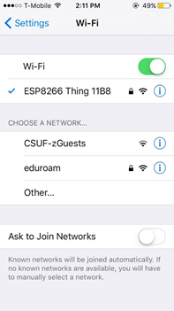

Fig. 1. Our mobile devices connected to the ESP8266 Thing 11B8.

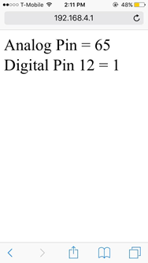

Fig 2. Connected device showing ADC and digital pin 12 readings while led on.

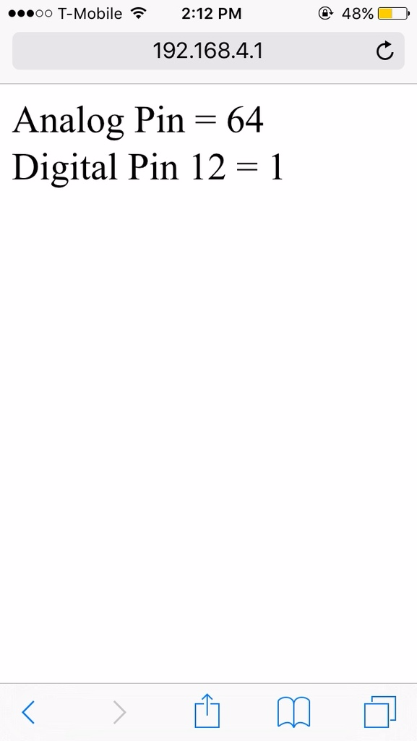

Fig 3. Connected device showing ADC and digital pin 12 readings while led on.

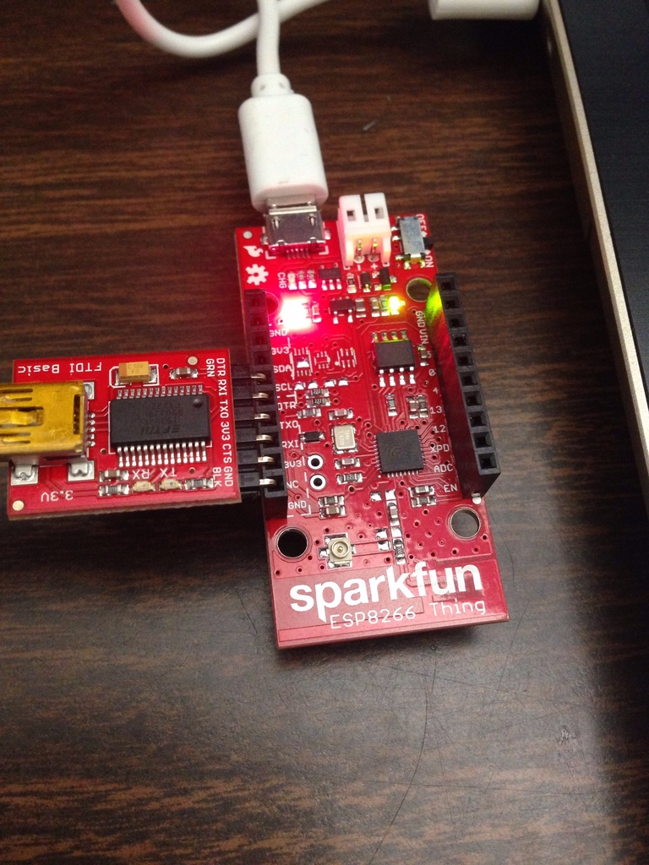

Fig 4. Turning on LED via mobile browser using 192.168.4.1/led/1

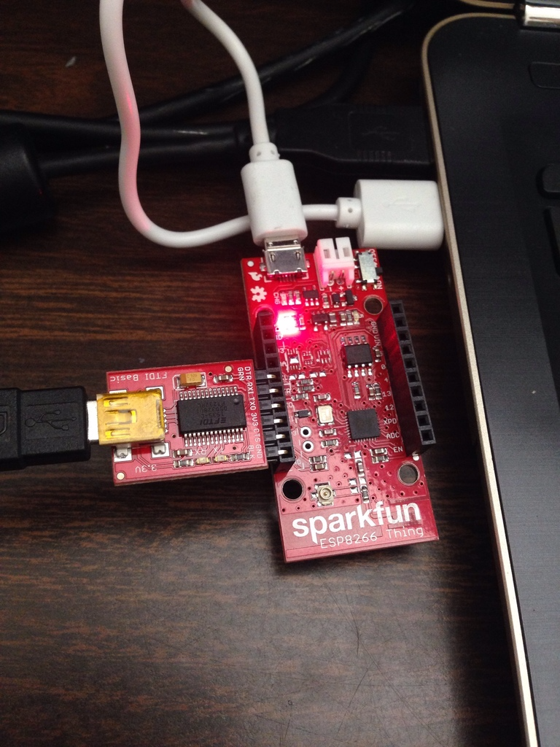

Fig 5. Turning off LED via mobile browser using 192.168.4.1/led/0

Conclusion

Learning about the Internet of Things is highly relevant in today’s technology driven world. General Electric and the McKinsey Global Institute has estimated that the Internet of Things will make up anywhere between $10 to $15 trillion dollars of the global GDP by 2025. Wearable Internet of Things devices grew by 235% in 2015. Given the massive growth and potential in IoT, gaining hands-on experience is useful for anyone who wishes to pursue this category of the tech industry. We were able to gain a good insight and experience on how to program a powerful IoT device. The tools available to us made it easy for us to get started on it and see the project live with the help of the ESP8266 board. We were to successfully use this board to set up an Access Point web server that allows devices relevant to our daily lives such as phones, laptops, and tablets to connect to the internet.

References

AP Web Server

[https://learn.sparkfun.com/tutorials/esp8266-thing-hookup-guide/example-sketch-ap-web- server](https://learn.sparkfun.com/tutorials/esp8266-thing-hookup-guide/example-sketch-ap-web-%09server)

ESP8266 Thing Hookup Guide

[https://learn.sparkfun.com/tutorials/esp8266-thing-hookup- guide?_ga=1.2240115.256908981.1475790501](https://learn.sparkfun.com/tutorials/esp8266-thing-hookup-%09guide?_ga=1.2240115.256908981.1475790501)

Hardware Assembly

<https://learn.sparkfun.com/tutorials/esp8266-thing-hookup-guide/hardware-assembly>

Installing the ESP8266 Arduino Addon

[https://learn.sparkfun.com/tutorials/esp8266-thing-hookup-guide/installing-the-esp8266- arduino-addon](https://learn.sparkfun.com/tutorials/esp8266-thing-hookup-guide/installing-the-esp8266-%09arduino-addon)

Posting to Phant

[https://learn.sparkfun.com/tutorials/esp8266-thing-hookup-guide/example-sketch-posting-to- phant](https://learn.sparkfun.com/tutorials/esp8266-thing-hookup-guide/example-sketch-posting-to-%09phant)

Powering the Thing

<https://learn.sparkfun.com/tutorials/esp8266-thing-hookup-guide/powering-the-thing>

Programming the Thing

<https://learn.sparkfun.com/tutorials/esp8266-thing-hookup-guide/programming-the-thing>

SparkFun ESP8266 Thing

<https://www.sparkfun.com/products/13231>

Wikipedia (2016). ESP 8266

<https://en.wikipedia.org/wiki/ESP8266>