Giver, Taker and Matcher Psychology in Multi-Agent Exploration
Bruno Leão 2012138765
Carlos Paiva 2009108909

Introduction

This paper tries to apply the Giver, Taker, Matcher (GMT) theory to exploration agents to study how agents should cooperate with each other for better results.
This theory was proposed by Adam Grant, as seen in the video presented on the bibliography, and consists on separating people in three classes, according to how willing to help other people they are. Those classes are:
- Giver: This person likes to help and is always willing to do so;
- Taker: This person only likes to be helped, not being much of a helper;
- Matcher: This person is the “eye for an eye” type, he will help, but he expects to be helped in return and if that does not happen, he will refuse to help again.

System Architecture
To simulate this, we created an environment with different types of objects that may only be identified by an agent who is specialized in that type of object. If an agent finds an object that he can’t identify because he is not specialized in it, he will ask the other agents for help through a broadcast method. If those specialists have a target, they will not respond to the call, as they are busy. If they do not have a target, they will respond according to their personalities:
- Giver: will always respond affirmatively;
- Taker: will always respond negatively;
- Matcher: keeps a list with scores for each other agent, which increase as he is helped by them and decreases if he helps them. If that score is not negative, he will help;
Each agent gains a point when he identifies an item and when another agent who he asked for help identifies the item for which help was requested, that is: in a situation when an agent finds an item that he cannot identify, this agent will ask for help identifying this item. If another agent comes and successfully identifies that item, both agents get a point. If nobody comes, that agent does not get a point and will move on.
The environment is randomly generated, although we can define the seed as we want. The agents will also be placed randomly on the field.
This paper will focus on how the ratio of giver, taker and matcher agents affects how long the agents take to identify all objects in the environment and on the individual performance of each agent.

Experimental Setup
We measured the performance of each personality distribution that is presented on the table 1.
All teams have 60 team members (Agents), exploring an ambient with 900 objects total, distributed equally in 3 different classes.
Distribution ID | % of Givers | % of Takers | % of Matchers
1 | 25 | 19 | 56
2 | 100 | 0 | 0
3 | 0 | 100 | 0
4 | 0 | 0 | 100
5 | 70 | 10 | 20
6 | 10 | 70 | 20
7 | 10 | 10 | 80
Table 1. Tested Personalities Distribution.
The control team corresponds to the distribution 1 team on table 1, this control team personality distribution is presented by Adam Grant on his book corresponding to the personality distribution of the employees in the companies that he had studied.

Results and Conclusions
1- Group performance
We had find that we get better performance when all the agents are givers as can be seen in figure 2, achieving the complete mapping of the environment in less than 2500-time unit’s. However, when we “infect” a team of givers with some takers or matchers the performance falls drastically as we can see in figure 5.
The environment that has only takers presented, as we expected and as the author of the GTM theory predicted, by far the worst result. The environment only with matchers presented a better result than the environment with takers only, but still had worst results, by far, than the only givers environment. The addition of givers in any of these environments improved greatly the overall performance of the team, as can be seen in the figures for the last 2 distribution.
The most surprising result is of the control environment, in which we used the data collected by Adam Grant on his research about the employee personalities on the companies that he has studied. On the control environment, we have that 90% of the environment objects are identified in a similar time of the fastest of the personality’s distributions, but differ in great way in terms of personality distribution of the best result, pointing that we still can have good performances with different personality distributions. Note that the only givers team is a unrealistic team and that the addition of other types of personalities on this team, as we had pointed, decreases greatly the overall performance of that team, turning it worse than the control team.
In the multi-agent exploration paradigm, we can see that creating a form of communication and cooperation between agents can drastically increase the performance of the overall system, even if not all agents have this ability, as can be clearly seen when we compare the results for the distribution 3 and the results for the distribution 6. Thus, it may be useful invest some time and effort in creating even a simple way for different agents with different capabilities to communicate while performing their tasks of environment exploration.

2- Individual Performance
We were surely happy to notice that our results match Adam Grant’s statistical studies figure 12. In the various tests we have made, like the one we showed in figures 8 and 9, givers have consistently a wider performance range than matchers and matchers than takers (this last one varies more from simulation to simulation). Also, givers are consistently both the best and the worst in terms of performance. Some of our simulations showed better performance for takers than matchers in general and sometimes takers can also perform really well individually, as shown in figure 10, even though, as shown in the previous section, they are detrimental to the group.
Another thing worth noting is that changing the ratio of givers, takers and matchers does not seem to affect their individual performance distributions. All the box-plots presented in figures 8, 9 and 10 are for distribution 1, but other distributions, as shown in figure 11 were tested without very different results.

Future work
Simulating different environments with rare objects or having agents with various specializations are topics for future research. Having various agents with different abilities, such as some who have higher or lower ratios of identifying one or more different types of objects would also be an interesting topic to research.

Bibliography
https://www.ted.com/talks/adam_grant_are_you_a_giver_or_a_taker

Give and Take: Why Helping Others Drives Our Success, Adam Grant

Images
Figure 1. Distribution 1.
Figure 2. Distribution 2.
Figure 3. Distribution 3.
Figure 4. Distribution 4.
Figure 5. Distribution 5.
Figure 6. Distribution 6.
Figure 7. Distribution 7.

Figure 8.
Figure 9.
Figure 10.
Figure 11: 80% Givers, 10% Matchers, 10% Takers.

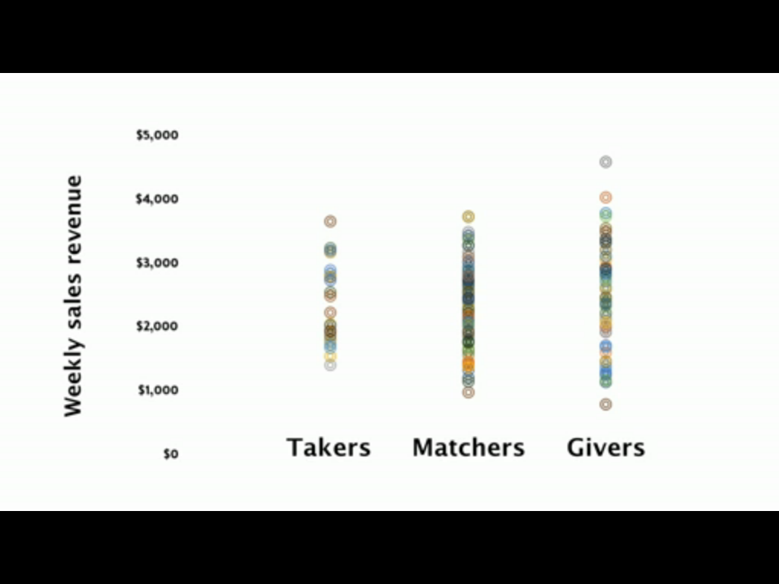
Figure 12: Adam’s Grant Statistical research.

