Project 3&4
Controlling Drone motors Via Bluetooth
Components Used:

Arduino Uno - 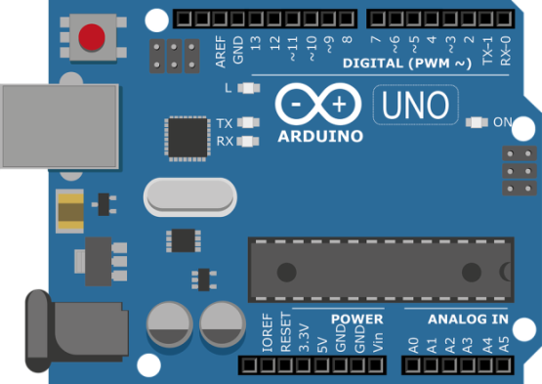
DC Motors - 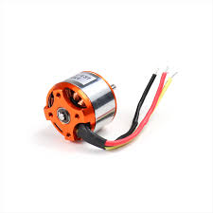
HC06( Bluetooth module) - 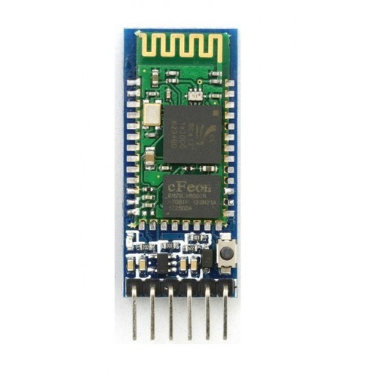

Battery (11.1V) - 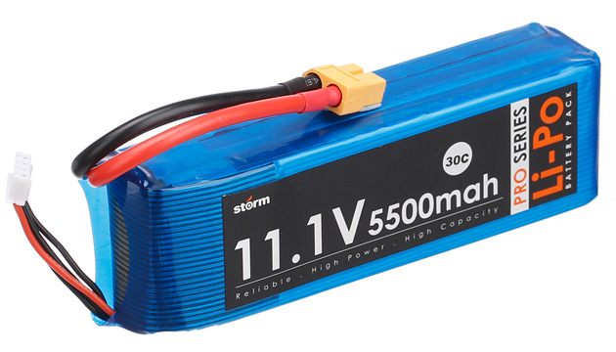
Jump Wires - 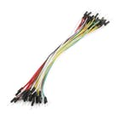
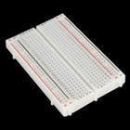
Breadboard (generic)-

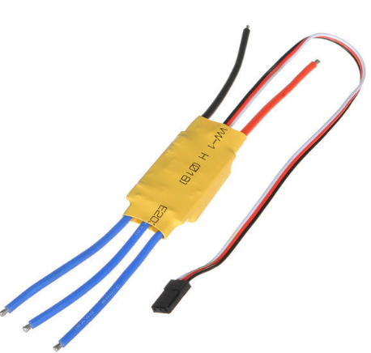
Electronic Speed Controller(30A) -

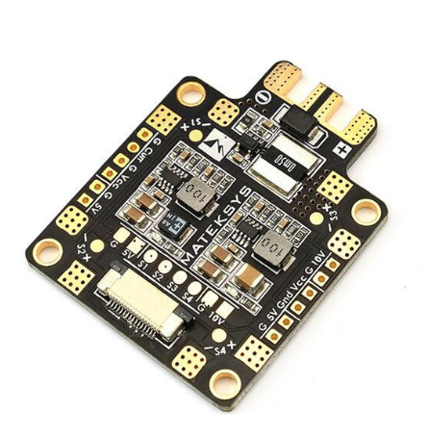
Power Distribution board (PDB) -
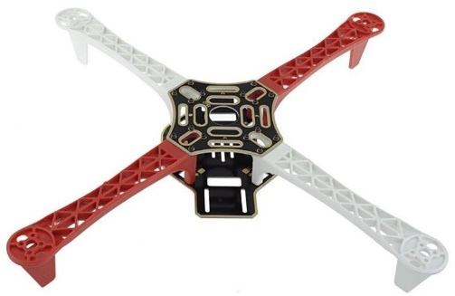
Drone Frame -

Fritzing Circuit – Schematic Diagram
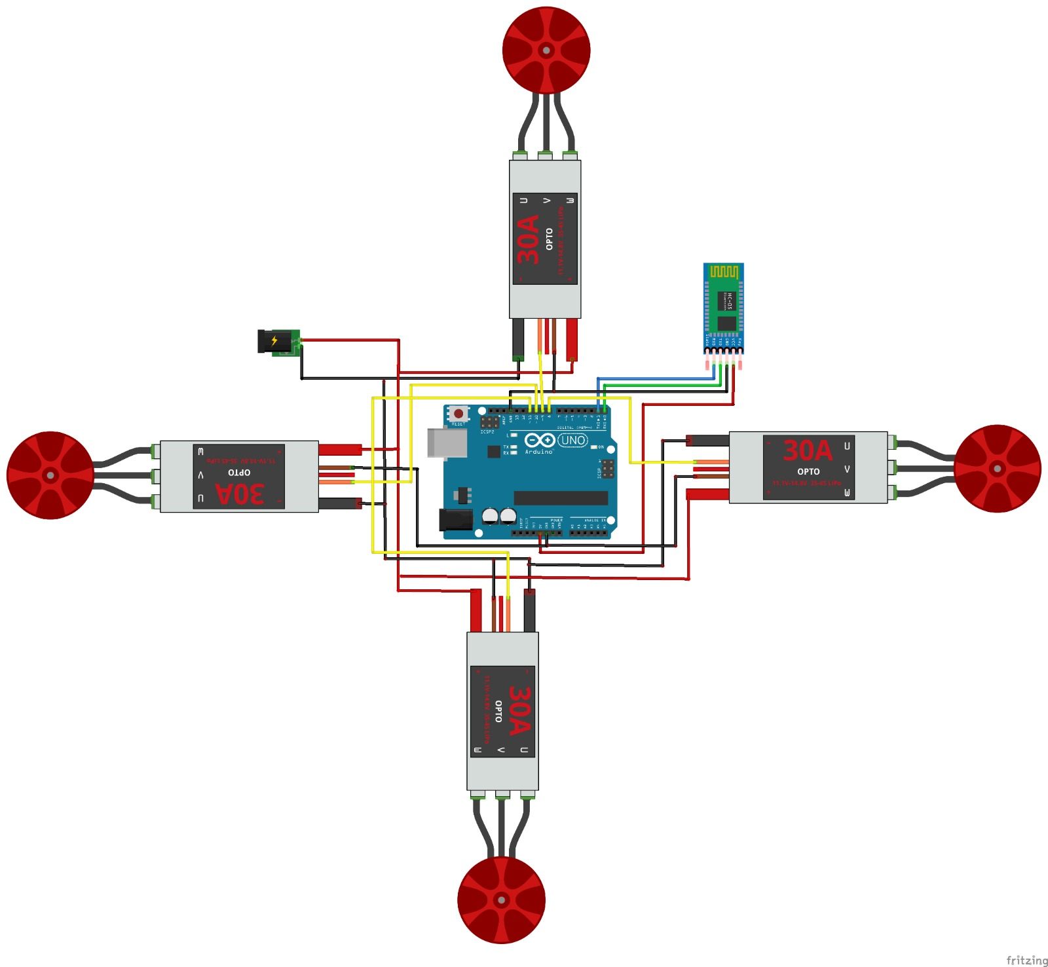
Connections
- Connect 4 of the motors to 4 of the Electronic Speed controller(u,v,w)
- Each of the 4 Electronic speed controller’s black and red wire Is connected to the battery pins
- Each of the orange wire from ESC is connected to the respective input digital pins (8,9,10,11) of Arduino
- Each of the brown wire from ESC is connected to the ground pin of Arduino
- Vcc and GND of Bluetooth controller is connected to the Vcc and GNd of the Arduino
- Transmitter pin of Bluetooth is connected to the receiver of the Arduino
- Receiver pin of the Bluetooth is connected to the transmitter pin of the Arduino
- Connect VCC, SDA, SCL and GND of PCA 9685 to 5v, A14, A15, GND of Arduino.
- Connect the USB to power up the Arduino and upload the code.

Implementation:
- Connection is given according to the fritzing circuit
- Drone Frame is fixed and the 4 DC motors is fixed to 4 corners of the drone frame
- Bluetooth module is attached to control the motors using Bluetooth app
- Android app is developed in which using Bluetooth we can control the motors
- Once the On button in the mobile app is pressed , all of the 4 DC motors start to function
- It keeps on operating until it is switched off
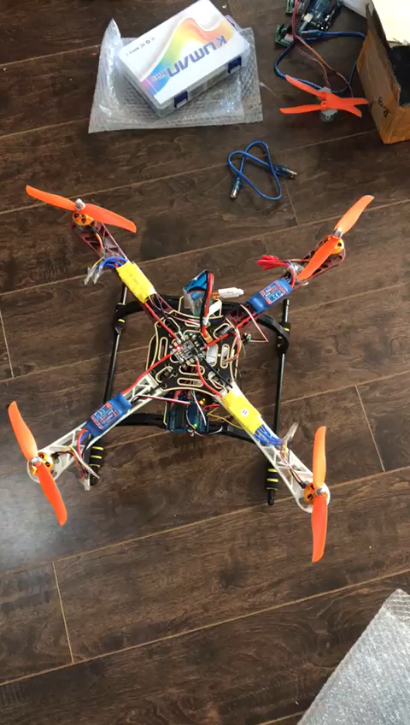
Thank You

