**Building the Perfect Sales Funnel**

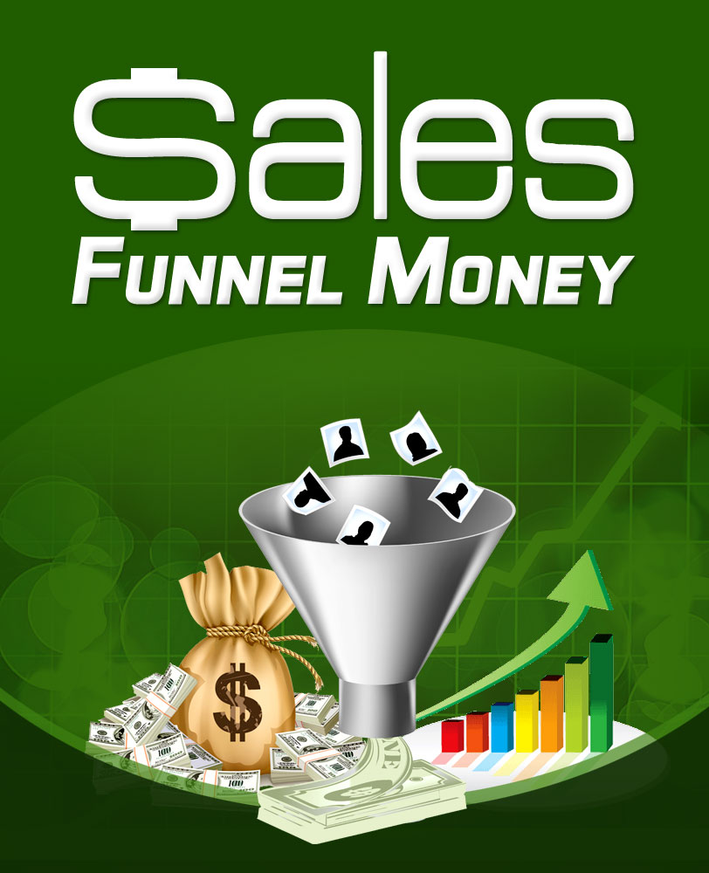

**Table of Contents**

Introduction.................................................................................3

Why is having an efficient sales system so important?........................5

The basic sales funnel model…........................................................8

The search for targeted traffic.......................................................11

Why is the sales funnel concept so important?.................................13

Why automation is essential….......................................................16

How do you handle prospects most effectively?...............................19   
How to automatically make a small commitment much larger….......19   
Creating and using effective landing pages…................................21   
You MUST test your landing pages…............................................28

With your landing page in place, what’s next?.................................30   
Step 1 – Keep as many prospects in your funnel as possible….........30   
Step 2 – The initial product sales process…..................................31   
Step 3 – Offer an upgraded version…..........................................32   
Step 4 -Making a one-time offer…..............................................34   
Step 5 -Make another one time offer…........................................35

Conclusion.................................................................................39

**Introduction**

There is no doubt that owning and running your own successful online business can be a tremendously liberating thing, as thousands of online entrepreneurs and marketers all over the world have discovered for themselves.

If you are already in a position where your business is successful, then congratulations are undoubtedly in order.

However, here’s a question for you.

Although your business is already successful, perhaps even already achieving as much as you could ever have hoped for, is there any possibility that you could be doing things more effectively? Are there ‘flaws’ in your marketing plan that are letting potential customers escape without putting their hand in the pocket to pull out their credit card, or giving you their email address?

Alternatively, you might just be starting out on the road to earning an online income, and if that’s the case, there is probably a great deal about internet marketing or online business that is confusing and apparently complex. Trust me, this is a position that even the most experienced of online marketers will understand because we have all been there and experienced exactly what you’re going through right this minute.

The problem with online marketing is that by the nature of the beast, there are dozens of new products hitting the market every week, and it is only natural that the creator of each of those products or services believes that they have just invented the best thing since sliced bread.

Quite naturally in most cases, the product creator has probably not achieved quite as much as they might believe they have. Nevertheless, the fact still remains that there is a mass of new information out there in the world of online marketing almost every day, an ‘information overload’ that can make getting your new online business off the ground seem dauntingly difficult.

But here is the most important thing. It does not have to be this way because running an online business does not have to be difficult or complex. It is simply a question of focusing on the key issues, ignoring information that is not directly related to the kind of business you plan to set up and run, and getting on with it.

This e-book is focused on one of the most important issues that any online marketer will ever face, which is a simple question of making your business as efficient as possible.

Whilst I have no doubt that there are dozens of new products out there in the market as you are reading this that appear to be more ‘cool’ or ‘sexy’ than this one, you should not ignore the information you will gather herein.

The basic truth is, the more efficient your system is, the less it matters what kind of business you are running, because you will be maximizing your profits at every turn in any case.

It is entirely irrelevant whether you are selling the latest ‘super duper gizmo-style widget’ or a product that has been around for years, with an efficient sales system in place, you are naturally able to squeeze every last drop of profit out of whatever it is you do.

It should be obvious that this is extremely important, but you may never have considered exactly why it is so important. You are about to find out.

**Why is having an efficient sales system so important?**

You’re probably aware that it does not matter how attractive your website is or how fantastic the product or service offer that you’re making from that site is either. If no one ever visits your website, it is totally impossible for you to generate any sales so without site visitors, it is equally inevitable that your business is going to collapse around your ears sometime very soon.

You may also understand that sending visitors to your website is not enough because unless those visitors are targeted, your sales process is far less than efficient. This is something we will look at in a little more detail later.

However, for the moment, let’s consider how you attract visitors to your site.

There are in essence three different ways of pulling visitors onto your web pages.

Firstly, you can buy visitors by using paid advertising like [Google AdWords](https://www.google.com/accounts/ServiceLogin?service=adwords&hl=en-US&ltmpl=adwords&passive=true&ifr=false&alwf=true&continue=https%3A%2F%2Fadwords.google.com%2Fselect%2Fgaiaauth%3Fapt%3DNone%26ugl%3Dtrue) to generate traffic. Doing things this way can be very efficient as long as you know what you’re doing with the possibility of driving visitors to your site in a matter of hours.

On the downside, you have to pay for advertising and it is a fact that when you are using AdWords in particular, it can work out extremely expensive until you have mastered exactly how the system works.

This is because the pricing structure adopted by Google is flexible with the cost of each click on your adverts varying according to whether your adverts and the supporting website at which your ads are ‘pointed’ are constructed in the way that Google want them to be.

There are of course dozens of alternatives to AdWords. Nevertheless, the fact is that most online marketers use AdWords because nearly 70% of the internet enabled population of the planet use the Google search engine rather than any of the alternatives.

In short, if you want your advertising to be seen by the largest number of potential prospects, then AdWords is the most sensible choice.

With AdWords, it is possible to reduce your costs by making sure that your adverts and your site comply with Google requirements. This can however take time.

The second option is to promote your business for free by publishing keyword focused articles, video materials on sites like YouTube, Vimeo, and Google video, forum marketing and so on. All of these methods are effective but they are usually far slower than using paid advertising and there is considerable time involved in preparing the materials in the first place.

For instance, unless you are an expert article author, it could take you anything from 30 minutes to 1 hour to do your initial research and then write your article. If you were to follow the advice of many experts who suggest that you should always submit at least five or six articles that are based on the same topic or subject matter together, it becomes fairly obvious that even something as simple as creating articles can be pretty time-consuming.

The third option is to ‘borrow’ traffic by getting involved in suitable joint-venture operations with other marketers in your market sector or niche. This is a fantastic way of marketing, because you are leveraging the popularity and market presence of the person you’re working with to generate business. Consequently, joint ventures are often the most successful form of marketing.

However, there is yet again a proviso because joint ventures do not happen overnight. You have to build or develop your relationship with the marketer with whom you’re planning to work and you have to put together a top quality package of marketing materials to make their job as easy as possible. It is likely that you will probably have to spend some time and not a small amount of effort convincing them that you know what you are doing and that everything is ready to go to the market.

If you think about these three different methods of driving traffic to your site, you will probably begin to note that there is a common theme running through everything you have read so far.

Every one of these individual traffic generation strategies has advantages over the others, but at the same time, each of them also has disadvantages. And in every case, the major disadvantage is remarkably similar.

No matter how you set up your systems to drive traffic to your site, there is a cost involved, whether that cost is measured in terms of money (paid advertising) or time (which in business often amounts to pretty much the same thing anyway).

To a certain extent, the way that you promote your business will be decided by your own value judgment of which is more important to you, keeping money in your pocket or saving your time.

In my experience, when you are a complete beginner, it is money that is the most valuable, primarily because you don’t have any. However, as your business becomes more successful and starts to generate income, the importance of time tends to come to the fore as money is always replaceable, but time never is.

And here is another critical thing to understand about the cost of the traffic that you generate to your site.

Each and every one of those visitors is expensive in some way or another. Indeed, getting them to come to your site for the very first time is the most expensive visit you will ever generate. To get to this point, you have had to spend time, money or both to go out onto the internet and ‘grab’ that visitor.

Until you did so, they were not aware of your site or business. Hence, it naturally follows that if you had not gone out there with promotional materials that attracted their attention, you would never have been in a position to present them with your offer.

Thus, it is an inarguable fact that getting new traffic to your site for the very first time could be expensive and that any subsequent visit to your site by someone who has already visited costs almost next nothing in comparison.

In some cases, the visitor will return to your site of their own accord, in which case there is really no cost to you at all. Alternatively, they might come back because you have a system in place that encourages them to return.

This system might take some time and effort to set up, but you only have to do the job once, after which your system continually pulls visitors back to your site. The cost per individual return visit is therefore negligible.

Knowing that each first-time visitor could be the most expensive that you will ever attract means that it has to make sense to ensure that you do everything possible to turn that visitor into an asset of your business.

This is essentially what having a sales system in place is all about.

An efficient sales system is one that is designed to squeeze every possible cent out of every visitor who ever comes to your site. To go one stage further, it is about maximizing the profits of your business because profits always equal incoming revenue minus costs. As we have already established, the cost of each visitor is the highest it will ever be when they visit for the first time.

So far, I have continually used the phrase sales *system*. However, it is relatively common in all forms of business, both online and offline, to present this sales process as a funnel, hence the title of this e-book. In the next chapter, I will illustrate why this is and how the concept works.

**The basic sales funnel model…**

There are dozens of different ways of illustrating the sales funnel concept because the exact make-up of this funnel will vary from business to business depending upon the demands and operating style of different businesses.

Nevertheless, there is always a general similarity in the basic depiction of the sales funnel model. Thus, we can use a general stylized sales funnel to begin to illustrate exactly how the sales funnel is applicable to online marketing.

The basic idea of the sales funnel is that at the top (the ‘mouth’ or widest part of the funnel) you have your potential prospects. At this point in time, these individuals have done nothing to signify that they are likely to do business with you at any time in the future.

Depending upon how you create your own funnel model, these prospects could be just outside the top of your funnel or just inside the top lip.

However, as a general rule, it is normal to assume that anyone who is actually inside the funnel has made a least some degree of commitment to your business, possibly something as simple or basic as visiting your site.

This is the most basic commitment level from a potential prospect to your business. The prospect has seen some form of promotional material that you have ‘seeded’ the net with, was interested in what you had to say and decided to visit your site to investigate a little further.

Thus, they have taken the very first step that you wanted them to take, hence the notion that they have already made some form of commitment to you, albeit a very small one.

At this point, having just entered the widest, uppermost part of your sales funnel, the prospect has a choice to make. Either they are going to find your offer to be of sufficient interest to commit themselves further or they are going to decide the opposite. In this case, they jump back out of your funnel, lost to your business forever.

It is this notion that people can ‘jump out’ of your sales system at any time they want which leads to the basic funnel concept. At every step of the process, there will be people who make the decision to go no further and back out. Hence, you have less and less people still interested in what you are doing as they move through your sales process (or down your sales funnel) meaning that your scope for business narrows because of the dwindling number of people still involved.

But even at this early stage, your first-time site visitor has a choice to stay or go. If they do not jump out of your sales funnel by closing your page forever, the next logical step is that they will increase their commitment to you to a greater or lesser degree.

For example, they may browse around your site to see exactly what you have to offer on a site-wide basis, an act that indicates that they are seriously interested in what you have to offer. Hence, this simple action indicates a higher level of commitment.

Alternatively, it is more common to ask them to take a specific action on this page, such as signing up for your mailing list, providing additional information or some action of this nature. If they choose to do this, the element of commitment is considerably higher because they have taken the action that you required.

In the first of these two commitment examples, the individual who takes a look at a few more pages on your site pushes themselves a little further down the funnel (or through your system) by this action.

However, we have already established that some people will already have backed out before now. Thus, there are less people still interested in what you have to offer at this slightly more advanced stage, hence the narrowing of the sales funnel.

On the other hand, the individuals who have taken the action that you asked them to take have pushed themselves considerably further down the funnel. At this level, there are again less people and therefore the funnel continues to get still narrower.

In the following simple sales funnel schematic, you might say that the upper blue layer represents the first time visitors that you have drawn to your site: Of these visitors, the ones who make a minor commitment to you by browsing around your site for a reasonable period of time might be imagined to have moved down to the next (green) level of the funnel.

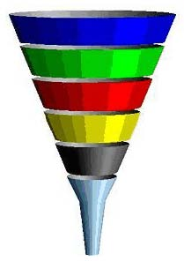

However, those who subscribed to your mailing list or took whatever other action you requested have moved past these slightly less committed people straight down to the red layer, where there are considerably less people and therefore a narrower funnel.

And so it goes on. The more commitment you are asking for from your site visitors, the less people are likely to make that commitment.

It should therefore be clear that the whole sales funnel concept is based upon the idea that selling products or services (whether online or offline) is a step-by-step process of pushing people down the funnel or through your sales system.

At each level of the funnel, you have to ask your prospect to increase their level of commitment knowing that by doing so you are going to drive some of these prospects or customers away.

This is absolutely inevitable but there is no inevitability attached to the number of people who might decide to jump out of your sales funnel at any particular level.

In other words, this book is going to show you how to create a sales funnel in such a way that you can prevent huge numbers of hot prospects from jumping back out of your funnel once you have got them to take the initial step that you want them to take.

Before doing that, let us consider how you get people to take the first step that you want them to take, which is to visit your site.

**The search for targeted traffic**

It is important to realize from the outset that the sales funnel concept does not work on the basis of pulling just anyone to visit your website. On the contrary, it is absolutely essential for the funnel concept to make any sense that the people you draw your website are targeted, pre-qualified visitors.

Using a simple example will explain this very easily. If you have a website based business that promotes weight loss products online, it is logical that the best prospect for your business is someone who is overweight that wants to change their life.

Consequently, you would target your marketing and promotional efforts in such a way that they would be put in front of people who are overweight. By doing so, you ensure that the majority of people who come to your site already represents a hot prospect because they are looking for or interested in the products you have to offer.

If however you bring someone who is trying to decide whether they want to buy an Xbox 360 or a scooter, the chances of that individual buying your products are almost zero.

Sure, it is perfectly possible that they might be overweight but they are still not going to buy. The fact is, they are not particularly interested in weight loss related products at this particular moment in time, so why would they?

They are searching for specific information that is completely different to that which you provide and they are therefore going to close your site within milliseconds.

Hence, all of your initial marketing efforts have to be focused on making sure that the people who you bring to your site (to the first, widest level of your funnel) are targeted visitors.

We have already considered the various different ways that you can drive traffic to a website. The only additional proviso should be made is that in each and every case, you have to make sure that your marketing efforts are targeted.

For example, your AdWords advertising materials must feature your primary keywords as must any articles that you publish on directory sites like [EzineArticles](http://ezinearticles.com/) as well as the descriptions that you attach to the videos that you publish at YouTube and so on.

This element of prequalifying visitors to your site is an essential part of an efficient sales funnel.

Or, to put it another way, without pulling targeted, pre-qualified visitors to your site, trying to construct an efficient, profitable sales system is a huge waste of time.

If the ‘front end’ of your system is not attracting the right kind of visitors to your site, then the chances of converting any of those visitors into customers are very remote indeed.

**Why is the sales funnel concept so important?**

As suggested, once you have targeted visitors entering your sales funnel, a percentage will make some kind of commitment to your business and a percentage will simply leave.

Consequently, your job in this situation is twofold.

Firstly, you should be applying every tool and resource available in an attempt to minimize the people who jump straight back out of your sales funnel after first entering.

At the same time (and secondly) you should also be doing everything within your power to ‘push’ people to the next lower level of your sales funnel as quickly and efficiently as you can. With every level that they descend further through the funnel, the more they are increasing their level of commitment and therefore their value to your business.

For example, if someone chooses to subscribe to your mailing list, you are in a position to send them a continual stream of promotional e-mails pushing your primary products.

At some point, it is likely that a percentage of prospects that you are e-mailing in this way will buy the products that you are promoting because it is widely accepted in online marketing that most prospects have to see an offer anywhere between seven and twenty times before they finally decide to buy (or not).

Of course, successfully selling a product in this way is exciting and rewarding because it puts money in your bank account, but it is not the end of the story. Indeed, it is really only the beginning.

Go back to the previous sales funnel illustration, and imagine that this first sales level is represented by the yellow level.

Note that there are a couple more layers further down that are even more tightly focused, getting ever closer to the narrowest point of the funnel. These levels represent people who have moved even further through the sales funnel, people from whom you can make even more profit.

It should be obvious that the likelihood of a prospect turning themselves into a customer by buying the product that you recommend will to an extent depend upon the price of that product.

If for example the product only costs $7, it is pretty much a no-brainer for anyone who has even the remotest interest in it to buy. Thus, if you were selling a $7 product you could probably anticipate big sales numbers whilst understanding that the income is going to be relatively low.

Logically speaking, it is going to be more difficult to sell a $27 product, and harder still to move one that is priced at $47. Nevertheless, as long as the product offers clearly outstanding value, even at these levels, you could expect to see reasonable sales figures.

So, let’s say that you sell a $7 or $27 product to your customer as the first piece of business that you have ever done with them. What do you do next? Is that it or are you going to push for something more?

I hope that you have answered in the affirmative to the second option rather than the first, because this is only the beginning as you will see when I construct a sales funnel for you step-by-step later in this report.

What you now know is that if you present a suitably well targeted offer to each individual customer (as they now are), they will buy at this price level.

What you don’t know is the depth of their interest in the subject on which they have just spent money. Nor do you know how far they are willing or able to go on spending money or where their price ceiling is.

So, if you have just generated a $27 sale, the next step is to offer that new customer a $47 or even a $67 product.

As you’ll discover, you should do this as soon after they have completed their initial purchase as possible because at that very moment, they are in full-on ‘buying mode’ and this is *always* the best time to ask for more business.

It is a fact of doing business online that the hardest thing in the world is to convince a new customer to get their credit card out of their wallet. Thus, once they have done so, you should maximize your returns by presenting them with an immediate upsell offer of some type.

Some of your new customers will buy, whilst others will decline the offer.

If they buy, that’s great, you have even more cash in the bank, but this is *still* not the end of the story. Now you need to know whether they have the wherewithal and/or the inclination to spend even more money on targeted products in your market.

The customer who buys your upsell offer could well be in the mood to keep buying, so you should keep offering them the opportunity to do so. And even for those customers who do not buy your upsell or anything else that you offer them, you should definitely start offering more higher-priced products in your promotional e-mail messages to them.

After the initial flurry of sales activity, at every step of the way, you must progressively narrow down and focus your business by establishing how far each individual customer who is on your mailing lists is willing to go. This concept is based upon the somewhat clichéd but nevertheless remarkably accurate notion called the [Pareto principle](http://en.wikipedia.org/wiki/Pareto_principle) or 80/20 rule.

When applied to sales, this principle dictates that 80% of your business will eventually come from 20% of your customers. To a large extent, my own experience indicates that this principle generally holds reasonably true.

What it means for your business is therefore relatively straightforward.

By continually qualifying your customers, thereby narrowing the number of people still in your funnel, you will gradually whittle it down to the situation where you have isolated the 20% of customers who are willing to spend the most money with you.

These are the people who will not bat an eyelid if you propose a $2000 or $5000 training course to them. They are therefore the customers who you should be focusing almost all of your attention on.

By isolating the individual customers who are going to make the most money for your business in this way, you ultimately ensure that your business is as profitable as it could be.

At the same time, you are not wasting your own time trying to work with customers who are never going to make a great deal of money for your business, so this ‘narrowing down’ process also makes your life easier and far less complicated as well.

**Why automation is essential…**

As you gradually build your business, you saw in the previous chapter how prospects will initially be ‘small price ticket’ customers who may then become ‘larger price ticket’ customers. Beyond this, some will ultimately become the kind of ‘major price ticket’ customers who according to the Pareto principle ‘pop out’ of the bottom of your sales funnel.

With every gradual move that your prospect makes through this process, the e-mail messages that you send them must change as they attain each progressively more profitable level.

For example, after they buy your first product, they may or may not take advantage of the initial upsell.

If they do not do so, then the first tranche of e-mail messages that you send them should promote the first upsell product that they have just turned down. Remembering that they need to see your sales message anywhere between 7 and 20 times, you should give them plenty of opportunity to buy this product by making the offer to them at least 10 times.

However, there comes a point where you have to accept that the reason they are not buying is something that you are not overcoming. In this case, after 10 e-mail messages have all promoted the same product without success, you should change tack by introducing a different product to the same customer.

Alternatively, if the customer *did* accept the upsell immediately after making their initial purchase and perhaps even other products besides, the next step is to promote an even more expensive product to them by e-mail. Once again, you should give them plenty of opportunity to buy this more expensive product, so I would recommend at least 10 e-mail messages focusing on the same product once again, before moving on to something different.

You must therefore have a series of outgoing e-mail messages being sent to your subscribers when they first join your list, followed by many, many more e-mail messages to them once they become customers who occupy various different levels in your sales funnel.

Furthermore, with each purchase that these customers make, it will be necessary to start a completely different series of e-mail messages because with each purchase, they are pushing themselves further through your sales funnel to another different level.

In short, an integral part of any well constructed sales funnel is an automated e-mail management system, because without this, your sales funnel can never work as efficiently or as profitably as you want it to.

For this reason, you must have an autoresponder system in place, and given that you want the system to work as effectively and efficiently as possible, it will pay you to use only the best.

Yes, you can of course use a free autoresponder, but from my own experience, I know that the more efficient your sales funnel system becomes, the more quickly you will outgrow a limited autoresponder system of the type that you might find for free.

In terms of spending money on an autoresponder, you have two choices, or at least in theory you do. However, because one option is so much better than the other, I would suggest that in truth, there is no real choice to be made.

Option one is to buy autoresponder software that you can install and run from your desktop or from your own web hosting account. The advantage of doing this is that once you have bought the software, you do not need to invest any more money in your autoresponder.

However, apart from this single advantage, there is a little or nothing else to recommend buying and using your own software in this way.

On the other hand, there are far too many disadvantages such as using your own bandwidth for outgoing e-mail messages, a general lack of flexibility and the likelihood that your software will fail to keep up with the latest autoresponder market developments. In addition, sending e-mail from your own ISP almost certainly means that you will encounter significant deliverability problems so that you will send lots of e-mails that do not arrive because the intended recipients ISP has anti-spam software blocking it.

Alternatively, there are web-based autoresponder systems where you have to pay a monthly subscription to use the service. Beyond this however, every advantage lies with this option because online systems of this nature offer almost every tool and feature that you could ask for.

They provide significantly enhanced flexibility in comparison to desktop or host-based software programs, they make all of the latest features and resources available as soon as they hit the market and with the right autoresponder system, you should have very few deliverability problems either.

The importance of this last factor should not underestimated.

If you convince a new prospect to subscribe to your mailing list but then because of your autoresponder, the initial ‘Welcome’ message never arrives, the only thing that can be said for certain is that this prospect will never become a customer.

After all, if they do not receive your e-mail message, how can they?

You need to automate as much of your business as you can, but you have to use the best tools to do so. If you do not, a significant percentage of your potential profitability will simply trickle away down the drain.

For this reason, there are a only few autoresponder systems that I would suggest you look, Aweber, Get Response and GLCHUB.

Aweber and Get Response are good services, if you don’t mind paying monthly fees and having to use another 3rd party email service. GLC HUB offers its service for a one-time fee, for life-time access membership and you don’t need a 3rd party email service with GLC HUB to use the email auto responder service.

Most online marketers seem to prefer these services, but having used all three services at various times, I would say that they are equally good as one another.

Given that successful automation is so mission-critical and that your autoresponder system is the heart of your automation, you should go with the one you feel most comfortable, or find one that you like.

**How do you handle prospects most effectively?**

As previously suggested, when you first manage to attract a new prospect to your site, their action in visiting represents the first level of commitment to your business, but you obviously want more than this.

Consequently, you have to decide what form you want this commitment to take when you choose what page of your site you are going to send the visitor to.

**How to automatically make a small commitment much larger…**

For instance, I have already suggested that if someone decides to browse around your site for a reasonable period of time, this indicates a heightened degree of commitment because they are obviously seriously interested in what you have to offer or say.

Nevertheless, inviting someone to browse around your site in this way is not the best way of doing things, because there is an inherent flaw in approach. Unless you have some way of identifying or recognizing the individual who is browsing around the site as they are doing so, it is possible that they could leave your site for good without doing anything else and you would be none the wiser.

Fortunately, there is something that you can do about this because you can add software to your site that will identify an individual who has either remained on your site for a specific period of time or has visited a certain number of pages on your site. Furthermore, the software will also identify return visitors as well and the best part of all is, it is entirely free!

If you use a web host that allows you to control your account using a cpanel, look for ‘Fantastico’ (or perhaps ‘Fantastico DeLuxe’) under the ‘Software/Services’ list:

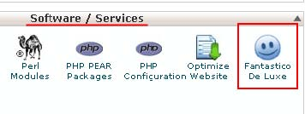

Click the link to be taken to a list of software programs that are already pre-installed on your site through the cpanel that you can activate with just a few clicks.

Look down the list of software available until you see ‘Crafty Syntax Live Help’ listed under the ‘Customer Relationship’ section:

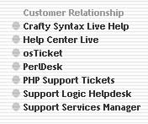

Some web hosts may not include this particular program in their cpanel listing, or you may be using a host that does not offer a cpanel, but that’s not a problem. In either situation, download the software from the [Crafty Syntax site](http://www.craftysyntax.com/) and install it manually by following the instructions on the site.

By adding a snippet of code that is created by the program to the pages of your site, you can do all of the things that I suggested earlier completely free of charge.

For example, if someone visits a certain number of web pages, the system will notify you or it can automatically send a pop-up message to that visitor asking them if they want additional help or (even better), it can offer them a free gift for subscribing to your site.

Furthermore, you can do exactly the same when someone comes back to your site for the third or fourth time (you can choose how many visits are necessary to trigger this), and you can watch the activity of any site visitor in real time whenever you want.

Consequently, if you had nothing automatic setup, you could always track your visitors activity before contacting them manually to offer further assistance or inviting them to subscribe.

However, the more effective way of using Crafty Syntax is to set it so that it automatically invites people to subscribe to your newsletter automatically whilst offering them a clearly valuable ‘bribe’ gift to subscribe.

Because so few people will have seen this kind of thing happen before when they are browsing around a website like yours, you will probably be pleasantly surprised how many people will take you up on your offer.

Now, as suggested, most marketers are not going to invite people to browse around their site in this way without asking for a specific commitment up front.

In other words, in most situations, it makes far more sense to direct your traffic to a landing page on your site, a page that is specifically designed to either collect e-mail contact information or to prompt your visitor to take a specific required action.

However, even if you do this, be aware that some of your visitors might still be tempted to look around your site before committing to subscribing to your mailing list or to taking the action you want to take.

Thus, even if you are using a landing page, it still makes sense to add an additional ‘backdoor’ way of collecting e-mail information or prompting the required action by using Crafty Syntax elsewhere on your site.

**Creating and using effective landing pages…**

There is no doubt that the most effective way of constructing your sales funnel is to have a landing page at the front end, a page where you specifically ask the visitor to take an action which represents a significant degree of commitment to your business.

As suggested, for online marketers who are trying to build a prospect mailing list, this is almost always a page to collect the visitors e-mail information. But there are some businesses where it might be more convenient or effective to seek an alternative action, so this would depend on the business you are in.

The first and perhaps most important thing to understand about a landing page is that it is a page which has only one purpose. You want your visitor to commit to your business by taking the action that you require with the only alternative option being that they close the page completely.

However, there is another consideration to bear in mind, depending upon how you are sending traffic to this landing page.

If you do not start off by doing so, it is fairly likely that at some point, using paid advertising will form a part of your promotional activities, and that in all likelihood means that you will begin to use AdWords.

This is important to factor in to your sales funnel plans from the beginning, because when you use AdWords, you have to create your landing pages in a way that Google approve of.

If you do not, then the cost that you will pay per click on your advertising will be significantly higher than you would have been paying if you ‘played the game’ the way AdWords wants you to play it.

There are several factors to take into account when creating a landing page that will attract a good [AdWords ‘Quality Score’](http://adwords.google.com/support/bin/answer.py?hl=en&answer=10215) which is what you have to do to minimize the amount you pay per individual click.

Firstly, there has to be some content of value on your landing page, and whilst this does not have to be sales page length, there nevertheless must be some content on the page.

In addition, this must be written content because the Google search robots do not as yet recognize content within videos. Consequently, even if you use a video landing page (a practice which is becoming increasingly popular), you must also include written content on the page, otherwise it will appear to be empty as far as Google are concerned.

The next thing that is necessary is to include certain internal links from your landing page to various other pages on your site. These must include links to your ‘Privacy’, ‘Terms and Conditions’, ‘Earnings Disclaimer’ and ‘Contact Us’ pages as well as to your ‘Site Map’.

Now as suggested earlier, you really do not want to include additional links on your landing page because by doing so, you present your visitor with various different options for leaving your page without taking the action that you want. If for example someone follows your ‘Earnings Disclaimer’ link, you can be pretty certain that they are not going to come back to your landing page to sign up. Thus, you really don’t want these links to be prominent or noticeable.

Add them to the bottom of the page where they are almost unnoticeable, and make sure that they are both small and in a relatively indistinguishable type color. However, do not be tempted to include them in the same color as the background, as Google will pick this up very quickly and penalize you for it. Hence, your links should look something like this:



Very small, not easy to read and hardly noticeable is perfect!

You might notice that the final link in this list is the ‘Site Map’ link. The reason that this is important for Google is that when they visit your landing page, they want to see what else you have on your site, which they find by following this link.

As far as Google is concerned, you cannot have *only* a landing page on your site. You must have other content pages as well which the Google search robot can find by following this site map link.

Furthermore, these content pages should give information about the same subject or topic around which you have created your landing page, plus, both your landing page and content pages should focus on the same or related keyword terms as well.

As you can see, Google are pretty demanding when it comes to the kind of site that they want to send visitors to through their AdWords program.

It is therefore far more effective to build and perfect your site – especially the landing page – *before* starting to use AdWords.

In this way, you can make sure that your site is content rich and that your landing page works before starting to spend money on advertising. When you do things in this way, you can be confident that your ‘Quality Score’ is going to be high and therefore the amount you will pay per click will be correspondingly low.

Okay, so what kind of landing page should you use?

The answer to this is, there is no single, simple answer.

Every market is different, and what works in one market sector or niche may not be at all effective in another. This is another sound reason for creating your landing pages and testing them before starting to spend money with Google. The last thing you should do is test when it is costing you money to do so.

Most commonly, there are two possible objectives that your landing page might have, and then there are two different ways that you can construct that page.

In the first case, the most common objective for the majority of online marketers is to collect e-mail information from their visitor. By doing so, they have the ability to send a continual stream of product suggestions and recommendations to that prospect.

When trying to collect e-mail information from a visitor to your landing page, it is a 99.9% given that you must offer this visitor a free gift of significant perceived value as a ‘bribe’ to persuade them to subscribe.

The days when a free subscription to your newsletter or e-zine would be sufficient are long gone, especially as the ever increasing tide of spam e-mail is making people ever more protective of their e-mail information.

In this respect, one experiment that you might like to try is to do something a little bit different in terms of the e-mail information that you collect.

Traditionally (and still the way that most marketers collect e-mail information) is to ask the visitor for their name and e-mail address.

The idea of asking for their name was that the marketer concerned could then set their autoresponder system so that it addressed outgoing e-mail messages to the new subscriber by name, which in theory was supposed to help develop a closer relationship with that subscriber.

However, the truth is that nowadays, most people know that this is an autoresponder trick, something that you set up automatically.

They are aware that just because your mail message to them begins ‘Hey Jack’ or ‘Hi Jill’, it does not for a moment mean that you have sat down and written that e-mail to them personally.

Consequently, this tactic of using the addressee’s name in your greeting is no longer effective. Hence, you might try asking your site visitors for only their e-mail address because in tests, the results of many experienced marketers who have tried this have matched my own.

I have found that if you only ask for the e-mail address, your subscription levels actually increase.

I believe that this is partly because you have automatically halved the work that the individual has to do to subscribe to your list and it might also be that, because you do not ask them for the name, it allows them to retain a higher degree of anonymity and privacy.

Anyway, this would certainly be something to test because it has definitely worked for me and for many well-known marketing names.

So, the most basic, ‘traditional’ but nevertheless still effective form of landing page is a text only page that offers a valuable free gift and requires a subscription in order to get hold of that free gift.

There does not need to be anything fancy or particularly clever about a page like this. In fact, the more distractions there are on the page, the less likely it is that your visitor will take the action you want. Consequently, this kind of page is often most effective when it is nothing more than plain black text on a white background.

For proof of this, this landing page example is used by the most popular online dating site for men and has been used pretty much unchanged for the past couple of years.

Whether it makes a big visual impression or not, this tells you that it is obviously working, which is of course the primary objective: Alternatively, you might want to try using a video landing page as these are becoming increasingly popular, perhaps because net users are becoming ever more comfortable with and interested in online video.

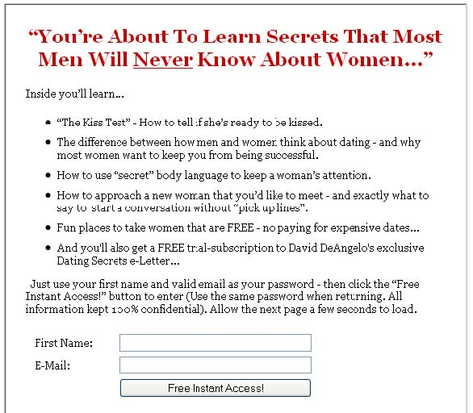

In this case, the landing page includes a short promotional video which pushes the benefits of either being subscribed to your site or of the product which you are promoting.

Within the video, there will be some kind of product presentation, accompanied by a suitable free gift offer and a call to action which details exactly what the site visitor has to do to get their free gift.

This example of a video landing page is simple and effective, but do note that there is some keyword (‘make money online’) focused written content on the page to give it some credibility with the search robots that will be sent by all of the major search engines, including Google:

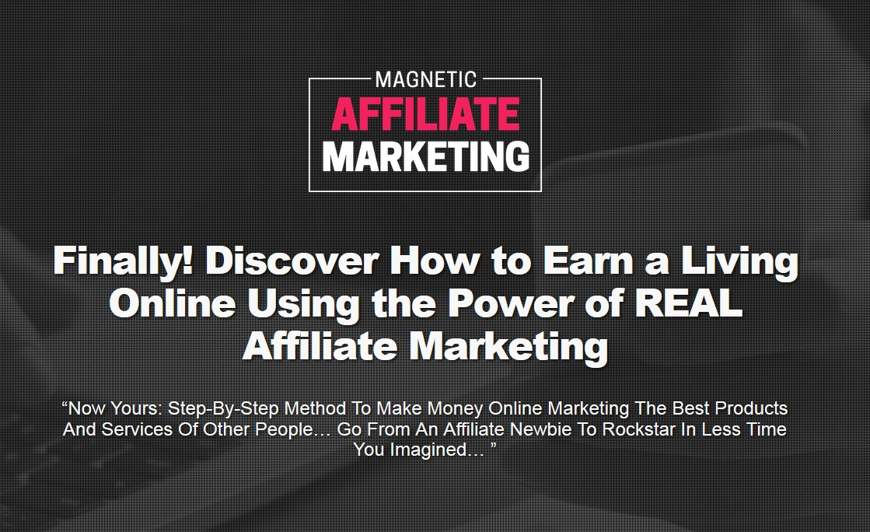

As you can see from both of the previous examples, these are what you might term ‘standard’ landing pages in that they are designed to collect e-mail information.

However, depending upon the business or market that you are operating in, you might adopt a slightly different approach.

For example, a company like this who are trying to generate leads for their mortgage business do not ask for contact information on the first page because I would guess that through testing, they have established that they have to ‘sell’ their services far more convincingly before doing so: Nevertheless, the basic principle is still the same because once the visitor clicks on the red ‘Get Started’ button, they clearly indicate their interest in mortgage finance by doing so.

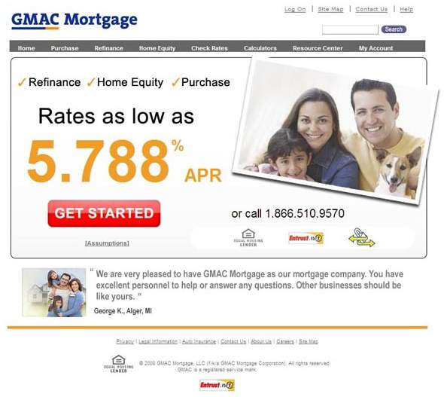

There are probably two or three more steps before the company behind this advert ask for contact information. But you can be absolutely certain that at some point, they will ask for contact details because otherwise, how can they send the information the customer will request?

Here is another example where one of the leading financial and investment sites, [the Motley Fool](http://www.fool.com/investing/basics/index.aspx) is offering an intriguing sounding report that apparently drove Bill Gates into early retirement (they claim), but of course you have to sign up for their mailing list to get your hands on it: In effect, both of the previous two landing pages have to work a little harder to grab your e-mail contact information and in order to do so, they take more time and space before they get around to making their ‘pitch’.

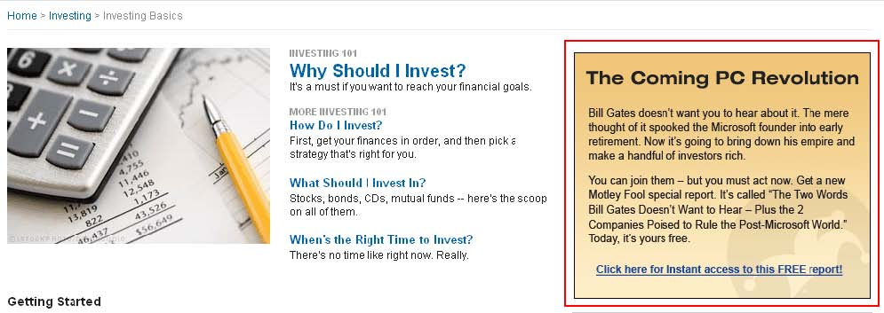

Nevertheless, the ultimate objective is still the same, which is to pull you into the top of their respective sales funnels by grabbing your contact information.

Now all you would need to do is to drive targeted traffic to your landing page in order to start building your prospect mailing list, thereby drawing your own visitors into your sales funnel.

**You MUST test your landing pages…**

One vital thing that you must do with your landing pages, particularly if you’re planning to use AdWords a little further down the line is to test, test and then test them again.

The first thing to establish is whether text only or video and text landing pages work best in your market sector or niche. Try to create a couple of pages that are broadly similar – copy and paste some of the information from the text only version onto the video page – and send 50 visitors or so to each different landing page version.

If after 50 visitors, you haven’t got a clear ‘winner’, take the number up to a hundred visitors each, but then try some different variations. In this way, you might try half a dozen or even a dozen different landing page variations before you have one or two that clearly outperformed the rest.

Incidentally, if you need free video landing page templates, try running a Google search for ‘free video squeeze page’ because at the time of writing, this returns quite a few sites where you can find suitable free templates (although the same templates seem to be offered by many sites).

At this point, you are still testing on a ‘macro-level’ by comparing video and text only format pages but once you have some idea which works best, you need to test on a micro level.

To do this, take your best performing landing pages, change no more than one or two words on the page, and then run back-to-back testing of two or three very slightly different versions against one another.

If one of your new versions performs better than the one you have been using previously, use the new one as your base starting point from now on. Change a couple more words from this most successful version before running back-to-back testing once again.

Testing is a continual, ongoing process because you can never reach a place where you have a perfect landing page. However, it is only by testing that you can establish what works best in your marketplace, so it is not something you can afford to ignore.

**With your landing page in place, what’s next?**

With your landing page in place, it is time to construct the rest of your initial product sales funnel in a way that is going to convince the maximum number of visitor prospects to subscribe to your list.

This simple expedient of minimizing the number of fresh new prospects who escape your sales funnel is probably the quickest and easiest way of doubling or tripling the profits of your business without having to do anything else whatsoever in terms of marketing or promotion.

In effect, you reduce the ‘leakage’ from your sales funnel, thereby generating considerably more subscribers and ultimately customers.

From here on in, I will walk you step-by-step through the initial sales and order process before highlighting several steps they can take on the back-end of this initial transaction to maximize your revenues.

Finally, having gone through this step-by-step, explaining each individual step along the way, I will bring the whole thing together into one integrated package so that you can see how the whole thing fits together.

**Step 1 – Keep as many prospects in your funnel as possible…**

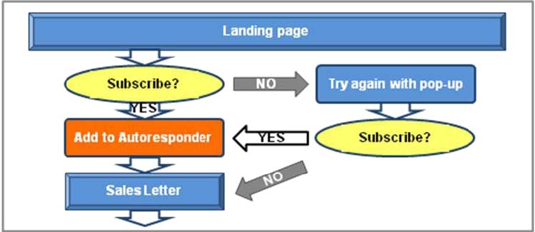

When a new visitor comes to your landing page, a proportion are going to sign up in order to get the free gift (or gifts) being offered without any further necessity for persuasion.

Obviously, the more valuable the gift or gifts that you are giving away are perceived to be, the more successful you are likely to be convincing people to sign up. Thus, it is important that you offer quality gifts and that you add a specific monetary figure to your landing page as a way of emphasizing how valuable the gift is.

Anyone who signs up straight away in this manner should automatically be added to your prospect mailing list, after which, you automatically set your autoresponder to immediately redirect them to your initial product sales page.

However, anyone who tries to click the back button or to close the page should be hit with a pop-up that offers another bonus gift in addition to the original one if they subscribe now.

I know that many people do not like pop-up windows but the fact is, this visitor is leaving your site anyway, so you have absolutely nothing to lose by doing this.

On the other hand, experience indicates that you have plenty to gain because a significant number of people will take the additional ‘bait’ of the extra free gift, adding many more names to your list without you having to do any more work.

This is what I was referring to when I mentioned minimizing unnecessary ‘leakage’ earlier – hit them with another free gift offer in a pop-up, and your subscriber numbers will increase significantly.

When they take the bait, they go into your autoresponder sequence in exactly the same way as they would have done had they subscribed originally and are redirected to the initial product sales letter in exactly the same way too.

**Step 2 – The initial product sales process…**

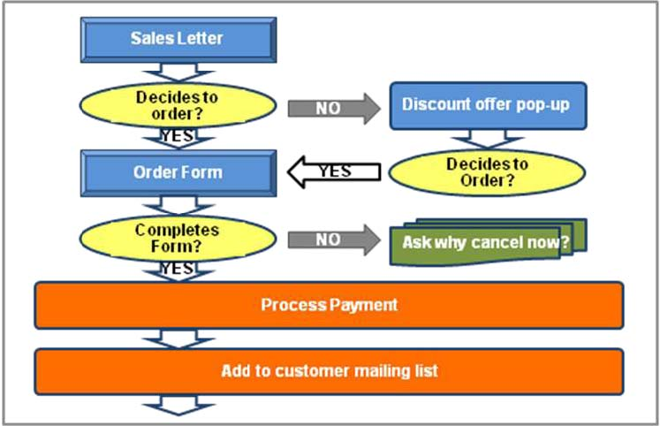

When your prospect is presented with your initial product sales page, they once again have an obvious ‘yes’ or ‘no’ choice to make.

If they decide that they want to purchase the product by clicking on the ‘Buy Now’ button on your sales page, all well and good, your system should automatically transfer them to the order page.

If however they decide they don’t want to buy the product and try to leave the sales page, you should again set your system to present them with a pop-up window offering the product again, but with an additional discount attached.

If this manages to convince them to buy a product, then redirect them immediately to the product order page. If on the other hand they are still not convinced, try presenting them with a brief survey or questionnaire asking them why they have decided not to proceed with the purchase.

Not everyone will complete this survey but those that do will provide extremely valuable information, information which might enable you to improve your systems (or perhaps your product) in the future.

Similarly, whilst the majority of people who land on the order page are likely to complete the ordering process and buy your product, there will be a few people who ‘dip out’ even at this late stage.

Again, do not be scared of presenting them with a short survey or questionnaire to find out what prompted their decision to pull out of the deal at such a late stage in the day.

Quite clearly, this nearly-customer was 98% convinced to make a purchase but something made them change their mind right at the last minute. Knowing what this ‘something’ is or was once again provides you with the kind of information that enables you to improve things.

Your system should be set so that anyone who complete the purchase is automatically added to your ‘first level’ customer autoresponder mailing list.

But it doesn’t stop there! In fact, we are only just getting warmed up…

**Step 3 – Offer an upgraded version…**

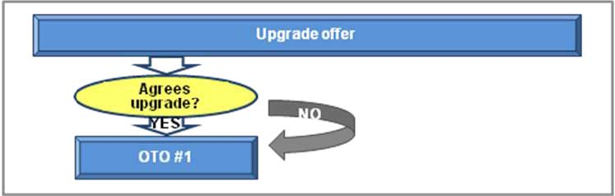

As well as adding the new customer to your autoresponder mailing list, you should immediately present them with an upgraded version of the original product that they have just bought that will cost them a few dollars extra.

This does not have to be anything particularly smart or fancy, because you can create an upgraded ‘Gold’ or ‘Platinum’ version by adding video materials if your initial product is an e-book as an example. Alternatively, you might add additional bonuses which will improve the usability or effectiveness of the product that your new customer just bought.

The crucial thing to understand is that at this point, the customer has just completed their initial purchase, so there is absolutely nothing to lose by offering an upgrade in this way, and once again, you are seeking to increase their level of commitment to your business.

They still have their credit card in hand and they are in ‘buying mode’, so the chances that they will invest a few more dollars in the ‘Gold’ or ‘Platinum’ version of your product are very good.

In this way, you will instantly increase the profits of your business by setting up your sales funnel system properly from the outset. In effect, you do the work once but you put extra money into your account time after time in return for that one-off effort.

There is another less tangible benefit as well.

By having a thoroughly professional sales funnel system in place, you emphasize to the customer that not only are they dealing with a professional organization (you may well be running a one-man operation, but the customer doesn’t know that) but you also make it very clear that you are running a business that is focused on selling, not on providing charity or ‘freebies’.

In many ways, this is another aspect of the qualification process in action.

As you will see in a moment, you have not finished with your sales efforts yet, and there may well be some customers who become upset or annoyed by what they might consider to be an overly aggressive sales attitude.

If this is what they believe, I would suggest that they are wrong because all you are doing is maximizing the potential of your business, which is what any professional business person would do. Nevertheless, there may be some people who become upset and choose to unsubscribe from your mailing list.

Don’t view this as a negative.

In fact, view it as very much the opposite, because the fact that they have chosen to remove themselves from your list in this way indicates that they would never have purchased from you again in the future in any event. Keeping them on your mailing list would therefore have been a complete and utter waste of time and wasting time is not something that you should be doing.

**Step 4 -Making a one-time offer…**

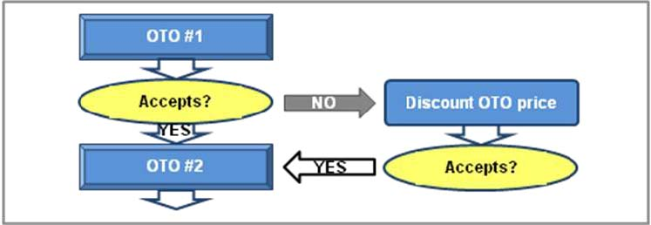

Whether the customer decides to accept the upgrade or not, the next thing to present to them is a one-time offer, a complementary product or service on which you can make a very attractive offer, usually a significant discount off the original product price.

However, the reason it is called a one-time offer is that the customer is only going to be presented with this ‘special offer’ this one time. In this situation, it is most common for the sales page to indicate that the customer cannot under any circumstances access this sales page ever again and that if they need or want to buy this product in the future, they will have to pay the original (significantly higher) price.

You must therefore ensure that the customer cannot access this page again in the future, because if they could, it would destroy your credibility in one fell swoop.

On the other hand, if your one time offer is sufficiently well targeted and complementary to the product that they bought a few moments ago, you should again generate plenty of additional sales at this ‘level’ of your sales funnel.

If the customer decides to buy this initial OTO, you should immediately transfer them to another one time offer the page.

Do not try to collect payment from them at this stage, because having finalized the payment for the initial product, you do not want to inconvenience the customer by asking them for another payment every time they buy an additional product. The worst thing that can happen if they decide to bail out of this continued process is that you’ll be left with nothing more than the original sale and their name on your customer mailing list, which is a tremendous result in any case, so relax about payment at this stage.

If the customer accepts the ‘Gold’ upgrade plus an OTO (or two) all of these products should be invoiced during the final checkout process rather than on a product-byproduct basis.

If on the other hand the customer decides that they do not want to buy your initial one time product offer, transfer them to a page where you offer the same product with a further discount included.

If they accept at this stage, fine, take them to the same (second) one time offer page that you would have transferred them to had they accepted this product in the first place.

If on the other hand they still are not interested, you should probably let it be, because you still have their mailing information and they have not unsubscribed from your list.

Consequently, whilst you didn’t manage to convince them on this occasion, you will have many more opportunities of doing so in the future.

**Step 5 -Make another one time offer…**

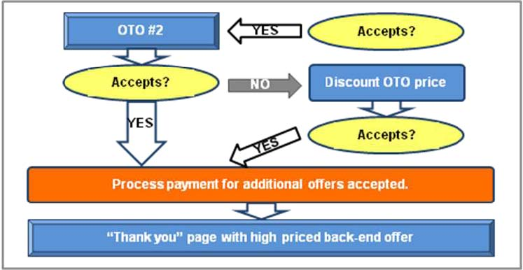

If your customer has accepted the first one time offer that you presented to them, there is absolutely no reason at all why you should not offer them yet another complementary product on a one-time offer basis.

Remember that what you are doing here is twofold.

Firstly and most obviously, you’re maximizing the income that you are generating from every individual customer who you are feeding through this initial sales funnel.

Secondly however, you are pushing the qualifying process along very rapidly, because with each additional sale, individual customers are moving themselves downwards through your sales funnel to the point where they become one of your most valuable customers.

Quite obviously, it is the people that are willing to spend most money with you that represent your best customers. Hence, by structuring your initial front-end sales process in the way I am suggesting, you are automatically fitting your customers into various different layers or areas of your sales funnel.

So, you present the customer with one final OTO which he (or she) either takes or leaves.

If they decide to buy this product as well, then you immediately transfer them to the credit card payment processing page where you collect the payment for all of the additional products that they have purchased.

If on the other hand they decide not to buy, you make them another offer of the same product at a cheaper price in the same way as you did with the first one time offer product.

Here again, they either say ‘yes’, so that you transfer them to the payment processing page, or ‘no’, in which case, you take one step back and start sending promotional e-mail messages to them.

However, there is one ‘final sting in the tail’.

After you have processed the final payment, you redirect the customer to a thank you page where you offer them a premium priced product such as a $2000 training course or a $5000 residential training boot camp.

By throwing this into the equation right at the end of the initial sales trail, you are trying to qualify whether this particular customer is one of the top 20% on whom you should be lavishing most of your care and attention.

By following this initial sales funnel model step-by-step, you are effectively compressing the whole sales funnel idea into this one transaction chain.

Of course, this compressed initial sales funnel is not meant to replace the traditional ‘longer term’ idea of building a sales funnel. There will undoubtedly be people who choose not to buy additional products who thereby remove themselves from this ‘compressed’ process whilst remaining in your longer term sales funnel who you will service by e-mail and generate additional income from a little further down the line.

So, how does this ‘compressed’ sales funnel model appear in its entirety?

Like this:

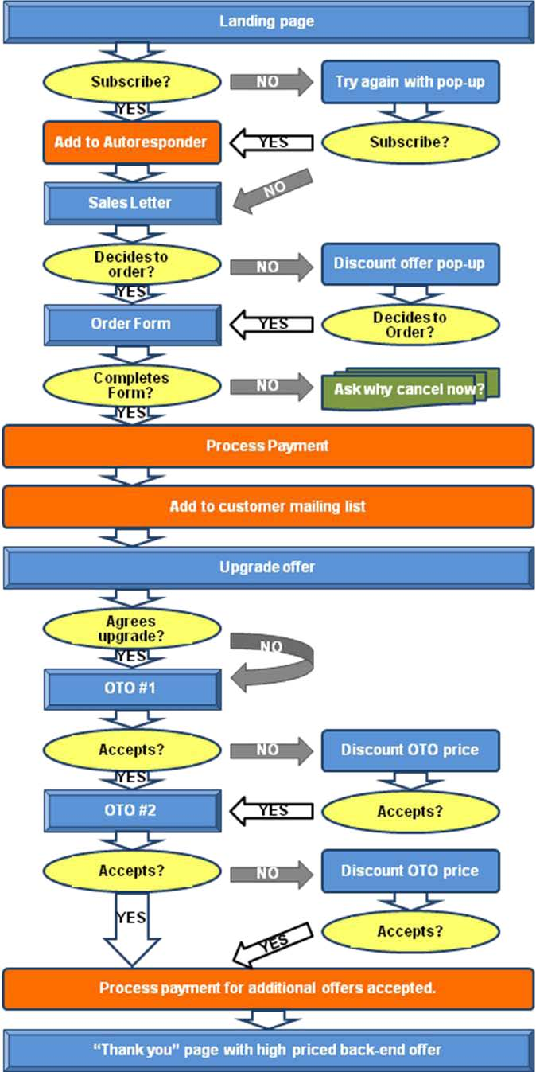

**Conclusion**

In this book, you should have learned a great deal about how you can apply the traditional sales funnel idea to online marketing, whilst you have also seen how you can apply this model on both a longer term and on a ‘compressed’ basis as well.

As suggested in the earlier chapters, the objective when creating an effective and efficient sales funnel is to try to keep as many prospects and customers inside your sales funnel as possible.

Every prospect that you bring in at the top of that funnel is going to cost you a great deal of money one way or another. Thus, you must reduce the amount of both prospects and customers who ‘escape’ your business before you have had a chance to maximize your returns from them.

And don’t forget that creating an effective and ultimately profitable sales funnel is something that you only have to do once. Yes, there is some work involved in testing various landing page formats one against the other and because you need different e-mail messages for all of the different ‘levels’ of your funnel, there is some work to be done creating those outgoing messages as well.

But once it is done, you need do no more than finesse, test and improve various aspects of your system, confident in the knowledge that it is already working extremely well in any event.

However much knowledge of the sales funnels concept you had when you began reading, I trust that you have now advanced your knowledge about both the theoretical and practical aspects of using sales funnels for maximum profits in your own business.

Simply by setting up your initial sales system as detailed in the previous chapter, you will increase the number of people you convert from prospects into customers. Moreover, each of those customers will become increasingly more profitable as you feed them down your sales funnel too.

You have all the practical knowledge that you need in order to improve the profitability of your business right here in front of you.

Now is as good a time as any to start putting it into action.