**Metric 1: - Mean Daily Discharge - MA1**



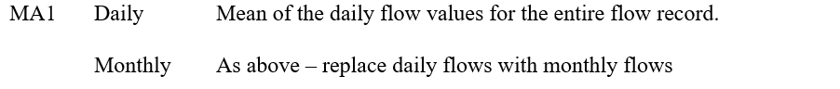*Fig 1.A.a: Definition of Mean Daily Discharge for Daily and monthly flows*

**Part A**

*Partl.a) MAI - Below function code is to find mean daily discharge between any two dates(i .e. , 
dfSDate=as Date. character (as character(dfSDate), 
mean_daily = subset (df, & Date 
output is.numeric)j) 
any month of 
*Enter start Date 
me an_da i I y_di s f I OW_da t a 
End Oate in YVYY-MV-DD format. is one example shown; — 
, "1980-05-01" , "1980-05-31 *Fig 1.A.b: Figure shows the function code for mean daily discharge, highlighted part shows the input of values given into the function (Detailed description of the functionality given in the function documentation). “flow\_data” is the first dataset that was imported.*



Machine generated alternative text:
> mean_dai "1980-05-01 
s eg_outfl ow 
0018_gage_07 331300 seg_outfl ow 
6. 676129+01 
" , "1980-05-31") 
331000 
1.778258+03 
seg 
outfl ow 
304500 
4. 579935+02 



*Fig 1.A.c: Figure shows the trimmed output; highlighted part shows mean daily discharge of the first column which is used for reference to test the quality control test of the function.*

flow datal - Excel 
Add-ins 
Help 'MP 
Chakri Pathi 
Home 
Cut 
*Copy • 
Insert Draw 
Calibri 
Page Layout 
12.7 
10.7 
10.6 
10.5 
10.4 
11.7 
121 
51.5 
15.6 
15.4 
13.5 
63.4 
45.5 
22.5 
16.1 
14.5 
13.8 
13.3 
13 
16.3 
1080 
382 
Formulas 
Data 
Review View 
Wrap Text 
C) Search 
Team 
Share 
BIU- 
— Merge & Center • 
Format painter 
Clipboard 
B123 
General 
$ -0/0' .00..0 
e.o .00 
Number 
Conditional 
Formatting • 
Format as Cell 
Table • Styles • 
Styles 
Insert 
13.5 
11.9 
11.7 
11.7 
128 
2290 
5080 
1600 
195 
29.4 
165 
410 
178 
38.4 
22.3 
21.7 
22.1 
49.5 
337 
497 
1340 
Delete Format 
cells 
24.6 
40.9 
152 
40.5 
91.1 
748 
107 
134 
67.2 
111 
77.4 
50.1 
43.1 
39.3 
36 
33.2 
42.9 
397 
111 
Sort & Find & 
Filter • Select • 
Editing 
133 
134 
135 
136 
137 
138 
139 
140 
141 
142 
143 
144 
145 
146 
147 
148 
149 
150 
151 
152 
153 
Ready 
5/11/1980 
5/12/1980 
5/13/1980 
5/14/1980 
5/15/1980 
5/16/1980 
5/17/1980 
5/18/1980 
5/19/1980 
5/20/1980 
5/21/1980 
5/22/1980 
5/23/1980 
5/24/1980 
5/25/1980 
5/26/1980 
5/27/1980 
5/28/1980 
5/29/1980 
5/30/1980 
5/31/1980 
980 
flow datal 
Type here to search 
423 
431 
438 
453 
558 
688 
1070 
2060 
2010 
1610 
1670 
1870 
2100 
2380 
2620 
2910 
3310 
3680 
6120 
14200 
Alignment 
15.4 
13.3 
11.4 
10.4 
59.9 
468 
1310 
1960 
1500 
969 
726 
653 
441 
323 
235 
183 
142 
217 
639 
1320 
2580 
41.6 
38.2 
36.3 
34.1 
208 
461 
552 
662 
595 
457 
351 
299 
243 
195 
162 
156 
312 
396 
469 
487 
113 
99.4 
88.2 
79.1 
80.6 
1720 
2950 
4060 
4090 
3300 
2550 
2040 
1720 
1390 
1070 
825 
662 
623 
1850 
132 
118 
105 
93.3 
112 
453 
1000 
2040 
3080 
4090 
4250 
3530 
2740 
2180 
1830 
1500 
1160 
1020 
803 
1190 
1.28 
1.25 
1.23 
1.23 
2.69 
42.7 
292 
366 
250 
209 
117 
54.8 
33.9 
43.1 
51.4 
19.1 
11.5 
18.1 
39 
110 
1.55 
1.52 
1.5 
1.49 
6.91 
102 
296 
367 
251 
211 
121 
55 
35.1 
44.3 
52.5 
37.6 
20.4 
14.8 
20.8 
50.3 
111 
0.53 
0.52 
0.52 
0.51 
17.4 
338 
34.4 
5.85 
5.59 
5.52 
56.3 
11.8 
7.35 
7.26 
7.18 
7.09 
12.5 
10.2 
162 
23.7 
91.7 
89.5 
155 
214 
467 
10100 
10500 
4190 
2260 
2500 
1570 
3380 
3390 
1220 
226 
194 
183 
935 
8210 
5410 
95.9 
91.4 
111 
178 
296 
3140 
11000 
8610 
3560 
2650 
2270 
2160 
3770 
2830 
1080 
431 
260 
213 
439 
4090 
9370 
Average: 66.76129032 
Count 
Sum. 
Clear • 
73.4 
81.5 
141 
232 
337 
5480 
6020 
1380 
1650 
1380 
602 
2010 
1580 
436 
142 
133 
127 
601 
3360 
2890 
2069.6 
12.6 
12.1 
24.8 
29.8 
19.2 
2220 
3160 
875 
315 
302 
200 
471 
585 
239 
138 
122 
115 
193 
3310 
3600 
12:04 PM 
6/20/2018   
*Fig 1.A.d: The highlighted part (in yellow) shows the average or mean of the first column between the dates 1st May 1980 and 31st May 1980 calculated in excel. The answer is 66.76129032 which is the same as the output we got it using the function. A similar test is performed for other columns in the dataset.*



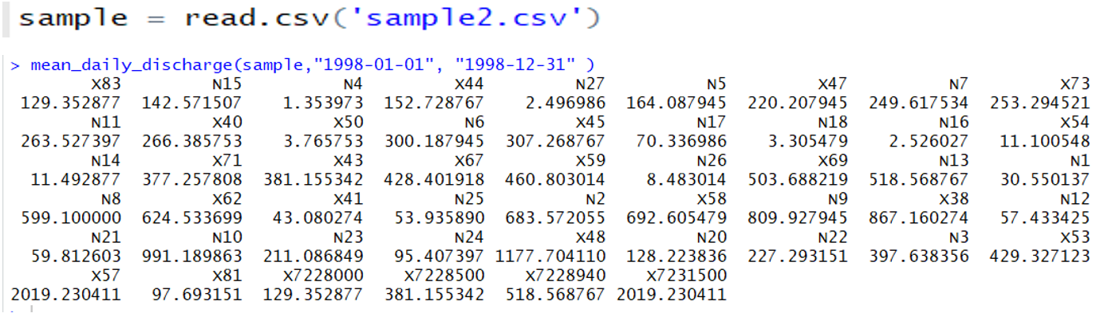  
*Fig 1.A.e: Figure shows the function worked for the other dataset “sample” that was imported, and the results are displayed.*

**Part B**

*Part I. b) 
- Below function ccH3e is to find mean daily discharge for any month between two years. 
scharge = function(df, c, a, b) 
dfSOate•as . Date. character(as . character CdfSOate) , 
d" V ear = 
df$"onth = • '*n")) 
Mean_parti = subset (df, Yeare=b) , 
(sapplyæean_particularmonth, is. numeric) 1) 
return (output) 
"Enter Datarr•ame, Month Of interest, Start Year & End Year in YYYY format. Be IOW is one example • 
5, 1980, 1990) 



*Fig 1.B.a: Figure shows the function code for mean monthly discharge, highlighted part shows the input of values given into the function. The month of Interest (1 to 12), Start and End year details are given as inputs. (Detailed description of the functionality given in the function documentation).*



seg_outfl 
6.676129„01 
, 5, 1980, 1980) 
seg_ou tf I ow_OOI 331000 
1.778258e.03 
seg_outfl ow_0034 _ gage_07304500 
4 .579935e.02   
*Fig 1.B.b: Figure shows the mean monthly discharge for May for the year 1980 only (Start and End year are given the same value). The value 66.76129 obtained for the first column is the same value we got in the above function of mean daily discharge.*



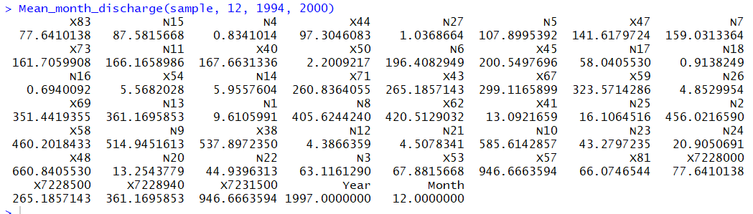

*Fig 1.B.c: Figure shows the mean monthly discharge for December between 1994 and 2000 years for the second dataset “sample”.*

**Metric 2: - Coefficient of Variation - MA3**

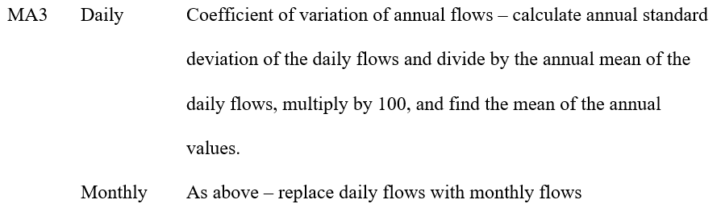

*Fig 2.A.a: Definition of Coefficient of variation for Daily and monthly flows*

**Part A**

*part2.a) - MAA - calculation of coefficient of variation between any two dates( i.e. , 
= function (df, a, b) 
dfSDate•as . Date. character (as . character(dfSDate), format" 
coeff_daily = subset(df, Oate 
Iy, is. numeric)J) 
for any 
return (output) 
'Enter Start Date & End Oate in format. is one example • 
Coeff_Va r_dai I y(fl ow_data, " 1980—01 —01 
• 1980-01-31") 



*Fig 2.A.b: Figure shows the function code for the coefficient of variation between any two dates, highlighted part shows the input of values given into the function.*







*Fig 2.A.c: Figure shows the trimmed output; highlighted part shows the coefficient of variation of the first column which is used for reference to test the quality control test of the function.*

Mean 
4.305509 
5.272258 
81.66348   
*Fig 2.A.d: The highlighted part (in yellow) shows the coefficient of variation of the first column between the dates 1st January 1980 and 31st January 1980 calculated in excel. First, we calculate the standard deviation using “STDEV.S” function and then the mean of the first column between the specified dates. Finally, we divide the results to obtain the coefficient of variation. The answer is 81.66348 which is the same as the output we got it using the function.*



**Part B**

*Part2.b) • 
MA3 - Calculation Of Coefficient Of variation for any month between years 
• function(df, c, a, b) 
dfSDate=as. Date. character(as. character(dfSDate), 
dfSYear 
as. numeric (format (dfSOate, "*Y")) 
dfSMonth = (format(dfSDate, • '*n")) 
coeff_particularmonth subset (df, Month-oc 
colMeans (coeff_parti numeric)]) 
Sapp I y (coeff_particularnonth, Sd) 
output 
Is.n 
return (output) 
*Enter Month of 
interest, 
Coe f t h C f OW_da t 
, 1, '1980', 
start Year & End Year in format. Below is one example - 
' 1980') 



*Fig 2.B.a: Figure shows the function code for the coefficient of variation for monthly flows, highlighted part shows the input of values given into the function.*

s eg_outfl 331300 
81.663480 
'1980', 
• 1980') 
seg_outfl ow_OOI 
54.127200 
seg_outfl ow_OO 
35.236781 



*Fig 2.B.b: shows the coefficient of variation for January month for the year 1980 only (Start and End year are given the same value). The value 81.663480 obtained for the first column is the same value we got in the above function of the coefficient of variation for daily flows.*



179.1239855 
125 .1879690 
658.0354084 
170.6487226 
314.7670252 
196.3999749 
165 .8037305 
125.4333620 
156.7591563 
176.1928411 
210.8501115 
200.2470406 
•1997', '2013') 
968.1888450 
151.8200408 
892.1902643 
118.0358390 
156.7169630 
157 .2459051 
581.5839911 
571.2263241 
269.1585544 
258.2633886 
x7228000 
x7228S00 
179.1239855 
156.7169630 
211.0674898 
118.8790845 
157.8461825 
187 .2069692 
203.6892447 
x7228940 
157.4567051 
146.1101430 
286.7628733 
345.4314186 
187 .5921258 
285 .8158459 
x7231500 
196.3999749 
131.8435119 
498.0242196 
154 .6308004 
218.6396425 
266.2141237 
Year 
0.2445703 
127 .4358117 
411.0092623 
157 
.4567051 
215.2999270 
252.7323708 
Month 
o. 0000000 
125 .0663665 
665.1460931 
562.8021321 
318.1634706 
252.4212572 

*Fig 2.B.c: Figure shows the coefficient of variation for September month between 1997 and 2013 years for the second dataset “sample”.*

**Metric 3: - Coefficient of Variation for April Month- MA27**

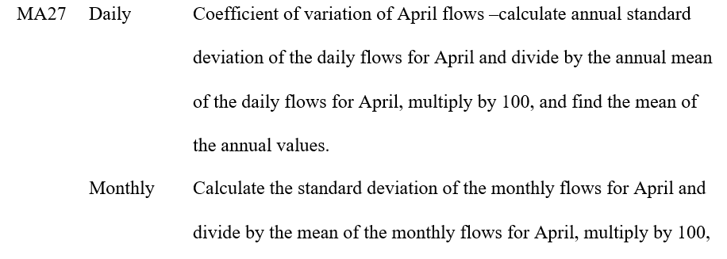

*Fig 3.A.a: Definition of Coefficient of variation of Daily and monthly flows for April. Metric 3 can directly be calculated by simply modifying Metric 2 parameters. However, I created a separate function.*

**Part A**  
Ida i 
10. 319325 
"1980-04-01", "1980-04-27") 
24.828387 
s e g_ou tf 
_gage_07304500 
71.779731 



*Fig 3.A.b: Figure shows the trimmed output; highlighted part shows the coefficient of variation between 1st April 1980 and 27th April 1980 for the first column which is used for reference to test the quality control of the function.*

Mean 
1.580003 
10.31932   
*Fig 3.A.c: Figure shows we get the same results in excel performing the coefficient of variation calculations for the first column between specified dates.*



**Part B**

  
*Fig 3.B.a: Figure shows the trimmed output for the coefficient of variation for monthly flows of April between 1988 and 1993.*

1998' , 
101.6268348 
NII 
92.2304585 
214.3222762 
89.8376593 
N21 
460.7875103 
182.4070919 
98.2027027 
91.7775375 
84.0024621 
92.1926392 
NIO 
129.5213601 
93.0159783 
265.2210600 
x50 
51,'.1641814 
84.1910410 
423.9960745 
395.6762510 
x7228000 
101.6268348 
'2013') 
96.9327546 
87.0290696 
83.2781718 
410.9227785 
356.1373147 
734.1661354 
87.1418770 
83.0998010 
99.6934435 
139.8930376 
x7228940 
83.4805430 
96.3904950 
85.0882226 
380.6905524 
100.5566344 
481.0410668 
x7231500 
182.4070919 
89.8520907 
318.3037244 
83.6269393 
118.3561957 
391.7054695 
Year 
o. 2300963 
92.3983210 
301.1018964 
92.6578180 
240.5217941 
x7228500 
84.1910410 
83.4805430 429.1638064 
122.4207092 461.5591811 
411.0365204 427.0533891 
Month 
o. 0000000 



*Fig 3.B.b: Figure shows the output for the second dataset “sample”; highlighted part shows the coefficient of variation for April month between 1998 and 2013 years for the first column which is used for reference to test the quality control of the function.*

STD 
Mean 
STD/Mean*100 
117.8389 
115.9525 
101.6258 



*Fig 3.B.c: Figure shows we get the same result for the first column in the excel as well.*

**Metric 4: - Minimum flows for May- ML5**

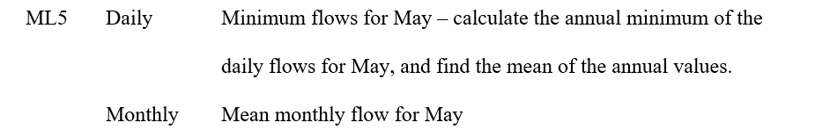

*Fig 4.A.a: Definition of ML5 metric.*

**Part A**

> = function(df , e, a,b) 
dfSDate•as . Date. character(as . character(dfSOate), 
d" V ear = 
as c (format , "%V")) 
dfSNonth = ' '*n")) 
df • subset(df & & Yeare•b), 
for (i in "Year")) ) 
values — 
, e] Cdf 
, values) 
(sapply(k , mean) ) 
return (output) 
[1] 28.55381 
" , "1980" , "2000") 



*Fig 4.A.b: Figure shows the function code for annual minimum daily flows for May, highlighted part shows the output which is the mean of the annual minimums of May month. This is between 1980 and 2000 which are given as inputs to the function.*

Year 
12.7 1980 
13.7 1980 
12.5 1980 
11.8 1980 
11.6 1980 
11.4 
1980 
11.3 1980 
11.2 1980 
11 1980 
10.9 1980 
10.1 1980 
10.6 1980 
10.5 1980 
10,4 1980 
11.1 
1980 
121 1980 
51,s 1980 
15,6 1980 
1 S „4 1980 
13,s 1980 
1980 
45,6 1980 
22,s 1980 
16,1 1980 
14,6 1980 
Month 
М ау 
Мау 
Мау 
мау 
мау 
мау 
мау 
мау 
мау 
мау 
мау 
мау 
мау 
мау 
мау 
мау 
мау 
мау 
мау 
мау 
мау 
мау 
мау 
мау 
мау 
10.4 
7.98 
25.9 
22.2 
10.7 
39.2 
12.7 
38.8 
46.2 
39,4 
49.S 
18.5 
23.3 
41,6 
22,9 
1,15 
28,ssgg1 



*Fig 4.A.c: Figure shows we get the same results in excel. I calculated the minimum of flow values of May for every year and took the mean of it.*

Machine generated alternative text:
> mum(sample, 
[1] 68.49 
"N15" , "1994" , "2013")   
  
*Fig 4.A.d: Figure shows the same function working for the second dataset “sample”.*

**Part B**  
  
Mean_may_discharge • function(df, a, b) 
dfSOate;as . Date. character (as. character(dfSOate), 
df S Yea r 
as numeric (format (dfSOate, • '%V")) 
dfSMonth = as. CdfSOate, "*n")) 
Mean_maymonth = subset (df, & (Years—a 8' Yeare=b) , 
, is numeric) ] ) 
return (ou tput) 
*Enter DataFrame, Month of interest, 
• 1988' , 
start Year & End Year in VYYY format. 
"1993') 
Below is one example shcmn:- 

*Fig 4.B.a: Figure shows the function code of mean monthly flow for may between any two years.*

  
*Fig 4.B.b: Figure shows the trimmed output of the above function between 1988 and 1993, highlighted part shows the Mean monthly discharge for May of the first column which is used for reference to test the quality control of the function.*



|  |  |
| --- | --- |
| Mean | 98.78548 |

*Fig 4.B.c: Figure shows we get the same results in excel.*

270.238710 
438.414516 
11. 569355 
885 .841935 
. 382258 
2303.011290 
297 .103226 
441.070968 
610.193548 
907 .801613 
1321.027419 
x81 
219.454839 
' 1998' , 
1.745161 
a. 230645 
617 .243548 
36. 316129 
136. 369355 
x7228000 
270.238710 
'1999') 
313.916129 
496.711290 
672.138710 
41.103226 
58.738710 
x7228500 
617 .243548 
2.948387 
504 .222581 
712 .619355 
968.080645 
1496.245161 
x7228940 
789.067742 
331.972581 
106. 582258 
14.045161 
978.135484 
102 .808065 
x7231500 
2303.011290 
395 .803226 
8.03709? 
770. 330645 
1101.216129 
144. 
193548 
Year 
1998. 500000 
425 .937097 
5.89838? 
789.067742 
1175.016129 
267 . 537097 
Month 
5 .000000 
430. 550000 
10.814516 
31.495161 
42 .612903 
292 .733871 

*Fig 4.B.d: Figure shows the same function working for the second dataset “sample”.*

**Metric 5: - High flow discharge index - MH17**

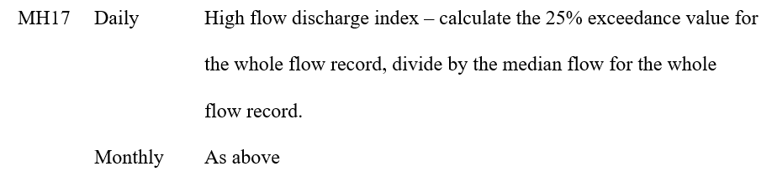

*Fig 5.A.a: Definition of High flow discharge index*

**Part A**  
> ndex = function(df , a, b) 
dfSDate•as . Date. character (as . character(df$oate), 
hi gh_daily = subset (df, & Date 
median) 
quants 
I y, 2 = quants) 
output= = median) 
return(output) 
Hi gh-flow_di scharge_i ndexcnow_data, "1980-01-01" , 
"2000-12-31") 
1 .626667 
2.14473? 
1.891892 
1.956204 
seg_outf ow_0034_gage_07304500 
1.993068 
1.880503 



*Fig 5.A.b: Figure shows the function code for High flow discharge index; highlighted part shows the output which is the high flow discharge index of the first column between 1st January 1980 and 31st December 2000.*

Date 
1/1/1980 
1/2/1980 
1/3/1980 
1/4/1980 
1/5/1980 
1/6/1980 
1/7/1980 
1/8/1980 
1/9/1980 
1/10/1980 
1/11/1980 
1/12/1980 
1/13/1980 
1/14/1980 
1/15/1980 
1/16/1980 
1/17/1980 
1/18/1980 
1/19/1980 
1/20/1980 
seg_outflow 
1.85 
3.04 
3.1 
3.08 
3.05 HFDI 
3.03 
3 
2.97 
2.95 
2.92 
2.89 
2.86 
2.83 
2.8 
2.77 
2.82 
2.75 
2.69 
2.66 
3.99 
48.8 
30 
1.626667 



*Fig 5.A.c: Figure shows we get the same results in excel. I calculated the High flow discharge index by dividing the 75th percentile of the data by the median.*

••1994-01-01 
"2014-12-31") 
1.680241 
1,637032 
x69 
1.757670 
N21 
3.162162 
x7228500 
1,678167 
1.677155 
1,642016 
1.761995 
NIO 
1.924977 
x7228940 
1.761995 
1.800000 
1.481069 
2.571429 
2. 714724 
x7231500 
2 .105001 
1.672840 
2 .000000 
1.818874 
3.194690 
I. 666667 
1.888889 
1.808336 
2 .008828 
1.642857 1.608036 1.625000 
1.931818 1.936170 1.675916 
2,625000 2.735294 1.799078 
3.000000 2.701149 2.758221 
1.614956 
1.678167 
1.797035 
2.744186 
1.621705 
1.713178 
1.844708 
2.105001 
1.620000 
1.749578 
1 .868102 
x81 
1.650823 
1.882353 
2.272727 
3.138889 
x7228000 
1.680241 

*Fig 5.A.d: Figure shows the same function working for the second dataset “sample”.*

**Part B**

Machine generated alternative text:
#part5 . b) 
MH17 
High flow discharge index 
25% of exceedance value or the 75th percentile 
Hi gh_fl ow_di s charge_i ndex_month 
functi on (df , c, a, b 
df$Date=as . Date. character (as . character (dfSDate), 
dfSYear 
as . numeri c (format (dfSDate 
dfSMonth 
as . numeric (format (dfSDate , 
Yom')) 
hi gh_month 
subset(df, Month==c 
Year>=a 
sapply(hi gh_month, medi an) 
co. 75) 
quants 
, 2, quantile ,probs — 
quants 
Year<=b) 
output= apply(high_month,2,quanti1e,probs—quants 
return (output 
#Enter DataFrame, Month, start Year & End 
Hi gh_fl ow_di s charge_i ndex_month (fl ow_data , 
Year in 
5,1980, 2000) 
sapply(hi gh_month, medi an) 
YYYY format. Below is one example shown: 

*Fig 5.B.a: Figure shows the function code of high flow discharge index for any month of interest between two years.*

> , 1998, 2000) 
2.113876 
2.071244 
1. 577259 
2.281481 
x7228500 
1.85821? 
1.982468 
2.032268 
1. 576605 
1. 548441 
x7228940 
1. 576605 
2 .000000 
I. 494453 
3.707317 
2.844471 
x,7231500 
1.867357 
2 .039110 
1.970588 
1. 515776 
2. 305263 
Year 
1.000500 
2.250000 1. 564103 
2 .214286 
1. 528624 
1. 583459 
Month 
1.000000 
2 .106895 
3.047619 
3.447811 
2. 362145 
1.768293 
3.104294 
2 .656600 
2. 320847 
1.821777 
1.462728 
2.474194 
2. 317102 
1.858217 
1.455588 
2.433566 
2 .301691 
1.709237 
1.407885 
1.867357 
2.225047 
x59 
1.673798 
1. 590847 
x81 
2.303498 
x50 
1.200000 
N26 
3.734694 
2. 320611 
x? 228000 
2.113876 

*Fig 5.B.b: Figure shows the same function working for the second dataset “sample”.*