**Metric 6: - Frequency of low pulse spells- FL3**



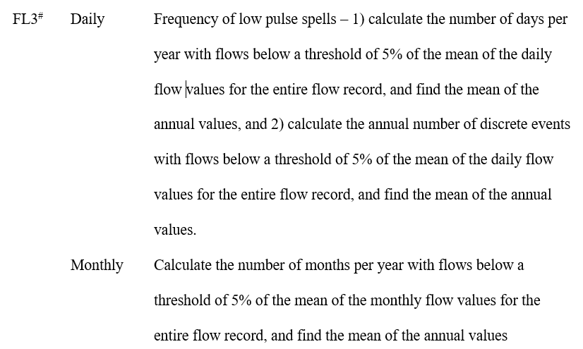



*Fig 6: Definition of Frequency of low pulse spells for Daily and Monthly flows*

**Part A.1)**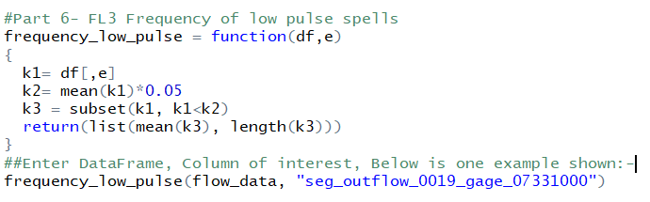



*Fig 6.A.1.a: The figure shows the function code that calculates the number of days per year with flows below a threshold of 5% of the mean of daily flow values along with the mean of those annual values, highlighted part shows the input of values given into the function which is the Dataset and Column of Interest.*" seg_outf I ) 
25.67333 



*Fig 6.A.1.b: The output of the code is nothing but the mean and number of days which are 25.67333 and 3 respectively for column “seg\_outflow\_0019\_gage\_07331000”. These results can be verified from the Excel.*

Date 
1/1/1980 
1/2/1980 
1/3/1980 
seg_outflow_0018_gage_ seg_outflc seg_outflc seg_outflc seg_outflc seg_outflc seg_outflc seg_outflc seg_outflc seg_outflc 
1.85 
3.04 
3.1 
2.02 
20 
0.17 
1.54 
4.56 
1.27 
8.81 
29.5 
2.62 
14 
34.3 
4.85 
13.7 
25.8 
0.01 
0.08 
0.31 
0.29 
0.35 
0.59 
2.01 
2.13 
2.11 
13 
28.5 
31.6 
11 
12.2 
12.2 
flow datal 
3 of 7671 raords found 
Average. 25.67333333 count4 sum: 77.02 



*Fig 6.A.1.c: The figure shows the results from Excel. Mean of the daily flow values for column “seg\_outflow\_0019\_gage\_07331000” is 1910.617328 which is calculated from excel and hence, 5% of the Mean is 95.53087. The values in the column less than 5% of the mean are 2.02, 20, and 55 recorded on 1st,2nd, and 3rd January of 1980 respectively. Therefore, the average or mean of these three values is 25.67333 (highlighted below) and the number of days are 3 which is the same output we got from the function.* **Part A.2)**



Machine generated alternative text:
f requency_l ow_di s c rete 
functi on (df , e, a, b 
df$Date=as . Date . character 
as . character (df 
Date<=b, select 
Date), format 
Date>=a 
kl 
N 
subset(df, 
dfC,e] 
1 ength (kl) 
mean (1<1) 05 
event—O 
fl ag=O 
for (i in 1: N) 
fl ag=l 
else 
i f (fl ag=l) 
event—event 
1 
fl ag=O 
i f (fl ag=l) 
event—event 
return (event) 
#Enter DataFrame , 
1 
Column of 
Interest, 
data, "seg 
Start & 
outfl ow 
End Date in 
f requency_l ow_di s c rete (fl ow 
-DDI format. Below is one example shown: 
331000" , "1980-01-01 " , "2000-12-31 



*Fig 6.A.2.a: Figure shows the function code that calculates the discrete number of events per year with flows below a threshold of 5% of the mean of daily flow values, highlighted part shows the input of values given into the function which is the Dataset, Column of Interest along with Start Date and End Date.*

Machine generated alternative text:
> frequency_low_discrete(flow_data, 331000 
" , "1980-01-01" , "2000-12-31") 


*Fig 6.A.2.b: From the output of the function for the above example, we see there is only 1 discrete event with flows below a threshold of 5% of the mean of the daily flow values which makes sense as the single event occurs between 1st Jan 1980 and 3rd Jan 1980 (same result as shown in fig 6.A.1.c).*

**Part B**

Machine generated alternative text:
f requency_l ow_pul s e_month 
functi on (df , e, a, b 
df$Date=as . Date . character (as . character (df$Date 
dfSYear 
as . numeri c (format (df$Date 
format 
dfSMonth = as. 
dfC,e] 
k2= mean (kl)*O.05 
k=list 
o 
df1 
for (i in unique(df1C, I' Year" 
Yom')) 
subset(df, Year>=a & Year<=b, select 
k3=df1$Month & 
df1 
, length (unique k3))) 
k=append (k , val ues) 
, I' Year" 
-TRUE)) 
return(sapply . data. frame 
#Enter DataFrame, Column of Interest, 
f requency_l ow_pul se_month (flow_data, " seg_outfl 311500 " 
Start & End Year in YYY format. 
Below is one example shown: 
, "1980" , "2000") 



*Fig 6.B.a: Figure shows the function code that calculates the number of months per year with flows below a threshold of 5% of the mean of monthly flow values, highlighted part shows the input of values given into the function which is the Dataset, Column of Interest, Start year and End year.*1980 
2 1981 
7 1982 
5 1983 
9 1984 
1985 
0 1986 
[22] 
0 1991 3 1992 
0 1993 
0 1994 4 1995 
4 1996 
" , "1980" , "2000") 
0 1987 
0 1988 
2 1997 
0 1998 
1 1989 
0 1990 
0 1999 
5 2000 *Fig 6.B.b: The output of the code shows a number of months in each year which has less than 5% of the mean of monthly flow values. These results can be verified from the Excel. I had taken the example of the 1980 year for verification.*



Machine generated alternative text:

*Fig 6.B.c: Figure shows the results from Excel, 5% of the Mean of the monthly flow values for column “seg\_outflow\_0074\_gage\_07311500” is 8.155699. All the values which are less than 8.155699 are filtered and displayed above. Clearly, we can see only in months of November and December there are occurrences of values going less than 5% of the mean. Therefore, in the year 1980, we get 2 months which is the same answer we get from the function code.*

**Metric 7: - Flood Frequency – FH5**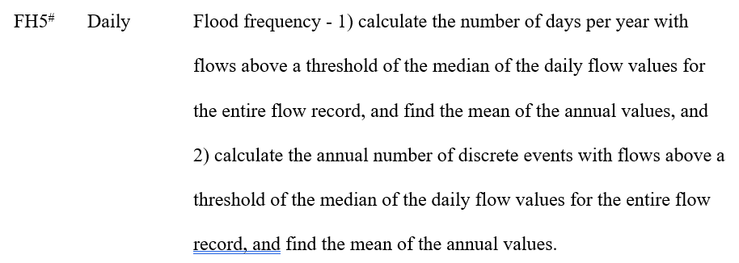*Fig 7: Definition of Flood Frequency for daily flows*



**Part A.1)**Machine generated alternative text:
fl ood_f requency= 
kl 
medi an (kl) 
subset (kl , 
functi on (df , e) 
kl>k2) 
k3 
) , length k3 
fl ood_f requency (fl ow_data , 
" seg_outfl ow_0036_gage_07 303000 " *Fig 7.A.1.a: The figure shows the function code that calculates the number of days per year with flows above a threshold of the median of daily flow values along with the mean of those annual values, highlighted part shows the input of values given into the function which is the Dataset and Column of Interest.*



> ow_data, 
[Lin 
[11 184.5473 
3829 
"seg_outfl ) 



*Fig 7.A.1.b: The output of the code shows the mean and number of days for column “seg\_outflow\_0036\_gage\_07303000” which has values more than the median of daily flow values. These results can be verified from the Excel.*

se 
outflow 0036 gage_07303000 
10 
12 
13 
15 
16 
18 
19 
20 
22 
34.3 
34.3 
34.3 
34.3 
34.3 
34.3 
34.3 
34.3 
34.3 
34.3 
34.3 
34.3 
34.3 
34.3 
34.4 
34.4 
34.4 
34.4 
34.4 
flow datal 
Sheet3 
184.5472969 
count 3829 sum: 7066316 *Fig 7.A.1.c: The figure shows the results of Excel. Median of the daily flow values is 34.2. Therefore, after we filtered out all the values that are greater than 34.2, we get a count of 3829 and mean of those values as 184.5472 (shown highlighted) which are the same results we got from the function code.*



**Part A.2)**Machine generated alternative text:
fl ood_f s c rete 
functi on (df , e, a, b 
df$Date=as . Date . character (as . character (df 
Date>=a & Date<=b, select 
Date), format 
kl 
N 
subset(df, 
dfC,e] 
1 ength (kl) 
medi an (1<1) 
event—O 
fl ag=O 
for (i in 1: N) 
fl ag=l 
else 
i f (fl ag=l) 
event—event 
1 
fl ag=O 
i f (fl ag=l) 
event—event 
return (event) 
#Enter DataFrame , 
1 
Column of Interest, Start & 
fl ood_f screte (fl ow_data, " seg 
End Date in YYYY-MM-DD format. Below 
is one example shown: 
_outfl 331300" , "1980-01-01 " , "1990-12-31 



*Fig 7.A.2.a: Figure shows the function code that calculates the discrete number of events per year with flows above a median of daily flow values, highlighted part shows the input of values given into the function which is the Dataset, Column of Interest along with Start Date and End Date.*

" , "1980-01-01" , "1990-12-31 
[1) 63 
, "1980-01-01" , "1980-12-31") 
' , "1980-01-01" , "1980-01-31 



*Fig 7.A.2.b: The output of the code shows the discrete number of events which has values more than the median of daily flow values for column “seg\_outflow\_0018\_gage\_07331300” only in the first month of 1980. These results can be verified from the Excel.*

   
Date 
1/3/1980 
1/4/1980 
1/5/1980 
1/20/1980 
1/21/1980 
1/22/1980 
1/23/1980 
1/24/1980 
1/25/1980 
1/26/1980 
1/27/1980 
1/28/1980 
1/29/1980 
1/30/1980 
1/31/1980 
seg_outflow 
c 
07331300 
4 
6 
21 
22 
23 
24 
25 
26 
27 
28 
29 
30 
31 
32 
0018 
3.1 
3.08 
3.05 
3.99 
22.3 
15.5 
8.44 
7.88 
7.69 
7.54 
7.41 
7.3 
7.2 
7.11 
7.02 

*Fig 7.A.2.c: Figure shows the results from Excel, the median of the daily flow values for column “seg\_outflow\_0018\_gage\_07331300” in the first month of 1980 is 3.04. All the values which are more than 3.04 are filtered and displayed above. Clearly, we can see there are two discrete events (i.e., 3rd January to 5th January and 20th January to 31st January). Therefore, for January month in the year 1980, we get 2 discrete events which are the same answer we get from the function code.*

**Metric 8: - Flood Frequency – FH3**

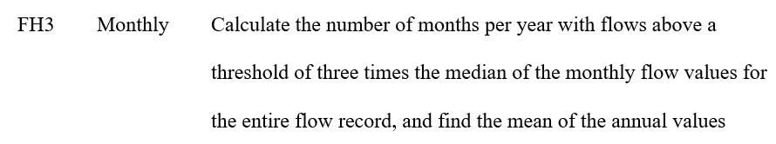

*Fig 8: Definition of Flood Frequency for monthly flows*

**Part A**

Machine generated alternative text:
#part 8- FH3 
f 1 ood_f requency_month 
functi on (df , e, a, b 
dfSDate=as . Date . character (as . character (df$Date 
df$Year 
as . numeri c (format (dfSDate 
df$Month = as. "%m" 
dfC,e] 
k2= median 
k=list 
o 
df1 
subset(df, Year>=a & Year<=b, select 
for (i in unique df1C, I' Year" 
format 
k3=df1$Month & 
df1C, 
, length (unique k3))) 
k=append (k , val ues) 
I' Year" 
-TRUE)) 
return (s apply(k ,mean , is . data. frame 
#Enter DataFrame, Column of Interest, 
Start & End 
fl ood_f requency_month (flow_data, " seg_outfl 
Year 
in YYYY format. 
Below is one example shown: 
_07 315700" , "1980" , "2000") 



*Fig 8.A.a: Figure shows the function code that calculates the number of months per year with flows above a threshold of 3 times the median of monthly flow values, highlighted part shows the input of values given into the function which is the Dataset, Column of Interest, Start year and End year.*

> , "1980" , "2000 
7 1983 
5 1984 4 1985 
7 1986 
7 1994 4 1995 
6 1996 8 1997 
[1) 1980 4 1981 
6 1982 
(223 
8 1991 
8 1992 
9 1993 
5 1987 
7 1988 
4 1989 
3 1998 
5 1999 
7 1990 
5 2000 



*Fig 8.A.b: The output of the code shows the number of months in each year which has occurrences of values more than 3 times the median of monthly flow values. These results can be verified from the Excel. We would verify the result for the 1980 year (highlighted)*

Date 
2/19/1980 
5/16/1980 
5/30/ 1980 
5/31/1980 
9/28/1980 
9/29/ 1980 
12/8/1980 
12/9/1980 
seg_outflow 
91.8 
121 
1080 
382 
532 
239 
340 
156 

*Fig 8.A.c: Figure shows the results from Excel, 3 times the median of the monthly flow values for column “seg\_outflow\_0018\_gage\_07331300” is 90. All the values which are more than 90 are filtered and displayed above. Clearly, we can see only in months of February, May, September, and December there are occurrences of values exceeding 3 times of median. Therefore, in the year 1980, we get 4 months which is the same answer we get from the function code.*

**Metric 9: - Low flow pulse duration- DL16**



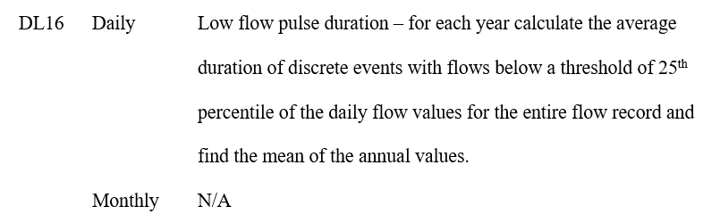

*Fig 9: Definition of Low flow pulse duration for Daily flows*

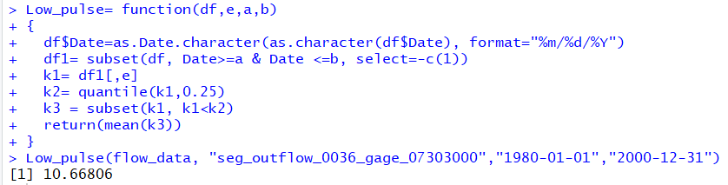

*Fig 9.A.a: Figure shows the function code that calculates the mean of flows below a threshold of 25th percentile of the daily flow values, the input of values given into the function are the Dataset, Column of Interest, Start date and End date.*

se 
outflow 0036 
flow datal 
1.2 
2.8 
2.94 
2.99 
3.01 
3.0 
3.05 
3.08 
3.09 
3.14 
3.14 
3.19 
3.21 
3.23 
3.24 
3.28 
3.31 
3.33 
3.35 
Sheet7 
106680608 
count: 1908 sum: 2035466 

*Fig 9.A.b: Figure shows the results from Excel, the 25th percentile of the daily flow values for column “seg\_outflow\_0018\_gage\_07331300” across the entire flow record is 16.4. All the values which are less than 16.4 are filtered and displayed above. Clearly, we can see the average of those values is 10.669. Therefore, we get the same answer as we got from the function code output.*

= function(df , e, a, 
df$oate=as . Date. character (as . character CdfSOate), format— 
df" subset(df, & Date 
data_abcwe = ILO (klek2) 
id_start = 
id_end = 
-1) 
Cbi , 
avg_durat i on 
mean(resL, 'Duration 'I) 
return (avg_duration) 
ow_data, 
" , "1981-01-01" , "1981-12-31") 

*Fig 9.A.c: Figure shows the function code that calculates the average duration of discrete events with flows below a threshold of 25th percentile of the daily flow values, the input of values given into the function are the Dataset, Column of Interest, Start date and End date.*

"seg_ou t f " 
1981-01-01" , "1981-12-31") 
[1] 11. 375 
" seg_ou t fl ow_OO 
" , " , "1981-01-31") 
[11 4 *Fig 9.A.d: The output of the code shows the average duration of discrete events across various time periods with flows below a threshold of 25th percentile of the daily flow values. These results can be verified from the Excel. We would verify the result for January month in 1981.*

Date 
outflow 
0036 
1/18/1981 
1/25/1981 
1/26/1981 
1/27/1981 
1/28/1981 
1/29/1981 
1/30/1981 
1/31/1981 
e 07303000 x 
6.42 
6.29 
6.16 
6.1 
6.02 
5.88 
5.76 
5.7 *Fig 9.A.e: Figure shows the results from Excel, the 25th percentile of the daily flow values for column “seg\_outflow\_0018\_gage\_07303000” for January month in 1981 is 6.42. All the values which are less than 6.42 are filtered and displayed above. Clearly, we can see there are two discrete events (i.e., 18th January and from 25th January to 31st January). Therefore, for January month in the year 1981, we get 2 discrete events and the average number of days for those discrete events is (1+7)/2 = 4, which is the same result we get from the function code.*

**Metric 10: - High flow duration- DH17**



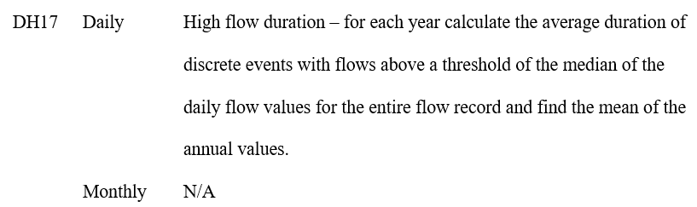

*Fig 10: Definition of Frequency of low pulse spells for Daily and Monthly flows*

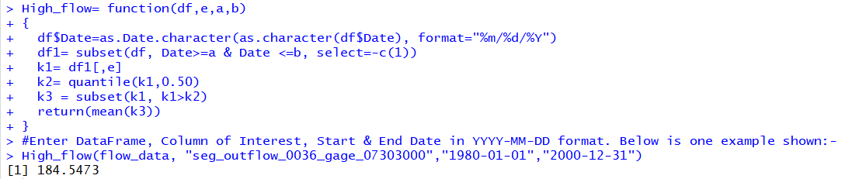

*Fig 10.A.a: Figure shows the function code that calculates the mean of flows above a threshold of median of the daily flow values, the input of values given into the function are the Dataset, Column of Interest, Start date and End date.*

seg_outflow_0036_gage_07303000 
10 
12 
13 
15 
16 
17 
18 
19 
20 
22 
Ready 
flow datal 
Sheet8 
Average; 184.5472969 
count: 3830 

*Fig 10.A.b: Figure shows the results from Excel, the median of the daily flow values for column “seg\_outflow\_0018\_gage\_07303000” across the entire flow record is 34.2. All the values which are more than 34.2 are filtered and displayed above. Clearly, we see the average of the filtered values is 184.547 which is the same answer we get from the function code.*

Hi = function(df , e, 
dfSDate=as Character CdfSDate), format— 
df• subset(df, Date.øa & Date 0b, 
kl = dfr,el 
data_above = ILO (kl>k2) 
id_start = Which Cd i f f (C (OL, 
id_end 
-1) 
cbi nd(kl Cid_start] , d_start+l) 
avg_duration 
mean(resC, 'Duration 'J) 
" , "1981-01-01" , "1981-12-31") 

*Fig 10.A.c: Figure shows the function code that calculates the average duration of discrete events with flows above a threshold of median of the daily flow values, the input of values given into the function are the Dataset, Column of Interest, start date and End date.*(..τε-το-τ86τ.. ' „το-το-Τ86Τ 
(..τε-ιτ-τ96τ.. ' „το-το-τς6Τ. *Fig 10.A.d: The output of the code shows the average duration of discrete events across various time periods with flows above a threshold of median of the daily flow values. These results can be verified from the Excel. We would verify the result for January month in 1981.*

1 Date 
4 
6 
10 
11 
12 
13 
14 
21 
22 
seg_outflow 
1/1/1981 
1/2/1981 
1/3/1981 
1/4/1981 
1/5/1981 
1/6/1981 
1/7/1981 
1/8/1981 
1/9/1981 
1/10/1981 
1/11/1981 
1/12/1981 
1/13/1981 
1/20/1981 
1/21/1981 
9.17 
8.94 
8.72 
8.51 
8.31 
8.12 
7.94 
7.76 
7.6 
7.44 
7.29 
7.15 
7.01 
7.44 
7.19 

*Fig 10.A.e: Figure shows the results from Excel, the median of the daily flow values for column “seg\_outflow\_0018\_gage\_07331300” in the first month of 1981 is 6.88. All the values which are more than 6.88 are filtered and displayed above. Clearly, we can see there are two discrete events (i.e., 1st January to 13th January and 20th January to 21st January). Therefore, for January month in the year 1981, we get 2 discrete events and the average of the duration of those 2 events is (13+2)/2 =7.5 which is the same answer we get from the function code.*