Liri-Node App Screenshots

By Chris Paul

April 4, 2019

Concert-this

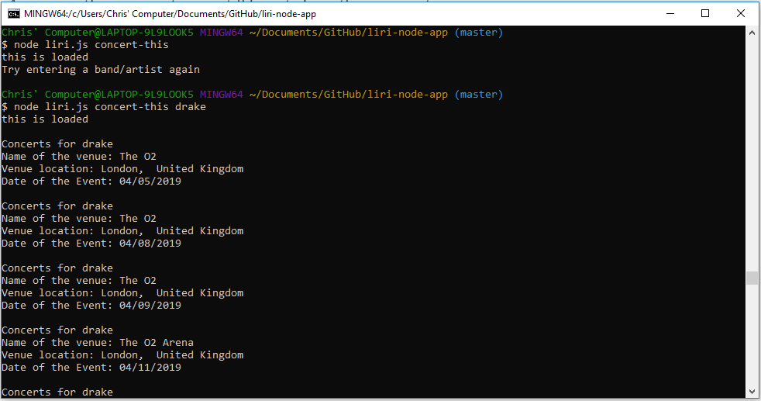

Spotify-this-song

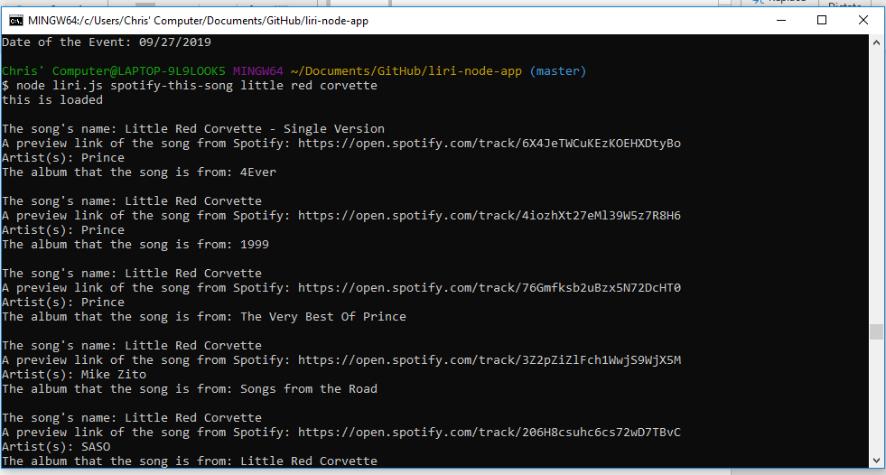

Movie-this

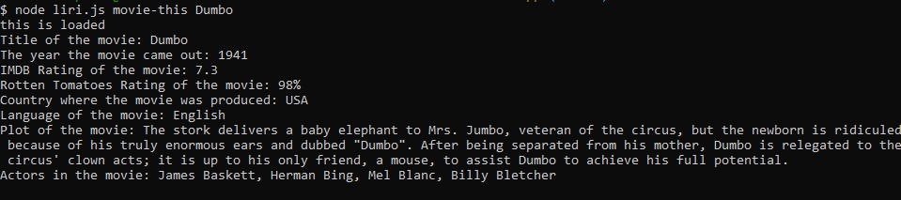

Screenshot of log info

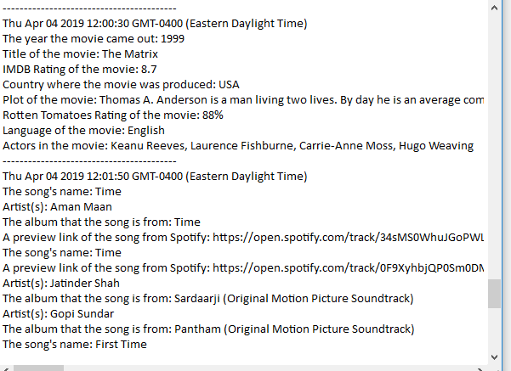

DoWhatItSays

