|  |
| --- |
| DELIVERABLES   * 2 pagebuilder pages: Poll Page01, Poll Page02   + New input for question 5   + external .js and .css files if necessary * 1 donation form embedded in Poll Page02   + QA donation form * 1 survey embedded in Poll Page01   + QA survey |

**Background Information**

This engagement piece will follow the same template as the [Pick Your Favorite Picnic](https://secure2.convio.net/cpc/site/SPageNavigator/pick_your_favorite_picnic_page01) poll.

**PIck Your Favorite Picnic: Page 01**

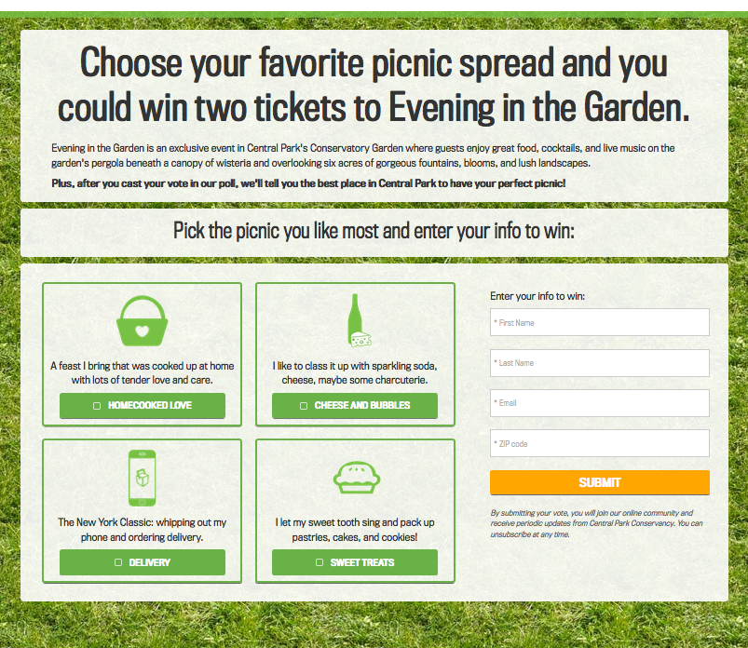

**Pick Your Favorite Picnic: Page 02**

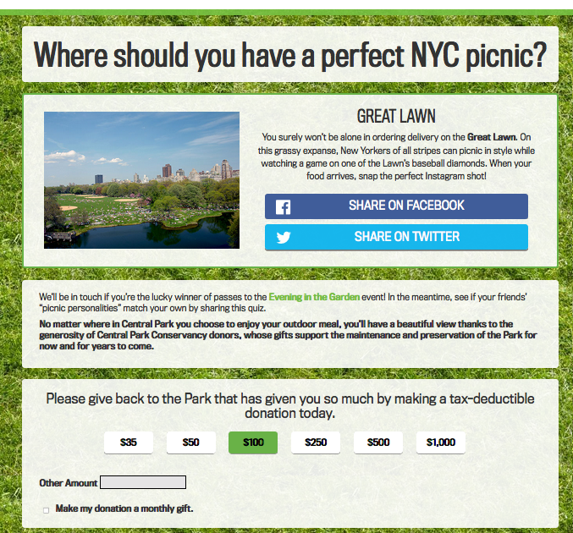

Please note that although Pick Your Favorite Picnic directs users to results page based on based on their answer ([pick 1](https://secure2.convio.net/cpc/site/SPageNavigator/pick_your_favorite_picnic_page02.html?x=iphone), [pick 2](https://secure2.convio.net/cpc/site/SPageNavigator/pick_your_favorite_picnic_page02.html?x=cheese), [pick 3,](https://secure2.convio.net/cpc/site/SPageNavigator/pick_your_favorite_picnic_page02.html?x=homecooked) [pick 4)](https://secure2.convio.net/cpc/site/SPageNavigator/pick_your_favorite_picnic_page02.html?x=sweets), the new poll will only have ONE results page.

**Comments**

*$scope.picks* Page01

You will need to add <p> {{*p*.*top-title*}}</p> after <div class="col-sm-12 myNumber myNumberNotPicked clickable" ng-click="vote(p.pick)"

ng-show="!isMobile || !pick || pick == p.pick">

**Copy**

**Page01**

*Title*: Central Park Summer Showdown

*Top Row*: Summer in Central Park is full of incredible events! We want to know: Which is the best of the best?

Select your favorite Central Park summer activity and you’ll be entered to win pre-performance hors d’oeuvres and two tickets to see Shakespeare in the Park!

*Middle/skinny row*: Which event is the best of the best?

*Choices:*

· Shakespeare in the Park

top-title: Shakespeare in the Park

pick: shakes

title: Shakespeare

description: NONE

image: summershowdownpoll_icons-01.png

· New York Philharmonic Concert

top-title: New York Philharmonic Concert

pick: phil

title: NY Philharmonic

description: NONE

image: summershowdownpoll_icons-02.png

· Summer Stage

top-title: Summer Stage

pick: stage

title: Summer Stage

description: NONE

image: summershowdownpoll_icons-03.png

· Marionettes at the Swedish Cottage

top-title: Marionettes at the Swedish Cottage

pick: marionettes

title: Marionettes

description: NONE

image: summershowdownpoll_icons-04.png

· None of the above: My favorite summer event in Central Park is: [Open fill-in-the-blank field]

**Page02**

*Title:* Thanks for weighing in!

*Second Row:* Think your friends might want to win pre-performance hors d’oeuvres and two tickets to see Shakespeare in the Park? Share this poll using the buttons below!

Facebook: Central Park Summer Showdown

Tell us what summer activity you love most, and enter to win a great Central Park prize.

Twitter: Pick your fave @CentralParkNYC Summer event & win big: http://bit.ly/XXXXXXX

*Third Row:* And if you can give back to your Park! Central Park Conservancy donors are crucial in maintaining this beautiful oasis in the midst of America’s largest and busiest city. Keeping the country’s most visited park in pristine condition is no small feat: More people visit Central Park’s lawns, walks and woods every year than Yellowstone, Yosemite and Grand Canyon National Parks combined.

**Give back to the Park that has given you so much by making a tax-deductible donation today.**