
theWindow
the newsletter of Christ Presbyterian Church, New Haven. volume 4, issue 1. summer 2002.

A Goodbye Letter
Tom Morrison
I can’t believe it was only four and a half years ago that we drove from Nashua, New Hampshire to New Haven in our big, yellow Ryder truck. While I drove the truck, Teri followed in our car with Katie who was only two months old. It was an extremely exhilarating time for me because I was getting my first crack at ministry and had the opportunity to take classes at Yale Divinity School. I was also extremely clueless. Oh yes, I had almost completed my Master of Divinity degree, but I came to realize very quickly that seminary was just a big survey course. Not only did I need to learn a lot more theology, I needed to learn about what it meant to minister to real, live people.
My first few weeks of ministry were just like experience I had when I started working in the hospital. The patients I worked with thought I knew a lot. After all, I had a white lab coat and stethoscope, which ostensibly legitimized me as a cardiac rehabilitation therapist. While I would carefully check the patient’s vital signs, read their EKGs, ask them questions, and scribble in their charts, I secretly wondered how somebody could have let me loose on the cardiac floor. I really knew very little and spent much time studying and asking questions of those who were experienced. I concluded that a certain reserve about one’s knowledge and abilities was a good thing. Some people call this humility. As I began my career in ministry, I came to believe that a minister should be characterized by humility, knowing that he is merely a servant and ambassador of Christ.
The saints of Christ Presbyterian Church have taught me a lot about humility. One of my first experiences was teaching a class on the Psalms. I felt fairly confident teaching the Psalms since I did well in Hebrew. I knew that my knowledge would be a tremendous boon to those unfamiliar with Hebrew poetry and the insight gained from a close reading of the Massoretic text. My youthful exuberance quickly faded, however, when I was given several glazed looks from those in my class. It seemed that my technical expertise was not making the impact I had so carefully calculated. My insights into the Scriptures seemed to have the same effect upon the congregation when I preached. When I would gather enough courage to look up from the pulpit at the congregation, I saw a veritable cornucopia of responses: glazed looks, people snoring, people drooling, people staring out the window, etc. I wasn’t offended; I rather knew I needed to change something and fast.
CONTENTS
 | A Goodbye Letter  Tom Morrison | 1
 | Fantasy Informed by Christianity  Matt Richardson | 2
 | Reformed Christian Fellowship  Jane Lee | 3
 | CPC Prayer Requests | 4
While I wasn’t boring people at church or students on campus, I was taking classes at the Divinity School. One of my Old Testament professors said that God uses the church to condition pastors. He was saying that churches, over time, develop a confessional sense and provide helpful feedback to those who bring the word of God to them in preaching. Now certainly people would confront pastors with their particular agenda that wasn’t biblical, but sometimes they would also talk to their pastor about legitimate concerns that bore on the accuracy of their sermons. I remember several times when people would raise very important issues about the text from which I was preaching. I am grateful for those who came to me with these points. I have tried my best to go back to the study and reexamine the Scriptures and ask what God was actually saying in the text.
The saints at Christ Presbyterian have also helped me to understand the human condition. Counseling situations are ideal for this kind of knowledge and experience. Time and time again, I had to think about how the gospel applied to those who were hurting. I was confronted with the question of whether redemption was “practical” to those who seemed to have insurmountable problems. Happily, I found that the gospel was indeed the very balm people required for the answer to their particular dilemmas.
I also found that there was an intersection between preaching and counseling. Historical and biblical studies prove that the church has been called to preach both the law and the gospel. The law is used by God surgically to reveal sin that is deeply imbedded within the soul (Rom. 3:20). The gospel speaks of the peace and comfort that God gives: “For in [the gospel] the righteousness of God is revealed from faith to faith; as it is written, ‘But the righteous man shall live by faith’” (Rom. 1:17). This is the righteousness that God imputes to His people through the work of Christ and they receive by faith alone. The gospel (good news) is life changing and is what the people of God need to hear every time the pastor talks with them or preaches to them.
The pastor learns about the gospel as he studies the Scriptures and time-tested creeds and confessions. He also learns about its priority from allowing the Scriptures to penetrate his own wicked heart. God, as He blesses the church with the Word and sacraments, also teaches pastors about the effects of the gospel. I have been impressed with how those at Christ Presbyterian have imbibed the grace that comes from the gospel. From the youngsters to the older members of our church, all have demonstrated the fruit of the Spirit as they have interacted with me. Teri, the kids, and I have been the recipients of an overabundance of love and mercy.
Therefore, I have found grace at this church in ways I could have never imagined. When I made mistakes and did silly things, I found brothers and sisters in Christ quick to forgive me. I experienced people loving me, bearing my burdens, and pitching in to help our family and me. These were the same people who knew they were sinners but believed in the power of the gospel to make them right with God.
As I move on to pastor a church of my own, I feel my deficit in knowledge and experience more acutely than ever. Nevertheless, I hope I retain this sense of lack and humility. After all, it is Christ’s church that I’m serving and He is the king and head of it. The promises of God and His fidelity to His covenant
are the basis of my hope and the rest of the saint’s hope. Jesus Christ sanctifies His church, cleansing her by the washing of water with the Word. May the saints of Christ Presbyterian Church never lose sight of the sweetness of Christ and His gospel. What a great hope we have in Christ for a secure future! “They shall hunger no more, neither thirst anymore; neither shall the sun beat down on them, nor any heat; for the Lamb in the center of the throne shall be their shepherd, and shall guide them to springs of the water of life; and God shall wipe every tear from their eyes.”
Teri, Katie, Benjamin, Abigail and I are eternally grateful to those at Christ Presbyterian Church. We will miss everyone!
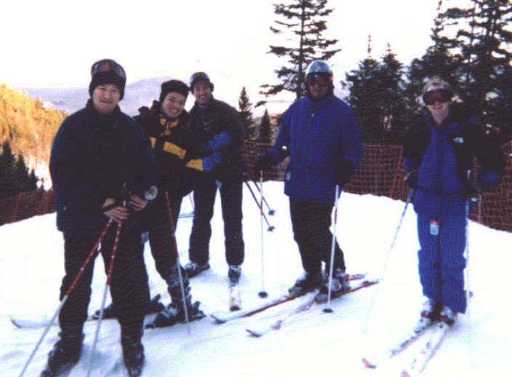

Members enjoy skiing at the church’s winter retreat.

Fantasy Informed by Christianity

Matt Richardson

Tolkien’s The Lord of the Rings trilogy is like no other work of fantasy or science fiction. Many fans would say this is because he virtually started the fantasy genre with his epic tale of elves, dwarves, hobbits, orcs, and men. Tolkien’s descriptions of these fantastic races are used in most fantasy literature, not those of Norse or English mythology. I believe that the influence of Tolkien’s Christianity in the plot, imagery, and character development is what makes this work truly special.
Tolkien did not write his work of fantasy as an apologetic to the unbeliever in the way that his friend C. S. Lewis wrote The Chronicles of Narnia. It is not a strict Christian allegory. Instead, he infused the story and its characters with a Christian understanding. An essential element of the fantasy genre is the struggle between good and evil. The struggle in The Lord of the Rings resonates with the Christian life pointing to something that humanity, as well as elves and dwarves, lacks and cannot provide for itself. The task given to the fellowship of hobbits, dwarves, elves, and men is virtually insurmountable, and throughout the first book they face many trials that nearly allow the Ring to fall into the control of the evil Sauron. In contrast with other works of fantasy, the goal is not defeating Sauron for the sake of 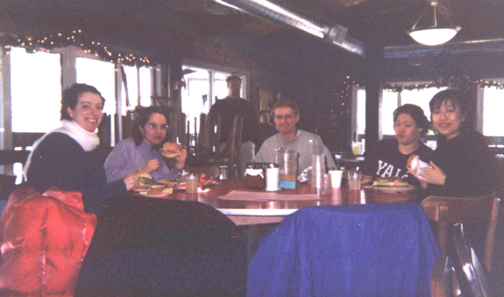

Folks appreciate a lunch break at the Camp Berea retreat.
freedom, unity of the races, heroism, or saving lives. It is not even about personal integrity or righteousness. The characters are struggling toward heaven.
Each day the characters battle sin in their personal temptations and fears. They are frequently reminded to hope that there is something more than what they see--something more beautiful, more joyous, more satisfying, and more powerful than the
inhabitants of the world. Personal temptation is evident when the
man Boromir assaults Frodo and tries to take the Ring, believing that he could use its power to save the world. By some awesome strength, almost too great to be his own, he is later redeemed through death while boldly slaying twenty orcs in battle and protecting two hobbits.
We see amazing joy in the pleasure the companions have visiting the elves at Rivendell and Lorien. Heaven itself is even referenced as the “land across the sea” to which the great elven queen Galadriel will return as the current age of the world comes to a close. Most important, we see many events in which the party is saved by seemingly coincidental yet miraculous events. For example, the great eagle Gwaihir saves Gandalf from imprisonment by the wizard Saruman. These events are a sort of Deus Ex Machina (god in the machine), a plot device often used so that an author can work himself out of a bind in his writing. However, when you realize that Tolkien is a Christian, it all makes sense. He believes in a literal God who even in a world of dwarves and elves would act in space and time for His own ends to the good of those who love Him.
These ideas about how Tolkien’s Christianity is expressed in The Lord of the Rings are borrowed from a tape series on C. S. Lewis from Christ Reformed Church in Anaheim, CA, where Kim Riddleberger is pastor. They have allowed me to see the series in a new light as I watched the movie and reread the first book.
When you have finished reading the trilogy, I highly recommend Tolkien’s Silmarillion, which gives a complete history of Middle Earth and explores these themes of temptation and redemption throughout. After all, it was Tolkien’s favorite.

Reformed Christian Fellowship

Jane Lee

As I reflect on my four years in Reformed Christian Fellowship at Yale, I realize that its most important impact on my life has come through the people I’ve met in the Fellowship. Through them, God has shown me the faith of some of the most devoted and steadfast Christians I have ever known.
Not everyone may be familiar with RCF and what it does. The fellowship is made up of undergraduate and graduate students as well as some young professionals. Many churches around the New Haven area are represented in the group. Each week, Tom leads us in study of the Scripture (currently Romans) at our large group meetings on campus. There is a separate women’s study led by Heather Woolbert and a men’s study led by Tom on other evenings during the week. On Thursday mornings, we begin the day with prayer led by Teri Morrison. The students have often praised God for the wonderful leadership that we have. We cannot say enough about the dedication and serving hearts of these leaders who drive to Yale to allow students to participate in these studies on campus. The way the leaders relate to students, making us feel at home and being eternally generous with their time, has been an integral component of making RCF feel like a place where we can share about our own faith and grow in Christ together.
Another important goal of RCF has been to serve the surrounding New Haven community through service projects. One Christmas, we were able to get over a hundred books donated from Barnes and Noble to distribute to the children at the Dixwell Community House. These elementary aged kids were thrilled when we visited them and sang Christmas carols, made crafts, and read stories with them. Our fellowship has also worked with Night Runners, a community service group at Yale, reaching children in the housing projects and adults in community shelters around New Haven. RCF intends to join ongoing and newly proposed initiatives with Hope for New Haven to serve the community in the future.

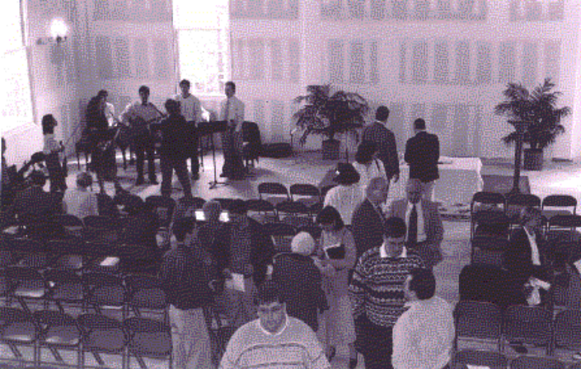
The CPC congregation enjoys fellowship after worshiping for the first time in the new sanctuary on Easter Sunday.

Living life in a way that brings glory to Christ is always challenging. College life seems to make it even more difficult. College students place no limits on themselves and their actions.

They see this time as the last chance to be reckless and irresponsible before being forced into the real world. That outlook becomes a life philosophy that is often inconsistent with Christianity. Yale also prides itself on being an open-minded place where students can express their thoughts and lifestyles without fear of censorship or condemnation. In fact, colleges in general hold to the philosophy, “To each his own.” We are taught to suspend judgment and avoid absolutes—for how can we even know absolutes exist? It is believed that everyone is entitled to his or her own opinion, and each is just as “correct” as the next. The concepts of right and wrong, good and bad—these signify limitations, judgment, and are generally considered “anti-intellectual.” In response to this environment, my involvement with RCF has truly been a growing experience for me. Meeting regularly on campus during the week, we study the Word together, pray together, fellowship together, and help each other overcome the challenges we face.
Many of the organizations I belong to on campus are composed of predominantly non-Christians and occasional “dormant Christians” (those who grew up in Christian households and went to church at home but somehow couldn’t pack Christianity into the family car when moving to college). Religion is secondary or altogether nonexistent in their lives. In high school, it was easier to ignore our differences and go about living separately. But college somehow forces us to face the issues head on and address the differences. During freshman year, one of my most difficult moments was when my very own English professor launched challenges against the Bible in the name of literary criticism. It was difficult having to confront these situations, stepping out of the zone of religious comfort. I admit that there were times when I wanted to abandon all my roles on campus and retreat to the sheltered safe haven of my Christian fellowship. But one of the most important things about our fellowship has been its encouragement of our involvement in the non-Christian environment around us. RCF has helped me to learn how to share the Gospel with my non-Christian friends and has hosted events that allowed me to invite friends from outside the fellowship.
Through reading the Word and prayer, the Fellowship has nourished us, helped us find rest in Him, and share our experiences of interacting with non-Christians around us. It has allowed me to come together with Christian students in the middle of the week re-focus my life on Christ, realize the power of prayer in the midst of a hectic schedule, and enjoy the fellowship of Christian students in a college atmosphere that’s not always conducive to Christian living. The friendships I’ve made through RCF will endure far beyond graduation. Through them, God has inspired and encouraged me. Through them, I have witnessed a living faith.
The role of RCF in my life can be summed up with a reference to Hebrews 5 and an analogy of a mother nursing her child. The Fellowship has weaned me from the milk and enabled me to slowly graduate to solid food. In high school, without having my faith challenged, I was content but also static in my walk with God. I feel that I have been truly blessed by the encouragement from my church and fellowship, which has really enabled my faith to grow.

CPC Prayer Requests

- Pray that the Holy Spirit would continue to work through CPC to reach people in greater New Haven with the gospel.
- Pray for the session as they make plans for the upcoming academic and fiscal year.
- Pray for the Morrison family as they move to California and Tom begins to pastor a church plant in Victorville.
- Pray for continuing wisdom and direction for Pastor Graham as he preaches the Word and ministers to the congregation.
- Pray that God would continue to provide financial resources for final building details and loan repayment.
- Pray that Hope for New Haven will be up and running by the end of the summer and that director June Burtis will find qualified Christian day care workers.
- Pray for a life-transforming experience for our youth during Summer Theology Camp.
- Pray for safe summer travels for all.
- Rejoice with the Tarantino family as they welcome baby daughter Sierra!

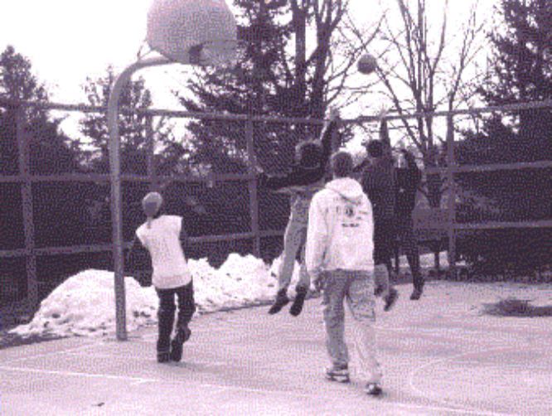

CPC and other youth enjoy a game of basketball on the Southern New England Presbytery retreat.

theWindow

135 Whitney Avenue, New Haven, CT 06510
www.christpresnewhaven.org

the newsletter of Christ Presbyterian Church

