Kubernetes

# Overview

Kubernetes is a portable, extensible, open-source platform for managing containerized workloads and services, that facilitates both declarative configuration and automation. Developed by google and open sourced in 2014, it allows for production grade container orchestration, making scalable applications quickly.

# Concepts

## Types of Depolyment

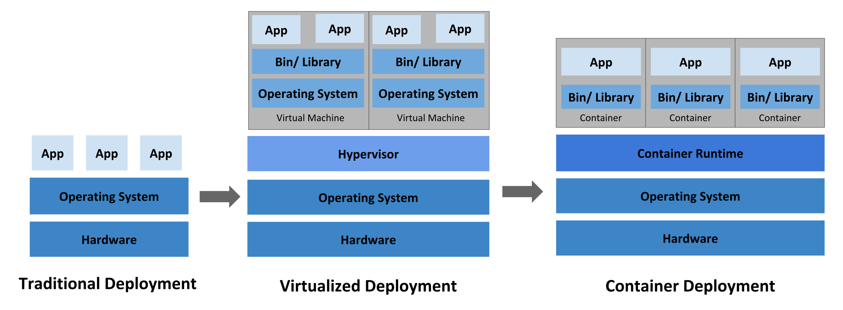

### Traditional

Applications running on phyiscal dedicated servers with a single operating system (OS). There is no way to define resource boundaries for the different programs running on the server, so there were often resource allocation issues and security implications.

### Virtualized

Multiple virtual machines (VM) running on one physical server cpu. Applications can be isolated between VMs, providing better management of resources and security between applications.

Each VM is a full machine running its OS on top of virtualised hardware. VMs were often used in the cloud with all servers being run by a large sysops manager.

### Containers

Containers are similar to VMs however they have relaxed isolations properies, allowing them to share the same OS. Being able to share the same OS allow containers to be very lightweight.

Containers have their own filesystem and share of hardware resources, but as they are decoupled from the OS they are portable across clouds and OS distributions.

Some of the benefits of running applications in containers are:

* Agile application creation and deployment
* CI/CD due to quick container deployment and easy rollbacks due to image immutability
* Separate dev and ops since containers are created at build/release time instead of deployment, allowing issues to be quickly picked up by the dev team.
* Environmental consistency due to containers running the same on a laptop as the cloud
* Loosely coupled elastic micro-services, since applications can be broken into smaller pieces which can be deployed and managed dynamically
* Resource management, since containers can be scaled quickly and dynamically to keep efficiency high

## Kubernetes

Kubernetes is a container management system, designed to manage distributed systems resiliently. It allows for automated scaling and self healing.

The key features of Kubernetes are:

* Service discovery and load balancing - kubernetes can expose a container using dns name or ip address, then load balance if traffic to the container is high
* Storage orchestration - automatically mount storage system
* Automated rollouts - describe the desired state for the deployed containers and kubernetes will change the actual state to match the desired state
* Automatic bin packing - provide a cluster of nodes to run containerised tasks and kubernetes will fit as best it can, even with limited resources
* Self-healing - restarts containers which fail, replace containers, and kill containers which do not respond to user defined health checks
* Secret and configuration management - store sensitive information such as ssh keys in kubernetes and then include in deployment without having the rebuild container images

## Components

A Kubernetes cluster is a set of worker machines called nodes, that run containerised applications in pods. Running a cluster across multiple computers provides fault tollerance and high availability.

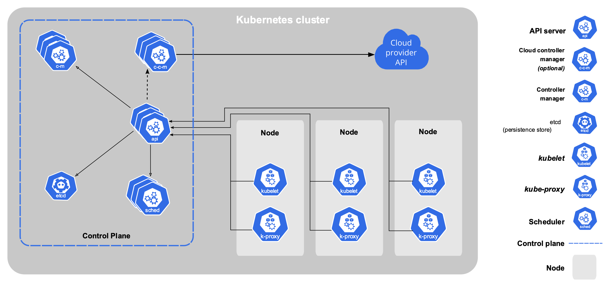

### Control Plane

Control plane components make global decisions about the cluster, along with detecting and responding to cluster events. While control plane components can be run on any machine in the cluster it is common to run all components on the same dedicated control machine, which does not container any user applications.

The control plane components are:

* kube-apiserver - Exposes the Kubernetes HTTP API allowing for user management of the control plane components. The API allows a user to query and manipulate the state of objects in the Kubernetes API. Most opertations can be performed using the kubectl cli.
* etcd - Key value store used as Kubernetes backing store for all cluster data. It is important to ensure the backing store data is backed up, incase of coruption or failure.
* kube-scheduler - Watches for newly created Pods with no assigned node and selects a node for them to run on. Takes into account the resource requirements, system contraints, data locality, and many more factors.
* kube-controller-manager - Runs the controller porcesses. Logically each controller has a separate process, but to reduce complexity they are compiled into a single binary and run as one. Manages:
  + Node controller - notices and responding to when nodes go down
  + Replication controller - Maining correct number ofpods for every replication controller object in the system
  + Endpoints controller - joins servers and pods
  + Server Account and Token controllers - Creates default accounts and API access tokenes for new namespaces
* cloud-controller-manager - Embeds cloud-specific control logic. Links cluster into cloud providers API to allow kubernetes to manage cloud specific scaling etc:
  + Node controller - check with cloud provider to see if node has been deleted in the cloud after it stops responding.
  + Route controller - Setting up routes in the underlying cloud infrastructure.
  + Server controller - For creating, updating, and deleting cloud provider load balancers.

### Node Components

The node components run on every node to maintaine running pods and provide the Kubernetes runtime environment:

* kubelet - Agent making sure the containers are running in a pod.
* kube-proxy - Network proxy implementing part of the kubernetes service concept. Maintains network rules on the nodes, allowing network communication to Pods from network sessions inside or outside of the cluster.
* Container runtime - Responsible for running containers, commonly Docker, but can also handle many other such as containerd

### Addons

There are many addons which use the Kubernetes resources to implement cluster features, some of these are:

* DNS - Serves DNS records to Kubernetes services, all clusters should have a cluster DNS.
* Web UI - Allows users to manager and troubleshoot applications running in the cluster
* Container Resource Mointoring - provides time-series metrics about containers.
* Cluster-level Logging - Cluster level logging mechanism responisble for saving container logs to a central log store with search and browsing interface

## Objects

Kubernetes objects are persistent entities in the system which represent the state of the cluster. Specifically, they define:

* What containerized applications are running, and on what nodes
* The resources available to those applications
* Policies around how the applications behave, for example: restarts, upgrades, and fault tollerance.

The object is a record of intent, so once created, the system will constantly work to reach the desired state defined in the record. There are two parts to objects:

* spec - desired state defined when creating the object
* status - describes current state of object, supplied and updated by the kubernetes system

### Defining an object

YAML file containing basic information and spec of the object.

The required fields are:

* apiVersion - kubernetes api version
* kind - kind of object to create
* metadata- data that uniquely identifies object, including name, uid, and optional namespace
* spec - desired state of the object

For example:

**apiVersion**: apps/v1 *# for versions before 1.9.0 use apps/v1beta2*

**kind**: Deployment

**metadata**:

**name**: nginx-deployment

**spec**:

**selector**:

**matchLabels**:

**app**: nginx

**replicas**: 2 *# tells deployment to run 2 pods matching the template*

**template**:

**metadata**:

**labels**:

**app**: nginx

**spec**:

**containers**:

- **name**: nginx

**image**: nginx:1.14.2

**ports**:

- **containerPort**: 80

A common way to then deploy this object is using the kubectl apply command, for example:

kubectl apply -f ./application/deployment.yaml --record

Optional fields are:

* labels - (key/value) specify identifying attributes of objects with relevance to user but not the core system, alphanumeric with dashes between words. labels can be used to select objects. prefix can be set with / before name
* annotations - (key/value) used to describe objects, however cannot be used to select

Recommended labels:

* common-prefix/name - mysql
* common-prefix/instance - mysql-abc
* common-prefix/version - "5.7.21"
* common-prefix/component - database
* common-prefix/part-of - wordpress
* common-prefix/managed-by - chris

### Types of object

* Deployment
* Node
* Service
* Job

## Containers

Containers are repeatable, decoupled application images which can be run anywhere while producing the same behaviour. Typically, containers are refered to in pod definition by their name and registery location, which allows them to be downloaded and deployed. For example, a container could be referred to in a deployment like:

image: fictional.registry.example:10443/imagename

Kubernetes provides several important resources to containers:

* filesystem - combination of image and one or more volumes
* information about container iteself such as hostname (name of pod), and environment variables
* information about other objects in the cluster - services available for container at creation

### Lifecycle hooks

Containers are provided with lifecycle hooks, allowing them to be aware of events in their management lifecycle. The hooks provided are:

* PostStart - Immediatley after a container is created
* PreStop - Immediatley before a container is terminated, it is a blocking hook so much be completed before the signal to stop the container is sent

Container handle the hooks by implementing and registering a handler for the hook. There are two types:

* Exec - specific command is executed inside the container
* HTTP - executes a HTTP request against specific endpoint on the container

## Workloads

A workload is an application running on kubernetes, run inside a pod. Pods represent a set of running containers in the cluster. Pods can be managed by workload resources, which configure controllers that make sure the right number and kind of pods are running to match the state specified.

Workload resources include:

* Deployments
* StatefulSet
* DaemonSet
* Job

## Pods

Smallest deployable unit which can be managed in kubernetes. A pod is a group of one or more containers, with shared storage and network resources. The shared context of. pod is created using a set of linux namespaces, cgroups, and other isolation methods, in a smilar way to how Docker isolates containers.

Generally, pods run a single container, but hey can run multiple container which are tightly coupled and need to work together.

Pods allow applications to scale horizontally by increasing the number of pods per application and load balancing between them. This is referred to as replication.

Pods are created from pod templates, defined in deployment specs as 'templates'. When templates are updated, new pods are created to match the spec in the templates, with old ones being removed.

Each pod is assigned an IP address, containers inside pod can communicate on localhost.

### Lifecycle

A pods lifecycle is defined in phases:

* Pending - Accepted by cluster but one or more container has not yet been set up fully and is ready to run
* Running - Pod is bound to node and all containers have been created, at least on container is running
* Succeeded - All containers in pod have terminated in success and will not be restarted
* Failed - All containers in pod have termined but one has failed (non-zero status or terminated by system)
* Unknown - State of pod could not be obtained

While a pod is running, kubernetes can restart containers to handle some kinds of fault. However, pods are designed to be quickly deleted and deployed, so in general pod do not self heal, instead if they fail, they are simply replaced to heal the system.

Since pod states rely on containers, there are also container states which are kept track of:

* Waiting - Container is not either running or terminated.
* Running - Container is executing without issues
* Terminated - Container began execution and ran to completion or failed

### Probes

A probe is an optional diagnostic performed by the kubelet on a container. The kubelet calls a handler implemented by the container, which allows the container to signal its condition.

There are three types of handlers:

* Exec - Executes specific command inside the container, successful if 0 exit
* TCPSocketAction - TCP check against Pods ip address on a specific port, successful if port is open
* HTTPGetAction - HTTP GET request against pods IP address on specific port and path, successful if response code 200 <= x < 400

There are three kinds of probe:

|  |  |  |
| --- | --- | --- |
| Probe | Behaviour | When to use |
| livenessProbe | Indicates if container is running, if it fails the kubelet kills the container, the container will then restart if it is subjected to a restart policy. If the container does not provide a liveness probe, default state is success. | Generally used when a container cannot crash on its own when unhealthy, or if specific behavior via probe indicates health. |
| readinessProbe | Indicates whether container is ready to respond to requests. Failure remove the pods IP address from the endpoints of all Services which match the Pod. Default state if failed, if container does not provide, default is success. | Generally used to only start sending traffic to a pod when it can process it, useful if container takes some time to load and traffic can be missed. |
| startupProbe | Inidcates whether application within container is started, if startup probe is provided, all other are disabled until it succeeds. On failure, the kubelet kills the container and restarts if policy is in place. | Good for containers which take a long time to come into service. Instead of setting long liveness intervals, set startupProbe with long period. |

### Deletion

Pods should be allowed to gracefully terminate when they are no longer needed instead of being killed, so they can clean themselves up.

When deletion is requested, the cluster records and tracks the intended grace period before forcefully killing the pod.

Typically the container runtime sends a TERM signal to the main process of each container, although this can be changed to STOPSIGNAL if the container responds to that instead. Once the grace period has expired, a KILL signal is sent to any remaining processes and the Pod is deleted from the API server.

### Preset

PodPreset is an API resource for injecting additional runtime into a Pod at creation time. Label selectors are used to specify the pods to which a given PodPreset applies. It allows templates not to have to specifiy all information for every pod.

Pod preset must be enabled in the API:

settings.k8s.io/v1alpha1/podpreset

by:

settings.k8s.io/v1alpha1=true --runtime-config

# Management

kubectl cli support several different ways of creating and managing objects. Kubernetes objects should be managed using only one technique, mixing and matching will cause undefined behaviour.

## Techniques

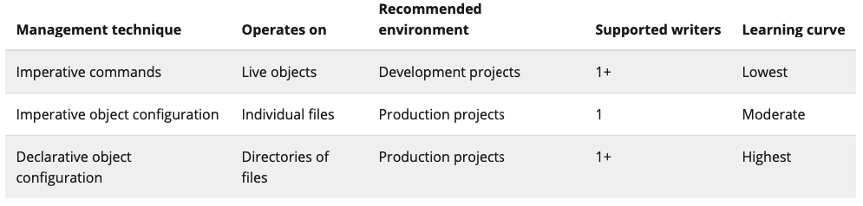

### Imperative commands

User operates directly on live objects in a cluster, operations are provided to kubectl as arguments or flags. For example:

kubectl create deployment nginx --image nginx

Pros:

* commands are simple and easy to learn
* requires only one step to deploy

Cons:

* does not integrate with change review process
* no audit trail
* no source of records apart from whats live
* no template for create new similar objects

### Imperative object configuration

kubectl command specifies the opertation (create, replace, etc) and provide at least one filename with object definintion. For example:

kubectl create -f nginx.yaml

Pros:

* Object configuration stored in source control such as Git
* Object configuration can be integrated into review processes
* Template for creating new similar objects

Cons:

* Knowledge of schema required
* Additional step to writing config file

### Declarative object configuration

User operates on object configuration files stored locally, however user does not define the operations to be taken on the files. The operations are automatically detected per-object by kubectl.

kubectl can display differences on a set of configs, then apply them. For example:

kubectl diff -f configs/

kubectl apply -f configs/

Pros:

* Changes made directly to live objects are retained, even if they are not merged back into configuration files
* Declarative object configuration has better support for operating on directories and automatically detecting operation types

Cons:

* Hardered to debug and understand when results are unexpected
* Partial updates using diffs create complex merge and patch operations

## Node management

Nodes can either self-register to the control plane or be manuallyed added as a node object. When nodes are created, kubernetes create a node object internally, checks it has been registered on the API server, and if it is healthly it can then start running pods.