BE PREPARED

Floods- flooding is a common, naturally occurring event in B.C. Although it can happen at any time of year, the most severe floods typically occur in spring — known as freshet — or during fall and winter. This seasonal flooding is usually caused by heavy rain and snowmelt. Homes may be at risk when flood water spreads to adjoining areas that are normally dry. Depending on the type and severity of flooding, it could take hours, weeks and potentially months for the water to recede and the clean-up to begin.

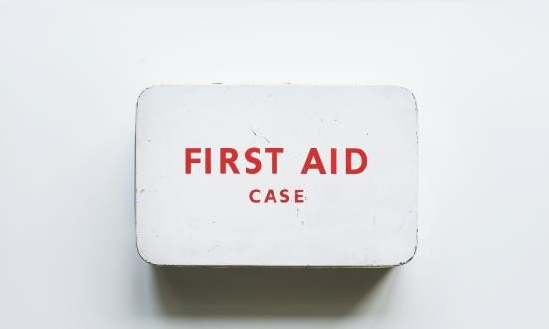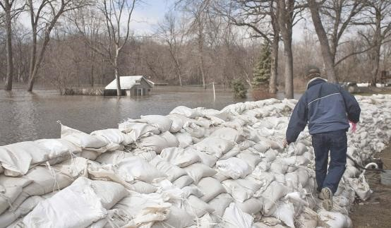

Protect Your Home and Property- Download the PreparedBC: Flood Information for Homeowners and Home Buyers guide to learn about protecting your home and property.

Flood Information for Homeowners and Home Buyers.

Recognize the Danger Signs- Heavy snowmelt may contribute to landslides and dangerous debris in creeks and waterways. Be safe and don’t go down to watch the rushing water. If you notice trees beginning to lean or bend near your home, or cracks developing in the hillside, consult an engineer or contact local authorities. If you live near a waterway, a change in water colour or rapid change in water level (especially a drop) could indicate a problem upstream. Call your local fire, police or public works department immediately if you suspect something out of the ordinary.

Sandbagging- It takes two people about one hour to fill and place 100 sandbags, giving you a one-foot-by-20-foot wall. Make sure you have enough sand, burlap or plastic bags (NOTE: you should tie the ends of plastic bags shut to prevent the sand and bags from washing away), shovels and time to prepare properly.

Sandbagging-

* It takes two people about one hour to fill and place 100 sandbags, giving you a one-foot-by-20-foot wall.
* Make sure you have enough sand, burlap or plastic bags (NOTE: you should tie the ends of plastic bags shut to prevent the sand and bags from washing away),
* shovels and time to prepare properly.
* It takes two people about one hour to fill and place 100 sandbags, giving you a one-foot-by-20-foot wall.
* Make sure you have enough sand, burlap or plastic bags (NOTE: you should tie the ends of plastic bags shut to prevent the sand and bags from washing away),
* shovels and time to prepare properly. 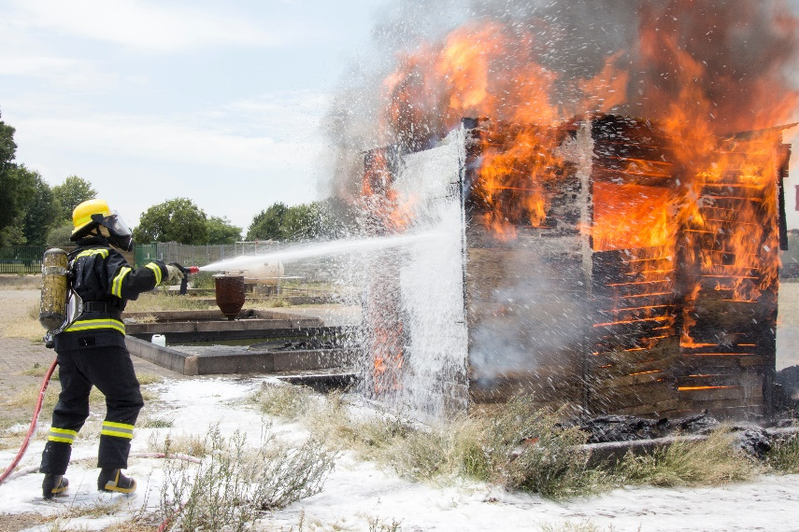
* Floods- flooding is a common, naturally occurring event in B.C. Although it can happen at any time of year, the most severe floods typically occur in spring — known as freshet — or during fall and winter. This seasonal flooding is usually caused by heavy rain and snowmelt. Homes may be at risk when flood water spreads to adjoining areas that are normally dry. Depending on the type and severity of flooding, it could take hours, weeks and potentially months for the water to recede and the clean-up to begin.

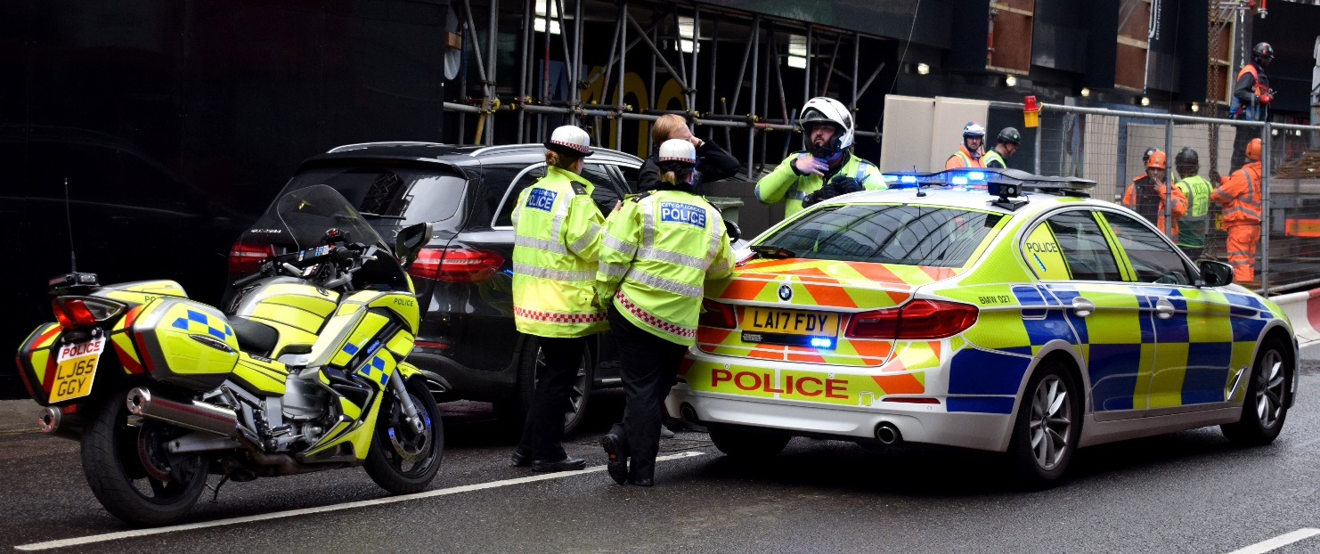

**LATEST UPDATES**

(blog-style RSS feed that can be easily pushed out to e-subscribers)

**MAP**

Embed TNRD Emergency Info Map <http://tnrd.maps.arcgis.com/apps/webappviewer/index.html?id=8ce7f3422b724dfeb1d6412c1897c6b7>

(I’ll add a blurb about searching the map below)

**BE PREPARED**

Types of Emergencies

* Floods
* Wildfires

**Floods**

Flooding is a common, naturally occurring event in B.C. Although it can happen at any time of year, the most severe floods typically occur in spring — known as freshet — or during fall and winter. This seasonal flooding is usually caused by heavy rain and snowmelt.

Homes may be at risk when flood water spreads to adjoining areas that are normally dry. Depending on the type and severity of flooding, it could take hours, weeks and potentially months for the water to recede and the clean-up to begin.

**Flood Preparedness**

Flood waters move fast, so develop a household plan, put together your emergency kit and connect with your neighbours. Learn about the emergency response plan for your area.

If you face a threatening flood situation, park vehicles away from streams and waterways, move electrical appliances to upper floors and make sure to anchor fuel supplies. Listen to local officials if you are asked to evacuate.

**Protect Your Home and Property**

Download the PreparedBC: Flood Information for Homeowners and Home Buyers guide (PDF, 2.22MB) to learn about protecting your home and property.

**Flood Information for Homeowners and Home Buyers**

<https://youtu.be/rNjTRyVSC0g>

**Recognize the Danger Signs**

Heavy snowmelt may contribute to landslides and dangerous debris in creeks and waterways. Be safe and don’t go down to watch the rushing water. If you notice trees beginning to lean or bend near your home, or cracks developing in the hillside, consult an engineer or contact local authorities.

If you live near a waterway, a change in water colour or rapid change in water level (especially a drop) could indicate a problem upstream. Call your local fire, police or public works department immediately if you suspect something out of the ordinary.

**Sandbagging**

It takes two people about one hour to fill and place 100 sandbags, giving you a one-foot-by-20-foot wall. Make sure you have enough sand, burlap or plastic bags (NOTE: you should tie the ends of plastic bags shut to prevent the sand and bags from washing away), shovels and time to prepare properly.

Instructions on how to build a sandbag dike to protect your property from flood waters.

**Sandbag Dike Tips**

<https://youtu.be/exb2iUgH8cI>

**Wildfires**

Many wildfires in B.C. occur far from cities and towns, but sometimes they threaten homes, businesses and infrastructure. Help keep your family safe by preparing in advance for a potential evacuation alert or order. Develop a household plan, put together your emergency kit and connect with your neighbours.

**Wildfire Readiness**

<https://youtu.be/-NmVROeq6vA>

**Prevent Wildfires**

Nearly half of all wildfires in B.C. are caused by human carelessness. You can make a difference by following a few simple rules.

* Heed prohibitions: check for bans and restrictions before striking the match
* Camp responsibly: In B.C., campfires can’t be larger than 0.5 metres by 0.5 metres. Keep a shovel or at least eight litres of water nearby to extinguish your fire, and don’t forget to create a firebreak. That means making a one-metre debris-free area around your fire by scraping down to the dirt. Before leaving, ensure your campfire is completely out and the ashes cool to touch. Check out this video to learn more
* Phone it in: call 1-800-663-5555 or *5555 on your cell if you spot smoke, flames or an unattended campfire

**Evacuation Stages**

* Evacuation Order: You are at risk. Leave the area immediately. You are encouraged to register all family members at the reception centre so, emergency responders know that you are safe
* Evacuation Alert: Be ready to leave on short notice. If you leave before or during this alert, it’s called a voluntary evacuation
* Evacuation Rescinded: All is currently safe and you can return home. Stay tuned for other possible evacuation alerts or orders

**Backcountry Closures**

Wildfires can impact backcountry recreation, resulting in area closures or restrictions. Campers and provincial park visitors should check with BC Parks for fire restrictions and closures and recreation site and trail users can check with Recreation Sites and Trails BC.

**FireSmart Your Property**

More and more people are making their homes in woodland settings. While beautiful, these locations come with a greater wildfire risk. Ensure your home insurance is up-to-date and includes adequate coverage for fire damage. You can also help protect your property by planning ahead. Start by completing a risk assessment in BC’s FireSmart Manual.

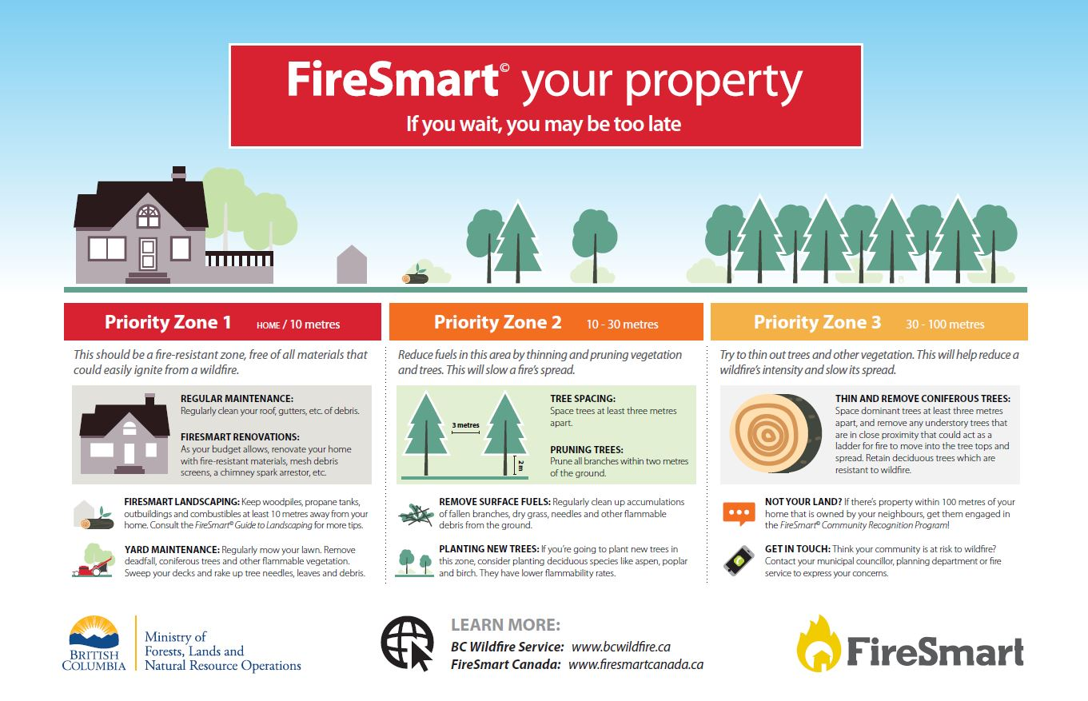

**Emergency Contacts**

In the event of an emergency, please call 911.

* Emergency operation centre (EOC) information line
  + 1-866-377-7188
* Fire Department
  + 911
* [RCMP](http://bc.rcmp-grc.gc.ca/ViewPage.action?siteNodeId=14&languageId=1&contentId=-1)
  + 911
* [BC Ambulance Service](http://www.bcehs.ca/)
  + 911
* [BC Emergency Support Services](http://www2.gov.bc.ca/gov/content/safety/emergency-preparedness-response-recovery/volunteers/emergency-social-services)
  + 1-800-585-9559
* [Animal Lifeline Emergency Response Team](http://www.alertcanada.org/) (formerly CDART)
* [BC Wildfire Service](http://www2.gov.bc.ca/gov/content/safety/wildfire-status)
* [Drive BC](http://www.drivebc.ca/)
* [Emergency Management BC (EMBC)](http://www2.gov.bc.ca/gov/content/safety/emergency-preparedness-response-recovery)
* [Fortis BC](https://www.fortisbc.com/Safety/ElectricalSafety/Pages/default.aspx)
  + For downed powerlines, please call 911 or Fortis BC at 1-866-436-7847
  + For a natural gas leak, please call 911 or Fortis BC at 1-800-663-9911
* [BC Hydro](http://www.bchydro.com/safety-outages.html)
  + For downed powerlines, please call 911
* [Interior Health Authority](https://www.interiorhealth.ca/Pages/default.aspx)
* [Recreation Site Closure and Warnings](http://www.sitesandtrailsbc.ca/default.aspx)
* [Interior Health](http://www.interiorhealth.ca/Pages/default.aspx)
* [Ministry of Environment](http://www.env.gov.bc.ca/eemp/incidents/2014/mount-polley.htm)

**LATEST UPDATES**

(blog-style RSS feed that can be easily pushed out to e-subscribers)

**MAP**

Embed TNRD Emergency Info Map <http://tnrd.maps.arcgis.com/apps/webappviewer/index.html?id=8ce7f3422b724dfeb1d6412c1897c6b7>

(I’ll add a blurb about searching the map below)

**BE PREPARED**

Types of Emergencies

* Floods
* Wildfires

**Floods**

Flooding is a common, naturally occurring event in B.C. Although it can happen at any time of year, the most severe floods typically occur in spring — known as freshet — or during fall and winter. This seasonal flooding is usually caused by heavy rain and snowmelt.

Homes may be at risk when flood water spreads to adjoining areas that are normally dry. Depending on the type and severity of flooding, it could take hours, weeks and potentially months for the water to recede and the clean-up to begin.

**Flood Preparedness**

Flood waters move fast, so develop a household plan, put together your emergency kit and connect with your neighbours. Learn about the emergency response plan for your area.

If you face a threatening flood situation, park vehicles away from streams and waterways, move electrical appliances to upper floors and make sure to anchor fuel supplies. Listen to local officials if you are asked to evacuate.

**Protect Your Home and Property**

Download the PreparedBC: Flood Information for Homeowners and Home Buyers guide (PDF, 2.22MB) to learn about protecting your home and property.

**Flood Information for Homeowners and Home Buyers**

<https://youtu.be/rNjTRyVSC0g>

**Recognize the Danger Signs**

Heavy snowmelt may contribute to landslides and dangerous debris in creeks and waterways. Be safe and don’t go down to watch the rushing water. If you notice trees beginning to lean or bend near your home, or cracks developing in the hillside, consult an engineer or contact local authorities.

If you live near a waterway, a change in water colour or rapid change in water level (especially a drop) could indicate a problem upstream. Call your local fire, police or public works department immediately if you suspect something out of the ordinary.

**Sandbagging**

It takes two people about one hour to fill and place 100 sandbags, giving you a one-foot-by-20-foot wall. Make sure you have enough sand, burlap or plastic bags (NOTE: you should tie the ends of plastic bags shut to prevent the sand and bags from washing away), shovels and time to prepare properly.

Instructions on how to build a sandbag dike to protect your property from flood waters.

**Sandbag Dike Tips**

<https://youtu.be/exb2iUgH8cI>

**Wildfires**

Many wildfires in B.C. occur far from cities and towns, but sometimes they threaten homes, businesses and infrastructure. Help keep your family safe by preparing in advance for a potential evacuation alert or order. Develop a household plan, put together your emergency kit and connect with your neighbours.

**Wildfire Readiness**

<https://youtu.be/-NmVROeq6vA>

**Prevent Wildfires**

Nearly half of all wildfires in B.C. are caused by human carelessness. You can make a difference by following a few simple rules.

* Heed prohibitions: check for bans and restrictions before striking the match
* Camp responsibly: In B.C., campfires can’t be larger than 0.5 metres by 0.5 metres. Keep a shovel or at least eight litres of water nearby to extinguish your fire, and don’t forget to create a firebreak. That means making a one-metre debris-free area around your fire by scraping down to the dirt. Before leaving, ensure your campfire is completely out and the ashes cool to touch. Check out this video to learn more
* Phone it in: call 1-800-663-5555 or *5555 on your cell if you spot smoke, flames or an unattended campfire

**Evacuation Stages**

* Evacuation Order: You are at risk. Leave the area immediately. You are encouraged to register all family members at the reception centre so, emergency responders know that you are safe
* Evacuation Alert: Be ready to leave on short notice. If you leave before or during this alert, it’s called a voluntary evacuation
* Evacuation Rescinded: All is currently safe and you can return home. Stay tuned for other possible evacuation alerts or orders

**Backcountry Closures**

Wildfires can impact backcountry recreation, resulting in area closures or restrictions. Campers and provincial park visitors should check with BC Parks for fire restrictions and closures and recreation site and trail users can check with Recreation Sites and Trails BC.

**FireSmart Your Property**

More and more people are making their homes in woodland settings. While beautiful, these locations come with a greater wildfire risk. Ensure your home insurance is up-to-date and includes adequate coverage for fire damage. You can also help protect your property by planning ahead. Start by completing a risk assessment in BC’s FireSmart Manual.



**Emergency Contacts**

In the event of an emergency, please call 911.

* Emergency operation centre (EOC) information line
  + 1-866-377-7188
* Fire Department
  + 911
* [RCMP](http://bc.rcmp-grc.gc.ca/ViewPage.action?siteNodeId=14&languageId=1&contentId=-1)
  + 911
* [BC Ambulance Service](http://www.bcehs.ca/)
  + 911
* [BC Emergency Support Services](http://www2.gov.bc.ca/gov/content/safety/emergency-preparedness-response-recovery/volunteers/emergency-social-services)
  + 1-800-585-9559
* [Animal Lifeline Emergency Response Team](http://www.alertcanada.org/) (formerly CDART)
* [BC Wildfire Service](http://www2.gov.bc.ca/gov/content/safety/wildfire-status)
* [Drive BC](http://www.drivebc.ca/)
* [Emergency Management BC (EMBC)](http://www2.gov.bc.ca/gov/content/safety/emergency-preparedness-response-recovery)
* [Fortis BC](https://www.fortisbc.com/Safety/ElectricalSafety/Pages/default.aspx)
  + For downed powerlines, please call 911 or Fortis BC at 1-866-436-7847
  + For a natural gas leak, please call 911 or Fortis BC at 1-800-663-9911
* [BC Hydro](http://www.bchydro.com/safety-outages.html)
  + For downed powerlines, please call 911
* [Interior Health Authority](https://www.interiorhealth.ca/Pages/default.aspx)
* [Recreation Site Closure and Warnings](http://www.sitesandtrailsbc.ca/default.aspx)
* [Interior Health](http://www.interiorhealth.ca/Pages/default.aspx)
* [Ministry of Environment](http://www.env.gov.bc.ca/eemp/incidents/2014/mount-polley.htm)