ELECTIVE 2

BSCPE-3D

Submitted By:
Balababa, Mikko Andrei D.
Culiat, Jecel P.
Dorneo, Jamaine Z.
Exconde, Paula Jane D.
Garcia, Irish P.
Lim, Kenth C.
Jarobel, Maria Nicole

June 2026

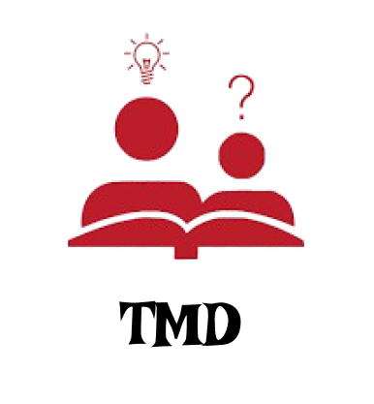

Figure 1. TMD Logo
Tutor My Dreams (TMD) is a web-based tutoring platform that connects students with qualified tutors to support learning and academic growth. The system allows students to search for tutors, book tutoring sessions, communicate with instructors, and monitor their learning progress through an easy-to-use online platform. It provides a convenient and organized way of managing tutoring services for both students and administrators.
Key Features:
User Features
- Inquiry Form
- Academic Subject
- Mission and Vision
- Business Profile Directory
Developer & Deployment Features
- Live Server Integration
- Secure External Port Forwarding
- Layout Management via CSS Media Queries
- JavaScript Event and Element Logic Tracking
System Architecture
The TMD platform follows a standardized Client-Side Web Architecture designed for smooth, responsive user experiences.
Frontend & UI
Built using structured HTML5 and styled with custom CSS, the frontend provides:
- Navigable UI links
- Layout cards focusing on visual
- Fully styled responsive grid components
Scripts & Logic
Developed using native JavaScript (JS), the logical layer manages:
- Input variable selections
- Event simulation handling
- Client-side verification and pop-up notifications

Technologies Used
Technology | Purpose
HTML 5 | Content Structure & Form Layouts
CSS3 | Responsive Layout Grid & Component Styling
JavaScript | Interaction, Input Catching & Alert Logic
Live Server | Real-time Local Browser Previewing
VS Code Dev Tunnels | Port Forwarding for External Link Previews

Project Development Team — Group 3
Jecel Mae Culiat – Created the website layout and coded the main frontend.
Irish Garcia – Assisted with the frontend and built the user forms.
Mikko Balababa – Handled the backend server and database setup.
Maria Nicole Jarobel – Tested the application and fixed coding bugs.
Kenth Lim – Helped develop the server-side logic.
Jamaine Dorneo – Managed project documentation and team coordination
Paula Exconde – Took charge of system integration and final deployment.

Core Page Breakdowns
1. Contact Inquiry Form (Home)
The primary landing area includes a functional contact section titled "Welcome Dreamers". It features built-in fields capturing user names, email configurations, and tailored text area messages. When validated, it generates a custom JavaScript browser greeting snippet confirming submission.

2. About Tutor My Dreams
This section lists the fundamental values of the company established in 2026:
Our Mission: To provide accessible, high-quality 1-on-1 tutoring that empowers students to reach their full potential.
Our Vision: To become the leading digital learning hub in the Philippines for K-12 and College students.
3. Subject Offerings
A structured cards grid showcasing the four cornerstone curriculum areas taught by the platform:
Mathematics: Algebra, Calculus, and Statistics.
Science: Biology, Chemistry, and Physics.
English: Grammar, Literature, and ESL.
History: Philippine & World History.
4. Business Profile
A centralized summary directory providing transparency regarding business standards:
Business Name: Tutor My Dreams (TMD)
Location: San Pablo City, Philippines
Expertise: Online Interactive Tutoring
Platform: Zoom / Meet / TMD Dashboard

User Features
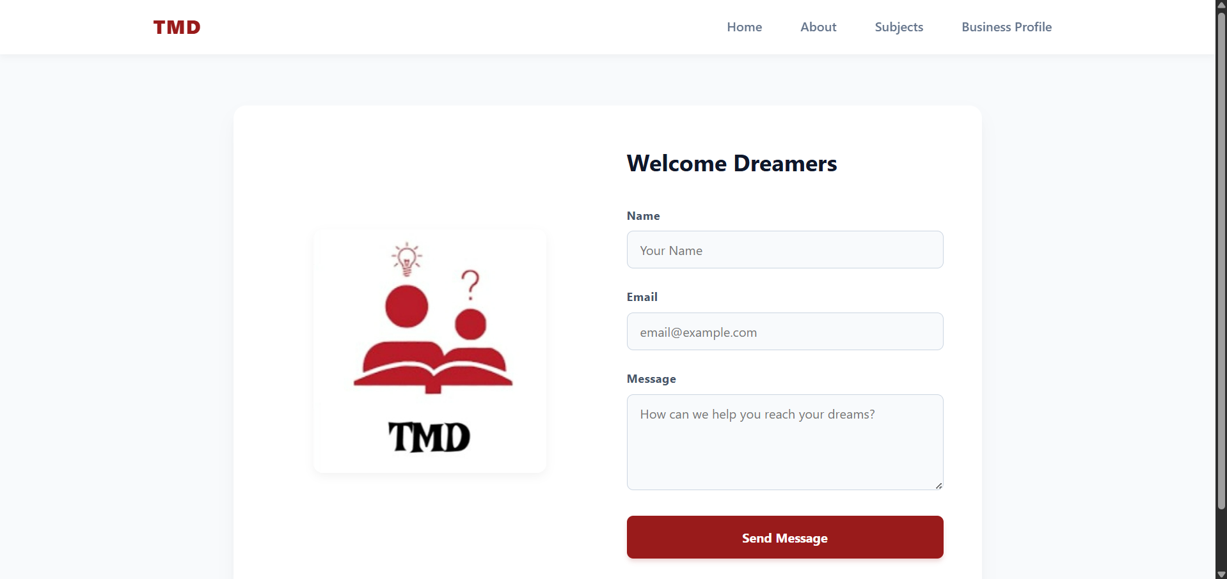
Figure 2. Inquiry Form
The website features a clean and user-friendly interface with a navigation menu that includes Home, About, Subjects, and Business Profile sections. It contains a contact form where users can enter their name, email address, and message to communicate with the organization. The page also displays the TMD logo and a welcoming message, creating a professional and inviting appearance. Additionally, the responsive layout organizes information clearly, making it easy for users to navigate and interact with the website.
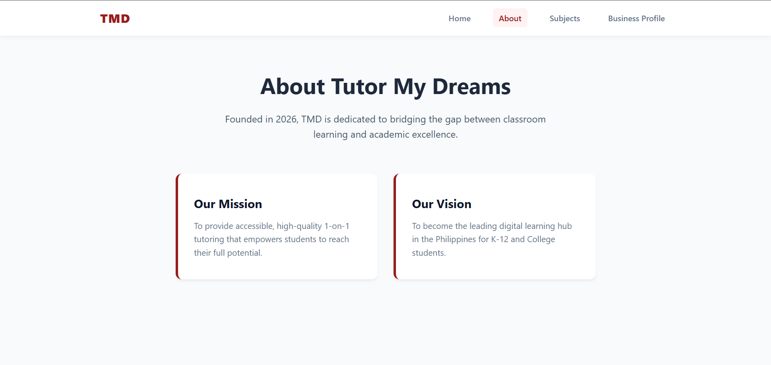Figure 3. Academic Subject
The About page provides information about Tutor My Dreams (TMD), including its background, mission, and vision. It introduces the organization as a learning platform dedicated to helping students achieve academic excellence through personalized tutoring. TMD's mission of providing accessible and high-quality one-on-one education while presenting its vision of becoming a leading digital learning hub for K–12 and college students in the Philippines. Its clean and organized layout makes the information easy to read and understand.

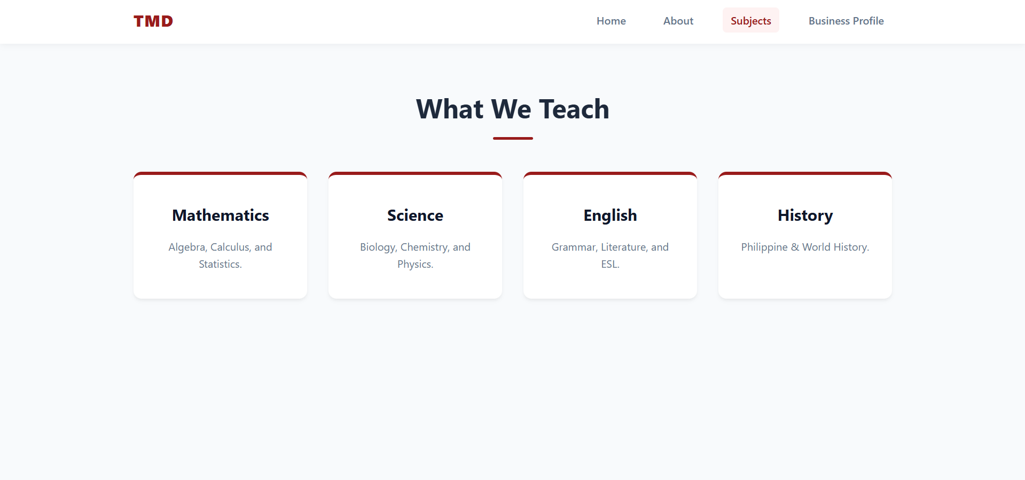
Figure 4. Mission and Vision
This page features a modern educational website design with a navigation bar, including Home, About, Subjects, and Business Profile sections. The "What We Teach" section highlights four main subjects Mathematics, Science, English, and History displayed in organized card-style layouts. Each subject card provides a brief description of the topics covered, making the information easy to read and understand.

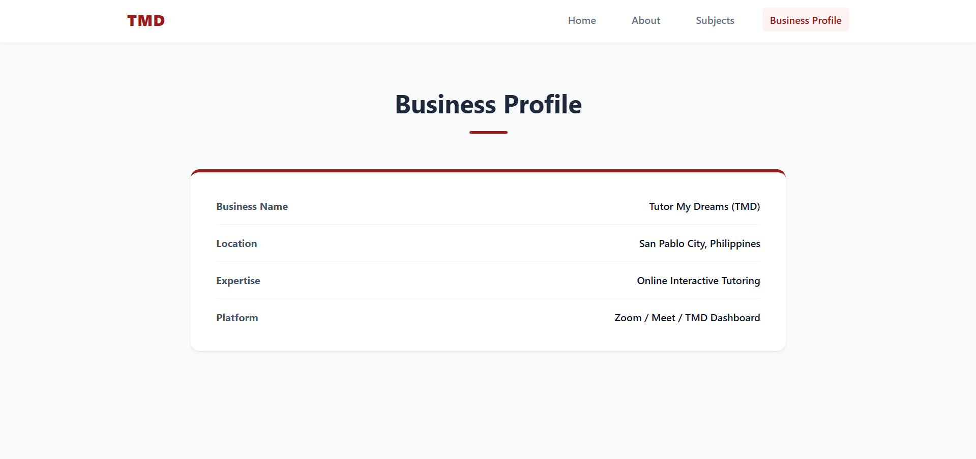
Figure5. Business Profile Directory
This page presents the business profile of Tutor My Dreams (TMD) in a organized layout. It provides key information such as the business name, location, area of expertise, and the platforms used for online tutoring. The design uses a structured table format, making the details easy to read and access. Its professional appearance helps establish credibility and gives visitors a clear overview of the tutoring service.

