Hurricane Zaphod is barreling down the South Atlantic towards Florida, currently rated at Category 3. Sustained winds are in the 111-129mph range, normally distributed. It may weaken to a Category 2, or strengthen to Category 4 or even 5, we don't know.  
We know that building codes in West Palm Beach mandate wind reistance up to 160 mph for commercially zoned buildings, 120 mph for residential, and 90 mph for mobile homes.  
When a building fails, it fails catastrophically, sending debris in the air. Bigger commercial buildings send more debris then small ones. A commercial building can withstand 1000 debris hits before failing, a residential building 500, and a mobile home 1. West Palm Beach has 100,000 buildings, with 20% commercial, 70% residential and 10% mobile homes.  
(note: I pulled numbers out of thin air -- if you find actual data, please update!).  
(note2: I'm deliberately disregarding wind direction and geospatial aspects -- that's too complex to deal with for now. For purposes of this model, all buildings are within striking distance of each other)  
You are a FEMA admin charged with estimating hurricane damage, as it makes direct landfall on West Palm Beach.

(1) Think about model boundaries, units of analysis and time. What am I missing here? Too much detail vs. not enough? (note: I deliberately missed a few things. This is a good reflection of what you experience with real clients)

**Assumptions**  
1. I assume that every building release 1 piece of debris and only hits one other building.

2. Two things destroy buildings (1) Wind (2) Debris

3. If the wind surpasses the code threshold 20% of the buildings will be destroyed, but not all.

4.

(2) Build a stocks-and-flows diagram for a direct hurricane hit -- think about hurricane approach, eye-wall, eye, and dissipation/departure

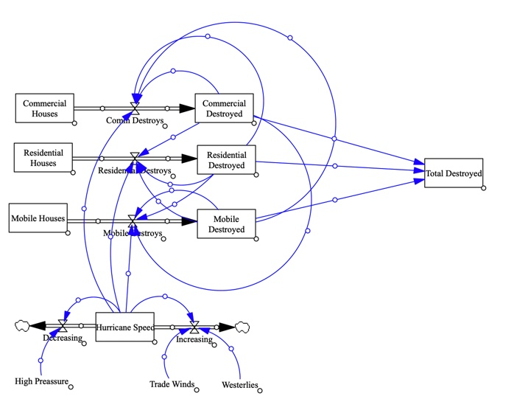

(3) Write out equations that connect stocks, flows and variables

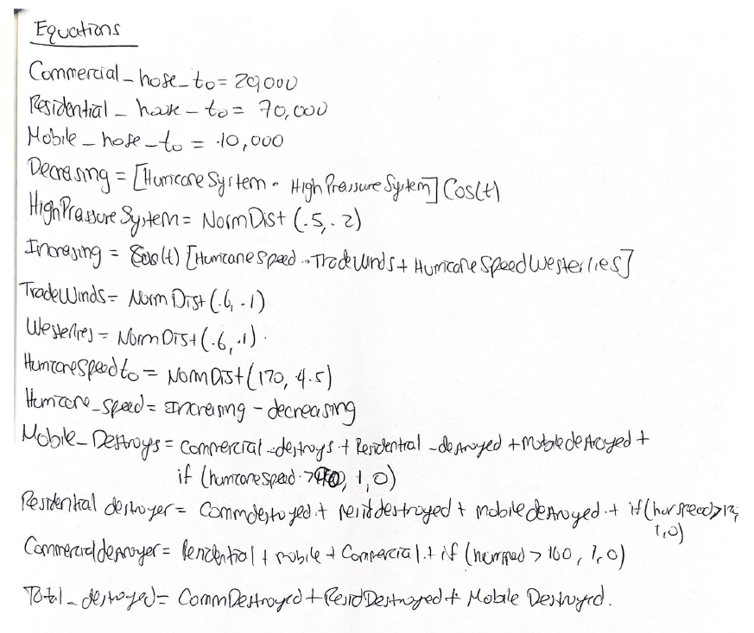  
(4) Using MicroSD, VennSim, InsightMaker, NetLogo or any other tool of your choice, try to build this model and estimate hurricane damage based on speed at landfall.



Units should be Hour instead of Month



Units in Thousands



(5) Run some experiments with this model -- enhance the building codes, get rid of trailer parkes, etc. Use a good experimental design technique. Describe your reasoning for experimental design

|  |  |
| --- | --- |
| Experiment | Houses Left |
| Increase Building code of commercial buildings to 200 mph | 48.254 |
| Increase Commerical code to 160mph | 46.648 |
| Increase code to 200 for Residential and and Commercial | 72.548 |

6.

According to the model and the calculations, if a hurricane this strong were to happen, Mar-a-Lago has a 17.5% of being destroyed. 7.5% comes from the hurricane, and 10% from debris.