My research report

Karl White

17.11.2014

## Introduction

Lorem ipsum dolor *sit* amet, consetetur sadipscing elitr, sed diam  
nonumy eirmod tempor invidunt ut labore et dolore magna aliquyam erat,  
sed diam voluptua. At vero eos et accusam et justo duo dolores et ea rebu.  
Stet clita kasd gubergren, no sea **takimata** sanctus est Lorem ipsum dolor sit amet.

## Results

Lorem ipsum dolor sit amet, consetetur sadipscing elitr, sed diam  
nonumy eirmod tempor invidunt ut labore et dolore magna aliquyam erat,  
sed diam voluptua. At vero eos et accusam et justo duo dolores et ea rebu.

* lorem
* ipsum
* dolor

1. et

* dolore
* magna

### The cars dataset

summary(cars)

## speed dist   
## Min. : 4.0 Min. : 2   
## 1st Qu.:12.0 1st Qu.: 26   
## Median :15.0 Median : 36   
## Mean :15.4 Mean : 43   
## 3rd Qu.:19.0 3rd Qu.: 56   
## Max. :25.0 Max. :120

### The plots

plot(cars)

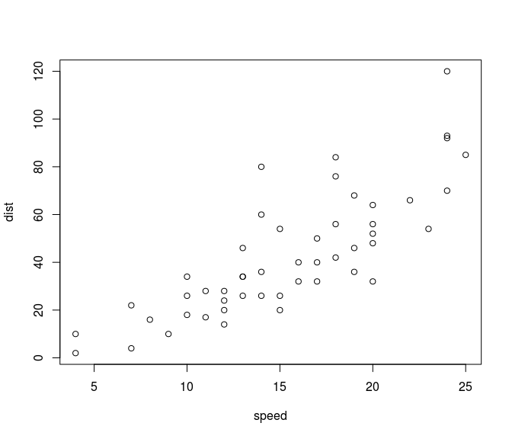

Lorem ipsum dolor *sit* amet, consetetur sadipscing elitr, sed diam  
nonumy eirmod tempor invidunt ut labore et dolore magna aliquyam erat,  
sed diam voluptua. At vero eos et accusam et justo duo dolores et ea rebu.  
Stet clita kasd gubergren, no sea **takimata** sanctus est Lorem ipsum dolor sit amet.

### The formula

$$V_{t}(S_{t})=\max_{x_{t}∈χ_{t}}\left(C(S_{t},x_{t})+γ\sum_{s^{′}∈S}{P}(s^{′}∣S_{t}^{n},x_{t})V_{t+1}^{n−1}s^{′}\right)$$

### A quote

Lorem ipsum dolor *sit* amet, consetetur sadipscing elitr, sed diam  
nonumy eirmod tempor invidunt ut labore et dolore magna aliquyam erat,  
sed diam voluptua. At vero eos et accusam et justo duo dolores et ea rebu.  
Stet clita kasd gubergren, no sea **takimata** sanctus est Lorem ipsum dolor sit amet.

42 is the answer to the meaning of life, the universe, and everything. *Douglas Adams*