SuperUser(admin@gmail.com) Password: test

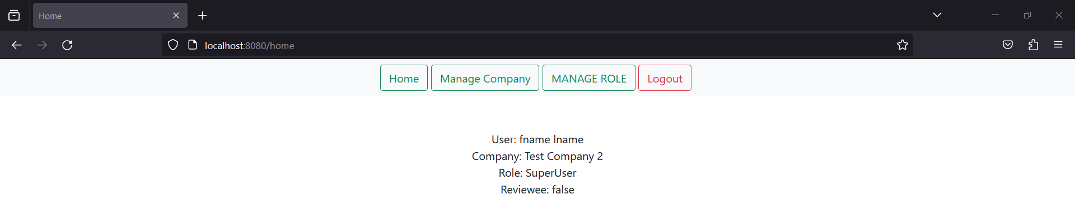

1. Manage Company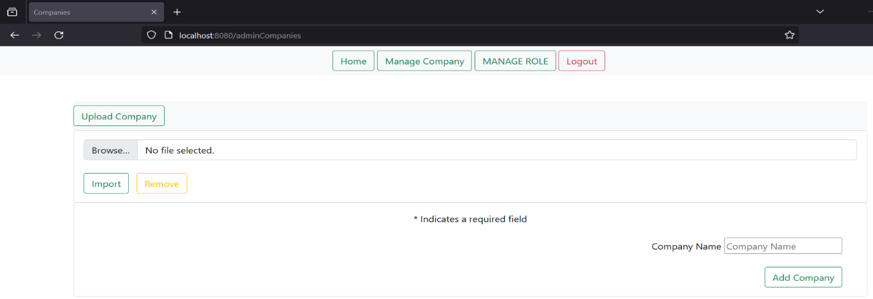
2. Manage Role

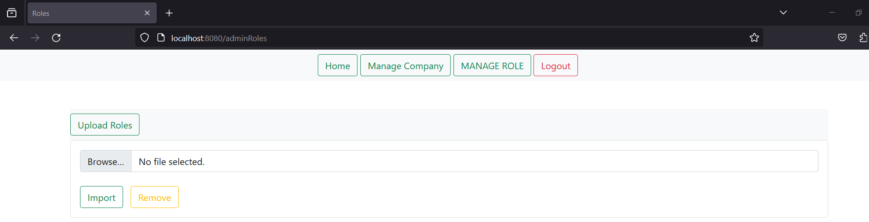

Admin(admin2@gmail.com) Password: test

1. Manage User

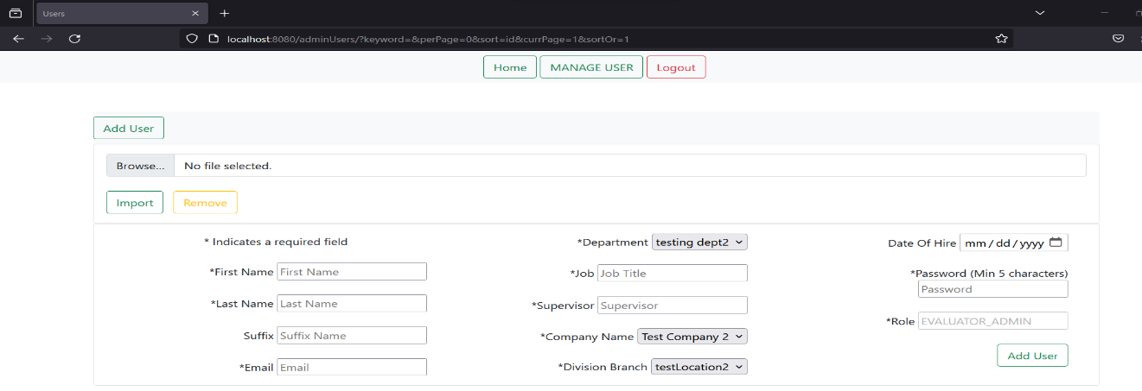

Evalutor_Admin(admine@gmail.com) Password: test

2.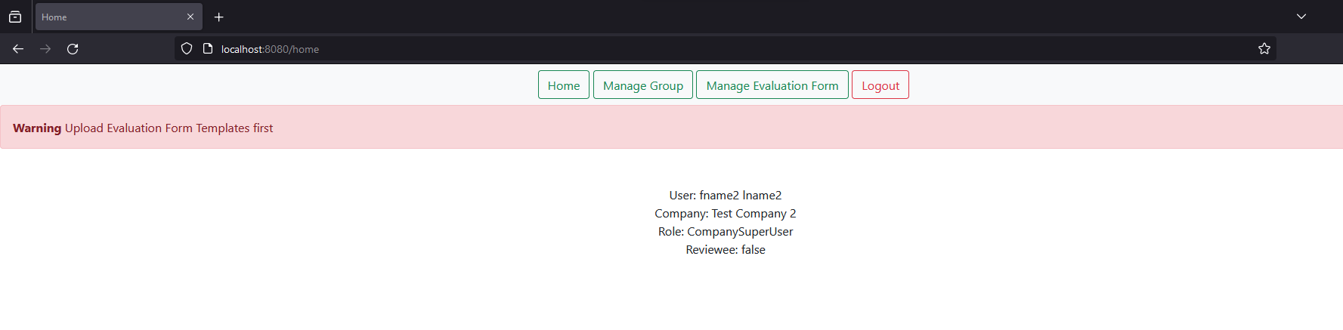

Reviewee user(user1@gmail.com) Password: test

View Groups they are in

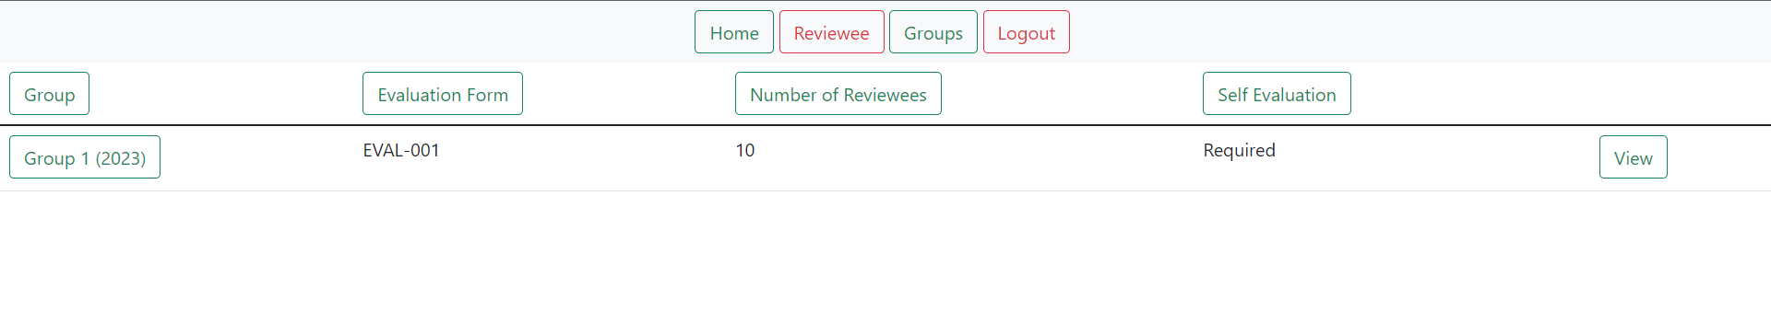

Reviewer user (user2@gmail.com) Password: test

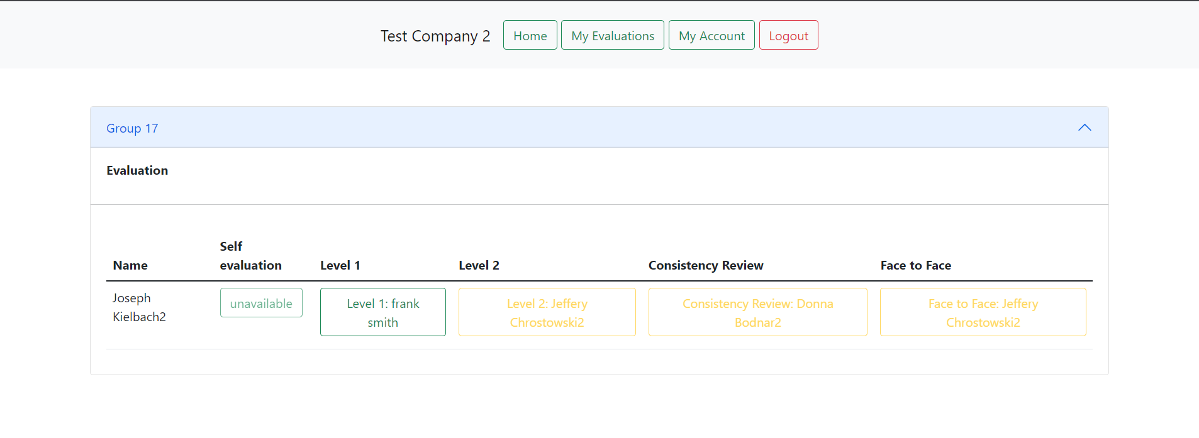

All Uploaded Users ([FirstnameLastname2@company2.com](mailto:FirstnameLastname2@company2.com)) Password: test