

Project Report for Shared Equipment Reservation and Maintenance System (SERMS)

Practice Module for Graduate Certificate in Architecting Scalable Systems

Team 07
Members:
Shi Wenqi
Zhang Hanming
Zhou Fanhao
Liu Tongyao
Wang Yuanmeng

CONTENTS
1. Introduction 4
1.1 Background 4
1.2 Business Needs 4
1.3 Stakeholders 5
1.4 Project Scope 5
1.4.1 Functionality in scope 5
1.4.2 Functionality out of scope 6
2. Project Conduct 6
2.1 Project Plan 6
2.2 Project Status 7
2.3 Project Metrics 7
3. Solution Overview 8
3.1 Logical Architecture & Design 8
3.1.1 Key Architectural Decisions 9
3.1.2 Tiers and Layers 10
3.1.3 Nodes and Subsystems 12
3.1.4 Platform Design 14
3.2 Physical Architecture & Design 20
3.2.1 Key Architectural Decisions 21
3.2.2 Technology and Services 22
3.2.3 Persistence Design 23
3.2.4 Detailed Design 25
3.3 Other Architectural Decisions 31
3.4 Architectural Limitation 31
4. Quality Attributes 32
4.1 Performance 32
4.2 Availability 33
4.3 Security 34
4.4 Extensibility and Maintainability 34
5. DevOps and Development Lifecycle 34
5.1 Source Control Strategy 34
5.2 Continuous Integration 35
5.3 Continuous Delivery 37
6. Scaling Further: From Scalable Monolith to Microservices 38
6.1 Target Microservice Architecture 39
6.2 Key Design Changes 40
6.3 Migration Roadmap and Trade-offs 40

Introduction

Background
University laboratories, makerspaces and teaching departments share a pool of high-value equipment such as cameras, oscilloscopes, VR headsets, 3D printers and laptops. Today these items are usually managed with spreadsheets, e-mail threads and paper sign-out sheets. Borrowers cannot see availability, approvers decide without context, custodians cannot tell who holds an overdue item, and faults reported at the desk are often lost before a technician sees them.
The Shared Equipment Reservation and Maintenance System (SERMS) replaces this manual process with one web application that covers the full lifecycle of a shared asset: search and reservation, approval, checkout, return, overdue follow-up, fault reporting and repair. Every step is tracked, audited and visible to the right role.
SERMS was built by Team 07 over four Sprints. All five core use cases and the administration, reporting and audit features are complete, merged to main and released through a gated GitHub Actions pipeline to https://serms.midas.cyou. In Sprint 4 the solution became a scalable modular monolith: stateless Spring Boot replicas sit behind an nginx load balancer and share one PostgreSQL 18 database, which also holds the HTTP sessions and scheduler locks. Releases are rolling updates with zero failed requests, and Prometheus and Grafana monitor every replica. This report describes that architecture from several viewpoints (context, logical, deployment, domain, data and detailed design), the DevOps lifecycle that delivers it, and how SERMS can evolve into microservices when load and team size justify it (Section 6).

Business Needs
- Fair, conflict-free access to scarce equipment. Two borrowers must never hold the same item for overlapping time slots, even under concurrent requests (Proposal business rules 1 and 12).
- Accountability. Every reservation, decision, checkout, return and repair is attributed to a user and kept in an append-only audit trail (rule 9).
- Faster turnaround. Approvers see pending requests with context; custodians find the right reservation by asset tag or borrower name; reminders reduce overdue loans.
- Asset health. A damaged return automatically opens a maintenance case and blocks new reservations until the item is repaired (rules 2, 7 and 8).
- Management insight. Utilisation, overdue and maintenance reports support purchasing and staffing decisions.
- Operability at campus scale. The system must serve at least 50 concurrent users within 2 seconds, survive the loss of one application instance and be released frequently without downtime.

Stakeholders
Table 1: Key business and IT stakeholders
Stakeholder | Role in SERMS | Main interest
Borrowers (students, staff) | Borrower | Find available equipment, reserve, see loan status and reminders
Lab managers | Approver | Approve or reject requests for controlled categories, with comments
Equipment desk staff | Custodian | Check out and receive items, record condition, see overdue loans
Technicians | Maintainer | Receive fault cases, diagnose, repair or retire equipment
Department administrators | Administrator | Manage users, roles, equipment and categories; reports; audit
Faculty IT / operations | Operator (no business role) | Secure hosting, backups, monitoring, releases
Course instructors | Assessor | Architecture quality, scalability, DevSecOps evidence
Team 07 (five developers) | Builders | One use case and one shared responsibility each

Project Scope
The scope follows the Project Proposal (functional requirements in Chapter 5, business rules in Chapter 6, non-functional requirements in Chapter 7). The architecture scope is wider than the implementation scope: SERMS is implemented as a horizontally scalable modular monolith and architected (designed and documented, not built) for a later move to microservices. Optional features were removed by the scope-freeze decision D-009 on 2026-10-14.
Table 2: Delivery phases
Phase | Delivered capability
Sprint 0 | Requirements, technology stack, data model, testing and pipeline rules
Sprint 1 | Login, roles, equipment search, reservation with overlap protection, CI
Sprint 2 | Approval, checkout/return, fault and maintenance, overdue notifications
Sprint 3 | Administration, reports, audit viewer, DevSecOps gates, containerised gated release
Sprint 4 | Scalable monolith (load balancing, shared sessions, scheduler locks, rolling update, monitoring); evidence, report, microservice evolution design

Functionality in scope
Table 3: Functionality in scope
ID | Requirement (Proposal section) | Owner
UC01 | Search equipment by name, category, location and time window; submit, view and cancel reservations; quota, duration, horizon and overdue-borrower rules (5.2, 5.3) | Shi Wenqi
UC02 | Review pending reservations; approve or reject with comments; no self-approval (5.4) | Zhang Hanming
UC03 | Check out a confirmed reservation; receive returns, record condition; damaged return opens a maintenance case (5.5) | Zhou Fanhao
UC04 | Report faults, assign technicians, diagnose, repair or mark unrepairable; maintenance history (5.6) | Liu Tongyao
UC05 | Overdue detection, due-soon and collection reminders, in-app inbox with unread count (5.5, 5.7) | Wang Yuanmeng
ADM | User and role administration, equipment and category management (5.1, 5.2) | Team
RPT | Utilisation, overdue and maintenance reports; append-only audit viewer (5.7) | Team
NFR | Security (BCrypt, CSRF, server-side authorisation), 2 s response for 50 users, backups, 70% business-logic coverage, DevSecOps pipeline (7, 8.3) | Team

Functionality out of scope
- E-mail notifications and QR-code scanning (optional in the Proposal; dropped by D-009). Both are designed as extension points: a new NotificationChannel adapter and a front-end scanner component.
- Automatic cancellation of expired pending reservations (backlog item R1.11, priority C).
- Payment, fines, inventory purchasing and integration with the university finance system.
- Real-time chat and WebSocket push; the inbox polls the unread count instead.
- A native mobile app; the responsive web UI supports desktop and tablet.
- Microservices, Kubernetes and a message broker are designed but not implemented (Section 6). Read replica, edge rate limiting, off-host backup copies and campus SSO are planned (Section 3.4).

Project Conduct

Project Plan
The team used Scrum with one-week Sprints, a GitHub Projects board (To Do, In Progress, Review, Testing, Done) and a shared Definition of Done: feature branch, pull request, all 15 CI checks green, a test bench in the same PR, regenerated API types, updated contracts and evidence saved during development. Each member owned one business use case and one shared responsibility, as shown in the WBS below.
Table 4: Work breakdown structure and estimated effort
WBS | Work package | Owner | Est. effort (person-days)
1 | Project management: backlog, Sprint plans, status, agile evidence | Shi Wenqi | 6
2 | Architecture and UI foundation: layering, page templates, shared components | Zhang Hanming | 8
3 | Data model: schema, Flyway migrations, constraints, data access | Zhou Fanhao | 8
4 | Quality: test strategy, security, ZAP, k6, coverage gate | Liu Tongyao | 7
5 | DevOps: repository, CI/CD, containers, deployment, operations | Wang Yuanmeng | 7
6 | UC01 Search and reserve | Shi Wenqi | 8
7 | UC02 Approval | Zhang Hanming | 6
8 | UC03 Checkout and return | Zhou Fanhao | 7
9 | UC04 Fault and maintenance | Liu Tongyao | 7
10 | UC05 Overdue and notifications | Wang Yuanmeng | 7
11 | Administration, reports, audit viewer | Team | 8
12 | Scalability: load balancing, shared sessions, scheduler locks | Wang Yuanmeng, Liu Tongyao | 4
13 | Integration testing, acceptance, release | Team | 6
14 | Report, diagrams and presentation | Team | 8
 | Total |  | 97

Project Status
All five use cases and the remaining Proposal scope are merged to main. The local acceptance on 2026-10-17 passed real API and browser checks for all five roles. On 2026-11-04 the scalable-monolith work (decision D-014) was implemented and verified:
- Backend: 690 unit and integration tests, including a two-replica cluster test; 101 PostgreSQL integration tests (30 UC02, 41 UC03/UC05/equipment, 30 UC04); business-logic line coverage 77.87% against the 70% gate.
- Front end: 188 component tests and 16 Playwright end-to-end tests (8 flows, desktop and mobile); no OpenAPI drift.
- Runtime: two replicas behind nginx, with one session served 20/20 by both; zero failed requests during rolling updates and after a replica was killed; 50-user k6 load with every p95 below 2 s.
Production at https://serms.midas.cyou is released only through the gated Deploy workflow, and it still runs the single-replica release until D-014 is merged and deployed. Outstanding items are listed in Section 3.4: member confirmations and the production release of D-014, the production daily-backup schedule, an authenticated OWASP ZAP scan, and sizing CPU for peak sign-in.

Project Metrics
Table 5: Milestones achieved
Date | Milestone
2026-10-05 | Sprint 2 in progress: UC01 complete, UC02-UC05 foundations on branches
2026-10-07 | PostgreSQL 18 becomes the only runtime database; migrations unified in the application
2026-10-13 | Complete local demo (React, Spring Boot, PostgreSQL 18) with all five use cases
2026-10-14 | Integration line merged; Spring Boot 4 security migration; scope freeze D-009
2026-10-15 | First gated production release of main (web + app + db containers)
2026-10-17 | Local acceptance close-out; DevSecOps, quality gates, admin, reports and UC05 closed
2026-10-24 | Unified 15-check merge and release gate; Dependabot security updates enabled
2026-10-25 | Architecture, ERD, pattern and pipeline diagrams for the final presentation
2026-11-04 | Scalable monolith: app replicas behind nginx, Spring Session JDBC, ShedLock, rolling update, Prometheus and Grafana; new load, failover and ZAP evidence

Table 6: Product and process metrics
Metric | Value
Pull requests | Numbered up to #117; every change merged through CI with merge commits
Commits on main | 244 (before the Sprint 4 scaling branch)
Backend automated tests | 690 regression (incl. 3 two-replica cluster tests) + 101 PostgreSQL integration tests
Front-end automated tests | 188 Vitest/RTL component tests + 16 Playwright E2E tests
Business-logic line coverage | 77.87% (1316 of 1690 lines; gate: 70% of service and domain packages)
k6, 50 users, 2 replicas | All checks pass; p95 all 1.21 s, reserve 0.31 s (target 2 s)
Rolling update under traffic | 0 failed requests in 4 runs (424-457 requests each)
Flyway migrations | V001-V009 (V008 HTTP sessions, V009 scheduler locks)
Required CI checks per PR | 15
ZAP baseline | Production 2026-10-17: 0 FAIL / 5 WARN / 62 PASS; local two-replica stack 2026-11-04: 0 FAIL / 2 WARN / 60 PASS

Table 7: Estimated effort by team member
Member | Use case and shared responsibility | Est. effort (person-days)
Shi Wenqi | UC01; requirements, Sprints, agile evidence | 14
Zhang Hanming | UC02; architecture, page structure, shared styling | 14
Zhou Fanhao | UC03; data model, database, migrations | 15
Liu Tongyao | UC04; testing, security, quality; integration and release | 20
Wang Yuanmeng | UC05; repository, CI/CD, deployment, operations | 16

Solution Overview
This chapter presents SERMS through complementary views: the system context and containers (C4 levels 1-2), tiers and layers, components (C4 level 3), the logical and physical deployment, the domain model (DDD), the data model and the detailed design of two critical use cases.
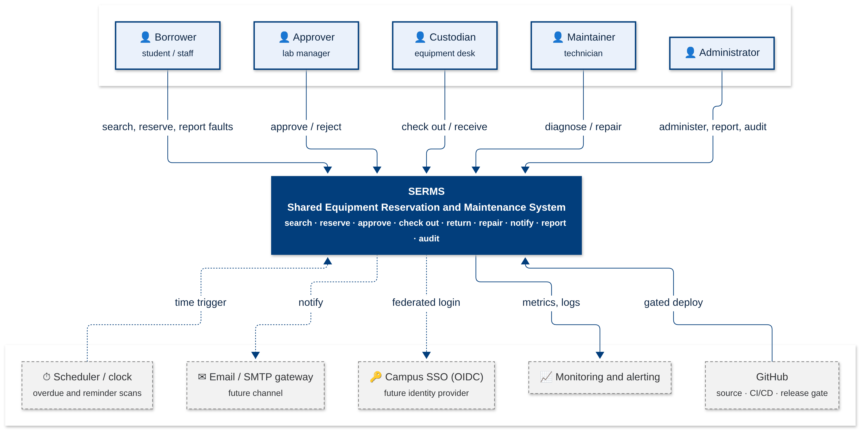
Figure 1: System context (C4 level 1): five human roles, the scheduler and external systems

Logical Architecture & Design
Logically, SERMS is one deployable application organised into ten business modules that mirror the bounded contexts of Section 3.1.4. The browser runs a React single-page application; nginx serves it and load-balances /api/* calls across identical, stateless Spring Boot replicas; PostgreSQL 18 is the single source of truth. Figure 2 shows the containers and their protocols.
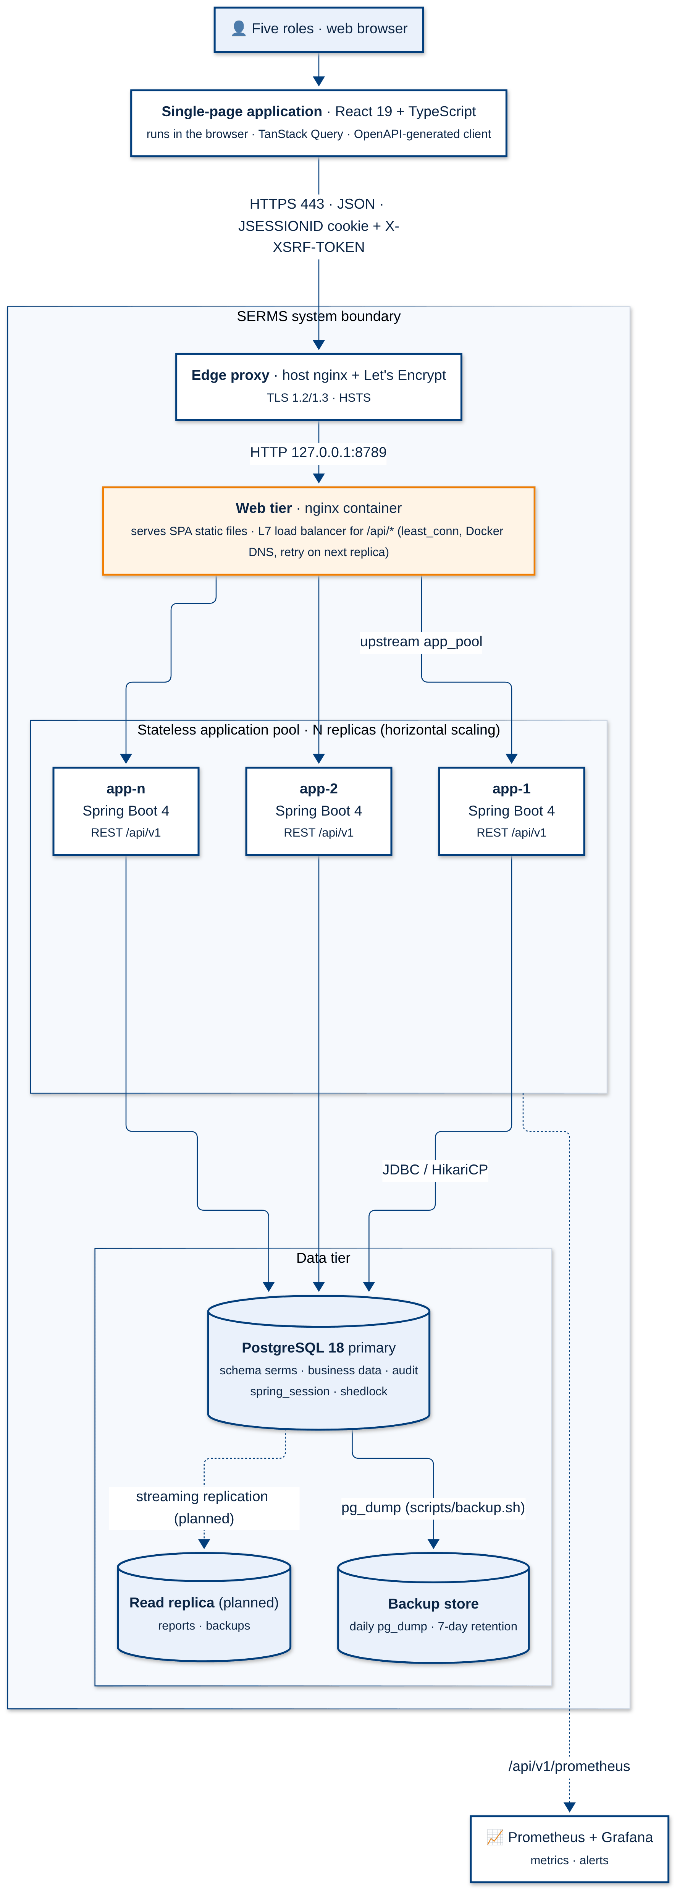
Figure 2: Container view (C4 level 2): scalable modular monolith behind a load balancer

Key Architectural Decisions
The key architectural decisions taken are as follows:
Table 8: Logical architectural decisions
Identifier | Description
AD-01 | Modular monolith instead of microservices. One Spring Boot application with module boundaries per bounded context. Trade-off: one deployable and ACID transactions across reservation, loan and maintenance (needed for overlap and lock-order guarantees) in exchange for coarser scaling and a shared release cadence. Microservice extraction is prepared through ports and domain events (Section 6).
AD-02 | Stateless application tier for horizontal scaling. No user state is kept in JVM memory: HTTP sessions are stored in PostgreSQL with Spring Session JDBC, and scheduled jobs take a ShedLock row lock. Any replica can serve any request, so replicas can be added, removed or restarted behind the load balancer without sticky sessions.
AD-03 | Separate SPA and REST API on the same origin. React talks to /api/v1 through nginx on the same host name. This avoids CORS and lets the browser use an HttpOnly, Secure, SameSite session cookie with a CSRF header instead of storing JWTs in JavaScript.
AD-04 | Four-layer modules (api, service, domain, repository). Controllers never touch repositories; business rules live in domain classes; services own transactions and @PreAuthorize checks. Modules call each other only through public services or ports.
AD-05 | Domain events for cross-module side effects. Reservation, approval, loan and maintenance publish events; notification and audit subscribe. Audit and notification requests are written in the same transaction, and delivery runs asynchronously after commit.
AD-06 | OpenAPI contract as the single API definition. The backend generates OpenAPI 3; the front end generates TypeScript types from it and CI fails on drift, so field mismatches fail compilation instead of production.

Tiers and Layers
SERMS uses four physical tiers and, inside the application tier, four logical layers. Figure 3 shows the responsibilities of each and the protocols between them.
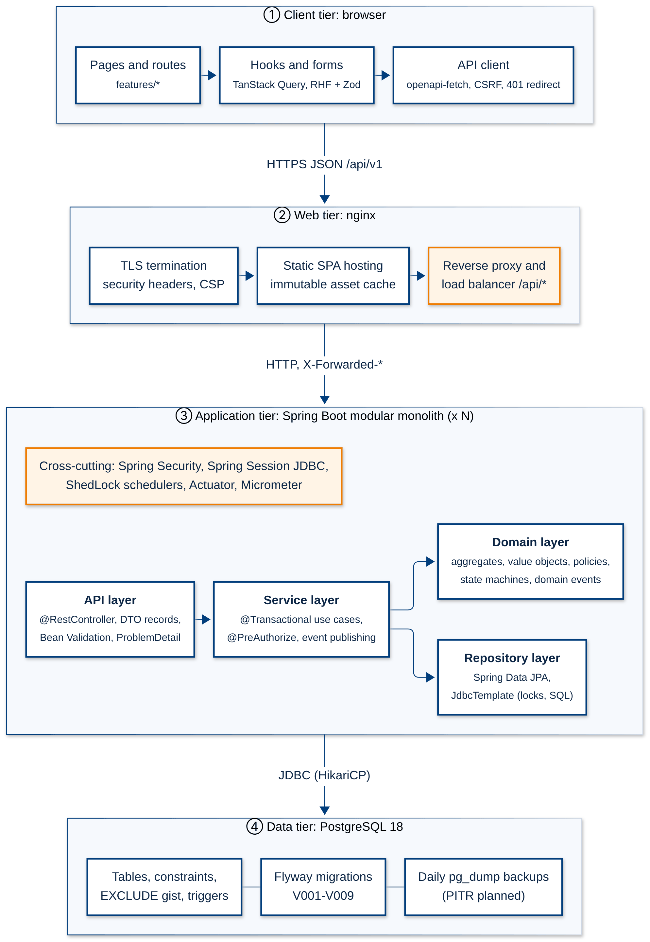
Figure 3: Tiers (client, web, application, data) and application layers
Table 9: Tier and layer responsibilities
Tier / layer | Responsibility | Must not
Client tier | Routing, forms with Zod validation, caching with TanStack Query, role-aware menus | Enforce authorisation (UX only)
Web tier | TLS, security headers and CSP, static SPA hosting, load balancing, health-based failover | Hold application state
API layer | REST controllers, DTO records, Bean Validation, RFC 9457 ProblemDetail errors | Contain business rules or access repositories
Service layer | Use-case orchestration, @Transactional boundaries, @PreAuthorize, events | Depend on HTTP types
Domain layer | Aggregates, value objects, policies (Strategy), state machines (State), approval chain | Depend on Spring MVC
Repository layer | JPA and JdbcTemplate queries, row locks, optimistic version checks | Make business decisions
Data tier | Constraints, exclusion constraint, append-only triggers, sessions, locks, backups | Be reachable from outside the backend network

Nodes and Subsystems
The table below lists the architecturally significant elements, their type and their provider. Custom modules are built by Team 07; infrastructure elements are open-source products.
Table 10: Solution elements and providers
Element | Type | Provider | Services provided / used
React SPA (frontend/) | Custom module | Team 07 (Zhang Hanming, all) | UI for five roles; uses REST API
nginx edge proxy | COTS (open source) | nginx, Let's Encrypt | TLS termination, HSTS, rate limiting
nginx web tier (web/) | COTS + custom config | nginx; config by Team 07 | Static hosting, L7 load balancing of /api/*
identity module | Custom module | Team 07 | Login, roles, session invalidation; used by all modules
equipment module | Custom module | Team 07 | Catalogue, categories, availability search
reservation module | Custom module | Shi Wenqi | Reservations, booking rules; port for approval
approval module | Custom module | Zhang Hanming | Decisions with policy chain
loan module | Custom module | Zhou Fanhao | Checkout, return, damage routing
maintenance module | Custom module | Liu Tongyao | Fault cases and repair workflow
notification module | Custom module | Wang Yuanmeng | Inbox, reminders, delivery worker
report and audit modules | Custom modules | Team 07 | Read-only reports, audit viewer
Spring Session JDBC, ShedLock 7.9 | Library | Spring, open source | Shared sessions (cookie JSESSIONID), cluster-wide scheduler lock
PostgreSQL 18 | COTS (open source) | PostgreSQL | Persistence, constraints, sessions, locks
Prometheus, Grafana | COTS (open source) | CNCF / Grafana Labs | Metrics, dashboards, alerts
GitHub Actions | SaaS | GitHub | CI/CD, security scanning, release gate

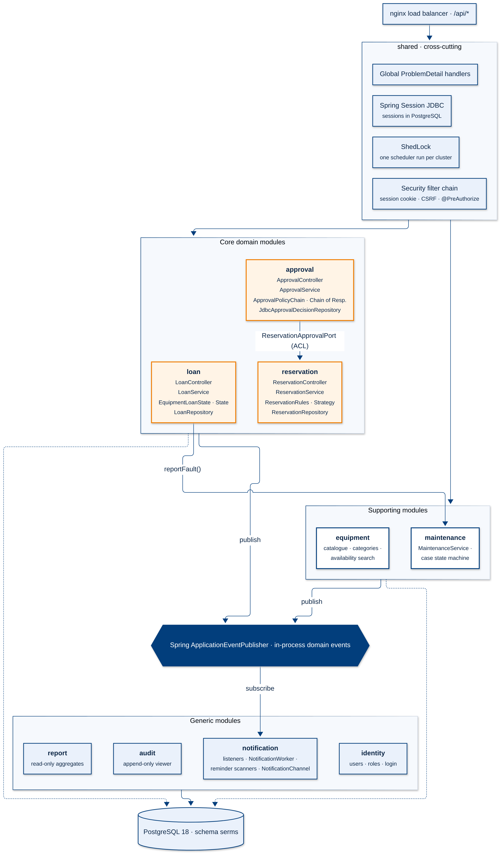
Figure 4: Component view (C4 level 3) of one application replica
Figure 5 abstracts the runtime into execution environments. The only stateful environment is the shared data tier; every business-logic replica is identical, which is what makes the monolith horizontally scalable.
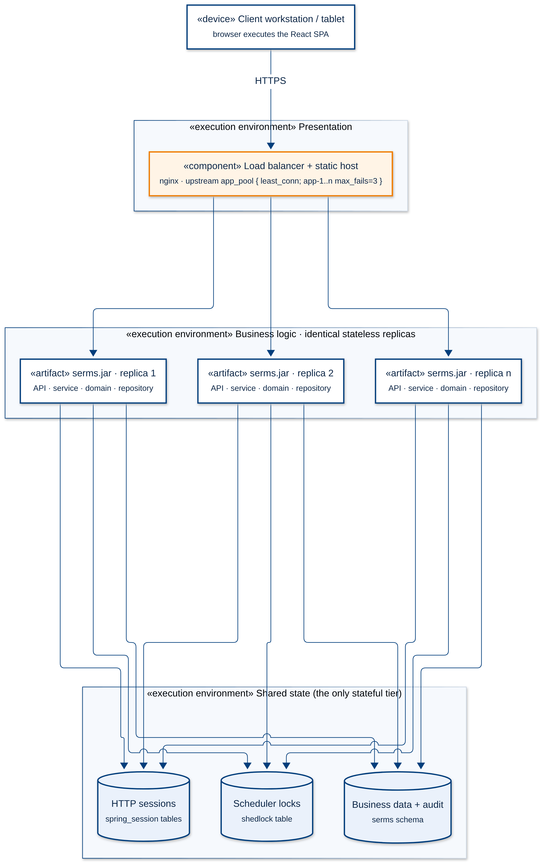
Figure 5: Logical deployment view: identical stateless replicas and shared state

Platform Design
SERMS is designed with Domain-Driven Design. Strategic design splits the problem into subdomains and bounded contexts; tactical design defines aggregates, value objects and domain events inside each context. Each bounded context maps to one backend module and one front-end feature folder, which keeps ownership clear for the five team members.
Table 11: Subdomains and bounded contexts
Subdomain | Type | Bounded contexts | Why
Equipment booking and circulation | Core | Reservation, Approval, Loan | Conflict-free booking and accountable hand-over are the reason SERMS exists
Equipment catalogue | Supporting | Equipment Catalogue | Needed by the core, but simple master data
Asset maintenance | Supporting | Maintenance | Specific workflow that protects the core from lending broken items
Identity and access | Generic | Identity & Access | Standard problem; replaceable by campus SSO
Communication | Generic | Notification | Standard inbox and reminders; channel adapters
Compliance and insight | Generic | Audit & Reporting | Append-only log and read models

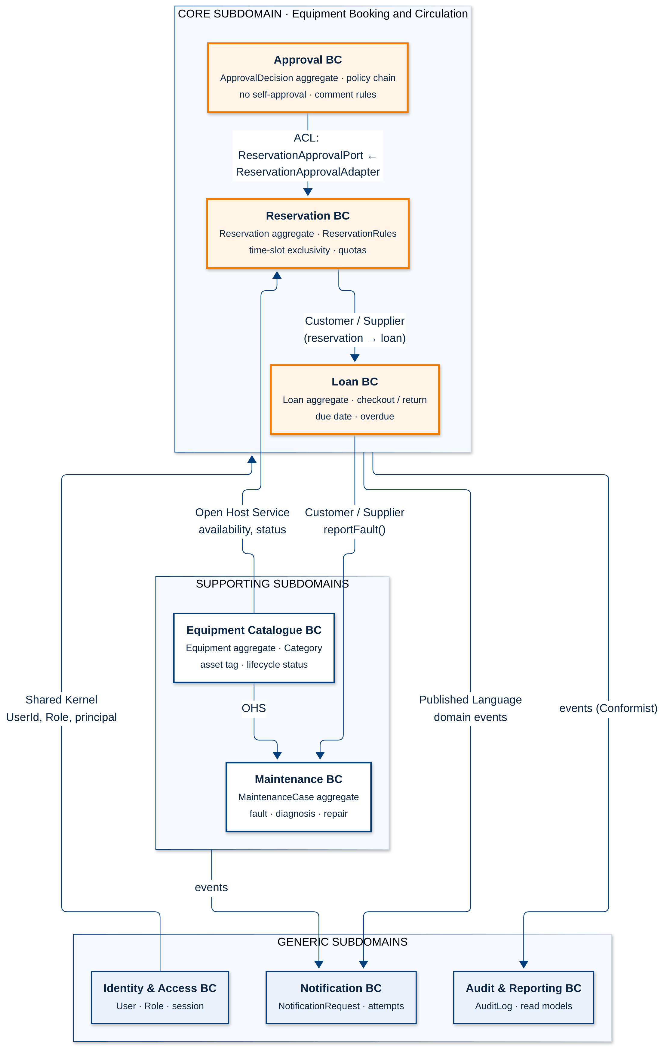
Figure 6: Strategic design: subdomains, bounded contexts and context-map relationships
The context map shows how contexts integrate. Approval uses an anti-corruption layer: it depends on its own ReservationApprovalPort and receives ApprovalReservationSnapshot objects, and the reservation module implements the port with ReservationApprovalAdapter, so Approval never sees reservation internals. Reservation and Loan, and Loan and Maintenance, are customer/supplier pairs. The catalogue is an open host service for availability and status. Identity provides a small shared kernel (user id, roles, principal). Notification and Audit consume a published language of domain events and are conformist.

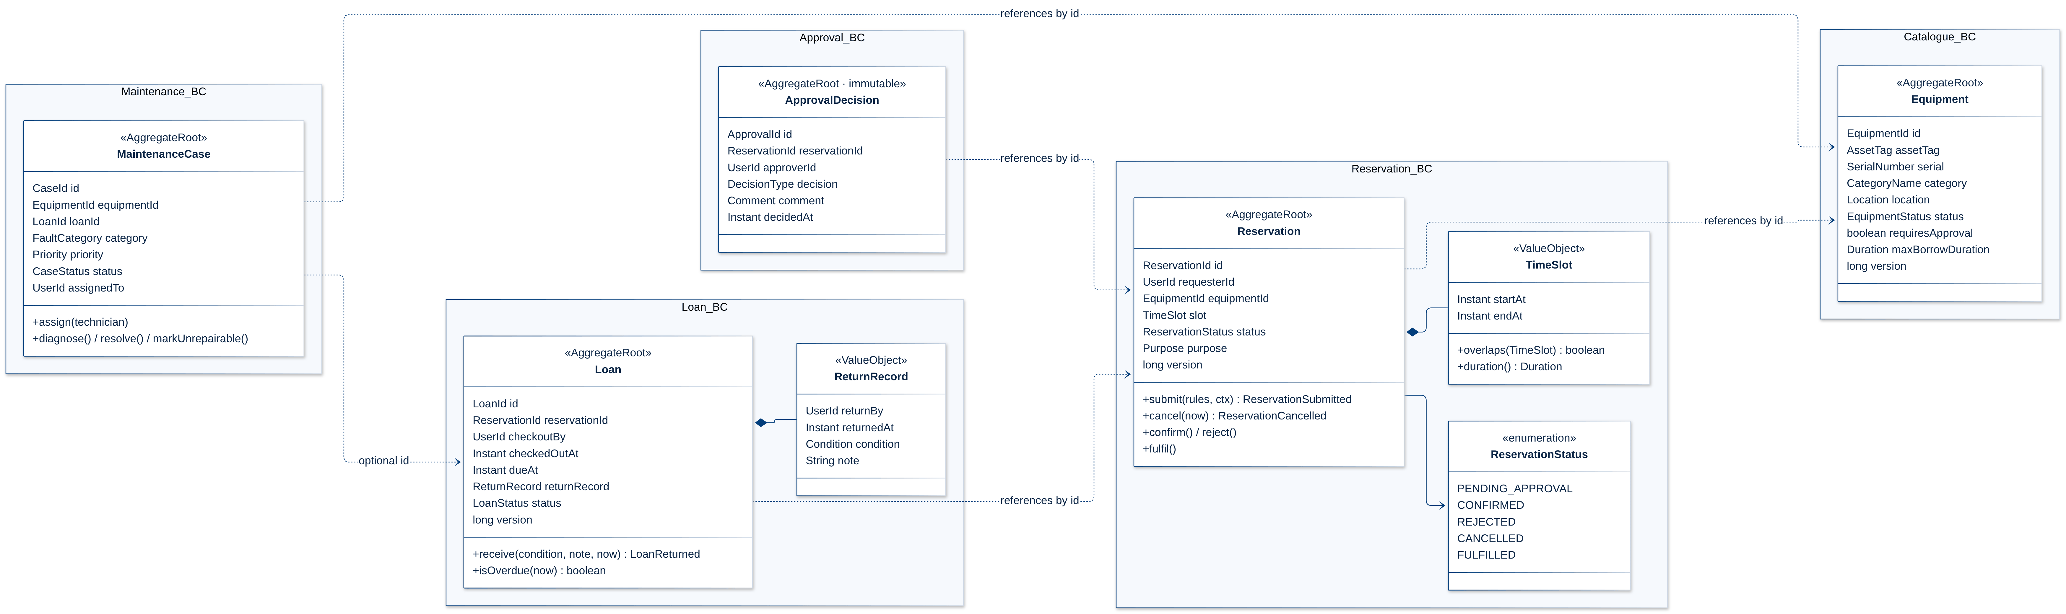
Figure 7: Tactical design: aggregates, entities and value objects (references between aggregates by id only)

Aggregate rules: one transaction changes one aggregate root except where the business requires atomicity (a damaged return updates the Loan and opens a MaintenanceCase in one transaction). Aggregates reference each other by identity only. Each root carries a version column for optimistic concurrency, and invariants are protected by both domain code and database constraints, for example TimeSlot non-overlap by the PostgreSQL exclusion constraint.
Table 12: Domain event catalogue
Domain event | Producer | Consumers | Effect
ReservationSubmitted | Reservation | Notification, Audit | Confirm to borrower; notify approvers if approval is required
ReservationCancelled | Reservation | Notification, Audit | Release slot; inform approver/custodian
ReservationDecided | Approval | Reservation (via port), Notification, Audit | Confirm or reject; inform borrower with comment
EquipmentCheckedOut (LoanEvent CHECKED_OUT) | Loan | Notification, Audit, Catalogue | Equipment ON_LOAN; schedule due reminders
EquipmentReturned (LoanEvent RETURNED) | Loan | Maintenance, Notification, Audit, Catalogue | Close loan; open case when DAMAGED; suppress reminders
LoanDueSoon / LoanOverdue | Reminder scanner | Notification | De-duplicated reminder per loan, type and due time
FaultReported / CaseAssigned / CaseResolved | Maintenance | Notification, Audit, Catalogue | Block or release equipment; inform technician and reporter

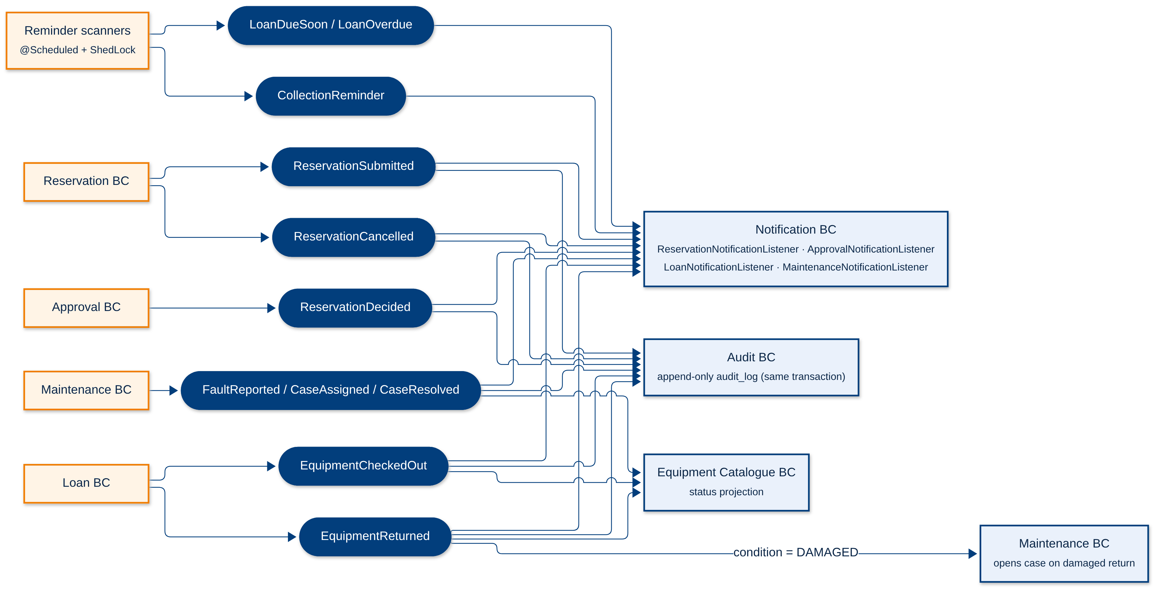
Figure 8: Domain event flow: producers, events and consumers
Producers and consumers. Inside the monolith events travel through Spring's ApplicationEventPublisher. Listeners that must be consistent with the business change (audit, notification request) run in the producer's transaction; delivery to the user runs later in NotificationWorker, with bounded retries and a de-duplication key enforced by a unique constraint. Because every event already has a stable identifier and payload, the same events can be written to an outbox table and published to a broker when contexts are extracted as services (Section 6).

Physical Architecture & Design
SERMS runs on one Linux virtual machine in Hong Kong with Docker Engine and Docker Compose. Host nginx terminates TLS and forwards to the web container on the loopback interface. The web container serves the SPA and load-balances API calls over N app replicas on an internal Docker network; the database container has no published port. Monitoring and backups run on a separate ops network. Figure 9 shows the physical view.
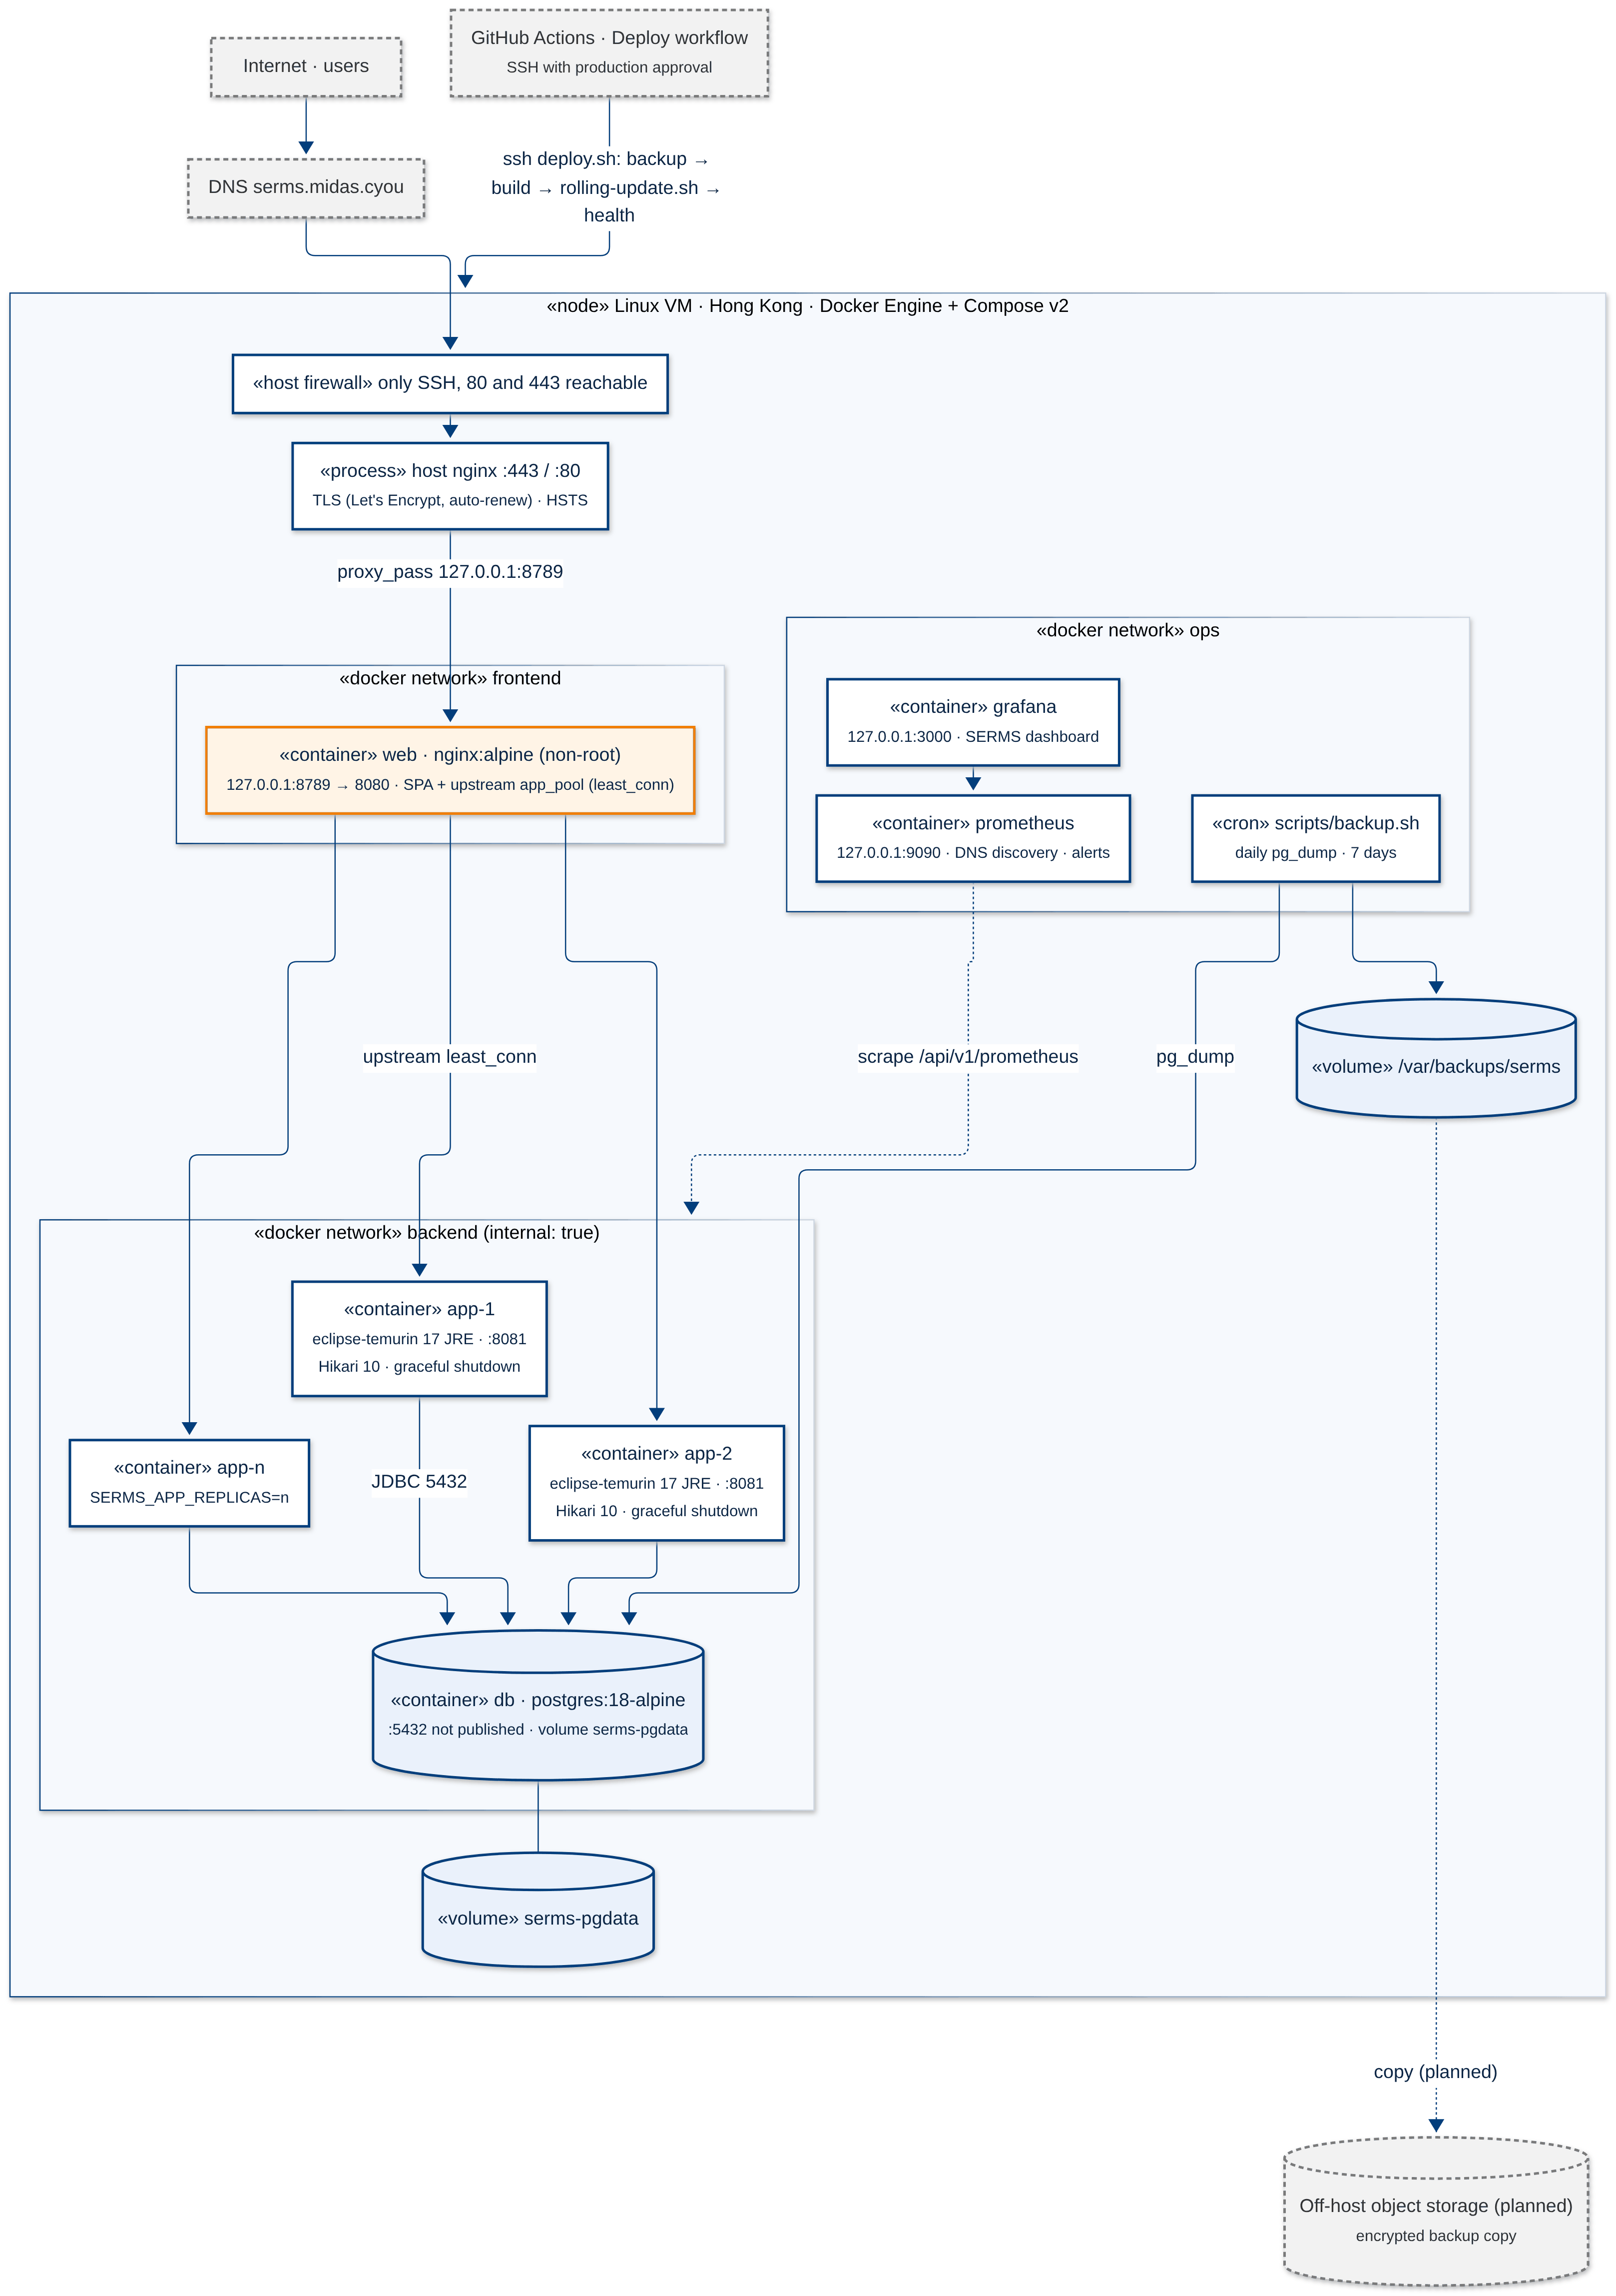
Figure 9: Physical deployment view (production)

Key Architectural Decisions
The key architectural decisions taken are as follows:
Table 13: Physical architectural decisions
Identifier | Description
AD-07 | nginx as the load balancer, with Docker DNS discovery. upstream app_pool { zone; least_conn; server app:8081 resolve max_fails=0; keepalive 32; }. The resolver re-reads Docker DNS every 2 s, so replicas join and leave without an nginx reload. A failed connect moves to the next replica (proxy_next_upstream, 1 s connect timeout, 10 s budget). A GET/HEAD that nginx itself could not deliver is replayed once. Measured: 0 failed requests during rolling updates and after a replica was killed. Trade-off: no extra component, and the same nginx already serves the SPA. The cost is fewer features than HAProxy or a cloud load balancer, with no active health checks in open-source nginx.
AD-08 | Sessions in PostgreSQL (Spring Session JDBC) rather than sticky sessions or Redis. Sticky sessions break on failover; Redis adds a stateful component to operate. Sessions are small and few (campus scale), so one indexed table is enough; Spring Session deletes expired rows every minute. The cookie keeps the contract name JSESSIONID and its HttpOnly, Secure and SameSite=Lax attributes. Revisit when session reads exceed a few hundred per second.
AD-09 | Docker Compose on one VM instead of Kubernetes. The Proposal excluded Kubernetes; Compose deploy.replicas: ${SERMS_APP_REPLICAS:-2} and scripts/rolling-update.sh give horizontal scaling and rolling replacement at far lower operating cost. The VM is a single point of failure, accepted for a campus pilot (Section 3.4).
AD-10 | Network segmentation. Three Docker networks: frontend (web, publishes 127.0.0.1:8789 only), backend with internal: true (web, app, db, Prometheus), and ops (Prometheus, Grafana on loopback ports). Only host nginx is reachable from the Internet. The app port and /api/v1/prometheus are never exposed; nginx answers 404 for the metrics path.
AD-11 | Immutable, SHA-tagged images built from one multi-stage Dockerfile. serms-app:<sha> and serms-web:<sha> run as non-root users; the same SHA is scanned by Trivy in CI and shown in the UI footer, so rollback means starting the previous tag.

Technology and Services
Table 14: Technology choices and trade-offs
Area | Technology | Rationale and trade-off
Front end | React 19, TypeScript 5 (strict), Vite 7, TanStack Query/Table, React Hook Form + Zod, shadcn/ui + Tailwind 4, Recharts | Mature ecosystem, accessible components, typed API client; larger bundle than server-rendered pages (mitigated by route-level code splitting)
Back end | Java 17, Spring Boot 4, Spring MVC, Spring Security, Spring Data JPA + JdbcTemplate | Team skills, strong security and transaction support; JVM memory per replica is higher than Go/Node
Scaling | nginx upstream, Spring Session JDBC, ShedLock, HikariCP | Stateless replicas without new infrastructure; database becomes the shared bottleneck
Database | PostgreSQL 18, Flyway | Exclusion constraints on tstzrange give race-free booking; triggers enforce append-only audit; one engine for business data, sessions and locks
API | REST + OpenAPI 3 (springdoc), RFC 9457 ProblemDetail | Simple, cacheable, contract-generated types; less flexible than GraphQL
Containers | Docker multi-stage builds, Docker Compose | Reproducible runtime for CI and production
Edge | Host nginx, Let's Encrypt, ufw | Free certificates with auto-renewal, small attack surface
CI/CD | GitHub Actions, GitHub environments with required reviewers | Integrated with PRs and branch protection; vendor lock-in accepted
Security tooling | gitleaks, Trivy, Dependency Review, Dependabot, CodeQL, OWASP ZAP, k6 | Covers secrets, dependencies, images, code and runtime; ZAP and k6 run outside the PR gate
Observability | Spring Boot Actuator, Micrometer, Prometheus, Grafana | Per-replica health and latency metrics; alerting on error rate and p95

Persistence Design
All persistent data lives in one PostgreSQL 18 database, schema serms, created only by Flyway migrations V001-V009. Each bounded context owns its tables (see the table-ownership table below); other contexts read them only through the owning module's service or a read-only report query. This ownership map is the basis for splitting the database per service later.
Figure 10: Logical data model (ERD) of the serms schema, including session and lock tables
Table 15: Table ownership and persistence period
Bounded context | Tables owned | Persistence period
Identity & Access | app_user, role, user_role | Life of the account; disabled, never deleted
Equipment Catalogue | equipment, equipment_category | Permanent; RETIRED items kept for history
Reservation / Approval | reservation, approval_decision | Permanent (audit and reports); decisions immutable
Loan | loan | Permanent
Maintenance | maintenance_case | Permanent maintenance history
Notification | notification_request, notification_attempt | Kept; proposed policy: archive after 12 months
Audit | audit_log | Append-only (UPDATE/DELETE rejected by trigger); proposed policy: at least 3 years
Platform | spring_session, spring_session_attributes (V008), shedlock (V009) | Session: 30 min idle timeout, expired rows deleted every minute; lock rows: reused per job name

Transactions and concurrency. Every use case is one @Transactional service method. Four techniques keep data consistent when many replicas serve concurrent users:
- Exclusion constraint. EXCLUDE USING gist (equipment_id WITH =, tstzrange(start_at, end_at) WITH &&) for PENDING_APPROVAL, CONFIRMED and FULFILLED reservations. The database rejects an overlapping insert (SQLSTATE 23P01) even if two replicas pass the application check at the same moment; the API returns 409 "This time slot is already reserved".
- Pessimistic row locks in a fixed order. Checkout and return lock equipment, then reservation, then loan (SELECT ... FOR UPDATE), which prevents deadlocks between replicas.
- Optimistic versions. Equipment, reservation, loan and maintenance_case carry a version incremented by trigger; clients send expectedVersion and receive 409 on a stale update.
- Idempotency and de-duplication. Notification requests have a unique dedup_key; ShedLock guarantees that only one replica runs each scheduled scan at a time.
Information architecture. The data inventory is classified into the groups below.
Table 16: Information architecture by data group
Data group | Data format | Proposed storage technology | Security requirements and controls | Trade-off consideration
Identity data (users, roles, password hashes) | Relational rows; email, display name, BCrypt hash | PostgreSQL (app_user, role, user_role) | Confidential/PII. BCrypt via DelegatingPasswordEncoder; never logged; admin-only API; session_version revokes sessions on role change | Kept in-house for the pilot; federating to campus OIDC removes password storage
Master data (equipment, categories) | Relational rows with UNIQUE asset tag and serial number | PostgreSQL | Internal. Write access for administrators only; optimistic versions | Relational integrity preferred over a document store
Transactional data (reservations, decisions, loans, cases) | Relational rows, timestamptz in UTC | PostgreSQL with constraints, triggers and locks | Internal. Row-level authorisation in services (borrowers see own records); audit on every change | Strong consistency (ACID) over write scalability; partition by year if volume grows
Audit log | Append-only rows; JSON-like change summary text | PostgreSQL audit_log with UPDATE/DELETE triggers | Integrity-critical. Insert-only, admin read-only viewer, included in backups | Same database keeps audit atomic with the change; a WORM store would add tamper evidence
Notifications | Relational rows: request, attempts, status | PostgreSQL | Internal; recipient can read only own inbox | Polling instead of WebSocket push keeps the tier stateless
Session and lock data | Serialized session attributes (bytea); lock rows | PostgreSQL (spring_session*, shedlock) | Secret (session ids). HttpOnly Secure cookie; short idle timeout; cleaned up by job | Avoids operating Redis; adds a small read and write per request. Measured: one session served 20/20 by two replicas
Backups | Compressed pg_dump custom-format files | Host backup directory (off-host encrypted copy planned) | Confidential; outside the checkout; 7 daily copies; restore rehearsed | Logical dumps are simple; WAL archiving would reduce RPO from 24 h to minutes

Detailed Design
Two architecturally representative use cases are designed at class and object level: UC01 Submit reservation (the core concurrency problem) and UC03 Receive a return (multi-aggregate transaction with lock ordering and a cross-context side effect).
UC01 Submit reservation. ReservationController validates the request DTO and resolves the authenticated principal. ReservationService.submit() runs in one transaction: it locks the equipment row, rejects retired or broken items, locks the requester's account status, builds a ReservationRuleContext and asks ReservationRules to evaluate five ReservationPolicy strategies (start in future, duration, booking horizon, open-reservation quota, overdue borrower). It then inserts the reservation as PENDING_APPROVAL or CONFIRMED depending on the category, appends an audit record and publishes ReservationSubmitted. New rules are added as new strategy classes without changing the service (open/closed principle).

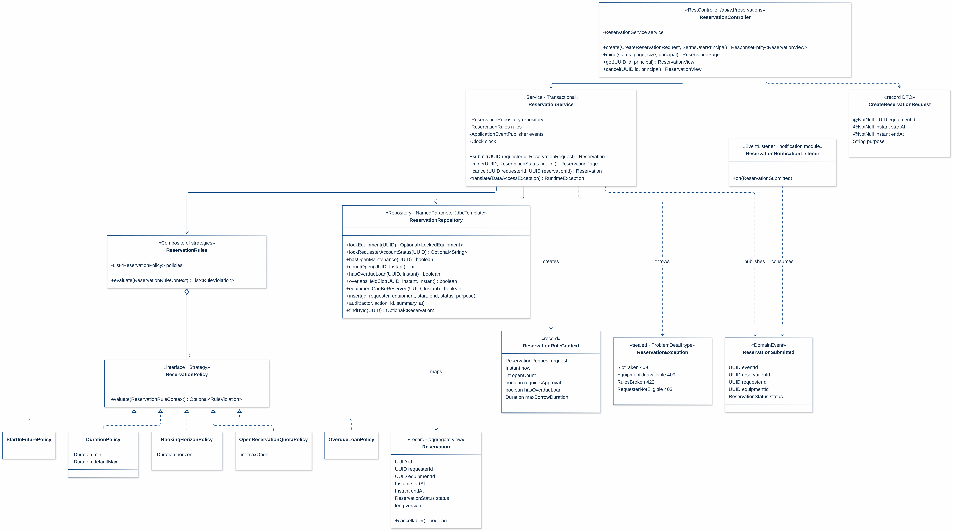
Figure 11: UC01 design class diagram (Strategy pattern for booking rules)
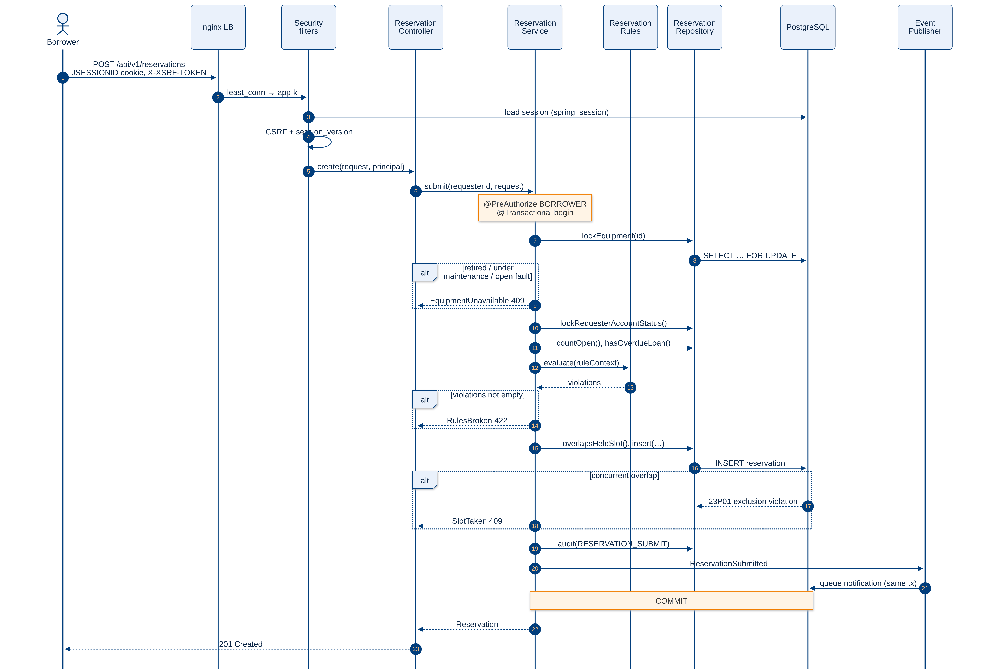
Figure 12: UC01 design sequence diagram: submit a reservation through the load balancer

The sequence shows why the design is safe across replicas: the session is loaded from the shared store, so any replica can handle the request; the equipment row lock serialises bookings for the same item; and the exclusion constraint is the final guard when two transactions on different replicas race (the alt block for the 23P01 exclusion violation). ClusterScalingPostgresTest exercises the shared-session part with two real application replicas on one database. Figure 13 shows the reservation lifecycle that the service enforces.
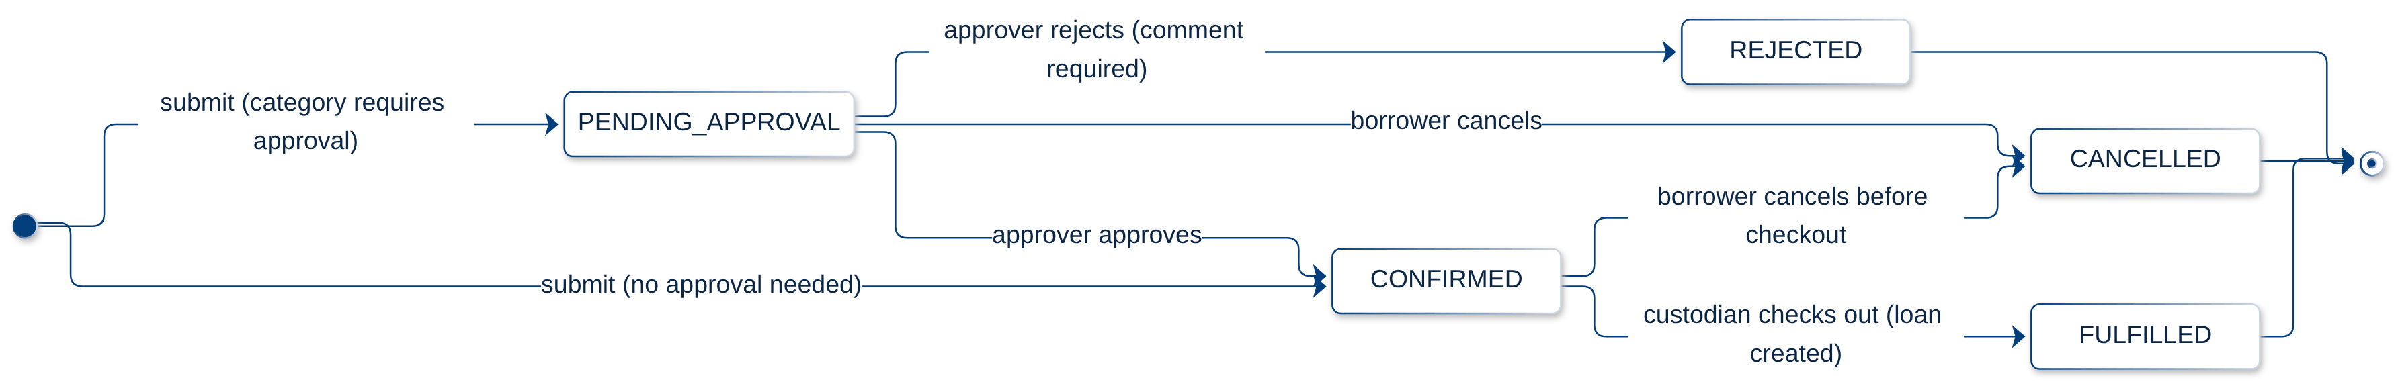
Figure 13: Reservation state machine
UC03 Receive a return. LoanService.receive() validates the condition (GOOD or DAMAGED; damage requires a note), locks equipment, reservation and loan in a fixed order, checks the expected version, and updates the loan. For a damaged item it calls MaintenanceService.reportFault() with category PHYSICAL_DAMAGE and priority HIGH, which opens a maintenance case and moves the equipment to UNDER_MAINTENANCE. The EquipmentLoanState enum (State pattern) computes the next equipment state from the remaining active maintenance and loans. Audit and the LoanEvent RETURNED event are written in the same transaction.

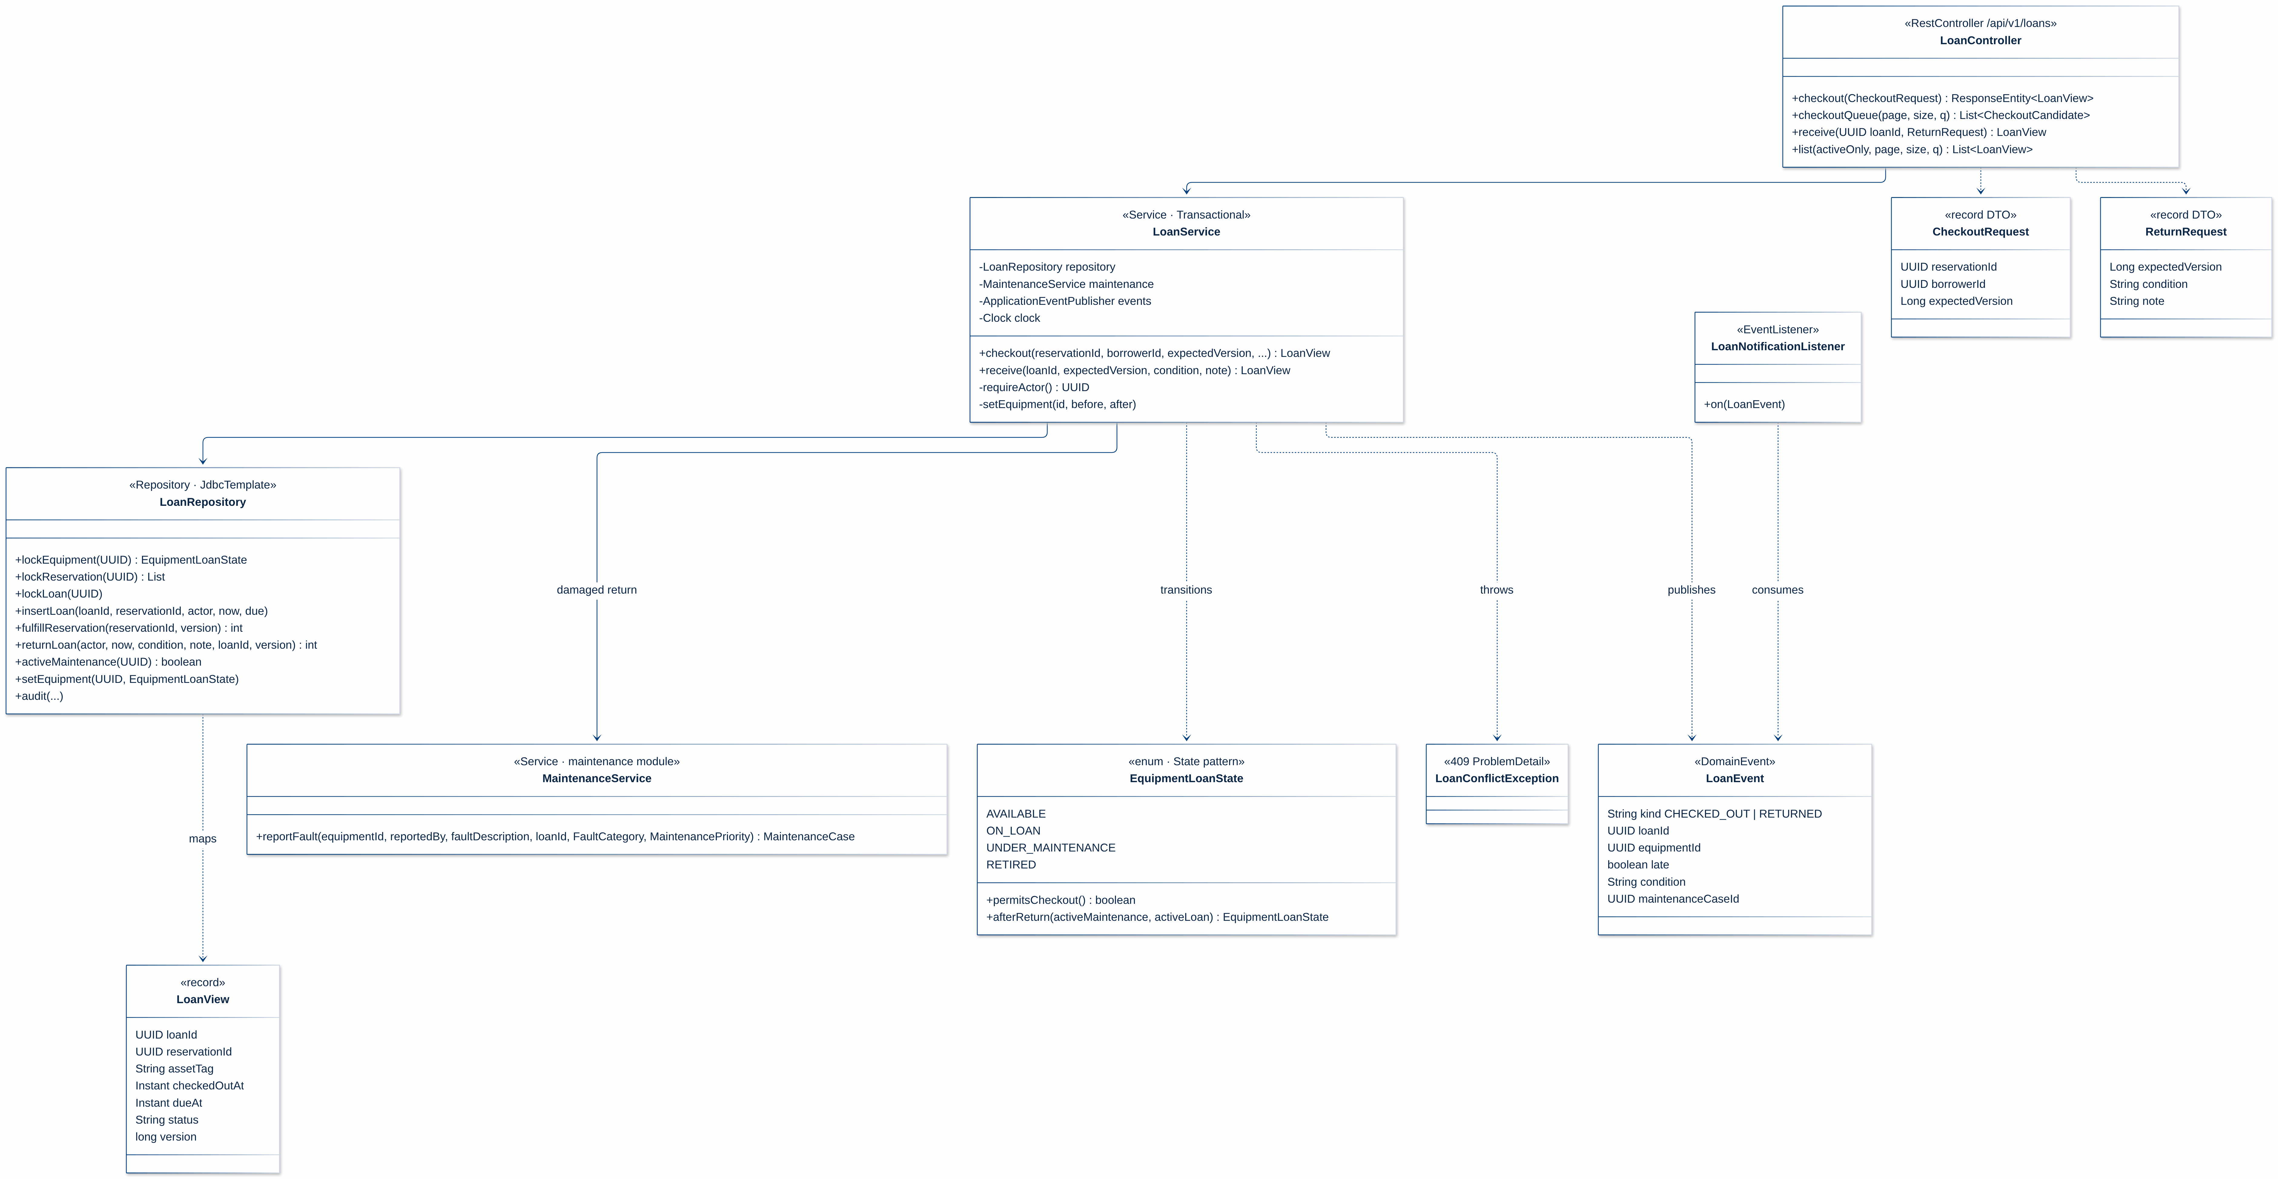
Figure 14: UC03 design class diagram (State pattern for equipment loan state)
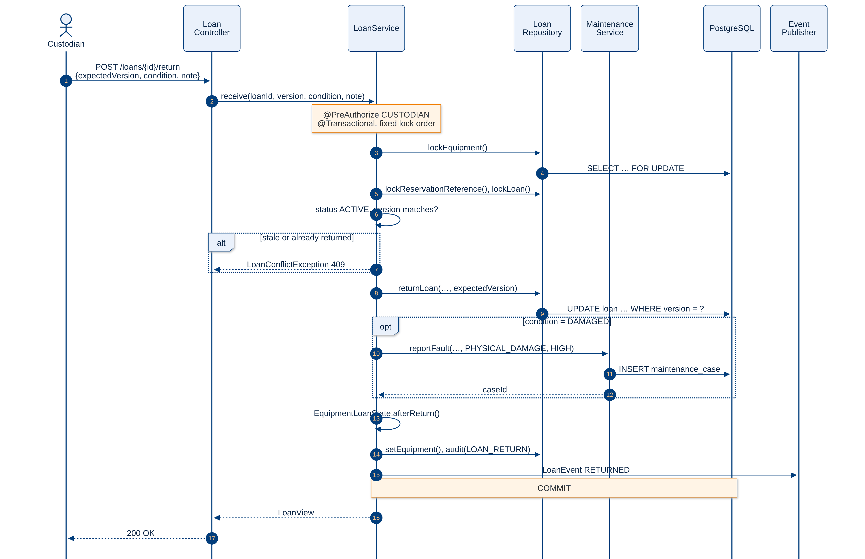
Figure 15: UC03 design sequence diagram: receive a return, damaged branch opens a maintenance case

Table 17: Design patterns used in the detailed design
Pattern | Where | Benefit
Strategy | ReservationPolicy implementations composed by ReservationRules | Rules change per category without touching the service
Chain of Responsibility | ApprovalPolicyChain with NoSelfApprovalHandler, DecisionCommentHandler | Approval checks can be reordered or extended
State | EquipmentLoanState, maintenance case state machine | Illegal transitions are impossible by construction
Observer | Domain events with Spring listeners | Notification and audit are decoupled from business modules
Adapter / Factory Method | NotificationChannel, ReservationApprovalAdapter | New channels (e-mail) and context isolation (ACL)

Other Architectural Decisions
The key architectural decisions taken are as follows:
Table 18: Other architectural decisions
Identifier | Description
AD-12 | Session cookie with CSRF instead of JWT bearer tokens. Same-origin deployment makes cookies simple and safe (HttpOnly, Secure, SameSite=Lax, CookieCsrfTokenRepository). session_version on the user row invalidates all sessions after a role change or deactivation. See Section 4.3.
AD-13 | Authorisation on the server only. @PreAuthorize on every service method plus URL rules; the UI hides buttons only for usability.
AD-14 | Time handling. timestamptz in the database, Instant in Java, ISO-8601 UTC in the API, Asia/Singapore in the UI; an injected Clock makes time-based rules testable.
AD-15 | Expand-and-contract migrations. Every Flyway migration is backward compatible with the previous release so that a rolling update can run old and new replicas against one schema (Section 5.3).
AD-16 | Polling for unread notifications every 30 s instead of WebSockets, to keep replicas stateless and avoid sticky connections (Section 4.1).
AD-17 | Scope freeze (D-009). E-mail, QR codes, ArchUnit, Spotless and SpotBugs dropped; CodeQL and ESLint cover static analysis.

Architectural Limitation
The key outstanding architectural issues in the solution are as follows:
Table 19: Outstanding architectural issues and roadmap
Identifier | Issue and impact | Description | Resolution | Owner | Status
AIS-01 | Single VM is a single point of failure | Host or disk failure stops all replicas and the database | Phase 2: second VM with keepalived virtual IP and PostgreSQL streaming replica; RTO 15 min | Wang Yuanmeng | Planned (next semester)
AIS-02 | Database is the shared scalability bottleneck | All replicas share one primary for writes, sessions and locks | Read replica for reports; PgBouncer; move sessions to Redis above ~500 req/s | Zhou Fanhao | Designed
AIS-03 | Sign-in is CPU-bound | BCrypt makes login the costliest call. With one vCPU per replica, 50 users give login p95 4.3 s on one replica and 2.1 s on two | Size CPU for peak sign-in (two replicas on 4 vCPU: 1.25 s), add a replica, or move to campus SSO. The former reserve-p95 miss (2.26 s, laptop) is not reproduced: 0.31 s on two replicas | Liu Tongyao | Mitigated
AIS-04 | Backup RPO is 24 h | Daily pg_dump only; production schedule still to confirm | Confirm cron; add WAL archiving for point-in-time recovery | Wang Yuanmeng | Open
AIS-05 | Module boundaries are conventions | ArchUnit dropped by D-009; a careless import can couple modules | Re-introduce ArchUnit or Spring Modulith verification in CI | Zhang Hanming | Planned
AIS-06 | ZAP scan is anonymous only | Signed-in pages are not covered by DAST | Authenticated ZAP scan per role in the post-deploy job | Liu Tongyao | Open
AIS-07 | A replica stopped outside Compose is not replaced | docker kill leaves one replica; requests keep succeeding, but capacity halves | Alert SermsTooFewReplicas; run docker compose up -d; a supervisor (systemd timer or Swarm/Kubernetes) in Phase 2 | Wang Yuanmeng | Open
AIS-08 | Production still runs one replica | D-014 is verified locally and in CI scripts but not yet released | Member confirmations (CI/CD, migrations, auth contract), merge, gated Deploy; users sign in once after the first switch | Liu Tongyao | Pending release
AIS-09 | No edge rate limiting or read replica | Host nginx limit_req and a PostgreSQL streaming replica are designed (Figures 2 and 9) but not configured | Configure host nginx with client-IP limits on /api/v1/auth/login; add a replica for reports and backups | Wang Yuanmeng | Planned

Quality Attributes

Performance
Target: 2 s response for 50 concurrent users; reports within 5 s (Proposal 7).
- Horizontal scaling: stateless replicas behind least_conn load balancing; capacity grows linearly until the database becomes the bottleneck.
- Database tactics: indexes on search, overlap and due-date columns; paginated list endpoints (page, size, sort); HikariCP pool of 10 per replica sized against PostgreSQL max_connections; JdbcTemplate for hot paths instead of ORM N+1 queries.
- Front-end tactics: hashed static assets cached for one year (immutable), route-level code splitting (the Recharts report bundle loads only when opened), TanStack Query caching and 30 s polling instead of push.
Evidence. A k6 scenario (scripts/load-k6.js) runs virtual users that each log in, search and reserve a distinct item. Each run uses fresh borrowers and items; the table averages the measured runs, without warm-up runs. The host had 4 vCPU; in the 1 vCPU rows each replica was limited to one CPU, as if each had its own small host.
Table 20: k6 results (p95, no failed requests in any run)
Scenario | Checks | p95 all | Login | Search | Reserve
50 users, 2 replicas, shared 4 vCPU (production setup) | 200/200 ×3 | 1.21 s | 1.25 s | 0.22 s | 0.31 s
50 users, 1 replica, shared 4 vCPU | 200/200 ×3 | 0.96 s | 1.04 s | 0.13 s | 0.14 s
50 users, 1 replica, 1 vCPU | 200/200 ×2 | 4.09 s | 4.28 s | 0.82 s | 0.86 s
50 users, 2 replicas, 1 vCPU each | 200/200 ×2 | 2.05 s | 2.10 s | 0.36 s | 0.42 s
150 users, 1 replica, 1 vCPU | 600/600 ×2 | 10.33 s | 11.00 s | 3.86 s | 2.97 s
150 users, 2 replicas, 1 vCPU each | 600/600 ×2 | 5.47 s | 5.70 s | 1.43 s | 1.40 s
150 users, 3 replicas, 1 vCPU each | 600/600 ×2 | 3.87 s | 3.99 s | 0.65 s | 0.82 s

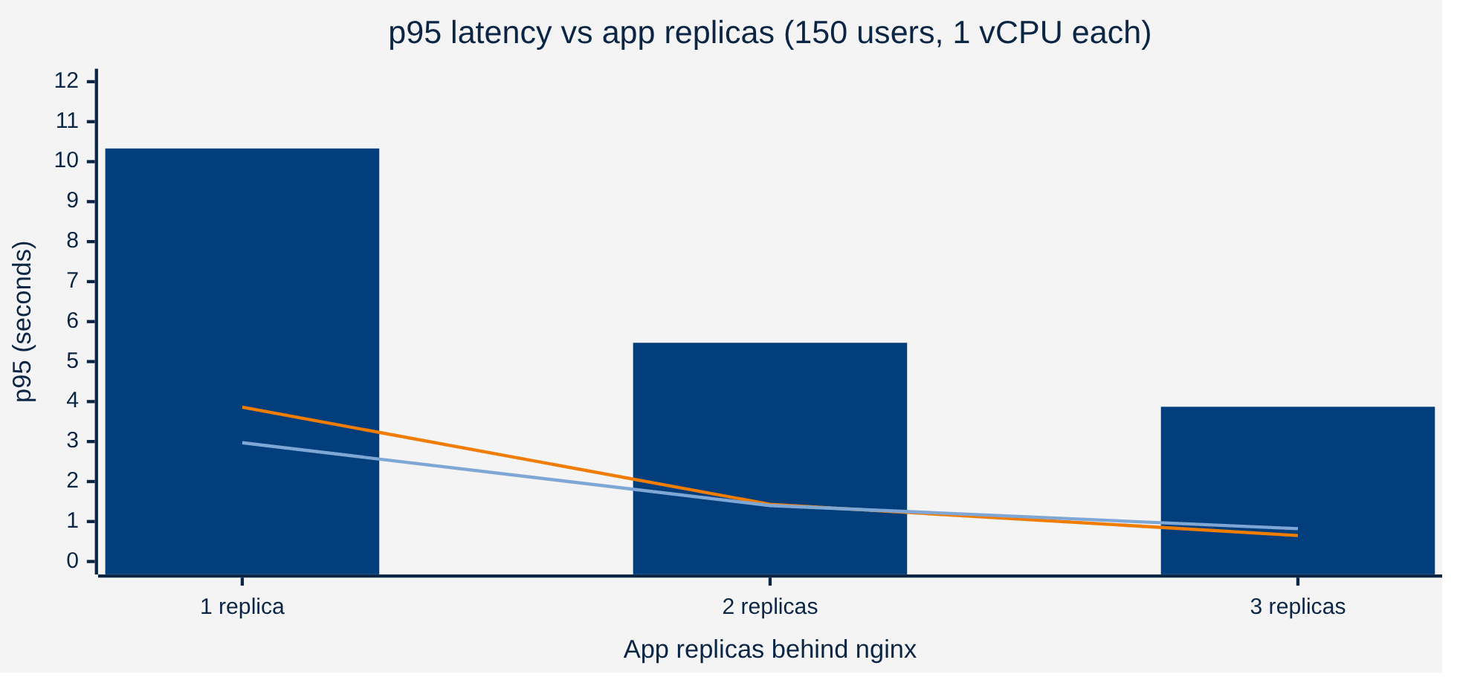
Figure 16: p95 latency with 150 users as replicas are added (bars: all requests; orange: search; light blue: reserve)
With 50 users on the production setup, every operation meets the 2 s target. The earlier 2.26 s reserve p95, measured on a laptop with one instance, is not reproduced. When each replica has its own CPU, adding replicas roughly halves latency, which is the expected horizontal scaling. On one shared 4-vCPU host a second replica does not speed up 50 users, because both replicas compete for the same cores; there it adds availability. Sign-in is CPU-bound by design (BCrypt), so capacity should be sized for peak sign-in (AIS-03). Raw results are in docs/evidence/scaling-20261104/.

Availability
- Redundancy: two app replicas by default. nginx moves a request to the next replica when a connect fails and replays a GET/HEAD it could not deliver. Measured: after one of two replicas was killed under continuous traffic, all 261 requests returned 200.
- Health checks: Docker health checks on /api/v1/health (liveness and readiness probes are also enabled) and pg_isready; restart: unless-stopped restarts crashed containers.
- Zero-downtime release: scripts/rolling-update.sh starts the new replicas, waits until they are healthy, then drains the old ones one at a time. Migrations are backward compatible. Measured: 0 failed signed-in requests in four rolling updates (Section 5.3).
- Recovery: pre-release and daily pg_dump with 7-day retention, rehearsed restore into a scratch database (runbook-backup.md); RPO 24 h, RTO under 1 h.
- Monitoring: Prometheus discovers each replica through Docker DNS. Alerts cover a replica down, fewer than two replicas, p95 above 2 s, 5xx above 2% and a waiting DB pool; the Grafana dashboard shows requests per replica.
- Known gaps: single VM (AIS-01); a replica stopped outside Compose is not replaced automatically (AIS-07).

Security
Table 21: Security controls by STRIDE category
Threat (STRIDE) | Control in SERMS
Spoofing | BCrypt password hashes; JSESSIONID cookie HttpOnly + Secure + SameSite=Lax; session-id rotation on login (also with Spring Session); session_version revocation; edge login rate limiting planned (AIS-09)
Tampering | CSRF token (XSRF-TOKEN cookie + X-XSRF-TOKEN header), Bean Validation + Zod + database constraints, optimistic versions
Repudiation | Append-only audit_log written in the business transaction
Information disclosure | TLS and HSTS, CSP and security headers, ProblemDetail without stack traces, /api/v1/prometheus answered with 404 at nginx and scraped only on the internal network, no secrets in images
Denial of service | Pagination limits, bounded retries, multiple replicas, 10 s upstream retry budget; edge limit_req planned (AIS-09)
Elevation of privilege | @PreAuthorize on every service method, no self-approval, admin-only role management with audit

DevSecOps controls run on every pull request: gitleaks (secrets), Trivy filesystem and image scans, Dependency Review, Dependabot security updates and CodeQL for Java and TypeScript. The OWASP ZAP baseline reported 0 FAIL / 5 WARN / 62 PASS against production (2026-10-17) and 0 FAIL / 2 WARN / 60 PASS against the local two-replica stack (2026-11-04).

Extensibility and Maintainability
- Modularity: one module per bounded context with api/service/domain/repository layers; modules communicate through services, ports and events.
- Extension points: new booking rules as ReservationPolicy strategies, new approval checks as chain handlers, new notification channels as NotificationChannel adapters, new event consumers as listeners.
- Contracts: OpenAPI-generated client types and written contracts in docs/contracts/; changes need affected-owner confirmation.
- Testability: injected Clock, port interfaces and Testcontainers make rules and races reproducible; 78% business-logic coverage with a 70% gate.
- Evolvability: ownership of tables per context and stable domain events make extraction into services possible without rewriting business logic (Section 6).

DevOps and Development Lifecycle

Source Control Strategy
SERMS uses GitHub flow with short-lived branches. main is protected: changes arrive only through pull requests, the branch must be up to date with main, all 15 required checks must pass, and history is preserved with merge commits. Branch names state type and owner, for example feat/<member>-<topic> or fix/<member>-<topic>. Each PR follows the template (scope, linked issue, tests, evidence, affected owners), and team Done requires at least one member check in addition to green CI. Dependabot raises grouped security-update PRs.
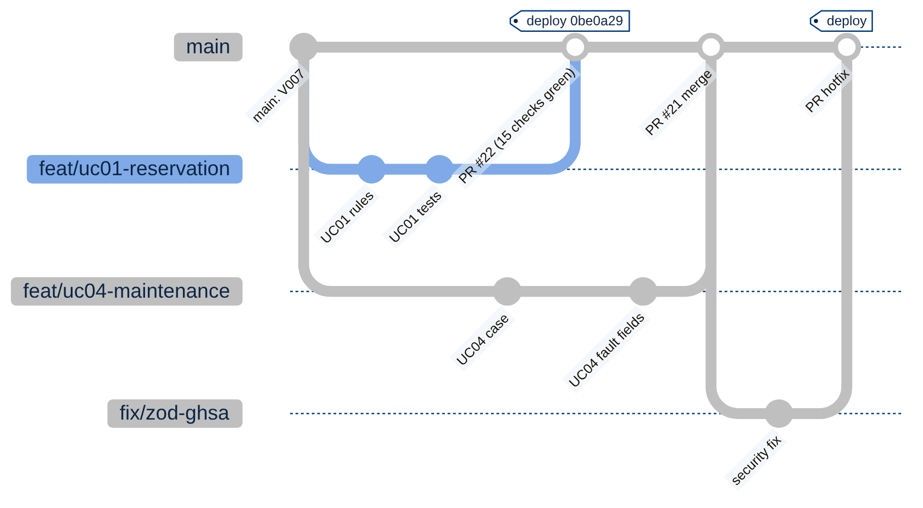
Figure 17: Branching model: short-lived feature and fix branches merged into protected main

Continuous Integration
Every pull request and every push to main runs the CI workflows in parallel (Figure 18). The 15 required checks are maintained in one list (scripts/verify-release.mjs) used by both branch protection and the release gate.

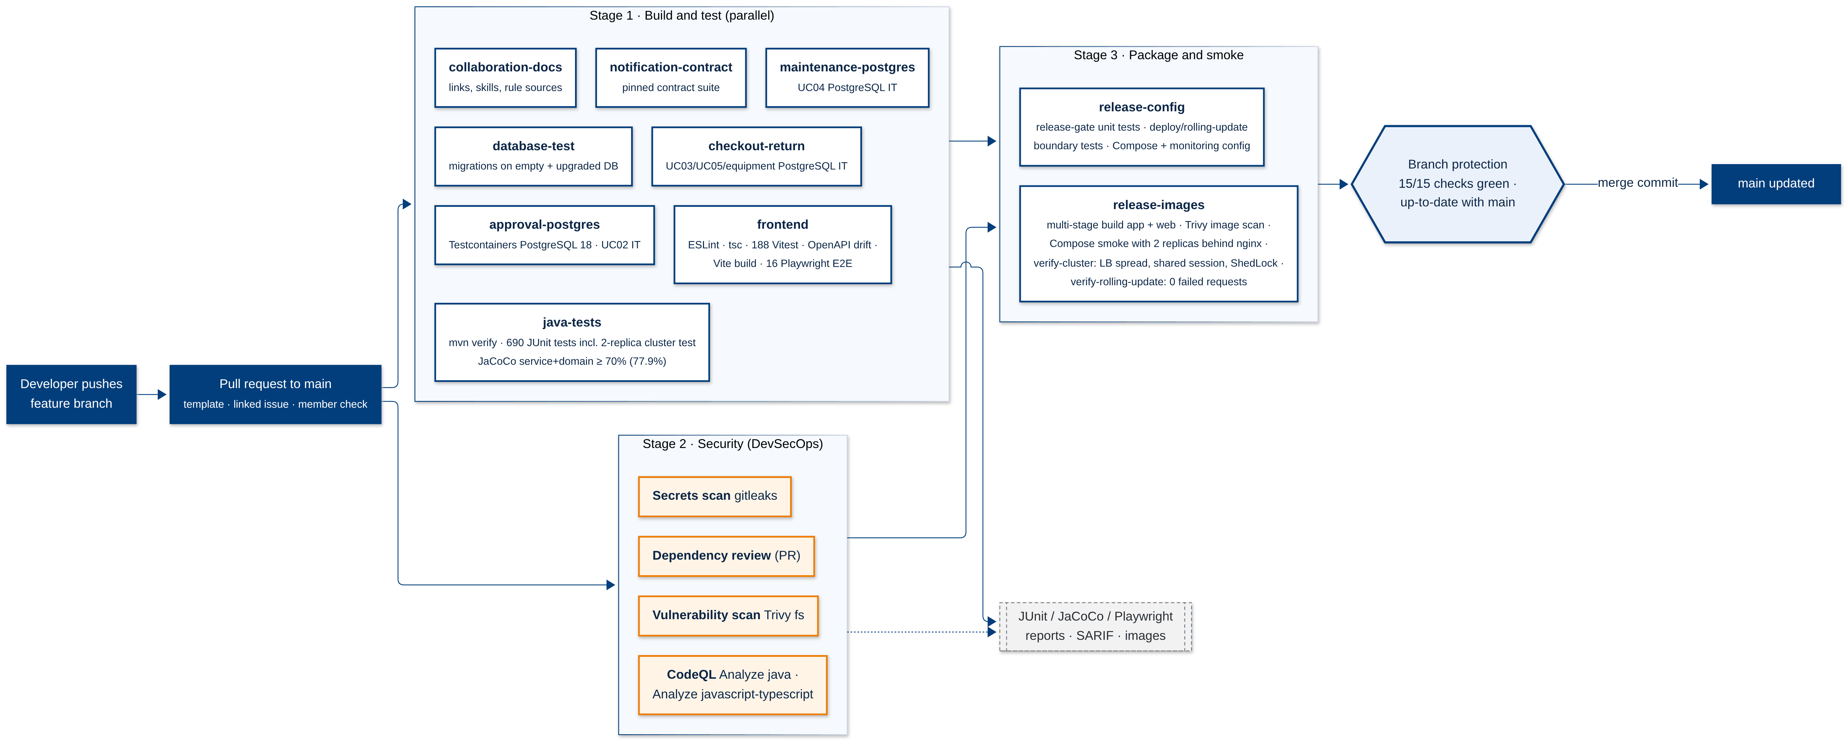
Figure 18: Continuous integration pipeline and the 15 required checks

Table 22: Test strategy and test evidence
Test level | Tooling | Scope | Evidence
Unit | JUnit Jupiter 6, Mockito, AssertJ | Policies, state machines, approval chain, services | 690 tests in java-tests
Coverage gate | JaCoCo | service + domain packages | 77.87% line coverage; build fails below 70%
Integration (real DB) | Spring Boot Test, Testcontainers PostgreSQL 18 | Concurrent reservations, checkout/return races, approval, maintenance, notifications | 30 UC02 + 41 UC03/UC05/equipment + 30 UC04
Cluster | ClusterScalingPostgresTest: two real replicas on one PostgreSQL | Login on replica A valid on B, logout ends it everywhere, ShedLock excludes the second replica | 3 tests in java-tests
Migration | Flyway on a clean and an upgraded database | V001-V009 | database-test
Contract | OpenAPI type generation, notification contract suite | Front/back API drift, notification adapter | frontend, notification-contract
Component | Vitest, React Testing Library, MSW | Pages, forms, role-aware UI | 188 tests
End-to-end | Playwright | 8 flows on desktop and mobile with mocked APIs; real all-role browser flows against the local demo | 16 tests; recorded acceptance 2026-10-17
Security | gitleaks, Trivy, Dependency Review, CodeQL, OWASP ZAP | Secrets, CVEs, code flaws, headers | SARIF in GitHub; ZAP prod 0/5/62, local 0/2/60 (FAIL/WARN/PASS)
Performance | k6 | 50-150 VUs login, search, reserve; 1-3 replicas | Section 4.1
Deployment smoke | Compose production profile, verify-compose.mjs, verify-cluster.sh, verify-rolling-update.sh | Two replicas behind nginx: headers, LB spread (20/20), shared session, ShedLock, logout everywhere, rolling update | release-images; 0 failed requests in 4 local rolling updates

Continuous Delivery
A push to main that changes application paths, or a manual dispatch, starts the Deploy workflow (Figure 19). The release gate refuses anything that is not the current main SHA with all 15 checks green and the SERMS_PRODUCTION_READY flag set. A human reviewer then approves the production environment. The deploy job connects over SSH with a pinned host key and runs scripts/deploy.sh:
- pre-release pg_dump backup;
- image build for the exact SHA;
- scripts/rolling-update.sh: new replicas start next to the old ones and apply expand-only migrations; once all are healthy and nginx has seen them, the old replicas drain one at a time;
- web recreation and a health check through nginx.
If a new replica is unhealthy, only the new replicas are removed and the previous release keeps serving. A later failure is rolled back by hand with the previous SHA images, which are kept. CI repeats the rolling update under signed-in traffic in release-images and fails on any non-200 response.
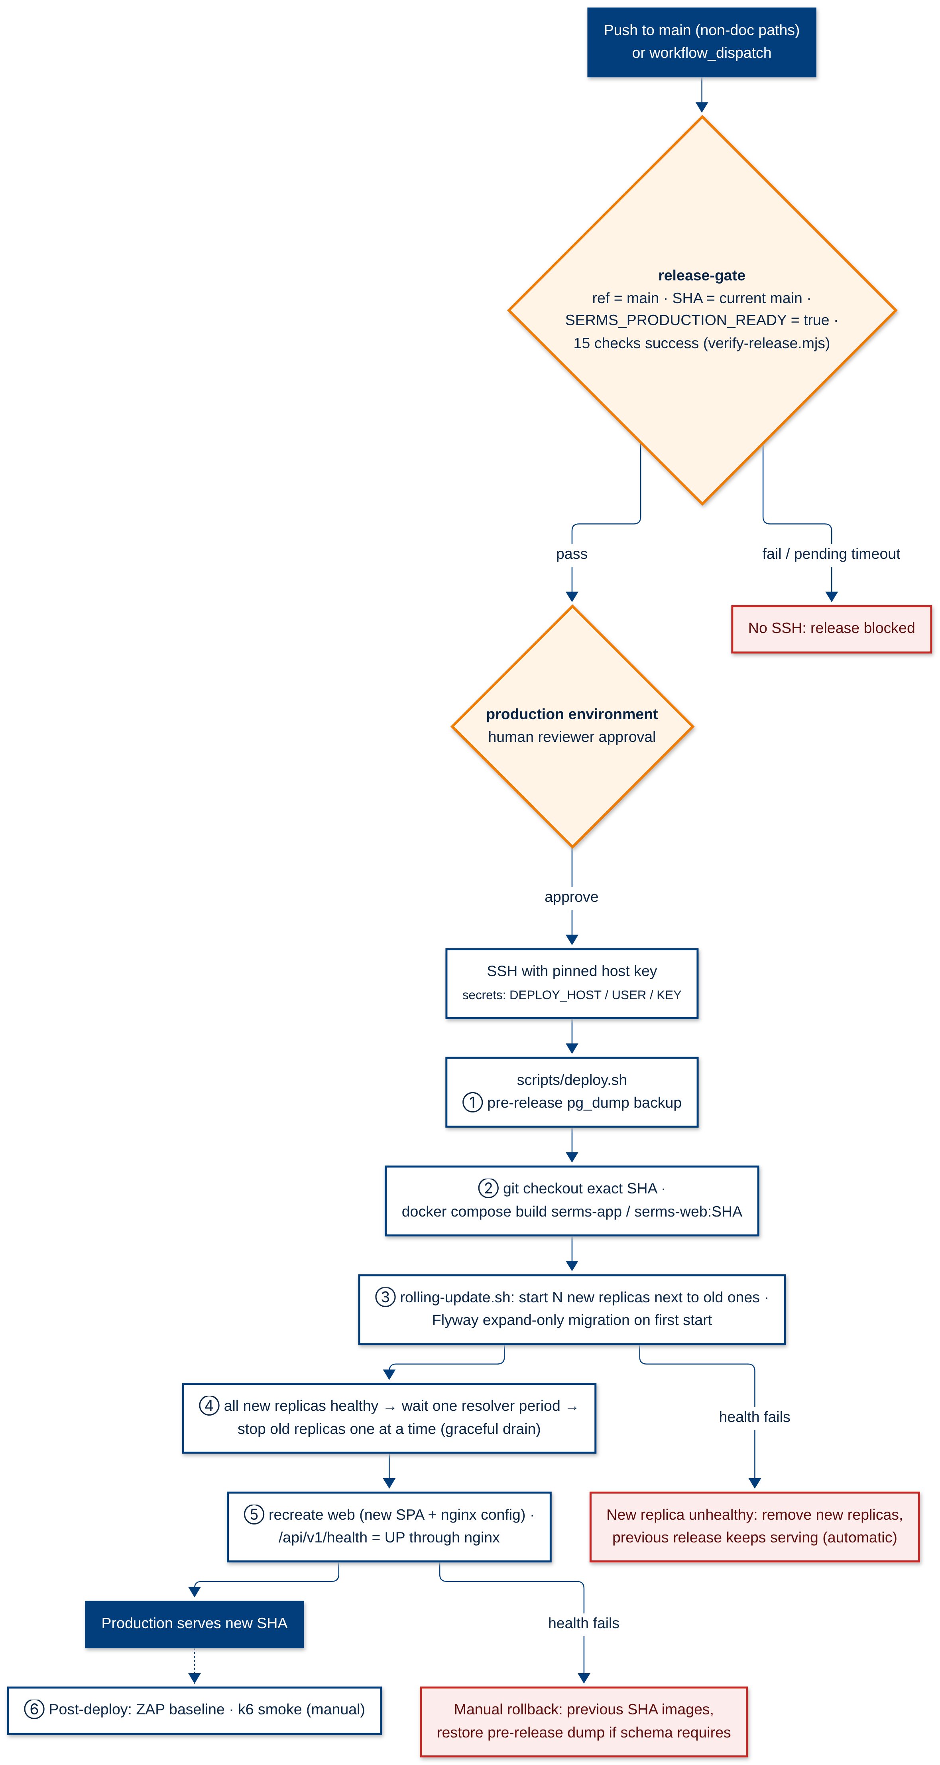
Figure 19: Continuous delivery pipeline with release gate, approval and rolling update

Scaling Further: From Scalable Monolith to Microservices
The scalable monolith meets campus-level load. If SERMS were adopted across the whole university (tens of thousands of users, many departments and teams), the bottlenecks would move to the shared database, the shared release cadence and team coordination. This chapter describes the target microservice architecture and the migration path.

Target Microservice Architecture
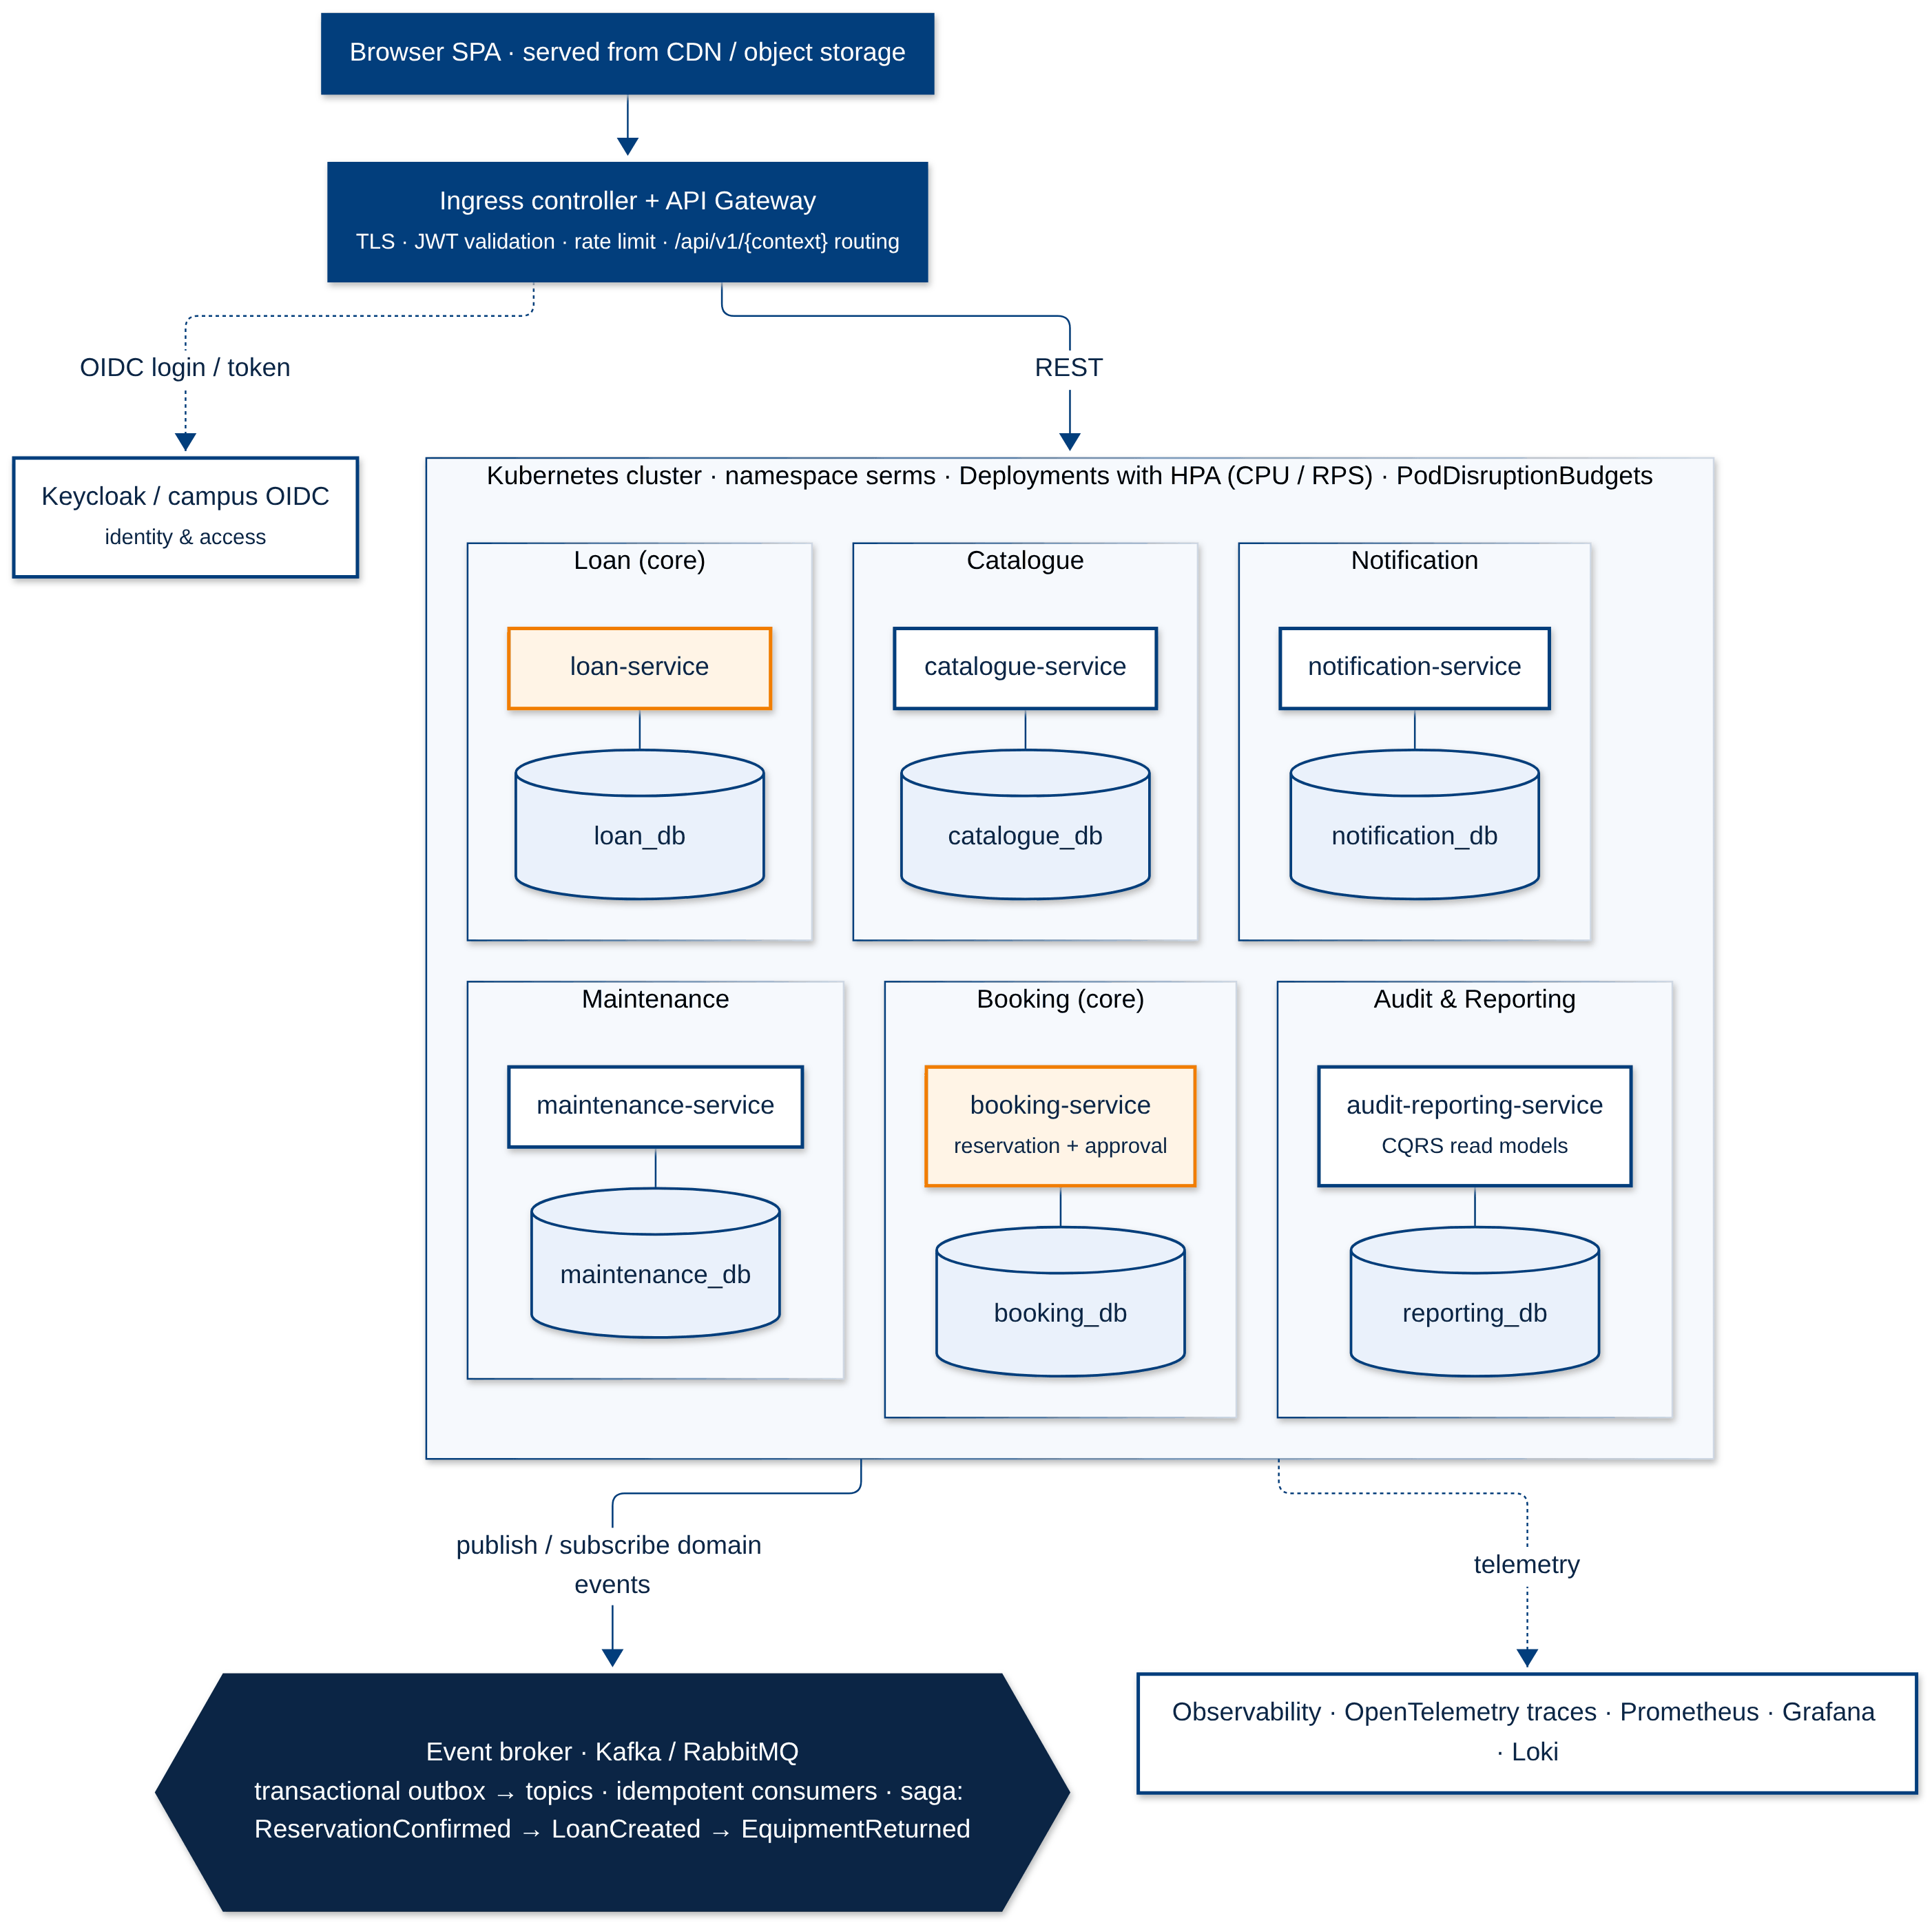
Figure 20: Target microservice architecture on Kubernetes (designed, not implemented)
Table 23: Service decomposition by bounded context
Service | From bounded context | Owns data | Integration
catalogue-service | Equipment Catalogue | catalogue_db | REST queries; publishes EquipmentStatusChanged
booking-service | Reservation + Approval | booking_db | REST; publishes ReservationSubmitted/Decided/Cancelled; consumes EquipmentStatusChanged
loan-service | Loan | loan_db | Consumes ReservationConfirmed; publishes EquipmentCheckedOut/Returned
maintenance-service | Maintenance | maintenance_db | Consumes EquipmentReturned(DAMAGED); publishes FaultReported/CaseResolved
notification-service | Notification | notification_db | Consumes all events; channel adapters (in-app, e-mail)
audit-reporting-service | Audit & Reporting | reporting_db | Consumes all events; CQRS read models
Keycloak / campus OIDC | Identity & Access | IdP store | OIDC; gateway validates JWTs

Key Design Changes
- Database per service. The table-ownership map of Section 3.2.3 becomes the split. Cross-context foreign keys are replaced by ids and local read models updated from events.
- Transactional outbox and broker. Each service writes its events into an outbox table in the same transaction and a relay publishes them to Kafka or RabbitMQ; consumers are idempotent using the event id.
- Sagas instead of distributed transactions. The reservation-to-loan and damaged-return-to-maintenance flows become choreographed sagas with compensating actions (for example cancel the loan if the equipment is under maintenance).
- Overlap guarantee stays local. Booking keeps the PostgreSQL exclusion constraint inside booking_db, so the core invariant remains a single-database guarantee.
- Identity. Replace session cookies with OIDC (Keycloak or campus SSO) and short-lived JWTs validated at the gateway; services stay stateless.
- Platform. Kubernetes Deployments with HorizontalPodAutoscaler, readiness probes, PodDisruptionBudgets, GitOps (Argo CD) and OpenTelemetry tracing across services.

Migration Roadmap and Trade-offs
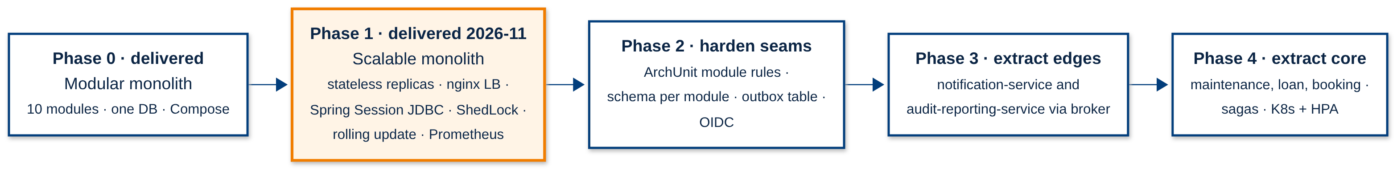
Figure 21: Strangler-fig migration roadmap (Phase 1 delivered in Sprint 4)
Extraction starts at the edges, where coupling is lowest: notification and audit/reporting already consume events only. Maintenance, loan and booking follow once the outbox and sagas are proven. The gateway routes each path to the new service or to the monolith, so the migration is incremental and reversible.
Table 24: Trade-offs between the scalable monolith and microservices
Aspect | Scalable monolith (now) | Microservices (target)
Scalability | Scale the whole app; DB shared | Scale hot services independently; DB per service
Consistency | ACID across contexts | Eventual consistency, sagas, outbox
Deployment | One pipeline, one artifact | Independent pipelines; contract tests between services
Operations | One VM, Compose | Kubernetes, broker, tracing; higher cost and skills
Team fit | Five developers, one repository | Several teams, one service each
When to move | Up to a few hundred concurrent users | University-wide adoption, independent release needs

For the current scale the scalable monolith is the right choice: it meets the quality targets with far less operational complexity, while the DDD boundaries, ports, events and table ownership keep the microservice option open.

