Retail Competitive Intelligence
Standalone Product Requirements, System Architecture, Data Contracts, and Codex Build Plan
PRODUCT  Standalone retailer competitive intelligence | V1 BENCHMARK  Walmart US | FIRST SLICE  Fresh Strawberries

Decision
Build this as a standalone Railway-hosted application, separate from CPGHero. Reuse the analytical methodology learned from eggs, milk, bananas, and strawberries as a generic engine with versioned Product Packs.

Executive Summary
- One generic engine will collect retailer search data, normalize offers, classify products, create valid product matches, calculate local competitive price position, validate results, and generate leadership outputs.
- Retailer-specific behavior belongs in Retailer Adapters. Product-category behavior belongs in Product Packs. These are independent configuration/plugin axes.
- PostgreSQL is the V1 control plane and durable task queue. Large immutable raw/normalized datasets live in S3-compatible Railway object storage, with Polars/DuckDB used for analytics.
- AI is bounded to ambiguous classification, comparison QA, insight interpretation, and narrative. It never becomes the authoritative calculator.
- Fresh Strawberries is the first production acceptance case; Eggs, Milk, and Bananas are subsequent regression tests that prove the abstraction.

What is included in the Codex package
Area | Included
Contracts | Product Pack, Collection Definition, Normalized Offer, Provider Error, AnalysisResult JSON Schemas
Collection | MetricsCart API samples, retailer endpoint/credit catalog, rate-limit design, durable queue SQL
Locations | Full 157,806-row location table, sample, profile, normalization rules
Analytics | Four reference Product Packs and validated golden outputs
Implementation | PostgreSQL schema, environment template, interface examples, staged Codex prompts
Quality | Prior HTML/Excel reference outputs and regression benchmarks

1. Product Requirements

Target user and job
The initial user is a retailer pricing, merchandising, category-management, or competitive-intelligence analyst who needs trustworthy store/ZIP-level evidence of assortment, availability, and price position against Walmart.

V1 workflow
1. Create or select a Product Pack and keyword collection definition.
2. Choose Walmart as benchmark, enable ALDI and Amazon Same Day, choose geography and page depth.
3. Review estimated location units, page count, and MetricsCart credits before starting.
4. Monitor collection progress, retries, 429 cooldowns, failures, and actual credits.
5. Normalize and classify products, run deterministic matching/analytics, review data quality and QA.
6. Publish the canonical AnalysisResult and render the app view, leadership HTML, Excel workbook, leadership email, and audit data.

V1 success criteria
- Strawberry full-data results reproduce human-validated golden metrics within declared tolerances.
- No strawberry-specific branching exists in the core collection/matching/analytics engine.
- Adding eggs is primarily a Product Pack/configuration exercise plus only generic capability additions.
- Estimated and actual page credits reconcile at retailer/run level.
- Multiple worker replicas cannot duplicate tasks or multiply the global MetricsCart quota.

2. System Architecture
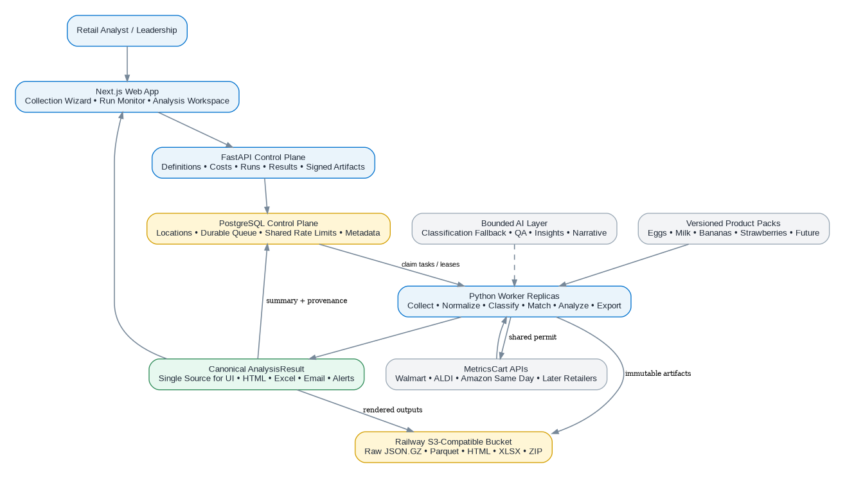

Service topology
Railway service | Responsibility
web | Next.js UI: collection wizard, run monitor, analysis workspace, report viewer
api | FastAPI control plane: auth, definitions, costs, runs, results, signed artifact access
worker | Python replicas: collection, normalization, classification, matching, analytics, exports
scheduler | Enqueue due definitions; can reuse worker image
postgres | Locations, durable queue, shared rate limit state, summaries, metadata, audit
bucket | Immutable raw JSON.GZ, Parquet datasets, HTML/XLSX/ZIP exports

V1 simplification
Do not add Redis at the start. PostgreSQL already provides the durable queue, leases, shared rate-limit coordination, run state, and auditability we need. Add Redis only after measured evidence shows a benefit.

3. Canonical Workflow
- Raw API responses are persisted before transformation so the analysis can always be reproduced.
- Normalized offers provide one retailer-independent representation of price, product identity, location, availability, pickup, and shipping.
- Product Packs define category scope, attributes, matching profiles, normalization, QA rules, and forbidden metrics.
- The immutable AnalysisResult is the only authoritative input to UI/report/email/alert renderers.

4. Location Master
Retailer/provider | Locations | Unique stores | Normalized ZIPs | Countries
Walmart | 4,683 | 4,683 | 4,190 | USA:4683
ALDI | 2,627 | 2,627 | 2,499 | USA:2627
kroger | 2,668 | 2,668 | 1,072 | USA:2667, (blank):1
Target | 2,148 | 2,148 | 2,079 | USA:2023, Australia:124, (blank):1
Safeway | 927 | 927 | 804 | USA:927
Albertsons | 753 | 753 | 339 | USA:753
H-E-B | 365 | 365 | 295 | USA:365

Normalization requirements
- Store_No and mc_location_id are strings; never cast provider/store identifiers to integers.
- For USA/PR numeric ZIP values shorter than five digits, left-pad with zeros to five characters.
- Retailer universe selection must include country; provider name alone is insufficient (e.g. Target includes USA and Australia).
- Preserve raw values alongside normalized values for auditability.
Important edge case
Target rows include USA and Australia in the same Provider value. Retailer-universe expansion must use canonical retailer + country. Store numbers and ZIPs are strings; leading zeros are meaningful.

5. MetricsCart Collection Layer

Enabled V1 endpoints
Retailer | Endpoint | Location grain | Credits/page | V1 status
Walmart US | /mc/walmart/search/zipcode/v2 | Store + ZIP | 1 | Enabled
ALDI US | /mc/new_aldi/serp/zipcode | Store + ZIP | 2 | Enabled
Amazon Same Day | /mc/amazon/search/zipcode/ | ZIP | 2 | Enabled
Kroger | /mc/kroger/search/zipcode | Store + ZIP | 3 | Catalogued
Target | /mc/target/search/zipcode | Pending verification | 4 | Disabled until verified
H-E-B | /mc/heb/serp/zipcode | Store + ZIP | 1 | Catalogued
Albertsons | /mc/albertsons/serp/zipcode | Store + ZIP | 2 | Catalogued
Safeway | /mc/safeway/serp/zipcode | Store + ZIP | 2 | Catalogued

Shared provider controls
- Provider key remains server-side and is passed as x-api-key query parameter only by the provider client.
- Provider cap: 3 RPS / 180 RPM; application defaults conservatively to 2 RPS / 108 RPM globally per credential.
- 429 responses become retryable rate_limit failures and update one shared paused_until state for all worker replicas.
- Products may appear under results, items, products, result.results, result.items, data.results, data.items, or data; generic extraction handles all supplied shapes.
- Credits are counted on successful 2xx pages; cost estimate is location units × max pages × retailer credit rate.

One-page strawberry collection estimate
Retailer | Location units | Credits/page | Estimated pages | Estimated credits
Walmart | 4,683 | 1 | 4,683 | 4,683
ALDI | 2,627 | 2 | 2,627 | 5,254
Amazon Same Day | 4,190 Walmart ZIPs | 2 | 4,190 | 8,380
TOTAL |  |  | 11,500 | 18,317

6. Durable Queue and Worker Safety
- Each collection task is identified by run + retailer + location scope + page + request fingerprint.
- A unique database constraint prevents duplicate logical tasks.
- Workers claim tasks transactionally with FOR UPDATE SKIP LOCKED, assign worker ID, lock time, and lease expiry.
- Expired leases can be reclaimed after worker failure.
- Run cancellation prevents new claims while retaining already collected immutable evidence.
- Actual credits are applied idempotently only once for a successful billable page.
Why this matters
The previous Search Monitor design correctly identified that process-local throttles become unsafe when Railway replicas scale. The standalone app solves that from V1 with a shared Postgres permit/cooldown state.

7. Product Pack Architecture
Product Pack | Primary unit problem | Critical attributes / modes | Important guardrail
Fresh Shell Eggs | Count/package | count, size, grade, color, organic, housing, brand | Price/dozen only after valid product match
Fresh Fluid Milk | Volume/package | volume, fat %, flavor, organic, lactose-free, ultrafiltered, A2, brand | Exact package size; keep same-brand, private-label, and equivalent modes separate
Fresh Bananas | Each vs weight/bunch | organic, variety, each/lb, bunch count, brand | do not equate each-price gap with weight economics
Fresh Strawberries | Package weight | weight, organic, form, specialty, brand | do not invent price per strawberry without count

Core rule
A new category should be added by publishing a new Product Pack. If common engine code begins accumulating category-name conditionals, the abstraction has failed and should be redesigned.

8. AI Agent Boundaries
Agent | Allowed | Forbidden
Classification fallback | Resolve ambiguous inclusion/attributes with structured confidence/evidence | Authoritative prices, counts, medians, unit conversions
Comparison QA | Recommend reject/review for suspicious matches | Silently rewrite comparison values
Insight | Rank validated findings and implications | Create new unsupported statistics
Narrative/report | Write leadership prose from AnalysisResult | Recalculate analytics independently

Default operating mode
AI can be feature-gated. Deterministic rules plus human review must remain a viable path if AI is disabled or unavailable.

9. Data Model
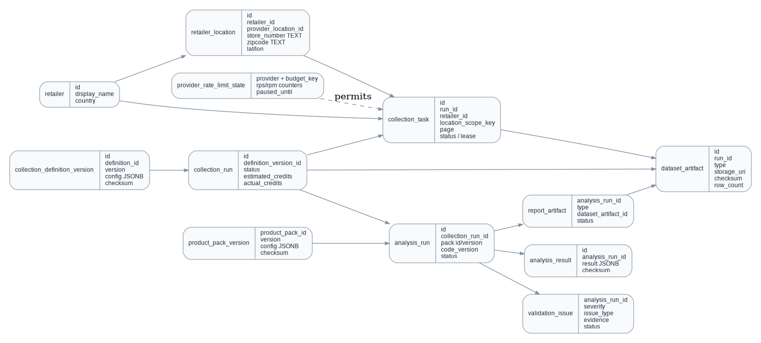

Storage strategy
- PostgreSQL stores control-plane state, not every heavy analytical row.
- Raw pages, normalized/classified offers, match detail, and exports are immutable object artifacts; Parquet is the preferred analytical format.
- AnalysisResult stores summary truth and provenance, including Product Pack version, collection definition version, artifact checksums, analytics build SHA, and AI metadata.

10. Application UX

Primary navigation
Area | Functions
Dashboard | Recent runs, failures, provider usage, major active alerts
Collections | New Collection, definitions, run history, scheduling
Analyses | Current/historical analyses, compare runs
Product Packs | Versions and configuration viewer
Reports | HTML, Excel, leadership email, audit package
Data Quality | Collection coverage, classification QA, match quality, API errors
Admin | Retailer adapters, location master, usage/credits, users/settings

New Collection wizard
1. What to analyze
2. Geography
3. Collection depth
4. Cost estimate
5. Analysis options
6. Review & Run

11. Golden Regression Strategy
Category | Validated source rows | What it stress-tests
Eggs | 386,889 | count/size/claims, many competitors, strict vs relaxed matching
Milk | 348,980 | volume, specialty claims, same-brand/private-label/equivalent modes
Bananas | 168,440 | each vs $/lb, bunch counts, variety/type
Strawberries | 297,443 | exact package weight, $/lb, organic, proximity sensitivity

Strawberry headline acceptance checks
- Walmart lower in 2,775 of 2,776 strict ALDI same-weight matches (99.96%).
- ALDI 10-mile validation: Walmart lower in 5,236 of 5,237 store/product matches.
- Amazon 1 lb conventional: Amazon lower in about 69.4% of 630 exact ZIP matches.
- Amazon 2 lb conventional: Walmart lower in about 94.2% of 497 exact ZIP matches.
- Amazon 1 lb organic: about 70.2% parity within the validated tolerance.
Regression policy
A changed golden metric can be legitimate, but it requires an explicit benchmark/version update with old/new values and evidence that the new method is more correct. Never silently drift.

12. Codex Build Sequence
Phase | Focus | Exit condition
Phase 0 | Repository foundation | Monorepo, pinned dependencies, migrations, CI, schema validation.
Phase 1 | Location Master | Import 157,806 rows, normalize ZIP/country/aliases, expose counts/search.
Phase 2 | Collection Control Plane | Definitions, estimates, runs, Postgres queue, leases, fake provider.
Phase 3 | MetricsCart Adapters | Walmart, ALDI, Amazon Same Day; raw persistence; shared throttling; retries.
Phase 4 | Strawberry Runtime | Canonical offers, Product Pack loading, classification, Parquet.
Phase 5 | Analytics & Validation | Strict/$lb/proximity matching, AnalysisResult, full golden regression.
Phase 6 | UI & Deliveries | Run monitor, analysis tabs, HTML/XLSX/email/audit renderers.
Phase 7 | Railway Production | Services, bucket, migrations, health, safe worker scaling.
Phase 8 | Prove Abstraction | Eggs, milk, bananas; audit product-specific code paths.
Phase 9 | Automation | Schedules, alerts, historical compare, budgets, email delivery.

How to start Codex
1. Create a new Git repository and place the handoff package at the root.
2. Have Codex read AGENTS.md before any implementation task.
3. Send prompts/00_CODEX_MASTER_PLANNING_PROMPT.md and explicitly require plan-only output.
4. Review/approve the repo plan, then execute the numbered phase prompts in order.
5. Attach the full strawberry raw datasets when Phase 5 is ready for full regression; later attach eggs, milk, and bananas.

13. Security and Operations
- API keys, database credentials, and object-storage secrets remain server-side Railway environment variables.
- Bucket is private by default; downloads use short-lived signed URLs.
- Structured logs contain run/task/retailer/location/page/worker/attempt but redact x-api-key.
- Roles: Admin, Analyst, Viewer.
- Monitor 429s, retries, task lease expiry, queue latency, provider latency, actual/estimated credits, classification review rates, match rates, QA blockers, artifact failures.

14. Open Items That Are Not Build Blockers
- Target ZIP endpoint needs one live verification because the newer catalog conflicts with an older snapshot.
- Exact provider page-size/has-more semantics were not supplied; V1 uses explicit max pages and stop-on-empty rather than guessing.
- Credits/page are known, but a credit-to-dollar conversion was not supplied. Track credits first; add dollar cost when an authoritative conversion is provided.
- Final product name/branding can be decided after the functional vertical slice is proven.

15. Package Inventory
- Normative schemas and examples.
- Four versioned reference Product Packs.
- Full location master plus normalization profile.
- Walmart, ALDI, Amazon response fixtures and 429 example.
- Retailer endpoints/credits catalog.
- PostgreSQL control-plane schema and safe queue-claim reference SQL.
- Four validated regression summaries and prior HTML/Excel outputs.
- Codex master planning prompt plus nine implementation-phase prompts.
- AGENTS.md architectural guardrails and README startup instructions.
Recommended next action
Give Codex the entire ZIP, have it unpack into a new repository, then send only the Master Planning Prompt first. Do not start by asking it to build the app in one large pass.

