AI-A01

Enterprise AI Reference Architecture
Day 1 Project Guide • Version 1.0 • 2 November 2026
Why we did it • What we did • How we did it
Project directory: /home/ai24/development/ai-projects/a-01-enterprise-ai-architecture
Status: Day 1 architecture documentation created and committed locally. GitHub repository created; remote push has not been confirmed in the conversation.

1. Executive summary
AI-A01 establishes a reusable enterprise architecture baseline for an eight-project AI architecture portfolio. Rather than building a monolithic platform, it defines layers, interfaces, cross-cutting controls, an open-source-first technology approach and a minimal vertical-slice prototype for subsequent implementation.
The project is scoped to three working days. Day 1 covers requirements, context and container diagrams, technology choices, architecture decisions and Git version control. Days 2–3 are planned implementation, testing and documentation activities—not completed results.

2. Why we undertook the project
- Create a consistent framework for AI agents, orchestration, model inference, enterprise data and integration.
- Make governance and operationalization explicit architectural concerns, rather than additions after deployment.
- Provide a shared baseline for A02–A08, with separate deeper projects for agent coordination, RAG, MCP, policy, digital twins, AgentOps and platform operations.
- Demonstrate practical architecture skills with inspectable diagrams, rationale, open-source tooling and reproducible commands.

3. Project scope and success criteria
Area | Day 1 result / future scope
Architecture model | Seven central layers plus two cross-cutting pillars; infographic saved locally
C4 Level 1 | System context source and PNG produced
C4 Level 2 | Container source produced and locally rendered with Mermaid CLI
Requirements | docs/01-architecture-requirements.md created
Technology stack | docs/02-technology-stack.md created
ADRs | Six proposed ADR documents created
Prototype | Planned for Day 2
Runtime/security validation | Planned for Day 3

4. Seven-layer reference model
Layer | Capability | Illustrative open-source stack
1 | Business experiences & channels | Open WebUI, Chainlit, Streamlit, FastAPI
2 | Agent applications | Python, LangChain, CrewAI, AutoGen
3 | Orchestration & A2A | LangGraph, Temporal; A2A as interoperability protocol
4 | Model gateway & inference | LiteLLM, Ollama, vLLM, llama.cpp
5 | Knowledge, memory & state | PostgreSQL, pgvector, Qdrant, Neo4j
6 | Enterprise integration | FastAPI, MCP, Kafka, n8n
7 | Data foundations & platforms | PostgreSQL, MinIO, DuckDB
Cross-cutting pillar A — Operationalization: deployment, CI/CD, evaluation, monitoring, reliability and cost control. Examples: Docker, Kubernetes, OpenTelemetry, Prometheus, Grafana, MLflow.
Cross-cutting pillar B — Security, Governance & Auditability: identity, secrets, authorization, guardrails, human approval and audit trail. Examples: Keycloak, Vault, Open Policy Agent and Trivy.
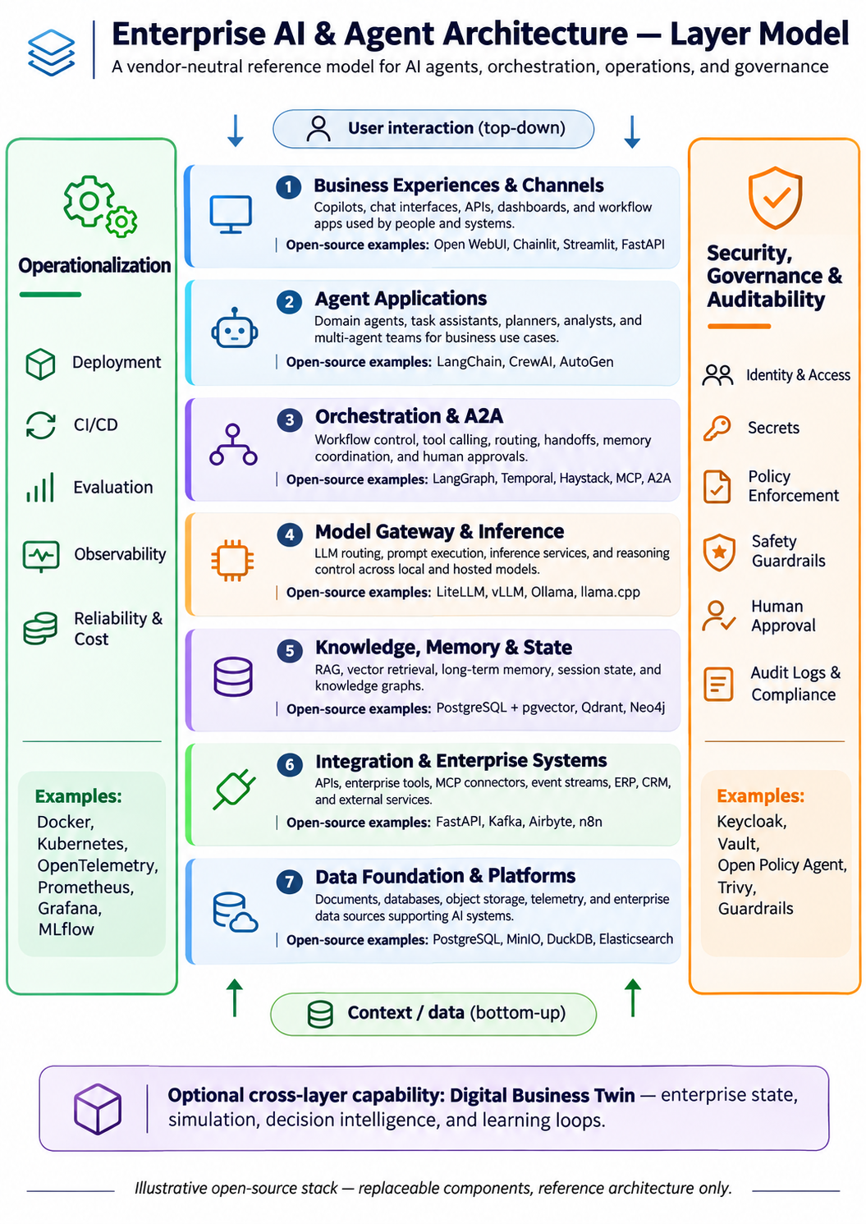
Figure 1. Seven-layer model with operationalization and security/governance pillars.

5. C4 Level 1 — System context
Purpose: describe the Enterprise AI Platform as a single bounded system, its users and the external systems on which it depends. Agents and framework internals are intentionally hidden at this level.
External actor/system | Relationship
Business user | Submits requests and receives recommendations with evidence
Platform operations team | Administers and monitors platform
Enterprise systems | Provide synthetic ERP/CRM operational information
Knowledge sources | Provide policies and reference documents
Model inference service | Local inference via Ollama
Identity provider | Authentication and identity context
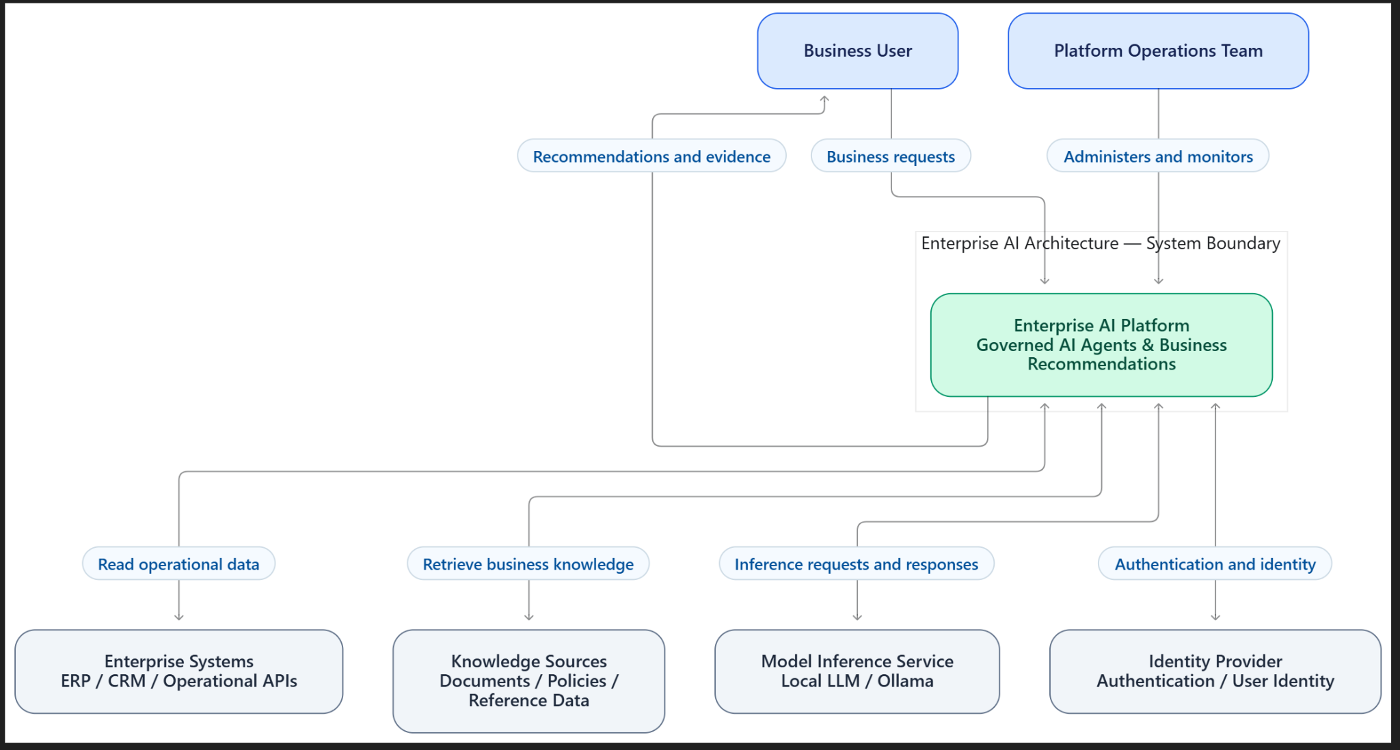
Figure 2. User-provided screenshot of the rendered system context diagram.

6. C4 Level 2 — Container architecture
Purpose: show logical deployable components inside the platform, recognizing that multiple conceptual services can initially share one Python process. Components: Web Interface/API; Agent Application; LangGraph Orchestration; LiteLLM Gateway; RAG Service; Enterprise Integration Service; Policy Enforcement; OpenTelemetry Observability; PostgreSQL/pgvector State and Knowledge. External dependencies: Ollama, synthetic ERP/CRM, documents and identity provider.
Key design constraint: policy must be checked at the tool execution boundary before any enterprise action. Authorization must not rely solely on model-generated text or prompt instructions. Runtime observability and error capture must cover sensitive-data redaction.
flowchart TB
User["Business User"] --> UI["Web Interface / API"]
subgraph Platform["Enterprise AI Platform"]
UI --> Agent["Agent Application"] --> Orch["LangGraph Orchestration"]
Orch --> Gateway["LiteLLM Gateway"]
Orch --> RAG["Knowledge Retrieval"]
Orch --> Integration["Enterprise Integration"]
Orch --> State[("PostgreSQL + pgvector")]
RAG <--> State
Integration --> Policy["Authorization / Policy"]
Orch -.-> Obs["OpenTelemetry"]
end
Gateway --> LLM["Ollama"]
Integration --> ERP["Synthetic ERP API"]
RAG --> Docs["Enterprise Documents"]
The above is a compact explanatory excerpt; the authoritative full diagram is diagrams/a01-c4-container.mmd in the local repository.

7. Technology decisions
ADR | Decision | Main trade-off
001 | Open-source-first modular design | More integration work in exchange for portability
002 | LangGraph for orchestration | Explicit state; framework dependency
003 | Ollama + LiteLLM | Local models plus an extra gateway layer
004 | PostgreSQL + pgvector | Simple initial deployment; future vector-specialist option
005 | Independent policy enforcement | More policy plumbing; deterministic authorization
006 | OpenTelemetry tracing | Instrumentation overhead; interoperability
ADRs were created with “Proposed” status; they should not be called accepted until reviewed.

8. How we implemented Day 1

8.1 Directory and files
cd ~/development/ai-projects
mkdir -p a-01-enterprise-ai-architecture/{diagrams,docs,src,tests}
cd a-01-enterprise-ai-architecture
mkdir -p docs/adr
ls -lh diagrams/ docs/ docs/adr/
Files created: README.md, docs/01-architecture-requirements.md, docs/02-technology-stack.md, six ADR Markdown files, a01-layer-model.png and two Mermaid diagram sources and PNGs under diagrams/.

8.2 Render Mermaid locally under WSL2
Mermaid CLI initially reported “No mermaid charts found in Markdown input” because the source files contained raw Mermaid syntax with a .md extension. Renaming to .mmd resolved detection. Puppeteer raised a post-install warning, but the subsequent diagram render completed successfully.
# Node installed through NVM; observed versions:
node --version # v26.13.0
npm --version # 11.20.0
npm install -g @mermaid-js/mermaid-cli

mv diagrams/a01-c4-container.md diagrams/a01-c4-container.mmd
mmdc -i diagrams/a01-c4-container.mmd -o diagrams/a01-c4-container.png -b white
explorer.exe "$(wslpath -w diagrams/a01-c4-container.png)"

mv diagrams/a01-c4-system-context.md diagrams/a01-c4-system-context.mmd
mmdc -i diagrams/a01-c4-system-context.mmd -o diagrams/a01-c4-system-context.png -b white

8.3 Windows Downloads to Ubuntu
ls -lt /mnt/c/Users/ai24/Downloads/*.png | head -10
cp "/mnt/c/Users/ai24/Downloads/mermaid-diagram (1).png" \
diagrams/a01-c4-system-context.png
ls -lh diagrams/
The original infographic was also copied from Windows Downloads and moved into diagrams/a01-layer-model.png.

8.4 Local Git and GitHub
git init -b main
# Create .gitignore, then:
git add .
git commit -m "AI-A01: initial enterprise AI reference architecture"
git status -sb
# Observed local commit: ed6796e

gh auth status
# GitHub repository created by:
gh repo create cpgrant/a-01-enterprise-ai-architecture --public --source=.
# Existing origin remote meant "Unable to add remote origin" was not fatal.
git push -u origin main
# Confirm push and tracking:
git status -sb
GitHub repository creation was confirmed by the CLI, but the final successful push was not shown in the supplied transcript. Verify before claiming repository publication.

9. Validation record and troubleshooting
Check | Evidence / status
File listing | Architecture docs, images and six ADRs confirmed via ls
Mermaid source | Source text displayed via cat and reviewed
Mermaid CLI | “Generating single mermaid chart” observed for container diagram
Git commit | ed6796e, main branch; clean working tree
GitHub repository | Created successfully as cpgrant/a-01-enterprise-ai-architecture
GitHub push | Unconfirmed in transcript
Running assistant prototype | Not yet implemented
Policy tests / traces | Not yet exercised
Other environment note: Ubuntu apt emitted duplicate Docker repository warnings; these were unrelated to the Mermaid rendering and Git work and may be addressed separately.

10. Planned Day 2 — Minimal working prototype
- Implement FastAPI request endpoint and synthetic ERP data endpoint.
- Create a deterministic LangGraph workflow with typed state and explicit steps.
- Call local Ollama via LiteLLM (or use a simpler adapter initially if setup becomes a time constraint).
- Add limited retrieval using seeded documents and PostgreSQL/pgvector where feasible.
- Enforce deny-by-default authorization at tool execution, not in natural-language instructions alone.
- Emit basic traces and return evidence-linked recommendations.

11. Planned Day 3 — Validation and publication
- Test permitted and prohibited enterprise tool calls, handling of missing data and model errors.
- Record logs/traces without leaking secrets or sensitive payloads.
- Document actual environment versions, exact commands and measured test outcomes.
- Review each ADR and accept/revise based on prototype evidence.
- Commit changes and confirm remote branch tracking before marking published.

12. Quick reference: repository and artifacts
GitHub target: https://github.com/cpgrant/a-01-enterprise-ai-architecture
Recommended location for this report: docs/AI-A01-Complete-Project-Guide-v1.0.docx
Keep Markdown and Mermaid source files as the editable source of truth. Update this Word report at meaningful milestones (Day 2 and Day 3) rather than overwriting design evidence.

