Statistics for Earth and Environmental Scientists

Homework #5

Handed out: Thursday, September 26 Due: Thursday, October 03, 11:59 p.m.

1. Answer the following (total of 100 points), Please make sure to write comments after every line of code. Not doing so may deduct points.

1. Upload the R script with your name (please save your scripts as Lab#5_your name or last name. (10 points)
2. Please paste the 4 plots into the Word file. Name them as plot1, plot2, plot3, plot4. (90 points)

**plot1**

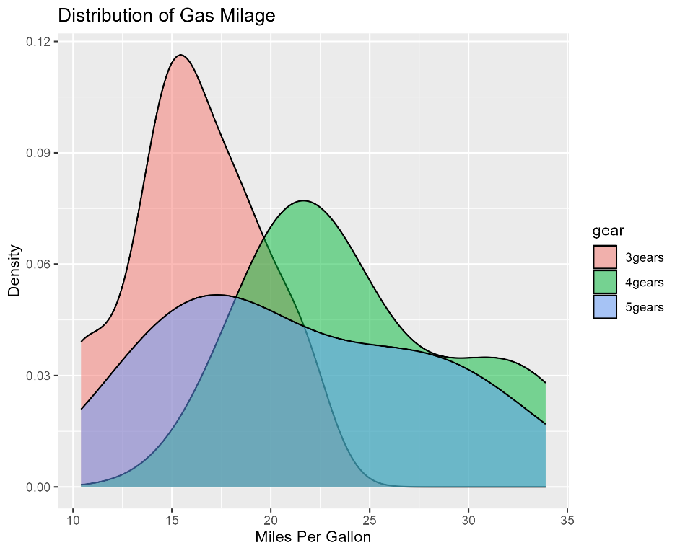

**plot2**

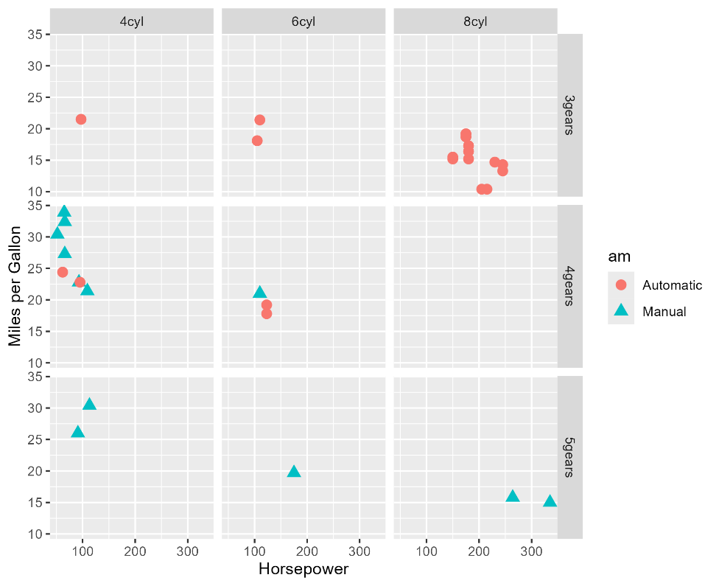

**plot3**

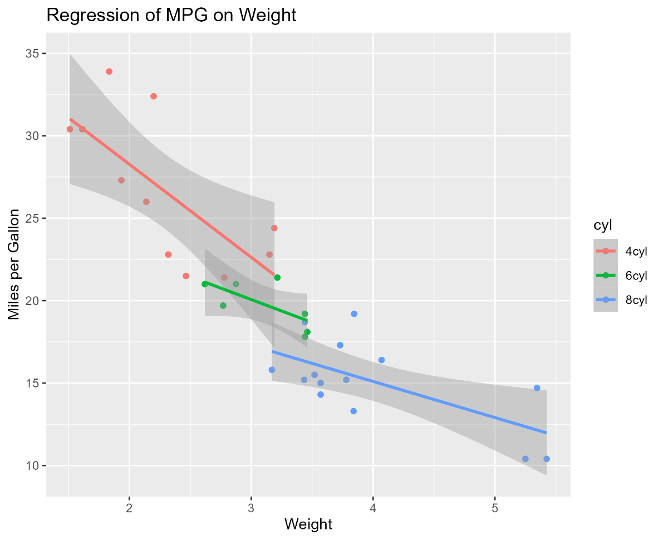

**plot4**

