Standard​ ​Text ​File

(e.g., for a transcription of a video-taped discussion)

The text file that is read into the CommandLineClassifier, main.cpp, should be formatted as follows:

# NUMBER

2 should be replaced by the number of ‘testing sessions’ pasted into the text file.



# HEADER

MVI_2, 2, TEST, ResearcherName1, and ResearcherName2 should be replaced by the session-specific details.

# QUESTION AND VERBAL RESPONSES

* It is recommended that prompting/clarifying question​s be labeled as Experimenter, but any non-participant ID will do
* Responses vary​ by​ the​ number​ of​ ​subjects​ in​ ​​each ​​session​ ​(can​ ​have​ ​subjects​ A-F,​ ​​but​ ​can also have​ any​ subset​ of​ ​these subjects)
* Each​ *verbal* ​response​ ​ends​ ​in​ ​punctuation​ and​ ​​is​ ​surrounded​ ​by​ ​“”
* Each response​ is transcribed exactly as heard (including ​ contractions, ​slang, etc.)​
* Keep in mind, each response will need to be rated by CommandLineClassifier users as one of the following, according to the criteria set forth by the project manager in the question body:
  + -1​ ​=​ ​anti​/negative
  + 0​ ​=​ ​neutral
  + 1 ​ =​ ​ pro​/affirmative

# QUESTION AND NONVERBAL RESPONSES

* Each​ *nonverbal* ​response​ ​ends​ is encapsulated by ()

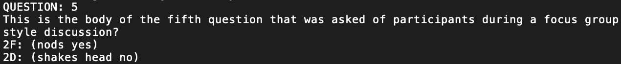

# END OF FILE

EOF should be the last line of the text file.

