**About Recipes**

A recipe is the most fundamental configuration element within the organization. A recipe:

* Is authored using Ruby, which is a programming language designed to read and behave in a predictable manner
* Must define everything that is required to configure part of a system
* Must be stored in a cookbook
* May use the results of a search query and read the contents of a data bag (including an encrypted data bag)
* May have a dependency on one (or more) recipes
* May tag a node to facilitate the creation of arbitrary groupings
* Must be added to a run-list before it can be used by the chef-client
* Is always executed in the same order as listed in a run-list

**Recipe Attributes**

An attribute can be defined in a cookbook (or a recipe) and then used to override the default settings on a node. When a cookbook is loaded during a chef-client run, these attributes are compared to the attributes that are already present on the node. Attributes that are defined in attribute files are first loaded according to cookbook order. For each cookbook, attributes in the default.rb file are loaded first, and then additional attribute files (if present) are loaded in lexical sort order. When the cookbook attributes take precedence over the default attributes, the chef-client will apply those new settings and values during the chef-client run on the node.

Note

Attributes can be configured in cookbooks (attribute files and recipes), roles, and environments. In addition, Ohai collects attribute data about each node at the start of the chef-client run. See <https://docs.chef.io/attributes.html> for more information about how all of these attributes fit together.

**Attribute Types**[**¶**](https://docs.chef.io/recipes.html#attribute-types)

The chef-client uses six types of attributes to determine the value that is applied to a node during the chef-client run. In addition, the chef-client sources attribute values from up to five locations. The combination of attribute types and sources allows for up to 15 different competing values to be available to the chef-client during the chef-client run:

| **Attribute Type** | **Description** |
| --- | --- |
| default | A default attribute is automatically reset at the start of every chef-client run and has the lowest attribute precedence. Use default attributes as often as possible in cookbooks. |
| force_default | Use the force_default attribute to ensure that an attribute defined in a cookbook (by an attribute file or by a recipe) takes precedence over a default attribute set by a role or an environment. |
| normal | A normal attribute is a setting that persists in the node object. A normal attribute has a higher attribute precedence than a default attribute. |
| override | An override attribute is automatically reset at the start of every chef-client run and has a higher attribute precedence than default, force_default, and normal attributes. An override attribute is most often specified in a recipe, but can be specified in an attribute file, for a role, and/or for an environment. A cookbook should be authored so that it uses override attributes only when required. |
| force_override | Use the force_override attribute to ensure that an attribute defined in a cookbook (by an attribute file or by a recipe) takes precedence over an override attribute set by a role or an environment. |
| automatic | An automatic attribute contains data that is identified by Ohai at the beginning of every chef-client run. An automatic attribute cannot be modified and always has the highest attribute precedence. |

**Attribute Persistence**

At the beginning of a chef-client run, all attributes are reset. The chef-client rebuilds them using automatic attributes collected by Ohai at the beginning of the chef-client run and then using default and override attributes that are specified in cookbooks or by roles and environments. Normal attributes are never reset. All attributes are then merged and applied to the node according to attribute precedence. At the conclusion of the chef-client run, the attributes that were applied to the node are saved to the Chef server as part of the node object.

**Attribute Precedence**

Attributes are always applied by the chef-client in the following order:

1. A default attribute located in a cookbook attribute file
2. A default attribute located in a recipe
3. A default attribute located in an environment
4. A default attribute located in a role
5. A force_default attribute located in a cookbook attribute file
6. A force_default attribute located in a recipe
7. A normal attribute located in a cookbook attribute file
8. A normal attribute located in a recipe
9. An override attribute located in a cookbook attribute file
10. An override attribute located in a recipe
11. An override attribute located in a role
12. An override attribute located in an environment
13. A force_override attribute located in a cookbook attribute file
14. A force_override attribute located in a recipe
15. An automatic attribute identified by Ohai at the start of the chef-client run

where the last attribute in the list is the one that is applied to the node.

Note

The attribute precedence order for roles and environments is reversed for default and override attributes. The precedence order for default attributes is environment, then role. The precedence order for override attributes is role, then environment. Applying environment override attributes after role override attributes allows the same role to be used across multiple environments, yet ensuring that values can be set that are specific to each environment (when required). For example, the role for an application server may exist in all environments, yet one environment may use a database server that is different from other environments.

Attribute precedence, viewed from the same perspective as the overview diagram, where the numbers in the diagram match the order of attribute precedence:

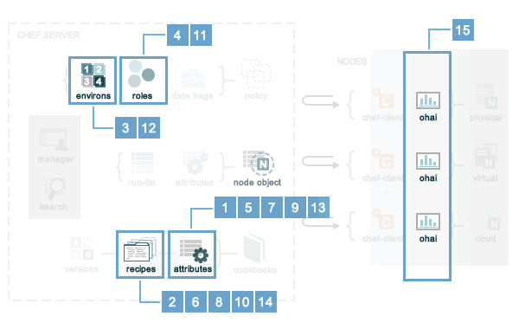

Attribute precedence, when viewed as a table:

