|  |
| --- |
|  |
| Cornfed Coworking |
| Website Layout Documentation |
|  |
| **[Craig Phephles]** |
| **12/27/2016** |

[Type the abstract of the document here. The abstract is typically a short summary of the contents of the document. Type the abstract of the document here. The abstract is typically a short summary of the contents of the document.]

Table of Contents

[To update the table of contents, right click the message below and select Update Field (F9 on PC, ⌥⌘U on Mac).]

**No table of contents entries found.**

1. Pages
   1. Page Tree

Home  
 ABOUT  
 FEATURES  
 MEMBERSHIP  
 EVENTS  
 RESERVATION

* 1. Home
     1. User Interface

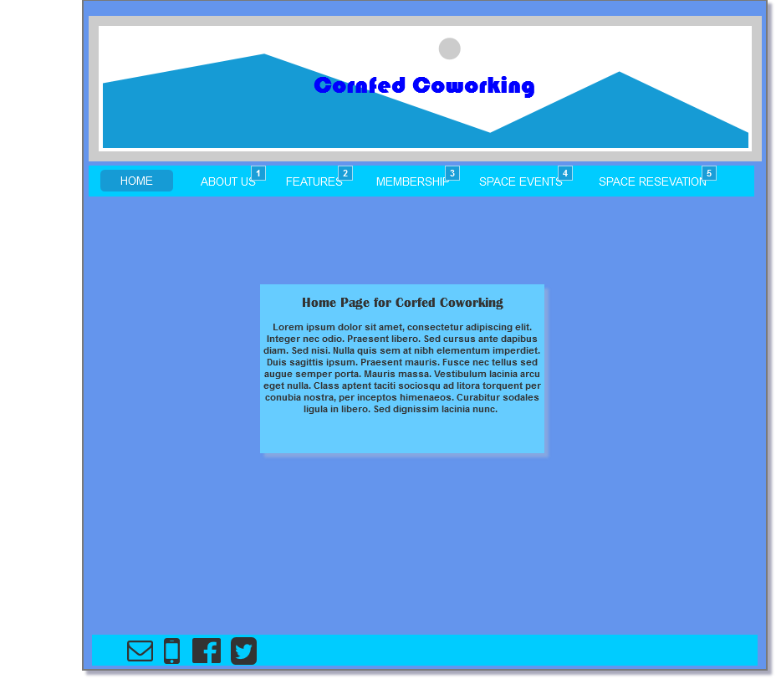

* + 1. Widget Table

|  |  |
| --- | --- |
| Footnote | Interactions |
| 1 | OnClick:  Case 1:  Open ABOUT in Current Window |
| 2 | OnClick:  Case 1:  Open FEATURES in Current Window |
| 3 | OnClick:  Case 1:  Open MEMBERSHIP in Current Window |
| 4 | OnClick:  Case 1:  Open EVENTS in Current Window |
| 5 | OnClick:  Case 1:  Open RESERVATION in Current Window |

* 1. ABOUT
     1. User Interface

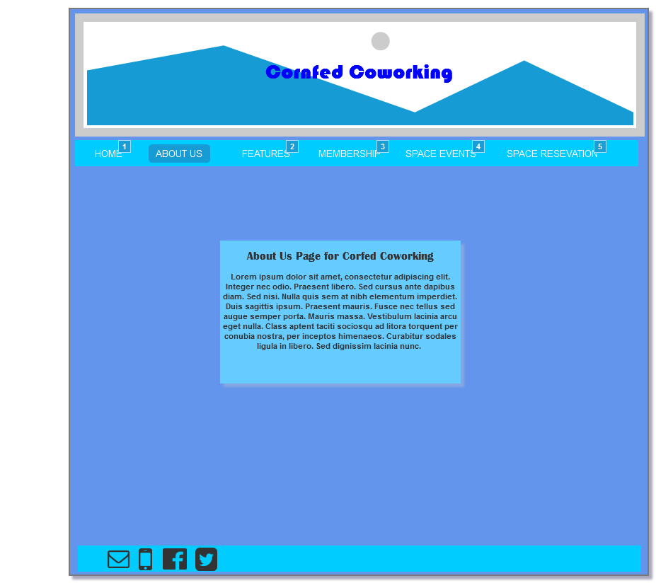

* + 1. Widget Table

|  |  |
| --- | --- |
| Footnote | Interactions |
| 1 | OnClick:  Case 1:  Open Home in Current Window |
| 2 | OnClick:  Case 1:  Open FEATURES in Current Window |
| 3 | OnClick:  Case 1:  Open MEMBERSHIP in Current Window |
| 4 | OnClick:  Case 1:  Open EVENTS in Current Window |
| 5 | OnClick:  Case 1:  Open RESERVATION in Current Window |

* 1. FEATURES
     1. User Interface

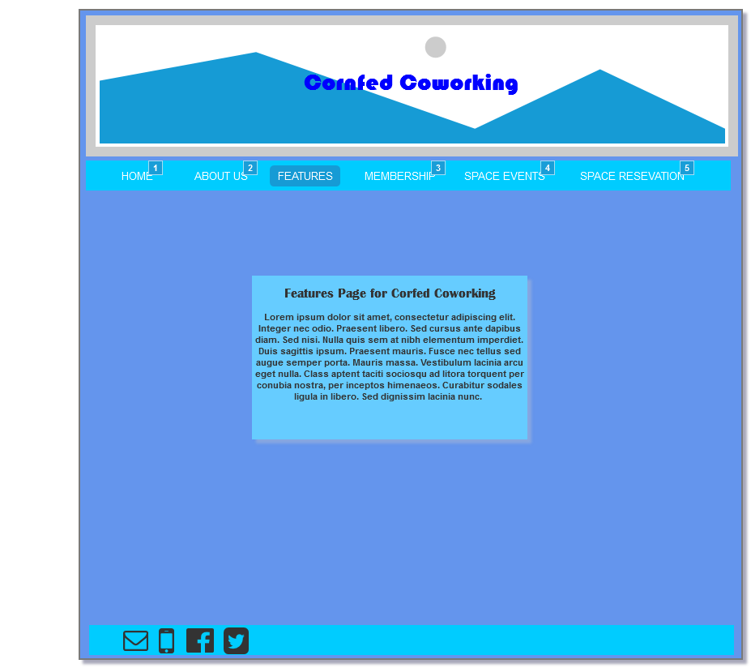

* + 1. Widget Table

|  |  |
| --- | --- |
| Footnote | Interactions |
| 1 | OnClick:  Case 1:  Open Home in Current Window |
| 2 | OnClick:  Case 1:  Open ABOUT in Current Window |
| 3 | OnClick:  Case 1:  Open MEMBERSHIP in Current Window |
| 4 | OnClick:  Case 1:  Open EVENTS in Current Window |
| 5 | OnClick:  Case 1:  Open RESERVATION in Current Window |

* 1. MEMBERSHIP
     1. User Interface

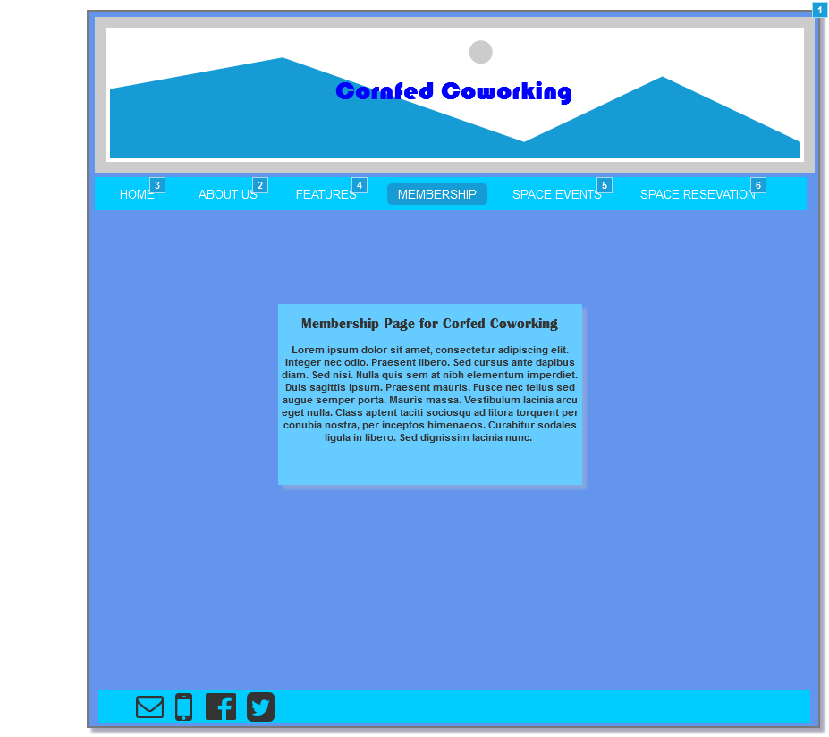

* + 1. Widget Table

|  |  |
| --- | --- |
| Footnote | Interactions |
| 1 | OnClick:  Case 1:  Open Home in Current Window |
| 2 | OnClick:  Case 1:  Open ABOUT in Current Window |
| 3 | OnClick:  Case 1:  Open Home in Current Window |
| 4 | OnClick:  Case 1:  Open FEATURES in Current Window |
| 5 | OnClick:  Case 1:  Open EVENTS in Current Window |
| 6 | OnClick:  Case 1:  Open RESERVATION in Current Window |

* 1. EVENTS
     1. User Interface

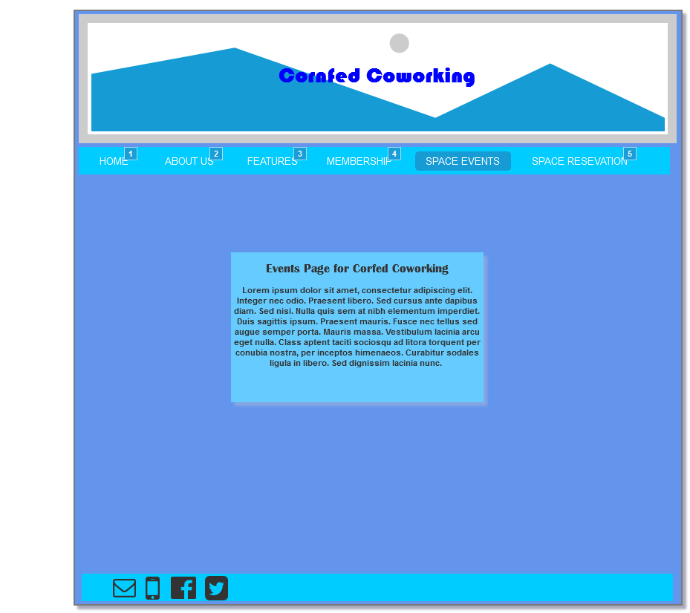

* + 1. Widget Table

|  |  |
| --- | --- |
| Footnote | Interactions |
| 1 | OnClick:  Case 1:  Open Home in Current Window |
| 2 | OnClick:  Case 1:  Open ABOUT in Current Window |
| 3 | OnClick:  Case 1:  Open FEATURES in Current Window |
| 4 | OnClick:  Case 1:  Open MEMBERSHIP in Current Window |
| 5 | OnClick:  Case 1:  Open RESERVATION in Current Window |

* 1. RESERVATION
     1. User Interface

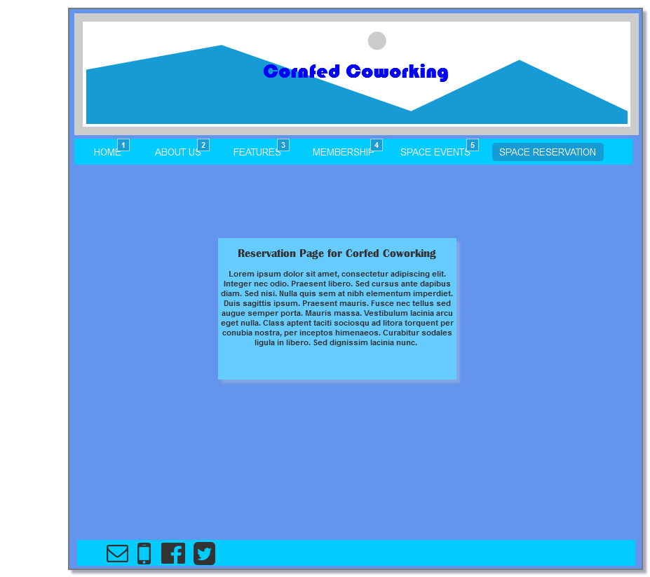

* + 1. Widget Table

|  |  |
| --- | --- |
| Footnote | Interactions |
| 1 | OnClick:  Case 1:  Open Home in Current Window |
| 2 | OnClick:  Case 1:  Open ABOUT in Current Window |
| 3 | OnClick:  Case 1:  Open FEATURES in Current Window |
| 4 | OnClick:  Case 1:  Open MEMBERSHIP in Current Window |
| 5 | OnClick:  Case 1:  Open EVENTS in Current Window |