Screenshot 1: Base case (n==1)

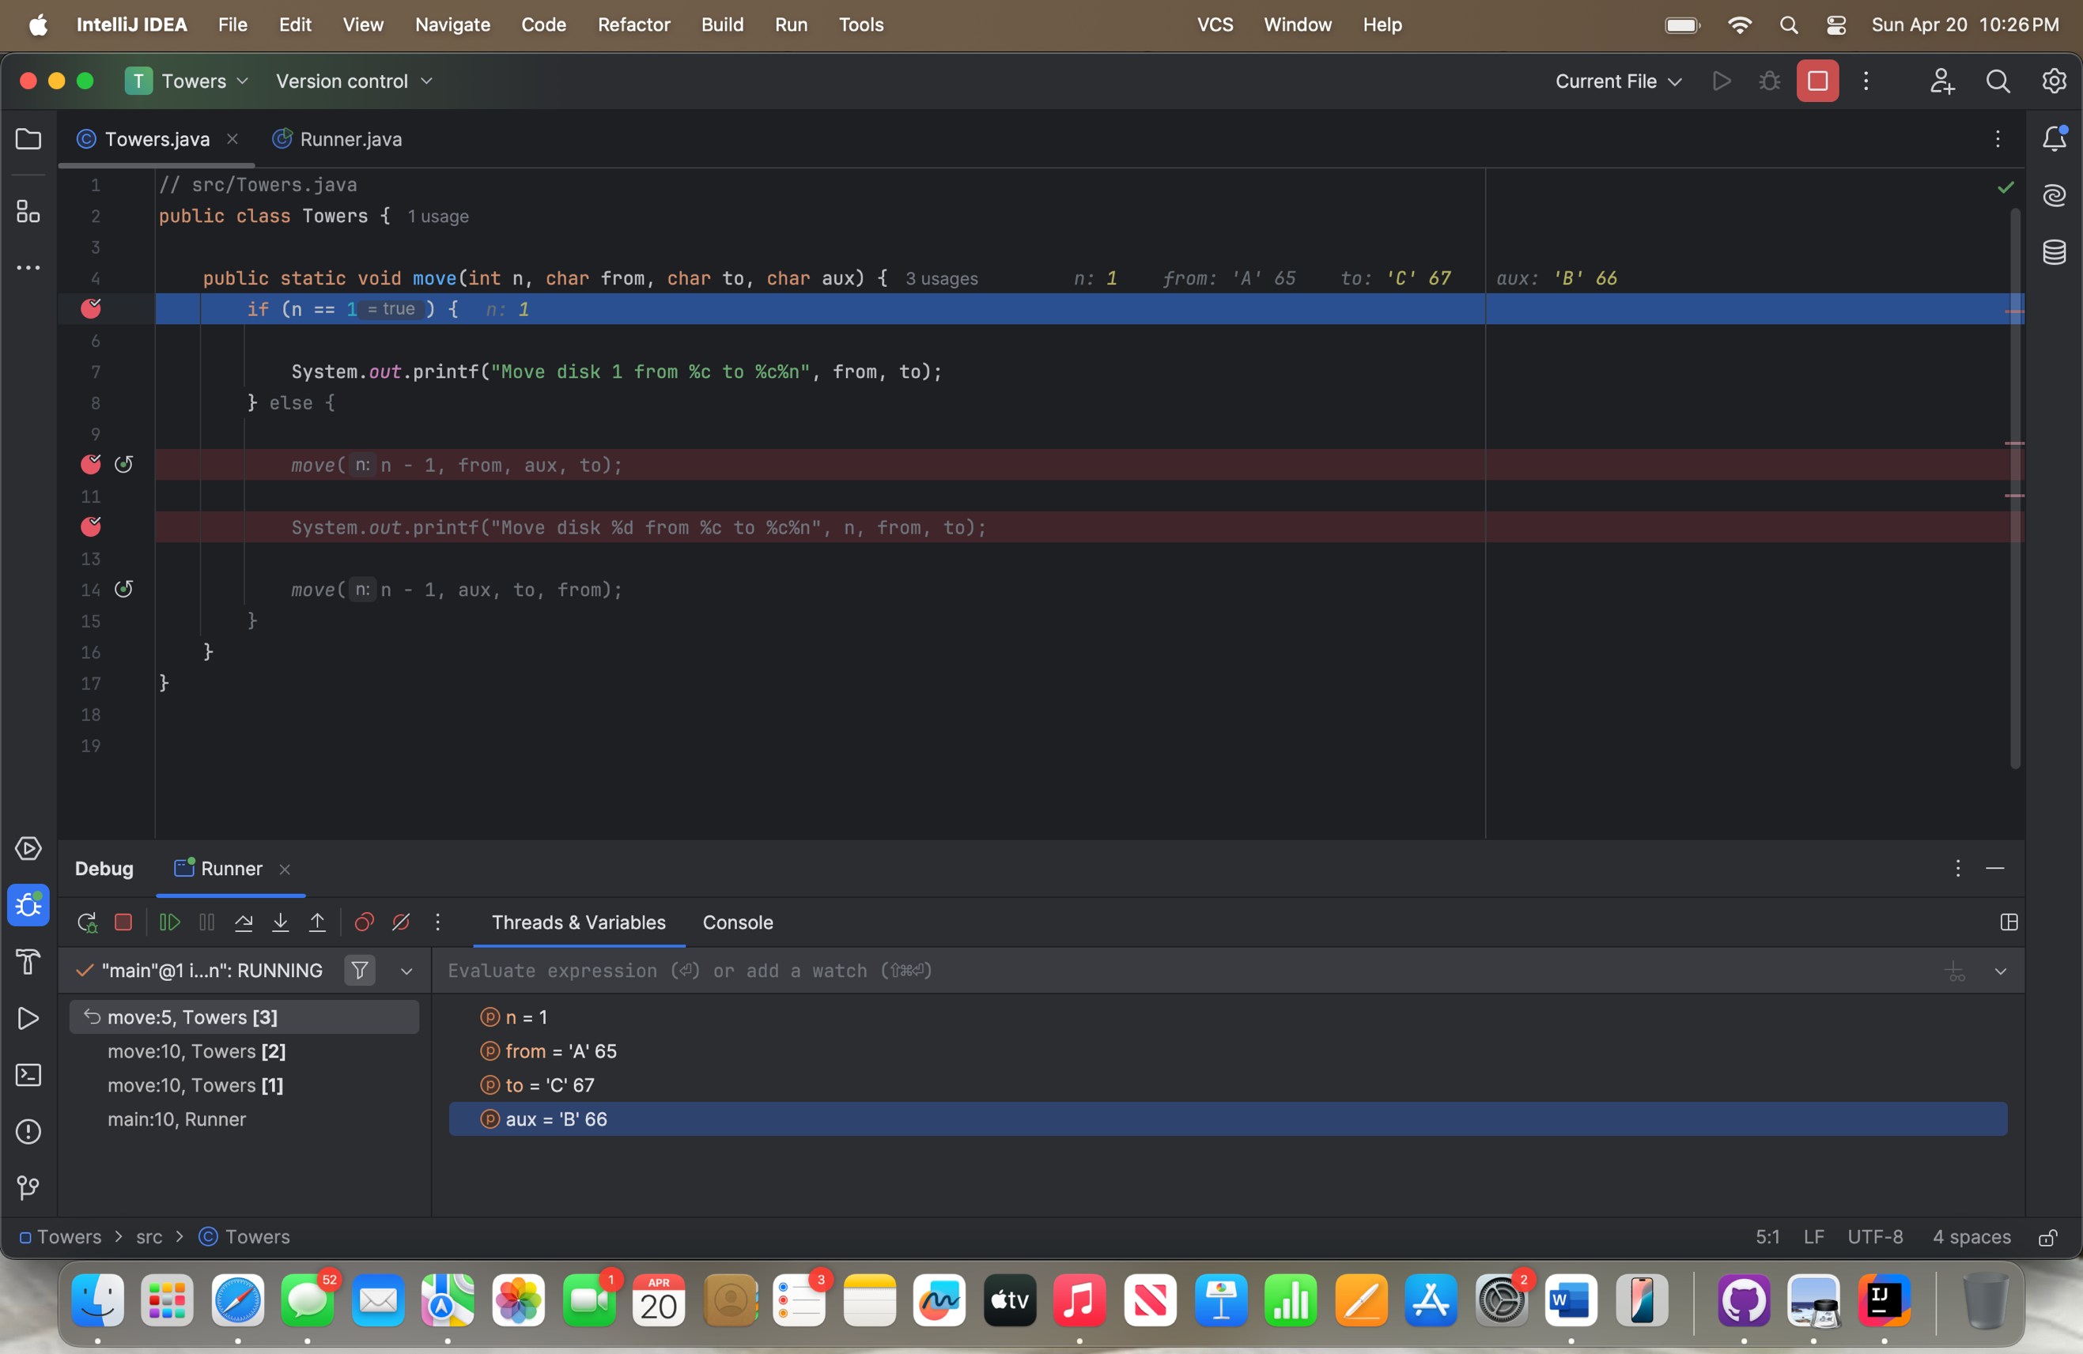

Screenshot 2: Before Recursive Call (n== 2)

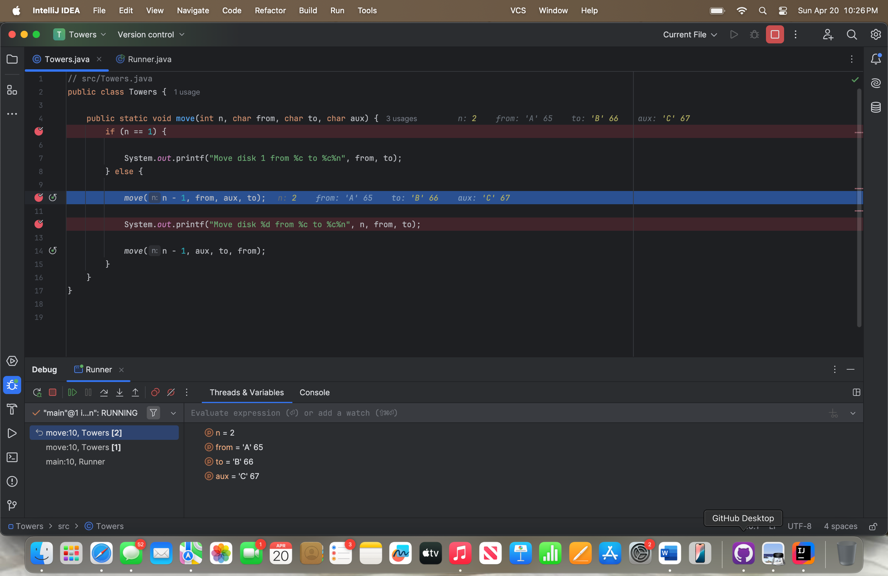

Screenshot 3: After Returning from Recursive Call (n == 2)

