Getting to Know Your Computer
The purpose of these exercises is to become comfortable navigating and managing your computer. Complete the exercises on your own computer.

Exercise 1 – Find your way around
Open the file manager on your computer.
Windows: File Explorer
Mac: Finder
Find these locations:
- Your Desktop
- Your Documents folder
- Your Downloads folder
Questions
- Where are files that you download from the internet normally stored?
- How can you change between viewing files as icons and viewing them as a list?
- Download the file test.R from DALE26 and open it with a texteditor
  - Add “print(‘hello world’)” and save it
- After you have installed R find this file on your computer - Rscript
- Make sure your Finder (Mac) or Stifinder has (Win) the “home” of the user in the left pane
Mac | Windows
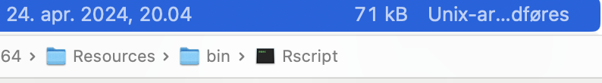 | 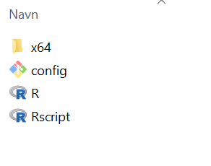
Dette er for brugeren “thor”  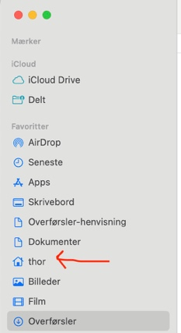 | Dette er for brugeren “test”  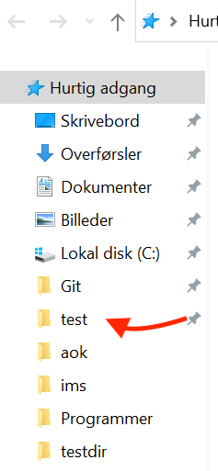

Exercise 2 – Create folders
Go to your Documents folder.
Create a new folder called:
DALprojects
Inside it, create three folders:
Data
R
Notes
Your folder structure should now look like this:
DALProjects
├── Data
├── R
└── Notes
Figure out how to rename the folder Notes to:
Docs

Exercise 3 – Create, copy, move and delete a file
Find the test.R file on your computer. If you cannot see the extension .R, figure out how to make your computer show file extensions. This is very important!
- Copy it into ComputerExercise.
- Make a second copy of the file.
- Move one copy into Data.
- Move the other copy into Documentation.
- Delete the copy in Documentation.
Find your computer's Recycle Bin / Trash and restore it.

Exercise 4 – Search for a file
Use your computer's search function to find the file you restored in Exercise 3.
Try searching using:
- the complete filename
- only part of the filename
- the file extension, for example .R
Challenge: Can you find all R files on your computer?

Exercise 5 – What is running on your computer?
Open the tool that shows the programs and processes currently running.
Windows: Task Manager
Mac: Activity Monitor
Answer:
- Which application is currently using the most CPU?
- Which application is currently using the most memory (RAM)?
- Launch Rstudio and see how much RAM it uses and what is its PID?

Exercise 6 – Investigate your computer
Find information about the hardware in your computer.
Operating system
CPU / processor
CPU speed
Number of CPU cores
RAM
Total disk/storage space
Free disk/storage space

Exercise 7 – Create a text file
Open a simple text editor.
Windows: Notepad
Mac: TextEdit
Mac users: make sure TextEdit is using plain text, not rich text.
Type:
Hello!

This is my first text file.

I am learning how files work on my computer.
Save the file inside your DALProjects folder as:
hello.txt
Close the text editor.
Use Finder/File Explorer to locate hello.txt.
Double-click it.
Does it open again?

Exercise 8 – Turn your text file into a Python file
Find:
hello.txt
Change its name to:
hello.R
Be careful: you need to change the file extension, not just the filename.
Your computer may warn you about changing the extension. Accept the change.
Questions
- What is a file extension?
- What did .txt tell the computer?
- What does .R tell the computer?
- Did the file's icon change?

Exercise 9 – Make a real R program
Open hello.R again in a text editor.
Replace its contents with:
name = "dit navn"
cat("{Hello}|{Hi}|{Goddaw} ", name, "\n")

Save the file. You have now created an R program.
Find the file using Finder/File Explorer and answer:
- What is its full filename?
- Which folder contains it?
- What is its file size?
- When was it last modified?

Exercise 10 – Run the R-program
Create this folder structure:
DALProjects
├── Data
│ └── Raw
├── IntroUger
│ └──test.R
└── Docs
Move test.R into the IntroUger folder.

Final difficult (!) challenge
Open your terminal (Mac) or PowerShell (Win) and copy the whole path to Rscript that you found above in the first exercise into the terminal (on windows remember to place a “&” before the path and pay attention to spaces) and the whole path to test.R and hit “enter”. It should print your name in the terminal
{Hello}|{Hi}|{Goddaw} Thorbjørn

