Getting to Know Your Computer
The purpose of these exercises is to become comfortable navigating and managing your computer. Complete the exercises on your own computer.

Exercise 1 – Find your way around
Open the file manager on your computer.
Windows: File Explorer
Mac: Finder
Find these locations:
- Your Desktop
- Your Documents folder
- Your Downloads folder
Questions
- Where are files that you download from the internet normally stored?
- How can you change between viewing files as icons and viewing them as a list?
- Find this file on your computer that you downloaded recently.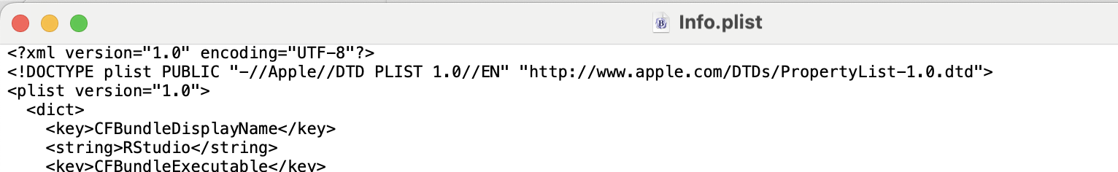

Exercise 2 – Create folders
Go to your Documents folder.
Create a new folder called:
ComputerExercise
Inside it, create three folders:
Data
Python
Notes
Your folder structure should now look like this:
ComputerExercise
├── Data
├── Python
└── Notes
Figure out how to rename the folder Notes to:
Documentation

Exercise 3 – Create, copy, move and delete a file
Find any small file on your computer.
- Copy it into ComputerExercise.
- Make a second copy of the file.
- Move one copy into Data.
- Move the other copy into Documentation.
- Delete the copy in Documentation.
Find your computer's Recycle Bin / Trash.
Can you find the deleted file?
Restore it.
Check that it has returned to its original location.

Exercise 4 – Search for a file
Use your computer's search function to find the file you restored in Exercise 3.
Try searching using:
- the complete filename
- only part of the filename
- the file extension, for example .pdf
Challenge: Can you find all PDF files on your computer?

Exercise 5 – What is running on your computer?
Open the tool that shows the programs and processes currently running.
Windows: Task Manager
Mac: Activity Monitor
Find the columns showing:
- CPU usage
- Memory usage
Answer:
- Which application is currently using the most CPU?
- Which application is currently using the most memory (RAM)?
- How much memory is it using?
- How many applications/processes seem to be running?
Now open another application, such as your browser.
What changes?

Exercise 6 – Investigate your computer
Find information about the hardware in your computer.
Record:
Hardware | Your computer
Operating system
CPU / processor
CPU speed
Number of CPU cores
RAM
Total disk/storage space
Free disk/storage space
Hint
On Windows, investigate Settings → System → About and Task Manager → Performance.
On Mac, investigate Apple menu → About This Mac and System Information.

Exercise 7 – Create a text file
Open a simple text editor.
Windows: Notepad
Mac: TextEdit
Mac users: make sure TextEdit is using plain text, not rich text.
Type:
Hello!

This is my first text file.

I am learning how files work on my computer.
Save the file inside your ComputerExercise folder as:
hello.txt
Close the text editor.
Use Finder/File Explorer to locate hello.txt.
Double-click it.
Does it open again?

Exercise 8 – Turn your text file into a Python file
Find:
hello.txt
Change its name to:
hello.py
Be careful: you need to change the file extension, not just the filename.
Your computer may warn you about changing the extension. Accept the change.
Questions
- What is a file extension?
- What did .txt tell the computer?
- What does .py tell the computer?
- Did the file's icon change?
Challenge: If you cannot see .txt, figure out how to make your computer show file extensions.

Exercise 9 – Make a real Python program
Open hello.py again in a text editor.
Replace its contents with:
name = input("What is your name? ")

print("Hello", name)
print("Welcome to Python!")
Save the file.
You have now created a Python program.
Find the file using Finder/File Explorer and answer:
- What is its full filename?
- Which folder contains it?
- What is its file size?
- When was it last modified?

Exercise 10 – Computer scavenger hunt
Without asking your teacher, find the answers to as many of these as possible.
- What is your computer's name?
- What operating system and version are you running?
- How much RAM does your computer have?
- What CPU/processor does it have?
- How many CPU cores does it have?
- How much free storage space do you have?
- Which application is currently using the most RAM?
- Which application is currently using the most CPU?
- Find your hello.py file and determine its exact location.
- Find a way to display the full path to hello.py.

Final challenge
Create this folder structure:
ComputerExercise
├── Data
│ └── Raw
├── Python
│ └── hello.py
└── Documentation
Move hello.py into the Python folder.
Create the Raw folder inside Data.
Delete any unnecessary files you created during the exercises.
When you are finished, you should be able to explain the difference between a file, a folder, a filename, a file extension, and a file path.

