**3. Select statement**

**3.1 (Queries on a single table)**

a) List all information about all departments

b) Find the empno for employees named MARTIN.

c) Find the employee(s) with a salary greater than 1500.

d) Find all job types – list each only once.

e) List the names of salesmen that earn more than 1300

f) List the names of employees that are not salesmen

g) List the names of all clerks together with their salary with a deduction of 10%

h) Find the name of employees hired before May 1981.

**3.2 (Aggregate functions)**

a) How many employees are there?

b) What is the average salary for employees in department 20?

c) How many different job titles are used?

d) What is the number of employees in the different departments

e) Show in decreasing order the maximum salary in each department together with the department number

**3.3 (Join)**

a) Find the location of ‘ALLEN’.

b) Find the name of employees in the sales department.

c) Find the highest salary of employees located in the sales department.

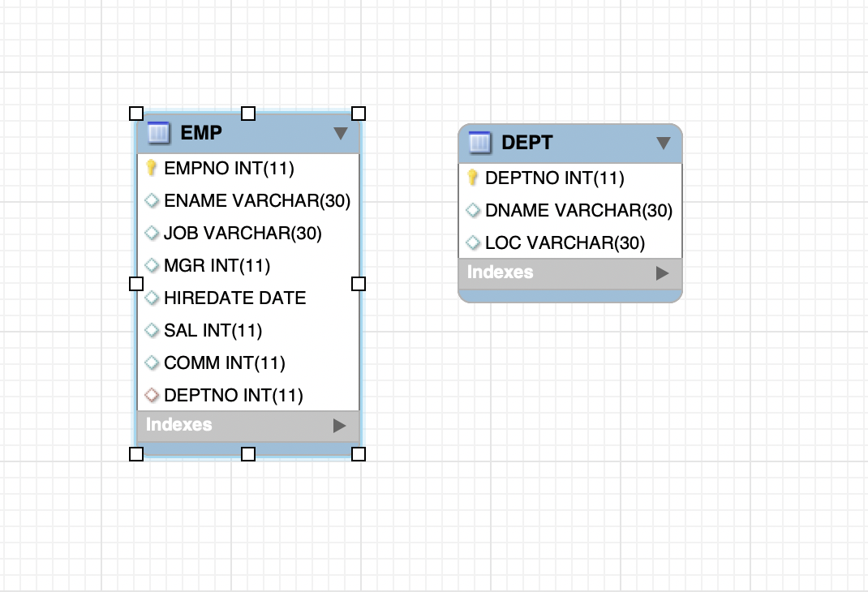

**Create extra table with Create Table statement**

Introduction:

The company sees a need for registration of company cars.

They have cars for specific employees, but they also have cars in a shared pool (i.e. not connected to a special employee). Some employees can even have more than one car as shown in this example where 4 cars are registered (REGNO represents registration number for a specific car).

The new database design can be expressed visually in an E/R diagram (entity-relationship diagram):

The E/R model reads like this:

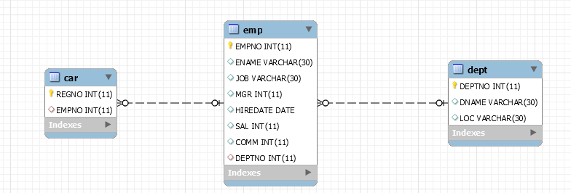

The company has 3 entities (an entity is a set of business objects with same properties): *dept*, *emp, car*

A relationship is a set of associations between participating entities.

A relationship has a degree, referring to the number of participants involved in a relationship. In the diagrammatic representation above, we can read that a car belongs to zero or one employee. An employee can have zero or more cars. A department has zero to many employees. An employee belongs to zero to one department.

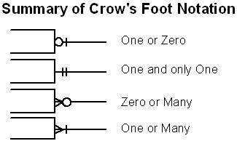

Your tasks:

a) Create the new table CAR

b) Insert minimum 4 registrations in the car table as in the data example above.

c) Try to make a new insert in the car table, where you use one of the same car registration numbers above. What happens? Why? 1

d) Change owner of car with registration number 40 to employee 7698.