Original game: http://www.smartgames.eu/en/smartgames/penguins-pool-party
Scanned for reference for the Python implenetation: https://github.com/cpina/penguins-game/
Please buy the game if interested in it: it's fantastic!

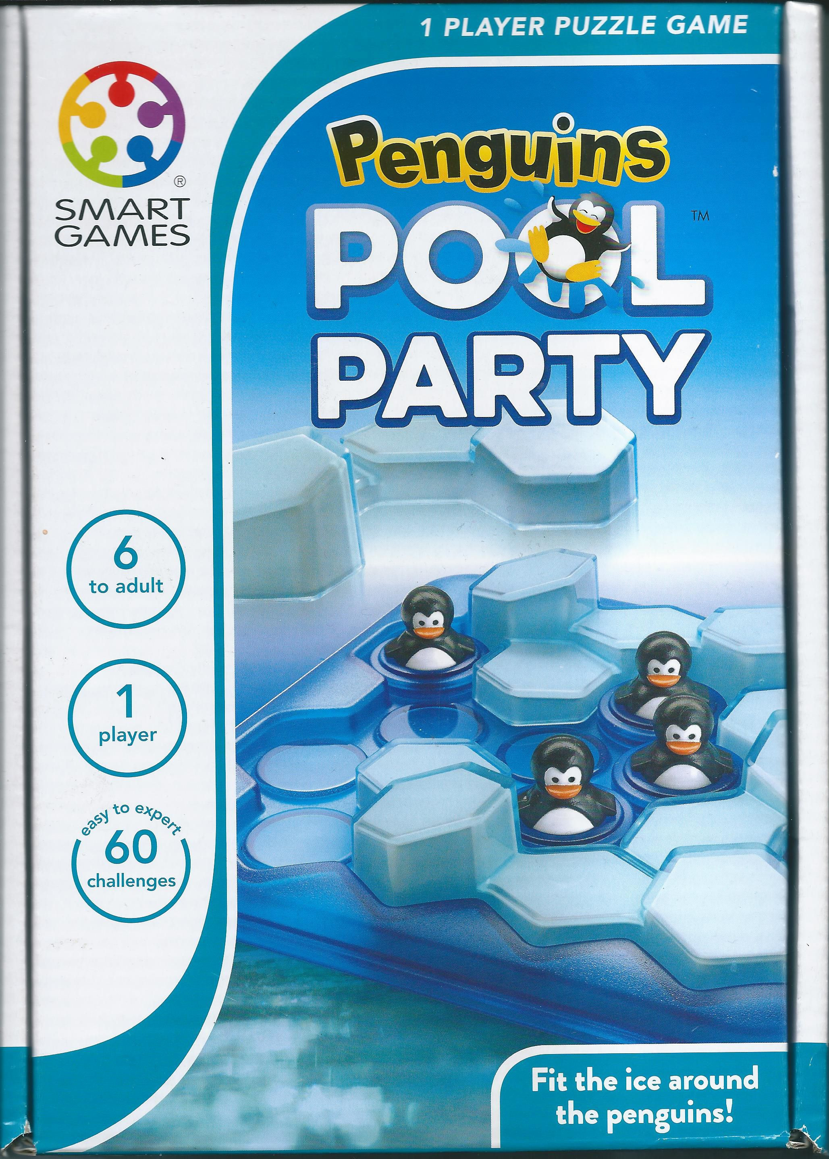
(front of the box)
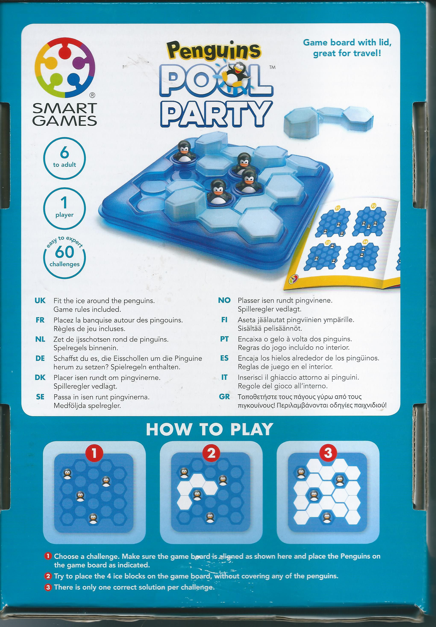
(back of the box)
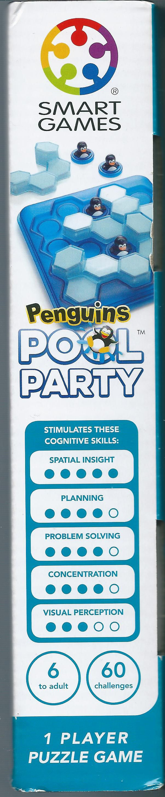

(Side of the box)

