Netbeans: Resolving Resource Issues

When you load up the Netbeans project files the project may show up in red. This means that Netbeans can not find something it needs. Typically the missing piece is the ‘res’ folder that we store all our resource files in.

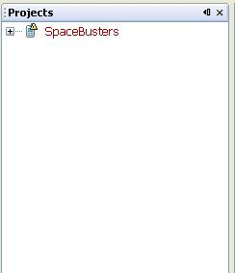

In order to resolve this issue we right click on the red project name and select “Resolve Reference Problems.”

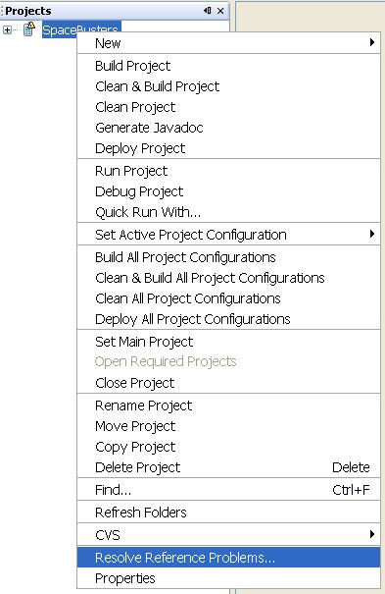

We then select the resolve button:

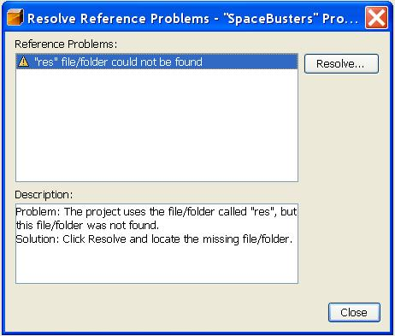

Next we find the ‘res’ folder and select it. And we will return to our Resolve Reference Problems dialog box. We can now hit close and our project will build and run correctly.

