Is there an optimal management strategy for Amazonian production forests?

# Abstract

Tropical forests harbour most terrestrial carbon and diversity on Earth. Despite increased attention in national and international policies, they are still being deforested or degraded at high rates. In Amazonia, the largest tropical forest on Earth, a sixth of the remaining natural forests is dedicated to timber production. Conciliating timber production with the provision of other ecosystem services (ESs) remains a major challenge for forest managers and policy-makers. This study applies a spatial optimisation of logging in Amazonian production forests to analyse potential trade-offs between three ecosystem services, namely timber production, carbon storage and biodiversity conservation. Logging regulations currently applied in the region result in sub-optimal ES-use efficiency. Long-term timber provision would require adoption of a land-sharing strategy at regional scale (i.e. extensive logging with low intensities), whereas retention of carbon and diversity would be favoured in opting for a land-sparing strategy (i.e. intensive logging concentrated in the outer fringes of the Amazon region). Depending on management goals and societal demands, either choices are likely to have deep implications for the future of Amazonian forests. Overall, our results highlight the need for a reevaluation of current logging regulations and for regional cooperation among Amazonian countries to enhance coherent and trans-boundary forest management.

# Introduction

By storing about 30% of the terrestrial carbon (Pan, Birdsey, Phillips, & Jackson, 2013), half of the world biodiversity (Pimm et al., 2014), regulating hydrological cycles (Fisher et al., 2009), or furnishing a wide range of timber and non-timber goods, tropical forests are of critical importance to support human welfare and mitigate ongoing climate changes. However, tropical forests are being converted into cropland at a higher-than-ever speed (2101 km2 per year between 2000-2012 (M. C. C. Hansen et al., 2013)) and are facing increasing pressure from human activities (Lewis, Edwards, & Galbraith, 2015). To tackle tropical forest loss, governments have long focused on forests conservation, mostly by setting up protected areas with restricted access and usage for human populations. However, this simple dichotomy (protected or not) poorly reflects the wide gradient of forest uses and their effects on tropical forests (de Castro Solar et al., 2015; L. Gibson et al., 2011).

In the tropics, c. 40% of sawn wood traded annually arises from natural forests (Payn et al., 2015). Brazil is among the largest producers of tropical round wood, with 24 million m3 (48% of its production) of logs harvested annually (2005-2008) in natural tropical forests (Blaser, Sarre, Poore, & Johnson, 2011). Selective logging is the dominant harvesting system in use, consisting in felling a few commercial trees and leaving the rest of the forest to natural dynamics. Because most of the forest cover remains after logging operations, selectively logged forests still harbour most of their initial carbon stocks, biodiversity, and other environmental features (Francis E. Putz et al., 2012). It has frequently been argued that integrating selectively logged forests into tropical forest conservation schemes is of primary importance (Edwards, Tobias, Sheil, Meijaard, & Laurance, 2014).

Even though the value of production forests in providing Ecosystem Services (ESs) is increasingly recognised, most conservation programs and payments for ES indeed focus on one particular feature (e.g. carbon in REDD+ programs (Laing, Taschini, & Palmer, 2016)), failing to account for forests multi-functionality and complexity (Van der Plas et al., 2018). Few studies have addressed multi-criteria decision-making in the context of optimizing ES provisioning in tropical forests. For instance, a plot-level study in a logging concession in Suriname found that trade-offs between carbon stock conservation and timber recovery are mediated by logging intensity (Roopsind, Caughlin, van der Hout, Arets, & Putz, 2018a).

Such plot-level studies provide useful insights for local forest managers, but conservation-related policies are more relevant at regional levels (Hein, van Koppen, de Groot, & van Ierland, 2006) (e.g. infrastructure planning, protected areas delimitation and logging regulation policies). Because ES provisioning varies in space (e.g. carbon stocks (Avitabile, Herold, Heuvelink, Lewis, Phillips, Asner, Armston, Asthon, et al., 2016) and biodiversity (Jenkins, Pimm, & Joppa, 2013)), complex spatial patterns in optimal ES provisioning are expected to emerge when scaling up (C. C. Gibson, Ostrom, & Ahn, 2000). Plot-level optimisation of ES provisioning can thus not be directly extrapolated to feed forest management policies at larger scales. Nevertheless, current logging regulations, including minimum cutting cycles, i.e. time periods between two logging events (e.g., 20 years in Bolivia and Peru, 35 years in Brazil, 65 years in French Guiana (Blaser et al., 2011)), and maximum logging intensities ranging 20-30 m3ha-1, are typically based on results from local plot-level studies. There is thus a need to inform policy makers with regional assessments of ES trade-offs in Amazonian production forests.

Here we aim at optimising ES provision in Amazonian production forests in a spatially-explicit framework. We analyse the effect of different logging intensities (no logging or 10-20-30 m3ha-1)and cutting cycle duration (15-30-65 years) on the provision of three ES: timber recovery, carbon storage, and biodiversity conservation. Our main research questions are: (i) what are the best management choices for future production forests, (ii) what are the consequences of these management choices on ES provision, and (iii) how does the projected demand for high-quality timber affects forest management and associated ES provision?

To answer these questions, we explore 8 management strategies (described in Table 1) and optimise ES with a timber production target of 35 Mm3yr-1, equivalent to the current timber production in Amazonia (Lentini, Pereira, Celentano, & Pereira, 2005). Strategies differ in terms of (i) ES prioritisation, (ii) total forest area allocated to production, (iii) whether total timber stocks must be recovered (i.e. sustainable timber yields) or not, and (iv) the application of a unique cutting cycle length (30 years). We compare the optimal spatial configuration of logging and resulting ES provision associated to each strategy. Finally, we analyse the consequences of changing the total timber production target depending on the management strategy.

# Materials and methods

## 3.1 Study region

The study region is the Amazon region, located in tropical South America, mostly in Brazil (60%). Amazonia is the most diverse and carbon-rich tropical biome on Earth (Avitabile, Herold, Heuvelink, Lewis, Phillips, Asner, Armston, Ashton, et al., 2016a; Pimm et al., 2014), covered by around 600 Mha of tropical rainforest, of which 400 Mha are intact forests without detectable human footprint (Potapov et al., 2017). To date, 47% of Amazonian forests is under legal protection (UNEP-WCMC & IUCN, 2016) (Figure1). However since the 1970' and the opening of the Transamazonian - the first road built deep inside the forest - 13.3% of the original forest extent has been clearcut, mainly for agricultural purposes: cattle ranching and, more recently, soybean production (Fearnside, 2017).

Even though Amazonia has already been deeply impacted by human activities and road building has continued steadily since the 1970', a great part of the biome is at a great distance from any road and thus inaccessible to most commercial activities (Figure 1).

Timber production through selective logging is the dominant forest use in the region, in terms of extent and generated income (Blaser et al., 2011). About 15% of Amazonian forests is designated for timber production (FAO, 2011). If selectively logged forests still retain most of their original levels of carbon and diversity (Francis E. Putz et al., 2012), forest recovery and resilience post-logging largely depend on implementation of logging in the field, the logging intensity and the cutting cycle length, *i.e.* the time left to the forest to recover (Piponiot et al., 2018; Rutishauser et al., 2015). In Amazonia, logging intensities vary between 5-30 m3 of timber extracted per ha, with an estimated average around 20 m3ha-1 in the Brazilian Amazon (Asner et al., 2005). Official minimum cutting cycle length varies from one country to another, ranging from 20 years (e.g. Peru, Bolivia (Blaser et al., 2011; Fredericksen, Putz, Pattie, Pariona, & Pena-Claros, 2003)) up to 65 years (French Guiana).

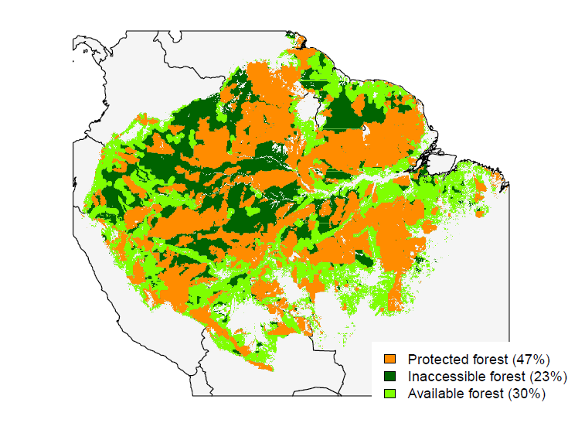

**Figure 1**: Availability of Amazonian forests for logging (forest cover > 90%). Orange areas are protected areas (except category VI of the IUCN), and are not included in our analysis. Dark green areas are forests that are > 25 km away from any road or track; light green areas are forests that are close (< 25 km) to a road or track.

## 3.2 Optimisation framework

The goal of the optimisation is to find the best spatial configuration of different land uses in a landscape. In this study, Amazonia was divided into a systematic grid of 556 1° cells, which correspond to the coarsest resolution of input maps (see supplementary material B, Figure S3).

The spatial optimisation seeks the most efficient spatial configuration of logging rules (cutting cycles and logging intensities) that minimises a cost function under pre-defined objectives. An annual timber production target is first set (Figure 2): the optimal solution must include enough logged cells to produce the desired amount of timber. Then a management strategy is defined (see Table 1 for a complete strategy description). The strategy includes (i) the weight of each ES (timber recovery, carbon storage and biodiversity conservation) in the cost function that will be minimised, (ii) the area of potential production forests (PPF) in each grid cell, and (iii) some additional constraints: sustainable timber yields (STY), unique cutting cycle length and intact forest landscape (IFL) conservation.

The optimal spatial configuration for one given strategy is then found using a methodology adapted from the optimisation software *Marxan with Zones* (Watts et al., 2009), using the package *prioritzr* (Hanson et al., 2018) developed in R programming language (R Core Team, 2017). Codes are available at *github.com/cpiponiot/ES_optimisation_Amazonia*.

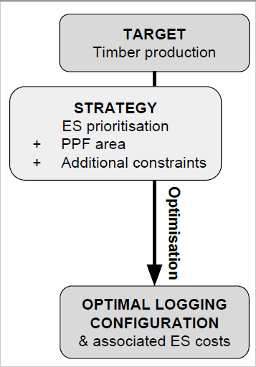

**Figure 2**: Diagram of spatial optimisation steps. PPF: Potential Production Forests, i.e. all forests that are accessible and where logging is allowed. The 8 strategies tested in this study are summarised in Table 1. The resulting logging configuration and associated changes in ES provision with a 35 Mm3yr-1 are presented in Figures 3 and 4, respectively. The effects of changing the timber production target are presented in Figure 5.

## 3.3 Strategy description

Different strategies to supply future timber demand in the region (Table 1 are tested: (i) *Timber*: only timber recovery is optimised in order to ensure long-term timber production, (ii) *Carbon*: only carbon is optimised as a climate change mitigation strategy, (iii) *Biodiversity*: only biodiversity is optimised as a conservation strategy, (iv) *Balanced*: long-term timber provision and conservation values (carbon and biodiversity) are balanced in the optimisation, as a multi-functionality strategy, (v) *Current*: balanced ES prioritisation under medium (30-yr) cutting cycles, (vi) *STY*: sustained timber yields (STY), i.e. the volume of timber extracted must be recovered at the end of the first cutting cycle, (vii) *Road building*: all areas, except currently-protected areas, are made available for logging, and (viii) *STY - Road building*: all areas, except currently-protected areas, are made available for STY logging. Both strategies involving the expansion of new roads mirror a land-sharing strategy. For the Timber strategy, total timber harvested can vary between 10-80 Mm3yr-1 (Figure 5), but 80% of IFL is maintained. Such an intensification of timber production in current production forests rather reflects a land-sparing approach.

In scenarios (i-v), the area suitable for logging is the same as defined previously ("Currently accessible" in Table 1). In the *Road building* scenarios (v-vi), we hypothesise that additional roads will be built: the new area suitable for logging ("All unprotected" in Table 1 corresponds to the total area with forest cover > 90% outside protected areas (independently of their current distance to a road), minus the 42% corresponding to slopes and areas near rivers (see section 3.5 and Figure S3 in the supplementary material).

**Table 1**: Strategies tested in this study. ES prioritisation refers to the weights given to ESs in the optimisation process: either only one ES (timber, carbon or biodiversity) is optimised, or weights are balanced between timber and conservation (carbon and biodiversity). PPF (potential production forests) are areas that can be logged in a given strategy: "Currently accessible" are areas that have >90% forest cover, are not protected and are within 25 km of an existing road or track (Figure 1; "All unprotected" are all areas with >90% forest cover outside protected areas (no road-distance restriction): see Figure S3 for maps of Amazonian PPF. Two optional constraints can be added: STY (Sustained Timber Yields) requires that the total timber stocks are recovered over all logged grid cells; the 30-yr cycle constraint allows only 30-yr cutting cycles.

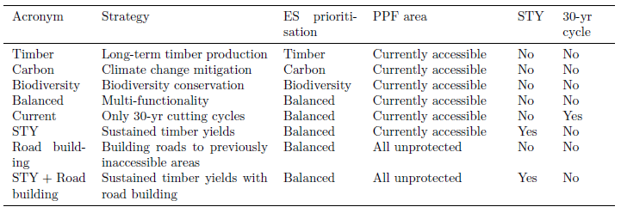

## 3.4 ES prioritisation

Spatially-explicit logging costs are estimated as the loss of each ES (i.e. carbon emissions, biodiversity loss, and timber stocks decrease) caused by logging operations and are calculated in each grid cell.

To reflect the range of practices currently in use in the region, logging could take one of the following feature: a logging intensity of 10 (Low), 20 (Medium) or 30 (High) m3ha−1, and a cutting cycle length of 15 (Short), 30 (Medium) or 65 (Long) years, or no Logging. Medium intensity and cutting cycle length correspond to current median logging practices in Amazonia.

The total cost of allocating logging type *z* to grid cell *p* is estimated as:

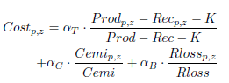

where αT , αC and αB are the relative weights of timber, carbon and biodiversity respectively.

Prodp,z is the timber extracted in a grid cell p when allocated to logging type z and Recp,z is the timber recovered at the end of the cutting cycle (Piponiot et al., n.d.): Prodp,z - Recp,z is thus the net timber loss. A constant K was added to avoid negative costs (when timber recovery exceeds timber extraction). K is set to the minimum cost value across all grid cells and all logging types. Cemip,z are the total carbon emissions caused by logging operations (log extraction, road opening and incidental damage) minus the carbon recovered after logging (Piponiot et al., 2016), integrated over the first cutting cycle period. Rlossp,z are vertebrates species loss (mammals and amphibians (Jenkins et al., 2013)) at the end of the first cutting cycle in a grid cell p when allocated to logging type z . ES losses are standardised by their respective sample mean.

When a unique ES (timber, carbon or biodiversity) is prioritised in a given strategy, its weight is set to 1 and the other 2 are set to 0. When ES prioritisation is balanced between production and conservation, αT = 0.5 and αC = αB = 0.25.

To analyse the effect of ES prioritisation on final ES costs, we ran 66 simulations with all combinations of weights from 0 to 1, with 0.1 steps. Results are analysed in the Supplementary material (Section C, Figure S4).

## 3.5 Potential Production Forest area

The total area of a grid cell ranged from 1.17 to 1.23 Mha. In each grid cell, we considered only areas suitable for logging, referred to as "potential production forests" (PPF). The area of all unprotected PPF was estimated as areas (i) having at least 90% of forest cover (M. C. C. Hansen et al., 2013), and (ii) not being under a full protection status (UNEP-WCMC & IUCN, 2016). To estimate the currently accessible PPF area, the areas that are more than 25 km away from any road or motorable track were removed (OpenStreetMap contributors, 2018). Additional information is provided in the Supplementary material (Section B).

The total areas of PPF ("all unprotected" and "currently available") are then calculated for each grid cell. Because part of a production forest area is considered as unsuitable for logging (slopes, areas around rivers and streams, etc) (Verissimo et al., 2006), the total area of PPF was multiplied by a coefficient π = 58% , calibrated with data from French Guiana concessions (Piponiot et al., n.d.).

## 3.6 Additional constraints

### Sustainable timber yields

An optional sustainable timber yields (STY) constraint was added to the *STY* and *STY + Road building* strategies. In these strategies, timber recovery over all grid cells must be greater or equal to harvested timber volumes:



where Prod_p,z and Rec_p,z area respectively the harvested and recovered timber in grid cell p allocated to logging type z.

### Unique cutting cycle length

In the "Current" strategy, grid cells can be allocated to only 4 logging types: 30-year cutting cycles (Medium) with 10-, 20- or 30-m3ha-1 logging intensities, or no logging.

### IFL conservation

Finally, an additional constraint to conserve biodiversity is added to all strategies: it consists in conserving most intact forest landscapes (IFL). IFL are irreplaceable for biodiversity conservation (L. Gibson et al., 2011), especially for species that are highly sensitive to forest degradation. Because Amazonian forests have high levels of endemism and all regions are not equivalent in terms of species composition, we defined the biodiversity conservation objective as follow: in each of the 6 ecoregions (according to ter Steege et al. (Ter Steege et al., 2013)), namely the Guiana Shield, eastern Amazon, southeastern Amazon, central Amazon, southwestern Amazon, and northwestern Amazon, 80% of IFLs (according to Potapov et al. (Potapov et al., 2017)) shall remain unlogged. Those include forests in protected areas, inaccessible forests (>25 km from a road or track), or forests inside grid cells that have been allocated to the "No Logging" type.

# Results

## Optimal logging configuration under current timber production target

Our predictions when optimising timber production (i.e. *Timber* strategy) in the region result in exploiting 90% of all production forests (over one cutting cycle), of which 12% are under high-intensity short-cycle logging and 77% under low-intensity long-cycle logging. Low-intensity logging is distributed in almost every region of Amazonia, except in the northeast where high-intensity logging prevails (Figure 3a). By contrast, maximising carbon and biodiversity retention results in preserving 82% of available forests, and logging 18% of available forests under the highest intensity (30 m3ha-1) and shortest cutting cycle (15 yr) allowed (Figure 3b-c). Logged areas are distributed in outer fringes of Amazonia: southeastern Amazonia for both carbon and biodiversity, northern Amazonia for carbon and the southwestern border for biodiversity.

Balancing timber, carbon and biodiversity (i.e. *Balanced* strategy) results in preserving 48% of available forests, logging 15% of available forests under high-intensity (30 m3ha-1) short-cycle (15 yr) logging and 36% under low-intensity (10 m3ha-1) long-cycle (65 yr) logging (Figure 3d). Similar to the *Carbon* and *Biodiversity* strategies, heavily logged areas are concentrated in periphery, especially in the southeastern border; low-intensity logging is concentrated in the south and northwest; central, western and northeastern Amazonia are mostly not logged.

Allowing only 30-yr cutting cycles results in preserving a smaller share of available forests (35%) while 22% are logged under high-intensity (30 m3ha-1) logging and 43% under low-intensity (10 m3ha-1) logging (Figure 3).

Constraining the full recovery of the timber volume extracted at the end of the cutting cycle (sustainable timber yields or STY) results in a very similar pattern (Figure 3f) as for the *Balanced* strategy. A slightly higher proportion (39% versus 36%) of forests are logged under low-intensity (10 m3ha-1) long-cycle (65 yr) logging and fewer areas are preserved (45% versus 48%).

Increasing forest accessibility through road building (Figure 3g) also results in a spatial configuration similar to the *Balanced* strategy. The total area under high-intensity (30 m3ha-1) short-cycle (15 yr) logging is slightly lower than in the *Balanced* strategy (13 Mha instead of 15 Mha) and the total area under low-intensity (10 m3ha-1) long-cycle (65 yr) logging is higher (55 Mha instead of 35 Mha). Adding a STY constraint did not change the final results (Figure 3h).

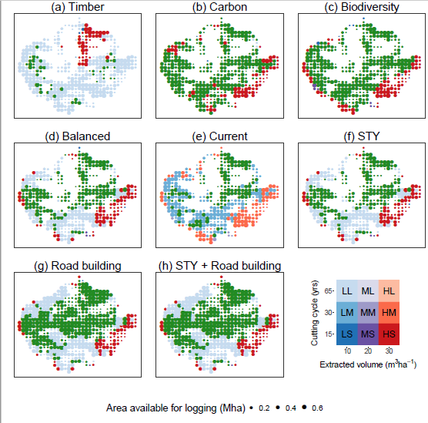

**Figure 3:** Results of spatial optimisation with the 8 strategies defined in Table 1. Production target is set to 35 Mm3yr-1. Green areas are not logged. The size of each dot is proportional to the PPF area (total area available for logging). Logging type colour (blue - purple - red) represent the logging intensity (Light: 10, Medium: 20 and High: 30 m3ha-1). The logging type transparency represents the cutting cycle length (Short: 15, Medium: 30, Long: 65 years): light colours correspond to longer cycles.

## Effect of strategy choice on ES provision

The *Timber* strategy results in the best final timber stocks (+1.4% of initial timber stocks, Figure 4a), but with highest carbon (-3.6% of initial carbon stocks, Figure 4b) and biodiversity (-5.8% of initial value, Figure 4c) losses. The *Carbon* and *Biodiversity* strategies both result in high timber losses (-2.2%), but low carbon emissions (-1.5% and -1.6% respectively) and low diversity losses (-2.4% and -2.2% respectively).

The *Balanced* and *STY* strategies result in almost no variation in timber stocks while the *Road* *building* and *STY + Road* building strategies result in a timber increase of 0.8% (Figure 4a). These four strategies have similar effect on carbon stocks and biodiversity: -2.3% carbon (Figure 4b) and -3.6% biodiversity (Figure 4c) in the *Balanced* and *STY* strategies, and -2.2% carbon and -3.7% biodiversity in the *Road* *building* and *STY* + *Road* *building* strategies.

From our results, it is evidenced that the *Current* strategy performs poorly at providing all three ESs. Indeed, this strategy results in the highest reduction of timber stocks (-2.3%) and the second highest reduction of carbon stocks (-3.5%) and biodiversity (-4.9%), not far behind the *Timber* strategy.

## Testing for a change in timber production

Our model framework allowed to test the ability of the 8 forest management strategies to supply a timber demand, ranging from 10 to 80 M m3yr-1.

Except for the *Timber* strategy, increasing timber production/demand results in an increase of area harvested (Figure 5a), and in a reduction of ESs provision (Figure 5d-f). For the *Timber* strategy however, the total area logged is at its maximum value (around 80 Mha) even at low timber production targets (Figure 5a). For this strategy, increasing timber production from 30 to 80 Mm3yr-1 would result in increasing mean logging intensity by 60% (from 10 to 16 m3ha-1) and decreasing mean cutting cycle length by 15 years (from 60 to 45 years) (Figure 5b-c).

The *Carbon* and *Biodiversity* strategies have similar behaviours: both rely upon high-intensity (30 m3ha-1) short-cycle (15 yr) logging practices, independently from the timber production target (Figure 5b-c). Increasing timber production in both strategies results in a linear increase in logged areas (Figure 5a).

When ES prioritisation is balanced (*Balanced* and *Road* *building* strategies), timber production is mostly achieved through low-intensity long-cycle logging when the production target is low (Figure 5b-c). However, increasing timber production under both strategies generates a shift from low-intensity long-cycle logging to high-intensity short-cycle logging (Figure 5b-c; Figure S5), and extended total area logged.

Adding the STY constraint to the *Balanced* and *Road* building strategies (respectively the *STY* and *STY* *+* *Road* *building* strategies) does not drastically change simulations when production targets are low (<40 Mm3yr-1). At higher production targets, mean logging intensity plateaus at approximately 15 m3ha-1 and mean cutting cycle stabilises at 50 years, resulting in a sharp increase in the total area logged (Figure 5a). Yet, intensifying logging or shortening cutting cycles would result in a net loss of timber stocks, expressed as negative timber variations (Figure 5d). The STY constraint can only meet 50 Mm3yr-1 in currently available PPF (i.e. in the *STY* strategy) and 60 Mm3yr-1 including all PPF (i.e. in the *STY + Road building* strategy).

Finally, the *Current* strategy (i.e. balanced ES prioritisation with cutting cycles of 30 years) results in low-intensity logging when the total production remains < 20 Mm3yr-1 (Figure 5b). Increasing timber production results in a sharp increase in the total area logged until 30 Mm3yr-1 (Figure 5a) and in a sharp increase in the logging intensity from 30 Mm3yr-1 to 80 Mm3yr-1 (Figure 5b). When the timber production target reaches 80 Mm3yr-1, the total area logged reaches its maximum value (around 80 Mha; Figure 5a) and all areas logged are under high-intensity logging (30 Mm3yr-1; Figure 5b). In terms of ES provision, *Current* strategy performs poorly compared to others, especially at high production target. For instance, maximum timber, carbon and biodiversity losses are reached at total timber productions of only 35, 40, and 50 Mm3yr-1, respectively.

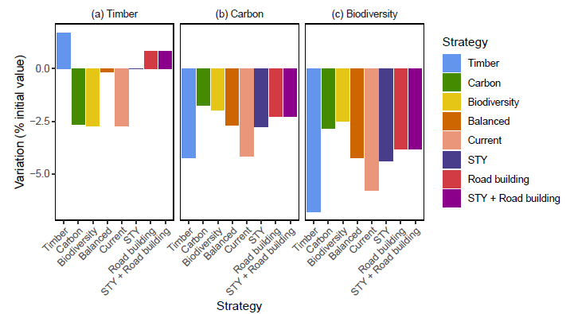

**Figure 4:** Impact of the 8 management strategies (described in Table 1 on total ES provision (% of the initial ES value). The timber production target is set to 35 Mm3yr-1. (a) Variation of regional timber stocks; (b) variation of regional carbon stocks; (c) variation of regional biodiversity. A positive value indicates an increase in total ES provision; a negative value indicates a loss in total ES provision. Variation of ES provision are standardised by the initial value of a given ES (i.e. initial timber, carbon stocks and mammals and amphibians richness for biodiversity) over all areas with forest cover >90% (see Figure S3 : "All forests").

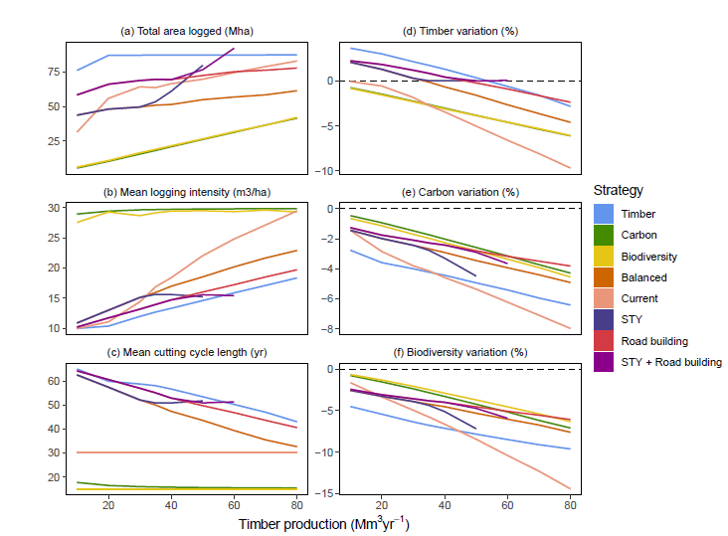 **Figure 5**: Characterisation of different strategies for timber production, depending on the timber production target. (a) Total area logged (Mha). (b) Mean logging intensity in logged areas (m3ha-1). (c) Mean cutting cycle length (yr). (d) Variation of timber stocks (% of the initial value). (e) Carbon emissions (% of the initial value) (f) Variation of biodiversity value (% of the initial value). The 8 strategies' characteristics are summarised in Table 1. *STY* and *STY + Road building* strategies could not sustainably provide more than 50 and 60 Mm3 of annual timber production respectively. In plots (d-f), values are calculated over all areas outside of protected areas. Additional maps with distribution of logging types (intensity, cutting cycle) are provided in the supplementary material (Figure S5).

# Discussion

## Importance of regional studies for forest management

The optimisation approach applied in this study has many implications for sustainable forest management in the region. Ecosystem services in selectively logged forests have already been studied, but almost always separately. Only few studies investigate trade-offs between ESs. Trade-offs between carbon retention and timber recovery were found in Guiana's logged forests (Roopsind, Caughlin, van der Hout, Arets, & Putz, 2018b), or among timber production and species richness at wider scale (Burivalova, Şekercioğlu, & Koh, 2014). These trade-offs were also shown to depend on land tenure and deforestation risk (Griscom, Goodman, Burivalova, & Putz, 2018). Forest owners generally manage forests in order to maximise financial benefits, through timber or non-timber forest products harvesting, eco-tourism or payments for ecosystem services. Local studies can help forest owners to set locally-relevant conservation goals, but generally fail to account for regional objectives.

Climate change mitigation and nature conservation goals are intrinsically trans-boundary, and are better addressed at regional or global scales (Hein et al., 2006). For instance, efficient delimitation of protected areas, definition of logging rules and road planning should be develop at regional scale among countries. Informing decision-makers with large-scale multicriteria analyses will thus be key to develop evidence-based policies. Today, very few studies have assessed regional-scale ESs trade-offs in Amazonia (but see O’Connell et al., 2018) and, despite its importance for the regional economy, none has investigated timber production.

Our results show that regional optimisation of ES provision results in a strong spatial structuring of logging. Intermediate logging cycles (30 yr) and intensities (20 m3ha-1) are virtually never chosen, and imposing some standardisation (e.g. 30-yr cutting cycles in the *Current* scenario) results in sub-optimal ES provision. This is evidence that forest management could benefit from regional studies, instead of applying uniform logging regulations based on a small set of local studies. Our results could help inform where and how logging should be prioritised depending on future demand for timber and other ESs.

One key point to bear in mind is that our simulations are restricted to the first cutting cycle. This is particularly important for STY strategy, as even if our predictions ensure as sustainable timber production over the first cutting cycle, we cannot rule out a decrease afterwards. There is almost no data on multi-cycle logging in Amazonia, and most study sites have only been logged once (Sist et al., 2015), although most PPF may have suffered multiple illegal reentries (Tritsch et al., 2016). Gathering more information on the effect of consecutive cutting cycles on forest dynamics is of utmost importance to glimpse at the future of production forests.

Further, our analysis did not explored the potential of improved logging techniques, generally known as Reduced Impact Logging (RIL), in enhancing simultaneously both ESs and timber productions. A compelling body of evidence shows that RIL practices could provide large improvements in terms of timber recovery, carbon emissions and biodiversity protection (Griscom et al., 2019; F. E. Putz, Sist, Fredericksen, & Dykstra, 2008; Tobler et al., 2018; West, Vidal, & Putz, 2014), and many authors thus argue that they should be an essential point in forest management strategies (Griscom et al., 2018; Runting et al., 2018). Despite those evidences, RIL techniques remained poorly implemented in the field (Blaser et al., 2011). We therefore decided to base our study on currently dominant logging practices, keeping in mind that ES provision would be improved if RIL was more widely implemented.

Finally, even though our findings provide an interesting insight on potential trade-offs that future forest managers and decision-makers will face, a large part (20-60%) of logging is done illegally in the Amazon (Brancalion et al., 2018; Finer, Jenkins, Sky, & Pine, 2014). Changing logging rules to maintain the environmental value of production forests can be jeopardised by the lack of control over their application. Improving Amazonian forests' governance will be key to maintain ecosystem services through informed management.

## How to improve ES provision in production forests?

The main strategy for maintaining high ES provision in production forests has in so far been the implementation of national regulation setting cutting cycle lengths and logging intensities. Those logging rules were thought to be a compromise between producing enough timber to make financial benefits, and letting the forest recover long enough to make logging sustainable Seydack2012. Several studies have however shown that current logging rules are not sufficient to recover pre-logging forest characteristics Zimmerman2012. Moreover, our results show that current regulation (30-yr cutting cycles, similar to the *Current* strategy) increases the loss of all ESs and leads to sub-optimal management of production forests (cf. Figure 4).

The spatial configuration of optimal logging (Figure 3) highlights major regional differences in Amazonian forests. Forests of the Guiana Shield (northeastern Amazonia) are less prone to natural disturbances (Espírito-Santo et al., 2014) and have thus adapted to those environmental conditions with low turnover rates and slow-growing species (Johnson et al., 2016; Quesada et al., 2012). Because they recover timber slowly, they are not logged when the demand for timber is low (see Supplementary material, Figure S5). When the demand for timber is high, however, Guiana shield forests are allocated to high intensity logging when timber recovery is optimised (Figure 3c): in this case the high logging intensity is predicted to decrease forest maturity, rendering forest more productive (Pérez-España & Arreguín-Sánchez, 1999; Piponiot et al., 2018; Rödig et al., 2018).

As Guiana shield forests harbour large amounts of carbon Avitabile2016 and vertebrates Jenkins2013, they are not selected for logging when biodiversity and carbon are optimised (Figure 3a-b). Forests of the Guiana Shield have also been shown to play a crucial role in the Amazonian hydrological cycle (Bovolo et al., 2018; Staal et al., 2018), enhancing the importance of their conservation in future management strategies. As for the Guiana Shield, northern and central Amazonian forests encompass high diversity of vertebrates (Jenkins et al., 2013) and carbon (Avitabile, Herold, Heuvelink, Lewis, Phillips, Asner, Armston, Ashton, et al., 2016b), and are thus rarely selected for logging when biodiversity and carbon storage are prioritised (Figure 3a-b). If conservation is the main objective of Amazonian forest management, the consolidation of the protected area network in central and northeastern Amazonian forests will provide high benefits for conservation and climate change mitigation, especially if this promotes a higher connectivity between existing protected areas (A. J. Hansen & DeFries, 2007).

Southeastern forests have, in turn, relatively lower diversity and carbon stocks. They are thus often allocated to high-intensity short-cycle logging when carbon and biodiversity are optimised (Figure 3a-b). However, due to intense forest degradation through logging, fragmentation and/or wildfire (Davidson et al., 2012; Foley et al., 2007), timber production in southeastern PPF may have been overestimated, even in closed-canopy forests (Asner, Keller, & Silva, 2004).

## Land-use strategies, trade-offs and implications for policy-making

Our results reveal that the main trade-off is between the long-term provision of timber and the conservation of carbon stocks and biodiversity (Figure S4). These results fit into the broader "land sharing vs land sparing" debate, and whether timber production should concentrate on a few intensely-logged areas (land-sparing), or be carried at low intensity over the entire landscape (land-sharing). Land-sparing logging was shown to create heterogeneous landscapes that favour higher levels of beta-diversity and maintenance of biodiversity at landscape scale (de Castro Solar et al., 2015; Edwards, Gilroy, et al., 2014). It has been argued however that under strong forest governance, land-sharing logging could optimise both carbon and diversity retention (Griscom et al., 2018). More recently, a simulation exploring different management strategies in East Kalimantan forests found that the optimal forest conservation strategy consisted in mixing both approaches: intensifying timber production through the conversion of degraded forests into plantations, and implementing reduced impact logging in current logging concessions and some natural forests (Runting et al., 2018). Our findings also show that a land-sparing approach (e.g. the *Carbon* and *Biodiversity* strategies) not only minimises biodiversity loss (Figure 3b, Figure 5f), but also reduce carbon emissions (Figure 3a, Figure 5e). However, these land-sparing strategies result in high timber losses compared to a land-sharing strategy (e.g. the *Timber* strategy, Figure 4a).

Our simulations reveal that there is no win-win strategy to sustain current timber demand and ESs provision in production forests. Further, current application of intermediate logging rules leads to increased ESs loss (Figure 5d-f). The fate of Amazonian production forests hence depend on political choices and on future societal demand for either ESs. If maintaining long-term timber supply from natural production forests is thought to be the goal (Zarin, Schulze, Vidal, & Lentini, 2007), then low-intensity logging should be preferred and applied across most of the Amazon, notably in the western part of the basin (Figure 3c). On the other hand, if there is raising concern and societal demand for preservation of carbon and biodiversity (e.g. carbon-based policies like REDD+ (Stickler et al., 2009), or the 1992 Rio convention on biodiversity (Barton, 1992)), policies should focus on conserving intact inland forests while allowing high-intensity logging in the fringes of the Amazon basin, where timber stocks will rapidly and sharply decrease due to over-exploitation. Alternative pathways include active forest restoration with intensive silviculture and mixed-species timber plantations (Lamb, Erskine, & Parrotta, 2005) to substitute production in over-harvested forests, but such interventions are costly and will require to adopt policies and financial incentives, e.g. through payments for ecosystem services (Salzman, Bennett, Carroll, Goldstein, & Jenkins, 2018).

Interestingly, the *Road building* and the *Balanced* strategies, which only differ in terms of area accessible for logging (Table 1, returned similar outcomes in term of biodiversity and carbon retention (Figure 5e-f). Building new roads enable to rationalise timber production in more or less productive PPF, and hence tend to increase ES provision overall (Figure 5d-f). Yet, logging roads are known to make forests more vulnerable to other uses, such as hunting, wood-fuel harvesting and illegal logging, which can increase carbon and biodiversity costs (Laurance, Goosem, & Laurance, 2009). Depending on the level of governance, forests could undergo indirect degradation that remains hard to be assessed, but could increase the environmental costs of the *Road building* strategy.

# Conclusion

Optimising ESs in production forests at the Amazon-basin scale results in strong spatial structuring of logging, which could not have been predicted from local studies only. Depending on ES prioritisation, optimal logging configurations range from timber-oriented land-sharing strategies that promote low-intensity logging and result in sub-optimal biodiversity and carbon retention, to conservation-oriented land-sparing strategies that maximise forest conservation but result in rapid timber depletion in highly logged forests, and will thus require finding alternative timber sources in the future. Our results stress the need for a concerted reevaluation of current logging rules in Amazonia, and the consequences of current management choices for ES provisioning in future production forests.