Policy brief - first ideas

# Introduction

Since the 1970s, selective logging has become the main silvicultural system in the tropics. This system is based on very simple rules: the harvest of a few commercial trees having reached a minimum cutting diameter, and a cutting cycle that is generally between 20 and 35 years. In the past decades, numerous studies have shown that in most cases these cutting cycles are insufficient to recover harvested timber volumes (Ter Steege, Welch, and Zagt 2002,Dauber, Fredericksen, and Peña (2005),Gardingen, Valle, and Thompson (2006),Macpherson et al. (2010),F. E. Putz et al. (2012)). Low-impact techniques have been recommended to reduce the damage caused by logging operations and improve tree regeneration and growth, but even though these techniques improve carbon sequestration in logged forests (T. a P. West, Vidal, and Putz 2014), they are not sufficient to ensure the recovery of commercial timber stocks (Sist and Ferreira 2007). Results from a recently-published study based on data from 845 ha of logged forests spread in the Amazon (Piponiot et al. 2019) show that when only a few species are harvested for timber, timber volumes quickly drop down after repeated 20 $m^{3}ha^{−1}$ harvests with 35 years cutting cycles: after only 2 logging cycles, the forest is almost depleted of its valuable commercial timber (Figure 1a). Even when all species with potential commercial value are considered, 35 year cutting cycles are not enough to recover the 20 $m^{3}ha^{−1}$ harvests (e.g. Figure 1b, 90% of total volume has commercial value, similar to values in Amazonia (Piponiot et al. 2019)).

Despite the slow recovery of selectively logged forests, this harvest system is still widely used because there are still several hundred million hectares of intact tropical forests, particularly in Amazonia where 400 million hectares are considered as intact (no detectable human footprint) (Potapov et al. 2017). These intact forests are however crucial for carbon sequestration and biodiversity conservation (Gibson et al. 2011), among other ecosystem services that could be reduced if these forests were over-harvested.

The main objective of this paper is to show the limits of selective logging to sustainably meet the demand for wood in the Amazon and to suggest alternatives for future action. These initiatives could be part of an anticipated forest transition that we consider to be urgent in order to conserve the Amazon rainforest.

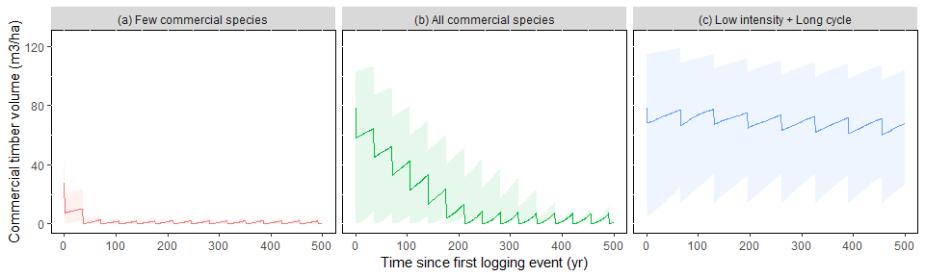

Figure 1: Commercial timber recovery in Amazonia under different scenarios: (a) 20 m3/ha every 35 years, with only 30% of timber volumes considered as commercial, (b) 20 m3/ha every 35 years, with 90% of timber volumes considered as commercial, (c) 10 m3/ha every 35 years, with 90% of timber volumes considered as commercial, (d) 20 m3/ha every 65 years, with 90% of timber volumes considered as commercial, (e) 10 m3/ha every 65 years, with 90% of timber volumes considered as commercial. Results were obtained with the VDDE model (Piponiot et al, 2018) calibrated with data from the TmFO network (Piponiot et al, in press). All trees > 50 cm dbh from species with potential commercial value are considered as timber (average: 87% of the total volume of trees > 50 cm dbh).

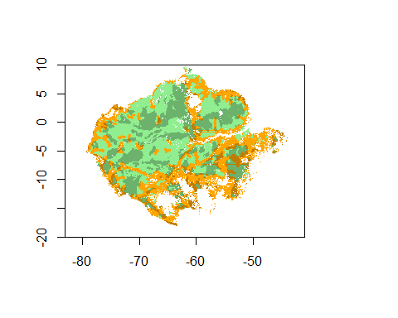

Figure 2: Map of Amazonian forests according to their protection status and human impact. Green areas are inaccessible forests (> 25 km from any track or road), and orange areas are accessible forests (< 25 km from a track or road). Shaded areas are protected forests.

# Preserving intact and inaccessible forests

The preservation of intact forests can bring several benefits, among which high levels of carbon sequestration and biodiversity (Gibson et al. 2011), and the limitation of soil erosion (Flores et al. 2019). The Amazon biome holds the largest area of intact tropical forests on Earth, with around 400 million hectares of forests with no detectable human footprint (approximately two thirds of the total forested area) (Potapov et al. 2017).

Selective logging and other human disturbances can have long-term consequences on intact tropical forests’ carbon stocks (Blanc et al. 2009), composition (Avila et al. 2015), structure (Verburg, Eijk, and Eijk-Bos 2003), and fauna (Burivalova et al. 2014), among others. For instance, selective logging can increase the proportion of low-wood density species for several decades (Baraloto et al. 2012), making these forests more vulnerable to increasingly frequent droughts (Aleixo et al. 2019).  
Preserving a high proportion of intact forests is thus critical for regional and global geochemical cycles as well as maintaining the resilience of Amazonian forests to global environmental changes (Davidson et al. 2012).

Today 45% of the Amazon biome is under some type of legal protection, but the effectiveness of the protection status is not yet sufficient, mainly due to the lack of core-funding (Gullison and Hardner 2018). As a consequence, illegal logging and deforestation also happen in protected areas (Laurance et al. 2012), although in lower proportions than outside protected areas (Barber et al. 2014). Funding to consolidate the Amazon protection network, in combination with rationalized road building to prevent avoidable forest degradation (Laurance et al. 2014), could help preserve the remaining intact forests of the Amazon.

# Controlling and reducing the pressure on logged forests

Current logging rules in Amazonia allow harvest intensities around 10 to 30 m ${}^{3}$ of timber per hectare every 20 to 65 years depending on the country (Blaser et al. 2011). For example in the Brazilian Amazon (60% of the total biome’s area), loggers are allowed to harvest up to 30 m ${}^{3}$ of timber per hectare every 35 years, even though in reality logging intensities are around 10 to 20 m ${}^{3}$ per hectare. These rules have been set up based on a small subset of experimental plots, but several studies suggest that current cutting cycles are not enough to recover commercial timber stocks (Piponiot et al. 2019), thus compromising the sustainability of selective logging.

Decreasing the logging intensity or increasing the cutting cycle length can help making logging more sustainable (Figure 1c).  
For instance, if 90% of all species could be harvested (which is optimistic compared to the relatively low number of species harvested today), a first estimation of sustainable harvesting rates would be approximately 10 $m^{3}ha^{−1}$ every 65 years (Figure 1c), but these numbers need to account for spatial and temporal variability in forest dynamics, and be adapted to local specificities.

Such a reduction in harvesting rates may not be compatible with current extraction rates (between 20 and 30 $Mm^{3}$ every year in the total Amazon region). The total area of forests available for logging (i.e. no logging restriction and < 25 km from a motorable track, xx area in Figure 2) is 190 Mha, 33% of all remaining forests. Around 60% of these areas are slopes, riparian reserves, and heavily degraded areas (Veríssimo, A., Pereira, Veríssimo, and Pereira 2014,F. E. Putz et al. (2019)). With a harvesting rate of 10 $m^{3}ha^{−1}$ every 65 years, the maximum production is 190 x 10/65 x 0.60 = 17.5 $Mm^{3}yr^{−1}$, which is lower than the current extraction rate. Moreover, this production potential will likely decrease in the future because of climate change and increased frequency of disturbances (Piponiot et al. 2019). Adopting more sustainable logging intensities and cutting cycles will thus not be enough to meet current extraction rates in the long run. Developing alternative timber sources early on.

# Actively restoring degraded forests

In Amazonia, a substantial part of forests, especially those that are easily accessible by road (see Figure 2), have been heavily disturbed by human activities (successive fires and logging) to the point that their structure and composition have been lastingly transformed (Rappaport et al. 2018). These degraded forests usually lack large trees and valuable timber species, and can in some cases be packed with lianas that constraint tree growth (Kennard et al. 2002,B. J. Enquist and Enquist (2011)). Their timber production potential can be restored with human interventions including liana cutting, enrichment planting of valuable tree species or girdling of competing non-commercial trees, along with active protection from fires and other disturbances to avoid further degradation and deforestation (Cerullo and Edwards 2019). These techniques have proven effective but require an initial investment and take time to give results. They can thus be a risky challenge for forest managers, especially in contexts where land tenure is insecure (Cerullo and Edwards 2019). This can be economically prohibitive when compared to instantly-available timber from natural forests. The transition to timber-oriented forest restoration will require funding for providing financial incentives, securing land tenure, and developing technical and government expertise in forest restoration.

# Reforesting and planting native species in abandonned areas

In the arc of deforestation, around 30% of agricultural lands are abandoned (Houghton et al. 2000). These lands can be used as timber plantations to replace timber from natural forests (Lamb 1998,Lamb, Erskine, and Parrotta (2005)), as well as providing several other benefits (Paquette and Messier 2010). Today, timber plantations in South America are dominated by monocultures of exotic species from two genera: *Eucalyptus* and *Pinus*. These exotic species have been selected for their high productivity but they have been the center of many controversies because of their effect on water use, soil humus and biodiversity (Majer and Recher 1999). Some studies suggest that mixed species plantations could not only increase the biodiversity of tree plantations but also improve their productivity (Erskine, Lamb, and Bristow 2006). However there is a lack today of mixed plantation experiments in the tropics in general and in Amazonia in particular, and there is thus a need for developing technical research and investing in mixed tree plantations with local species to produce the next generation of timber outside natural forests.

There is an additional advantage to tree plantations: having more control over future crop trees. Betting on natural forests for future timber production is risky: ongoing climate change and increase in fire frequency and other disturbances is increasing tree mortality in Amazonian forests (Brienen et al. 2015), and potential huge diebacks are not to be excluded (Allen et al. 2010). The composition and structure of future Amazonian forests is thus highly uncertain.  
Forest restoration and plantations can be managed to increase resilience to future climate changes, for example by planting species adapted to expected climatic conditions (Guariguata et al. 2008).

# Conclusion: an anticipated forest transition

Amazonian forest management is now at a decisive turning-point. Natural forest are not enough to sustainably provide meet the demand for timber, and their timber production potential is likely to decrease in the coming decades due to increased temperatures and frequency of disturbances such as droughts and fires. Intact and timber-rich forests still prevail but they provide important benefits such as high carbon storage and biodiversity that could be decreased by predatory logging. Alternative timber sources such as forest restoration for timber and timber plantations could help sustainably meet the demand for timber but there is a time lag between the moment they are planted and the moment timber can be harvested. Planting and restoring degraded forests now will provide for timber in the decades to come. To be effective, management policies should aim at increasing forest governance and protection, financing restoration and reforestation plans with national and international funds.

# Additional figures

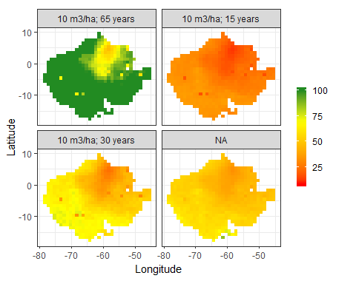

Maximum proportion of timber recovery in Amazonia at the end of the first cutting cycle. Logging intensities and cutting cycles are respectively: (a) 20 m3/ha and 35 years, (b) 10 m3/ha and 35 years, (c) 10 m3/ha and 60 years. Results were obtained with the VDDE model (Piponiot et al., 2018) calibrated with data from the TmFO network (Piponiot et al., 2019). All trees > 50 cm dbh from species with potential commercial value are considered as timber (average: 87% of the total volume of trees > 50 cm dbh).

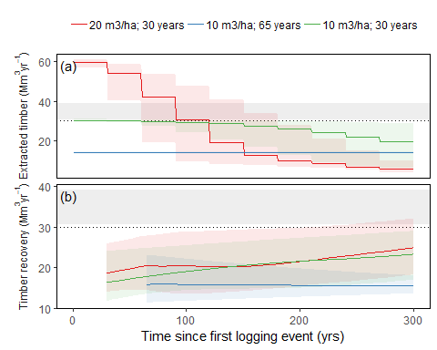 # References

Aleixo, Izabela, Darren Norris, Lia Hemerik, Antenor Barbosa, Eduardo Prata, Flávia Costa, and Lourens Poorter. 2019. “Amazonian rainforest tree mortality driven by climate and functional traits.” *Nature Climate Change*. doi:[10.1038/s41558-019-0458-0](https://doi.org/10.1038/s41558-019-0458-0).

Allen, Craig D, Alison K Macalady, Haroun Chenchouni, Dominique Bachelet, Nate McDowell, Michel Vennetier, Thomas Kitzberger, et al. 2010. “A global overview of drought and heat-induced tree mortality reveals emerging climate change risks for forests.” *Forest Ecology and Management* 259 (4): 660–84. doi:[10.1016/j.foreco.2009.09.001](https://doi.org/10.1016/j.foreco.2009.09.001).

Avila, Angela Luciana de, Ademir Roberto Ruschel, João Olegário Pereira de Carvalho, Lucas Mazzei, José Natalino Macedo Silva, José do Carmo Lopes, Maristela Machado Araujo, Carsten F. Dormann, and Jürgen Bauhus. 2015. “Medium-term dynamics of tree species composition in response to silvicultural intervention intensities in a tropical rain forest.” *Biological Conservation* 191. Elsevier B.V.: 577–86. doi:[10.1016/j.biocon.2015.08.004](https://doi.org/10.1016/j.biocon.2015.08.004).

Baraloto, Christopher, Bruno Hérault, C. E Timothy Paine, Hélène Massot, Lilian Blanc, Damien Bonal, Jean-François François Molino, Eric A. Nicolini, and Daniel Sabatier. 2012. “Contrasting taxonomic and functional responses of a tropical tree community to selective logging.” *Journal of Applied Ecology* 49 (4): 861–70. doi:[10.1111/j.1365-2664.2012.02164.x](https://doi.org/10.1111/j.1365-2664.2012.02164.x).

Barber, Christopher P., Mark A. Cochrane, Carlos M. Souza, and William F. Laurance. 2014. “Roads, deforestation, and the mitigating effect of protected areas in the Amazon.” *Biological Conservation* 177 (November). Elsevier Ltd: 203–9. doi:[10.1016/j.biocon.2014.07.004](https://doi.org/10.1016/j.biocon.2014.07.004).

Blanc, Lilian, Marion Echard, Bruno Herault, Damien Bonal, Eric Marcon, Jérôme Chave, and Christopher Baraloto. 2009. “Dynamics of aboveground carbon stocks in a selectively logged tropical forest.” *Ecological Applications* 19 (6). CIRAD, UMR Ecologie des Forêts de Guyane, Kourou, French Guiana.: 1397–1404. doi:[10.1890/08-1572.1](https://doi.org/10.1890/08-1572.1).

Blaser, Juergen, Alastair Sarre, Duncan Poore, and Steven Johnson. 2011. “Status of Tropical Forest Management 2011.” Vol. 38. <http://www.itto.int/news{_}releases/id=2663>.

Brienen, Roel J W, Oliver L Phillips, Ted R. Feldpausch, Emanuel Gloor, Timothy R. Baker, Jon Lloyd, G Lopez-Gonzalez, et al. 2015. “Long-term decline of the Amazon carbon sink.” *Nature* 519 (7543). Nature Publishing Group: 344–48. doi:[10.1038/nature14283](https://doi.org/10.1038/nature14283).

Burivalova, Zuzana, Çağan Hakkı Şekercioğlu, Lian Pin Koh, Çaǧan Hakki Şekercioǧlu, and Lian Pin Koh. 2014. “Thresholds of Logging Intensity to Maintain Tropical Forest Biodiversity.” *Current Biology* 24 (16): 1893–8. doi:[10.1016/j.cub.2014.06.065](https://doi.org/10.1016/j.cub.2014.06.065).

Cerullo, Gianluca R., and David P. Edwards. 2019. “Actively restoring resilience in selectively logged tropical forests.” Edited by Jennifer Firn. *Journal of Applied Ecology* 56 (1): 107–18. doi:[10.1111/1365-2664.13262](https://doi.org/10.1111/1365-2664.13262).

Dauber, Erhard, Todd S. Fredericksen, and Marielos Peña. 2005. “Sustainability of timber harvesting in Bolivian tropical forests.” *Forest Ecology and Management* 214 (1-3): 294–304. doi:[10.1016/j.foreco.2005.04.019](https://doi.org/10.1016/j.foreco.2005.04.019).

Davidson, Eric a., Alessandro C. de Araújo, Paulo Artaxo, Jennifer K. Balch, I. Foster Brown, Mercedes M. C. Bustamante, Michael T. Coe, et al. 2012. “The Amazon basin in transition.” *Nature* 481 (7381): 321–28. doi:[10.1038/nature10717](https://doi.org/10.1038/nature10717).

Enquist, Brian J., and Carolyn A. F. Enquist. 2011. “Long-term change within a Neotropical forest: assessing differential functional and floristic responses to disturbance and drought.” *Global Change Biology* 17 (3): 1408–24. doi:[10.1111/j.1365-2486.2010.02326.x](https://doi.org/10.1111/j.1365-2486.2010.02326.x).

Erskine, Peter D., David Lamb, and Mila Bristow. 2006. “Tree species diversity and ecosystem function: Can tropical multi-species plantations generate greater productivity?” *Forest Ecology and Management* 233 (2-3): 205–10. doi:[10.1016/j.foreco.2006.05.013](https://doi.org/10.1016/j.foreco.2006.05.013).

Flores, Bernardo M., Arie Staal, Catarina C. Jakovac, Marina Hirota, Milena Holmgren, and Rafael S. Oliveira. 2019. “Soil erosion as a resilience drain in disturbed tropical forests.” *Plant and Soil*. Plant; Soil. doi:[10.1007/s11104-019-04097-8](https://doi.org/10.1007/s11104-019-04097-8).

Gardingen, Paul R. van, Denis Valle, and Ian Thompson. 2006. “Evaluation of yield regulation options for primary forest in Tapaj??s National Forest, Brazil.” *Forest Ecology and Management* 231 (1-3): 184–95. doi:[10.1016/j.foreco.2006.05.047](https://doi.org/10.1016/j.foreco.2006.05.047).

Gibson, Luke, Tien Ming Lee, Lian Pin Koh, Barry W. Brook, Toby a. Gardner, Jos Barlow, Carlos a. Peres, et al. 2011. “Primary forests are irreplaceable for sustaining tropical biodiversity.” *Nature* 478 (7369). Nature Publishing Group: 378–81. doi:[10.1038/nature10425](https://doi.org/10.1038/nature10425).

Guariguata, Manuel R., Jonathan P. Cornelius, Bruno Locatelli, Claudio Forner, and G. Arturo Sánchez-Azofeifa. 2008. “Mitigation needs adaptation: Tropical forestry and climate change.” *Mitigation and Adaptation Strategies for Global Change* 13 (8): 793–808. doi:[10.1007/s11027-007-9141-2](https://doi.org/10.1007/s11027-007-9141-2).

Gullison, Raymond E., and Jared Hardner. 2018. “Progress and challenges in consolidating the management of Amazonian protected areas and indigenous territories.” *Conservation Biology*, May. doi:[10.1111/cobi.13122](https://doi.org/10.1111/cobi.13122).

Houghton, R. A., D. L. Skole, Carlos A. Nobre, J. L. Hackler, K. T. Lawrence, and W. H. Chomentowski. 2000. “Annual fluxes of carbon from deforestation and regrowth in the Brazilian Amazon.” *Nature* 403 (6767): 301–4. doi:[10.1038/35002062](https://doi.org/10.1038/35002062).

Kennard, D. K., K. Gould, F. E. Putz, T. S. Fredericksen, and F. Morales. 2002. “Effect of disturbance intensity on regeneration mechanisms in a tropical dry forest.” *Forest Ecology and Management* 162: 197–208. doi:[10.1016/S0378-1127(01)00506-0](https://doi.org/10.1016/S0378-1127(01)00506-0).

Lamb, David. 1998. “Large scale ecological restoration of degraded tropical forest lands: the potential role of timber plantations.” *Restoration Ecology* 6 (3): 271–79. doi:[10.1046/j.1526-100X.1998.00632.x](https://doi.org/10.1046/j.1526-100X.1998.00632.x).

Lamb, David, Peter D. Erskine, and John A. Parrotta. 2005. “Restoration of Degraded Tropical Forest Landscapes.” *Science* 310 (5754): 1628–32. doi:[10.1126/science.1111773](https://doi.org/10.1126/science.1111773).

Laurance, William F., D. Carolina Useche, Julio Rendeiro, Margareta Kalka, Corey J.A. Bradshaw, Sean P. Sloan, Susan G. Laurance, et al. 2012. “Averting biodiversity collapse in tropical forest protected areas.” *Nature* 489 (7415): 290–93. doi:[10.1038/nature11318](https://doi.org/10.1038/nature11318).

Laurance, William F., Gopalasamy Reuben Clements, Sean Sloan, Christine S. O’Connell, Nathan D. Mueller, Miriam Goosem, Oscar Venter, et al. 2014. “A global strategy for road building.” *Nature* 513 (7517). Nature Publishing Group: 229–32. doi:[10.1038/nature13717](https://doi.org/10.1038/nature13717).

Macpherson, Alexander J, Mark D Schulze, Douglas R Carter, and Edson Vidal. 2010. “A Model for comparing reduced impact logging with conventional logging for an Eastern Amazonian Forest.” *Forest Ecology and Management* 260 (11). Elsevier B.V.: 2002–11. doi:[10.1016/j.foreco.2010.08.050](https://doi.org/10.1016/j.foreco.2010.08.050).

Majer, Jonathan D., and Harry F. Recher. 1999. “Are eucalypts Brazil’s friend or foe? An entomological viewpoint.” *Anais Da Sociedade Entomológica Do Brasil* 28 (2): 185–200. doi:[10.1590/S0301-80591999000200001](https://doi.org/10.1590/S0301-80591999000200001).

Paquette, Alain, and Christian Messier. 2010. “The role of plantations in managing the world’s forests in the Anthropocene.” *Frontiers in Ecology and the Environment* 8 (1): 27–34. doi:[10.1890/080116](https://doi.org/10.1890/080116).

Piponiot, Camille, Edna Rödig, Francis E Putz, Ervan Rutishauser, Plinio Sist, Nataly Ascarrunz, Lilian Blanc, et al. 2019. “Can timber provision from Amazonian natural forests be sustainable?” *Environmental Research Letters*.

Potapov, Peter, Matthew C. Hansen, Lars Laestadius, Svetlana Turubanova, Alexey Yaroshenko, Christoph Thies, Wynet Smith, et al. 2017. “The last frontiers of wilderness: Tracking loss of intact forest landscapes from 2000 to 2013.” *Science Advances* 3 (1): e1600821. doi:[10.1126/sciadv.1600821](https://doi.org/10.1126/sciadv.1600821).

Putz, Francis E., Tracy Baker, Bronson W. Griscom, Trisha Gopalakrishna, Anand Roopsind, Peter M. Umunay, Joey Zalman, Edward A. Ellis, Ruslandi, and Peter W. Ellis. 2019. “Intact Forest in Selective Logging Landscapes in the Tropics.” *Frontiers in Forests and Global Change* 2 (June). doi:[10.3389/ffgc.2019.00030](https://doi.org/10.3389/ffgc.2019.00030).

Putz, Francis E., Pieter a. Zuidema, Timothy Synnott, Marielos Peña-Claros, Michelle a. Pinard, Douglas Sheil, Jerome K. Vanclay, et al. 2012. “Sustaining conservation values in selectively logged tropical forests: the attained and the attainable.” *Conservation Letters* 5 (4): 296–303. doi:[10.1111/j.1755-263X.2012.00242.x](https://doi.org/10.1111/j.1755-263X.2012.00242.x).

Rappaport, Danielle, Douglas Morton, Marcos Longo, Michael Keller, Ralph Dubayah, and Maiza Nara Dos-Santos. 2018. “Quantifying long-term changes in carbon stocks and forest structure from Amazon forest degradation.” *Environmental Research Letters*.

Sist, Plinio, and Fabricio Nascimento Ferreira. 2007. “Sustainability of reduced-impact logging in the Eastern Amazon.” *Forest Ecology and Management* 243 (2-3): 199–209. doi:[10.1016/j.foreco.2007.02.014](https://doi.org/10.1016/j.foreco.2007.02.014).

Ter Steege, Hans, Ivan Welch, and Roderick Zagt. 2002. “Long-term effect of timber harvesting in the Bartica Triangle, Central Guyana.” *Forest Ecology and Management* 170 (1-3): 127–44. doi:[10.1016/S0378-1127(01)00777-0](https://doi.org/10.1016/S0378-1127(01)00777-0).

Verburg, Rene René, Clara van Eijk, and Clara van Eijk-Bos. 2003. “Effects of selective logging on tree diversity, composition and plant functional type patterns in a Bornean rain forest.” *Journal of Vegetation Science* 14 (1): 99–110. doi:[10.1658/1100-9233(2003)014[0099:EOSLOT]2.0.CO;2](https://doi.org/10.1658/1100-9233(2003)014[0099:EOSLOT]2.0.CO;2).

Veríssimo, A., Pereira, D., Adalberto Veríssimo, and Denys Pereira. 2014. “Produção na Amazônia Florestal : características , desafios e oportunidades.” *Parcerias Estratégicas* 19 (38): 13–44.

West, Thales a P, Edson Vidal, and Francis E. Putz. 2014. “Forest biomass recovery after conventional and reduced-impact logging in Amazonian Brazil.” *Forest Ecology and Management* 314. Elsevier B.V.: 59–63. doi:[10.1016/j.foreco.2013.11.022](https://doi.org/10.1016/j.foreco.2013.11.022).