Swansea University
School of Engineering
EE306: Modern Control Systems
Frequency Response Design of a Lag Compensator
Dr Chris P. Jobling

This Matlab M-book examines the design of phase-lag cascade compensators using Bode diagrams.

Analysis
The plant is a type 1 servomechanism with transfer function:
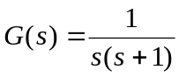.
The system has unity gain feedback and the compensated closed-loop system is to have a static velocity error constant of 10 and a phase margin of 45°.
Defining the system in Matlab
nG = 1; dG = [1, 1, 0];
G = tf(nG,dG);
H = tf(1,1);
Go = G;

In order to display the sort of diagrams we want, I need to do more work with the graphics than is strictly necessary. In other words, you shouldn't worry too much about the Matlab commands shown here. We recommend that in a real interactive design session you make use of the ltiview to examine the system response diagrams.
First of all, I want to show the uncompensated frequency response diagrams plotted with the asymptotic bode curves. There is no built-in function for the latter so I have included the source code for a function asymp that does what we want. See the appendix for information of how to use this function.
We predefine the frequency values that we want:
w = logspace(-2,1);
Now we calculate the maginitde and phase
[m0,p0] = bode(Go,w);

The result of [m0,p0] = bode(Go,w) produces a data structure. We need to convert the magnitude to decibels and extract the data into column vectors for plotting.
m0dB = 20*log10(m0);
m0dB = reshape(m0dB,length(w),1);
p0 = reshape(p0,length(w),1);

The asymptotic magnitude. We need the state space matrices:
[Ao,Bo,Co,Do]=ssdata(Go);

and then the asymptotic response is computed using the function asymp:
am0dB = asymp(Ao,Bo,Co,Do,w);

The plots
clf
subplot(211)
semilogx(w,m0dB,w,am0dB),...
axis([0.01, 10, -40, 60]),...
title('Lag Compensation Example - Uncompensated Plant'),...
legend('Magnitude','Asymptote'),ylabel('Magnitude Go(jw) (dB)'),xlabel('Frequency (rad/s)'),...
grid
subplot(212)
semilogx(w,p0),...
title('Lag Compensation Example - Uncompensated Plant'),...
legend('Angle Go(jw)'),ylabel('Phase Go(jw) (degrees)'),xlabel('Frequency (rad/s)'),...
grid

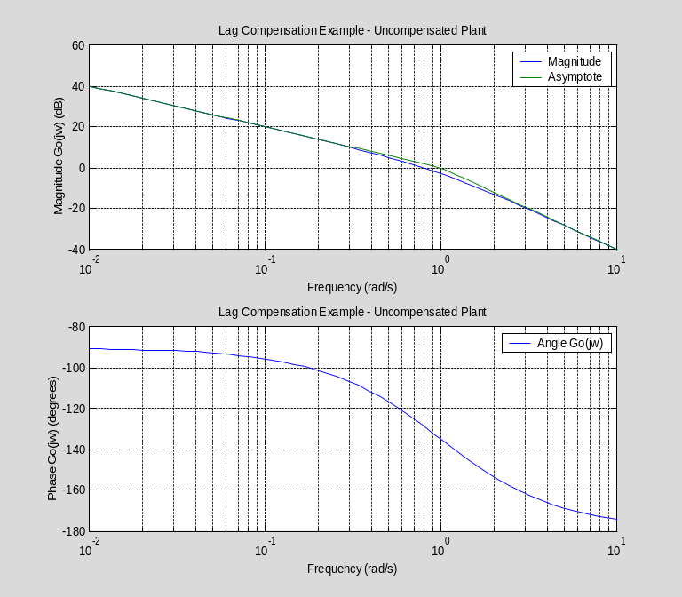

The gain cut-off frequency 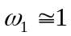 rad.s⁻¹ and the phase margin 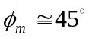. Thus the transient performance requirements are already satisfied.

Lag Compensation for Steady-State Performance
For this system:
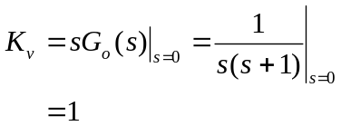
We want K_{v} =10 so, lag compensation is needed to raise the low frequency gain to 10. The lag compensator has transfer function
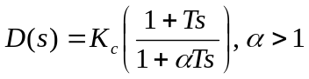.
Examining the frequency response of this compensator we see that
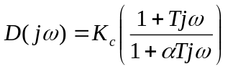.
The low frequency response is
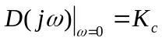,
and the high frequency response is
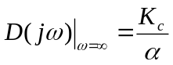.
Since α > 1, the low frequency gain is higher than the high frequency gain. The problem with a lag compensator is that the price we pay for this increase in the low frequency gain is a phase-lag. To illustrate this, let us take an example system:
Kc = 5; alpha = 3; T = 1;
Deg = tf(Kc*[T, 1],[alpha*T, 1])

Transfer function:
5 s + 5
-------
3 s + 1

clf
bode(Deg)

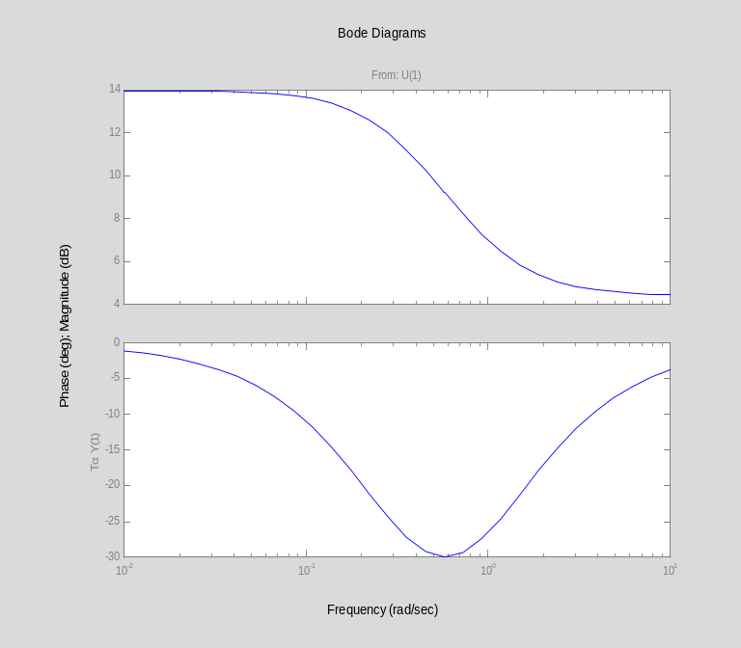

The price paid for the increase in the low-frequency gain is a significant phase lag at the centre frequency. We must avoid adding any affects of this lag to the plant transfer function at the gain cut-off frequency as this would reduce the phase margin and hence stability. So, we arrange the lag compensator as follows.
The compensator is designed to have unity high frequency gain.
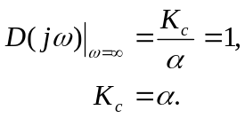
This will avoid any change in the gain cut-off frequency ω₁. The low frequency gain is thus given by
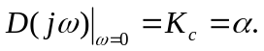
We also ensure that the lag effect is restricted to the low frequency region: so we make sure that the break-frequency of the zero (ω_{z} = 1/T) is located at least a decade lower than the gain cut-off frquency ω_{1.}

Let us set up a lag compensator with these considerations in place.
Kv = 10; w1 = 1; % rad/s
alpha = Kv; % low frequency gain required
Kc = alpha; % compensator gain
wz = w1/10; % 1 decade below gain cut-off
T = 1/wz; % zero value
D = tf(Kc*[T, 1],[alpha*T, 1])

Transfer function:
100 s + 10
----------
100 s + 1

We produce a new Bode diagram for the gain compensated system. The same commands are issued as before.
DGo = series(D,Go);
[m1,p1] = bode(DGo,w);
m1dB = 20*log10(m1);
m1dB = reshape(m1dB,length(w),1);
p1 = reshape(p1,length(w),1);
% Asymptotic magnitude
[A1,B1,C1,D1]=ssdata(DGo);
am1dB = asymp(A1,B1,C1,D1,w);
% Plots
clf
subplot(211)
semilogx(w,m1dB,w,am1dB),...
axis([0.01, 10, -40, 60]),...
title('Lag Compensation Example - Lag Compensated Plant'),...
legend('|DGo(jw)|','Asym. |DGo(jw)|'),...
ylabel('Magnitude (dB)'),xlabel('Frequency (rad/s)'),...
grid
% Phase is unchanged
subplot(212)
semilogx(w,p1),...
title('Lag Compensation Example - Lag Compensated Plant'),...
legend('DGo(jw)'),ylabel('Phase DGo(jw) (degrees)'),xlabel('Frequency (rad/s)'),...
grid

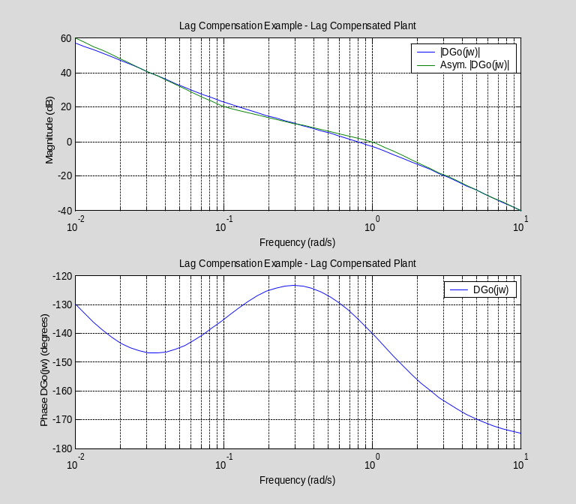

How have we done? The low frequency gain has certainly increased by 20 dB (10). What about the phase margin?
clf
margin(DGo)

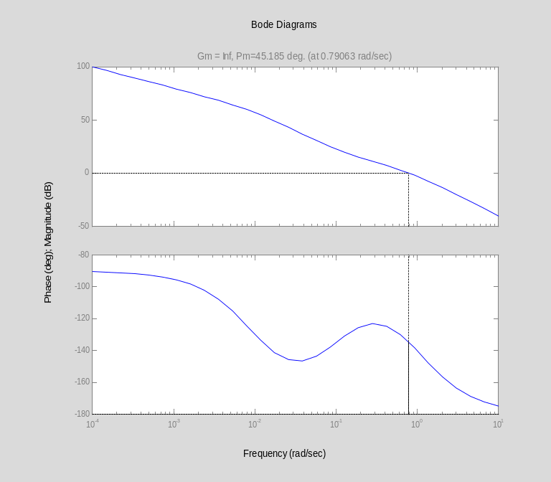

The phase margin is 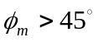 and ω₁ = 0.79 rad.s⁻¹.

Evaluation of the Design
We now put everything together to evaluate the design.

Bode Plots
% Bode
% blue - Uncompensated Go(jw)
% green - Lag Compensator D(jw)
% red – Lag compensated DGo(jw)
bode(Go,D,DGo,w),...
title('Bode Diagrams: Lag Compensator'),...
grid

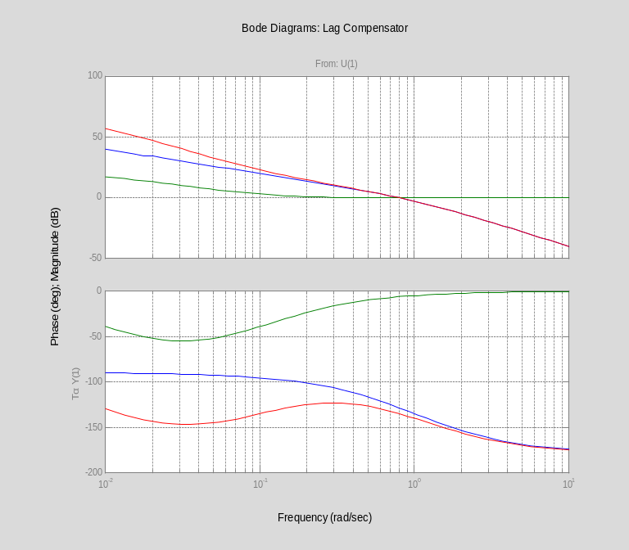

Nyquist Diagrams
% Nyquist
% blue - Uncompensated Go(jw)
% green - Lag Compensator D(jw)
% red – Lag compensated DGo(jw)
nyquist(Go,D,DGo,w)
title('Nyquist Diagrams: Lag Compensator'),...
grid

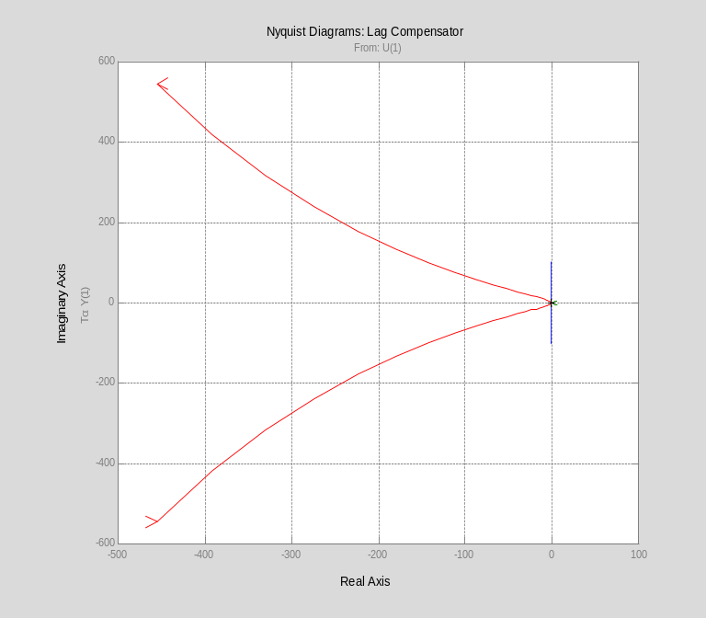

Nichols Charts
% Nichols
% blue - Uncompensated Go(jw)
% green - Lag Compensator D(jw)
% red – Lag compensated DGo(jw)
nichols(Go,D,DGo,w)
title('Nichols Charts: Lag Compensator'),...
grid

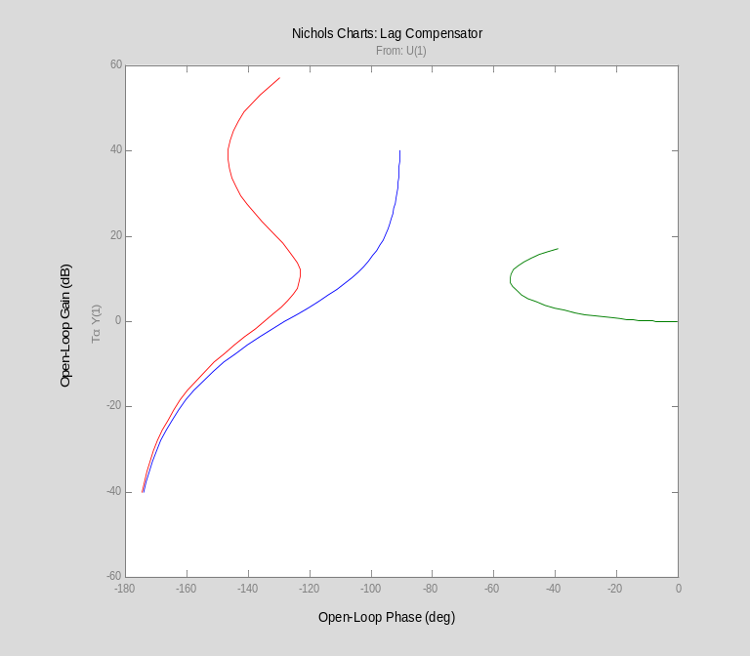

Closed-Loop Frequency Response
Now we examine the closed-loop frequency responses. Notice the slight increase in peak magnification M_{max}.
Gc0 = feedback(Go,1);
Gc1 = feedback(DGo,1);
[mc0,pc0]=bode(Gc0,w);
[mc1,pc1]=bode(Gc1,w);
mc0 = 20.*log10(reshape(mc0,length(w),1));
mc1 = 20.*log10(reshape(mc1,length(w),1));
semilogx(w,mc0,w,mc1),...
grid,...
title('Closed-loop Frequency Response for Lag Compensated System'),...
legend('|Go(jw)|','|DGo(jw)|'),...
xlabel('Frequency (rad/s)'),...
ylabel('Magnitude (dB)')

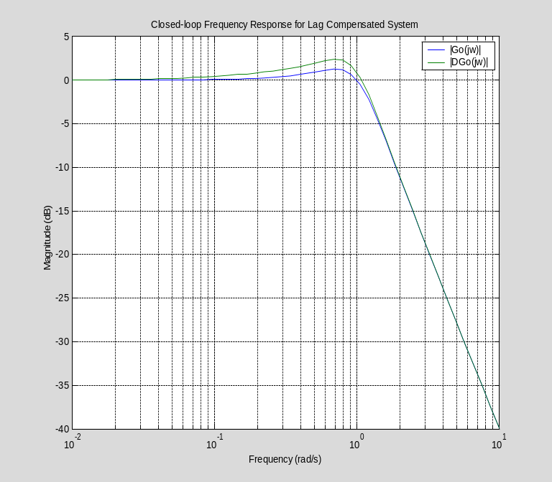

Closed-Loop Step Responses
Firts we examine the closed-loop step responses. Notice the increase in peak overshoot %OS and the slighly longer settling time.
% Blue – uncompensated
% Green - Lag compensated
clf
step(Gc0,Gc1),title('Closed-Loop Step Response')

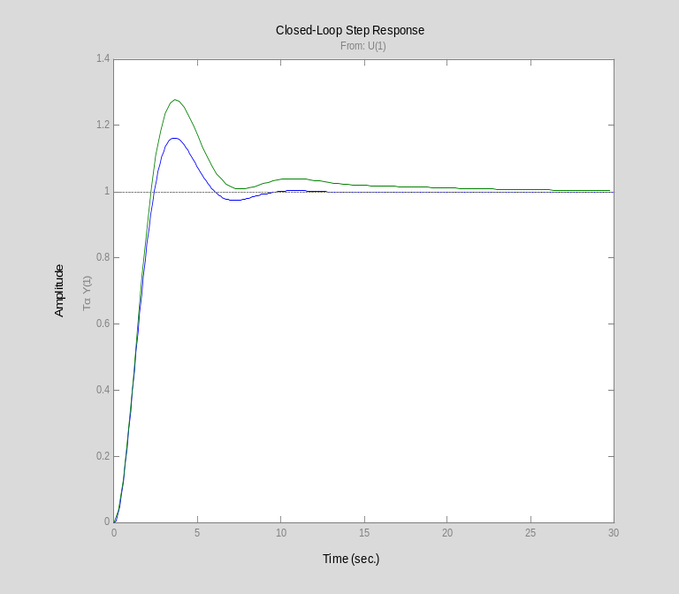

To compute the ramp error response we need to add an integrator to the error reponse:
integ=tf(1,[1 0]);
re0 = integ*(1/(1 + Go));
re1 = integ*(1/(1 +DGo));
clf
step(re0,re1), title('Velocity Error Response')

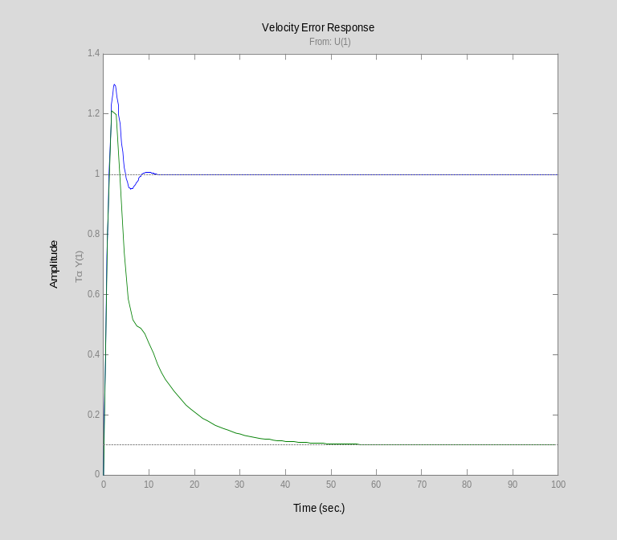

The velocity error is reduced to 10% from 100% showing that K_{v} is indeed 10. However, note the considerable time taken to reach the final value. This is quite typical of a ramp response response for a lag compensator.

Appendix – The Matlab Function asymp
The function asymp is used to determine the asymptotic magnitude response (in dB) of a system defined by a state-space model. The function is not built-in to Matlab so we provide a listing here. The text should be copied and pasted into the Matlab editor and saved as aymp.m in either the working directory or a directory located on the Matlab path (e.g. H:\WORK). Important Note: you will not be able to evaluate this M-Book unless asymp is available to Matlab.
function [mata] = asymp(a,b,c,d,w)
%ASYMP Asymptotic bode magnitude response of continuous-time linear systems.
% [MAG] = ASYMP(A,B,C,D,W) calculates the asymptotic frequency response
% of the system:
% .
% x = Ax + Bu -1
% y = Cx + Du G(s) = C(sI-A) B + D
%
%
% Vector W must contain the frequencies, in
% radians, at which the Bode response is to be evaluated. ASYMP returns
% matrix MAG with LENGTH(W) rows. MAG is returned in decibels.
%

% C.P. Jobling Dingyu Xue 14-02-88
% @(#)asymp.m 1.3

[num,den]=ss2tf(a,b,c,d,1);
%strip off small coefficients of numerator
num=num(abs(num)>1.0e-10);
[zer,pol,k]=tf2zp(num,den);
%strip infinite zeros
zer=zer(zer~=inf);
table = [abs(pol), -1.*ones(length(pol),1)];
table = [table; abs(zer),ones(length(zer),1)];
sort(table);
bode_k=20.*log10(k);
mata=zeros(1,length(w));
%add in contributions from frequency terms
for i=1:length(table)
break_f = table(i,1);
%get points below break frequency
low_f=w<break_f;
%get points above
high_f=~low_f;
if break_f == 0
break_f=1;
else
bode_k=bode_k+table(i,2)*20.*log10(break_f);
end
mata=mata+[zeros(size(w(low_f))),table(i,2)*20*log10(w(high_f)./break_f)];
end
mata=mata+bode_k.*ones(1,length(w));
return

Or lead compensated plant in a lag-lead compensated system.
The phase lag will then be close to zero at the gain cut-off frequency.

