Hi Chris, Dom,

I have updated GitHub by reverting back and including Chart functionality.

In order for the application to work for you, I would suggest doing a couple of things.

1. Delete the IEXTrading database in SQL Server Object Explorer

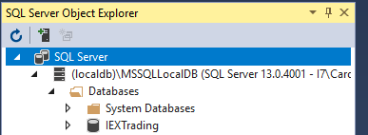

Reason: The companies table has new fields. Once you run the IEXTrading application, it will create a new database instance.

1. Clone a new copy of the repository from GitHub to your Visual Studio instance:

https://github.com/caroled7/2018_Fall_Assignment4_ActiveCloudSite.git

1. The current version has the following home page:

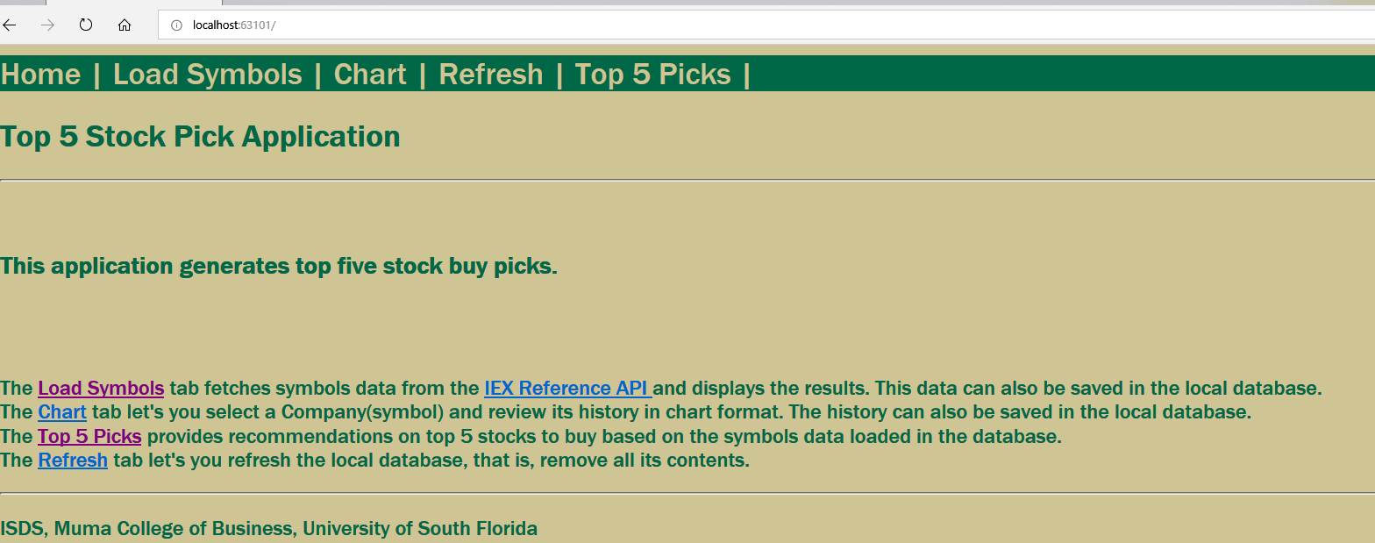

1. Load Symbols currently loads data based on following API: <https://api.iextrading.com/1.0/stock/market/collection/sector?collectionName=Materials>

The HomeController.cs file has a Symbols action which calls the IEXHandler.cs file where the API call is actually made.

ENHANCEMENT IDEAS: I am thinking the API call may be a good candidate for expanding the functionality. Currently it calls the Materials sector. But enhanced

Functionality could provide a list of sectors to pick from and retrieve such as Energy, Financials, Industrials, etc.

Another (possibly easier) option would be to filter based on existing information in the Companies table such as symbol, name, close.

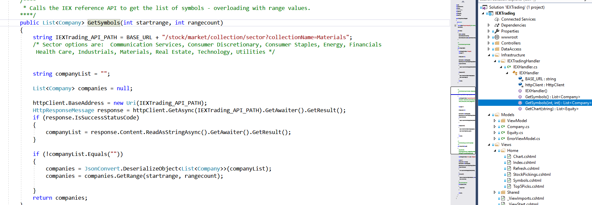

1. Other new functionality is the Top 5 Picks.

In order to create this new page, I had to modify several files:

_Layout.cshtml

Index.cshtml

HomeController.cs public IActionResult Top5Picks()

New Top5Picks.cshtml file

The HomeController file is where Dom’s stock pick logic can be found.

If creating the .cshtml file does not work using scaffolding approach, then you might want to try saving the Top5Picks.cshtml file as Top5Sell.cshtml and manually editing it.

Then, if you still get an error, you can try debugging by placing breakpoints in the code. It looks like debugging only applies to .cs files. Therefore I would place in a break point in the top5sells code and step into it.

As an example, the screenshot below shows step into button and breakpoint using Top5Picks instead of top5Sells.

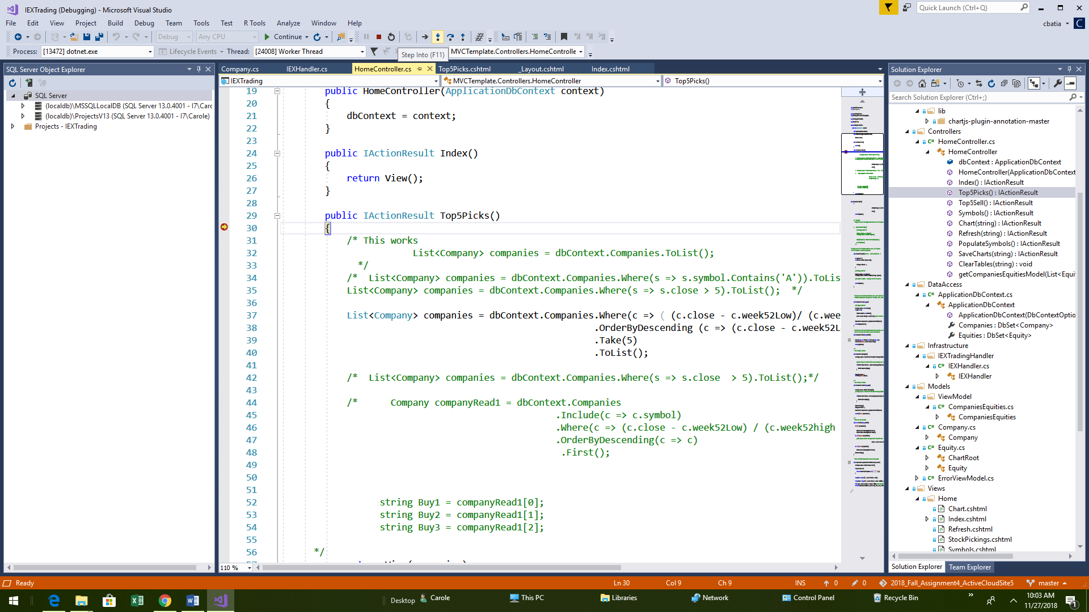

There are some tutorials on debugging that might help.

https://docs.microsoft.com/en-us/visualstudio/debugger/debugging-absolute-beginners?view=vs-2017

ENHANCEMENT IDEAS: Another possible Enhancement would be to create a Top5Sells.cshtml file, update all the related files and modify the logic as Dom had previously suggested.

I also have not set up an option to save the Top 5 Picks to a database table. That is more involved as it would require creating a new data object which then would generate a new data table. If you want to try it, please go ahead. I believe professor will require 2 new tables to be created for the final project, so that would put us ahead of the game.

## What we have left to do:

1. Link to the web application – I guess this means we need to deploy to Azure? I am not sure if deploying to the local usf server will work
2. Link to GitHub repository – I think this is what he wants? https://github.com/caroled7/2018_Fall_Assignment4_ActiveCloudSite
3. Description for Stock picking strategy that is implemented in your code – Dom can you work on this since you gathered the logic?

**BOTTOM LINE:**

I think we are in pretty good shape since the basic stock picking functionality that is required for the assigment is now in place.