Microsoft has a tutorial on Exception Handling which is the programming methodology used to handle errors which might be helpful: https://docs.microsoft.com/en-us/dotnet/csharp/programming-guide/exceptions/

The error we are getting is below:

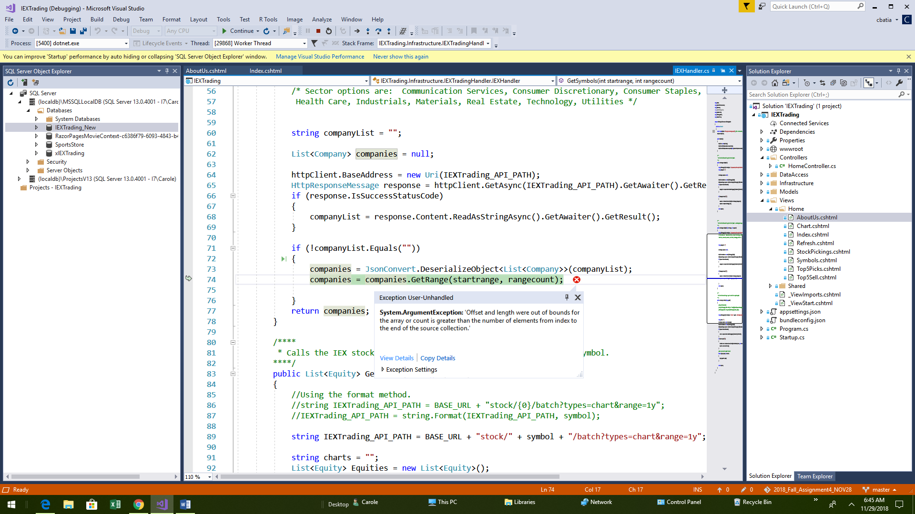

I think if we created a try/catch block around the command – that would be one way to handle error.

Another way to handle error would be to determing how many elements are in the companies array and creating variables that store that information. Then, when calling the getRange function, we could compare the length of the companies array and make sure the startrange (starting index) and range count are not greater than the length of the array. If the range is greater, then return message of some sort (would need to figure out how to do this). IF the range is not greater, than store data. A case statement would be a good way to attempt this.

Generally speaking, programming objects are very stupid. They only know how to do things within some predefined conditions. If they encounter a condition they are not programmed for, they freeze up by erroring out. The good thing is the error message is a clue to what they don’t know how to handle. Normally, the next step is looking at the specific functionality that is having a problem and understanding how the current error is a scenario they don’t understand. Then you have to figure out how to remedy that scenario (best approach) or else wrap your code with a try catch block.

Generally speaking, error handling and trying to get functions to work is very time consuming. When fixing one error, another error might crop up. It can easily take hours or days to get something to work correctly.