PARO

“RC1”Quick-Start Guide:

- Use the Power Switch to turn Paro on.

- The display will show a WiFi SSID (network name) to connect to. Connect to this network from any WiFi-enabled device (PC, smartphone, etc.).

- Once connected, Paro will display a web page on your device and the Display will show a random security code. Enter this security code on the web page to proceed to configure and “Arm” Paro’s mission.

- Use the Power switch to turn Paro off or to reset Paro at any time.
- Charge or externally power Paro using the USB-C connector on the side. Paro’s internal battery, when fully charged, should last for about 24 hours of continuous operation (depending on Paro’s mission parameters).

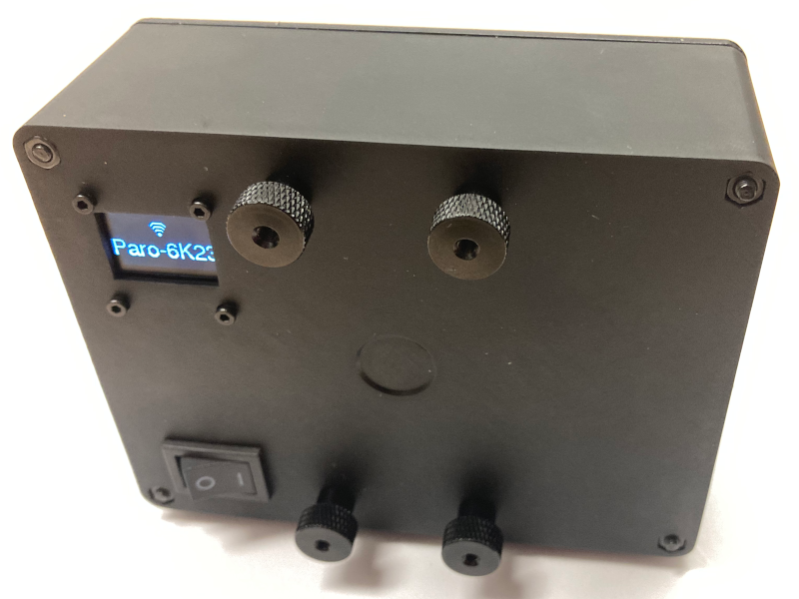

Display

Power Switch

For the PARO user manual and service manual, please visit https://github.com/cpknight/Paro:
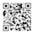

If the web page does not automatically display, connect to the WiFi network indicated and visit http://10.0.0.42/ using your device’s web browser. Rev B 20231028

