**Visio 2013 Tutorial – IST 659**

1. Choose Crow’s Foot Database

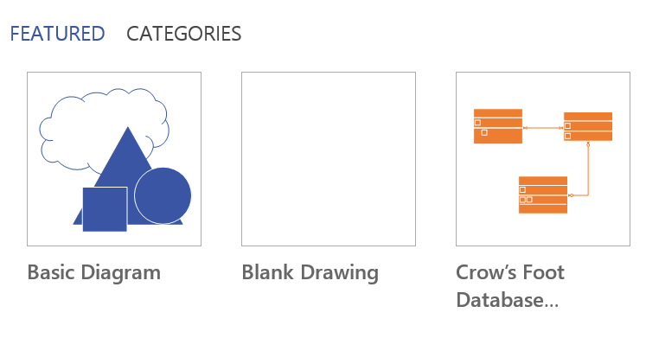

1. Drag one entity from the shapes to the panel

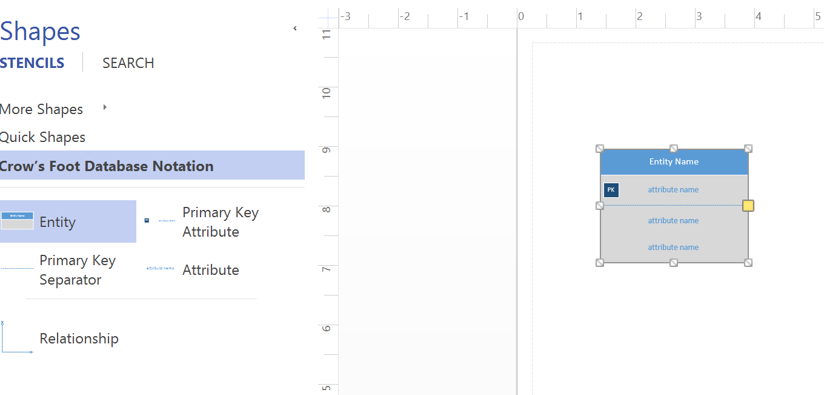

1. Add Attributes
   1. attention, it is hard to distinguish required fields from optional ones, so better use different font sizes, where larger fonts are required fields, and smaller fonts are optional.

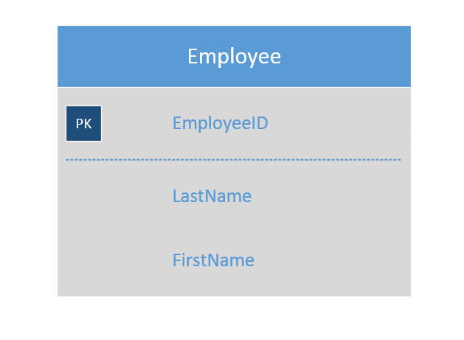

1. Drag a relationship onto the panel and connect the entities.

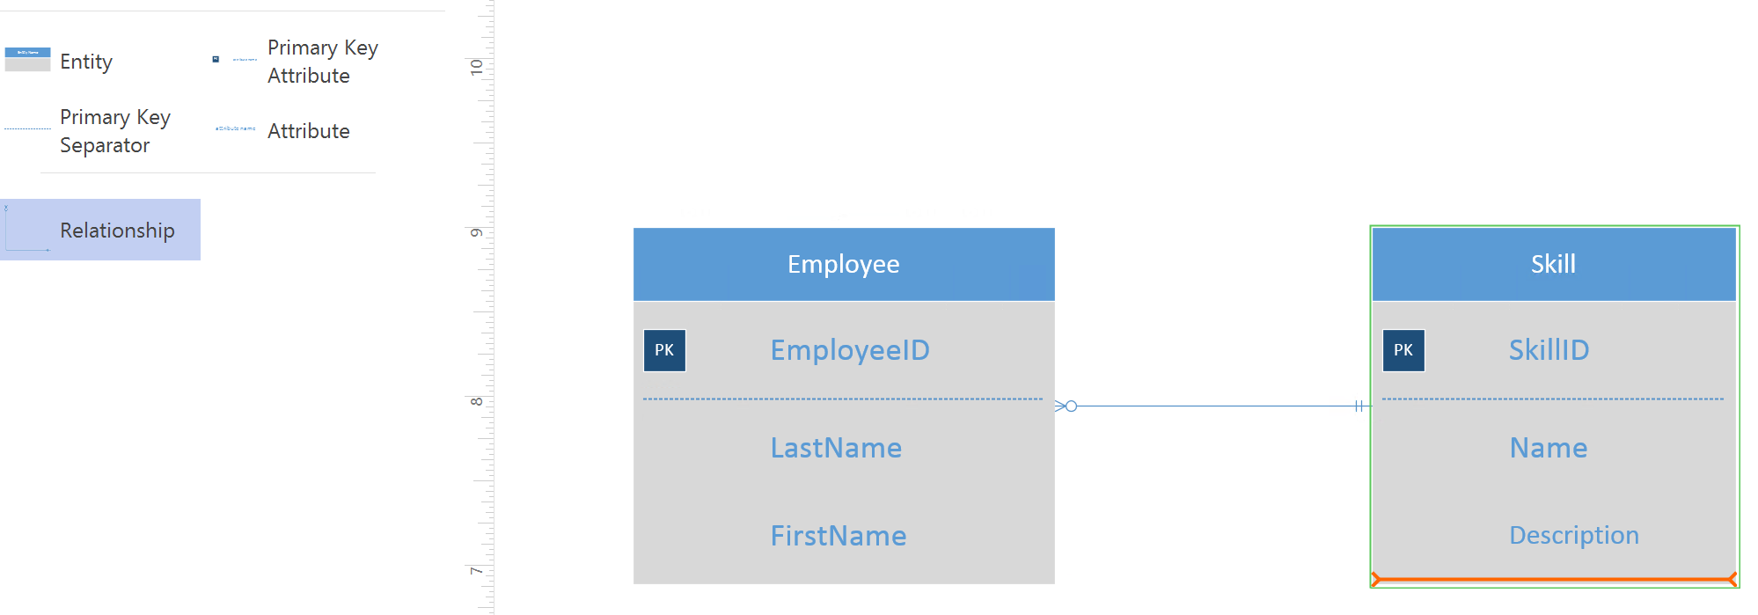

1. Right click the relationship line, then choose “Format Shape”.
   1. Attention:
      1. make sure you edit the “Begin Arrow type” and “End Arrow type” to specify the cardinality and cardinality constraints
      2. edit the “Begin Arrow size” and “End Arrow size” to make sure they are big enough, and easy to read.

