**LAB 3 Due: Sunday 12:00 Noon**

**Name: Pan Chen**

1. **Question1:**

**Business Rules:**

A member is able to send request to connect with zero or multiple other members in the network.

A member can accept zero or multiple requests to connect from other members.

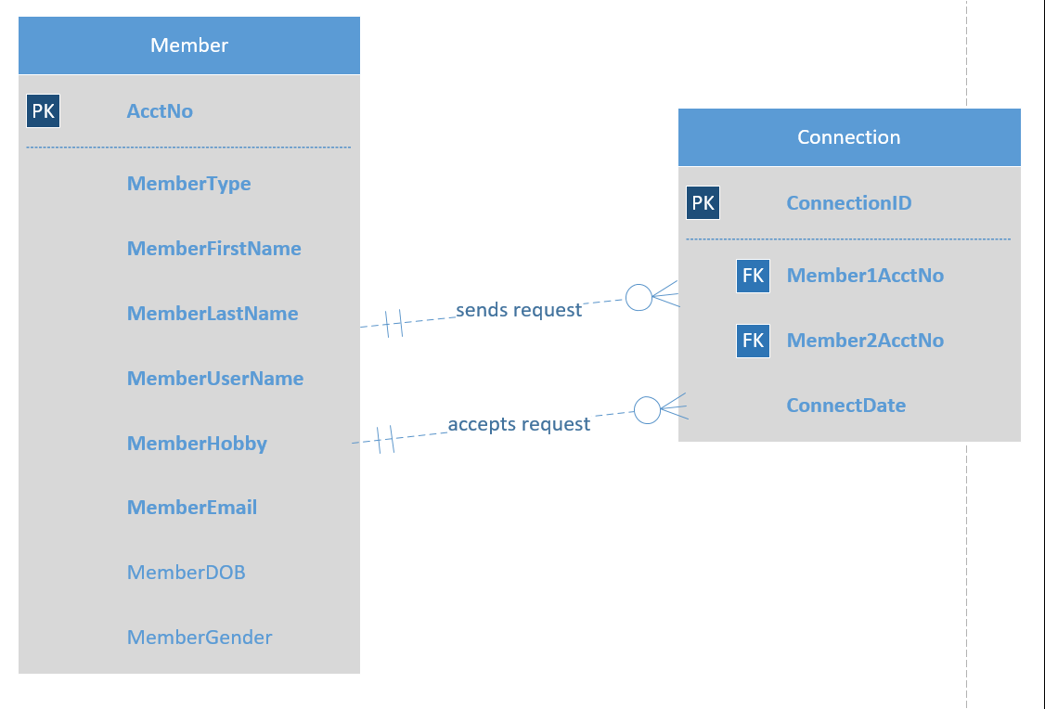





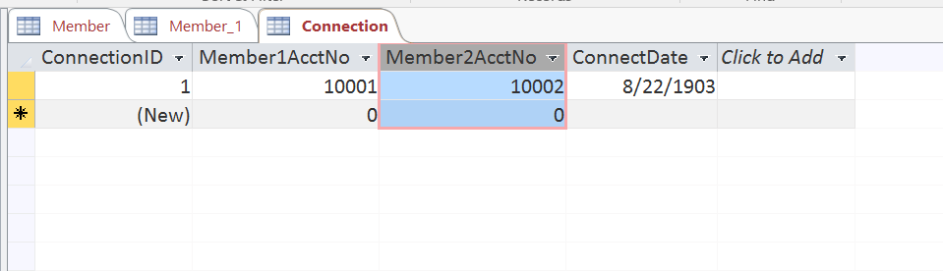

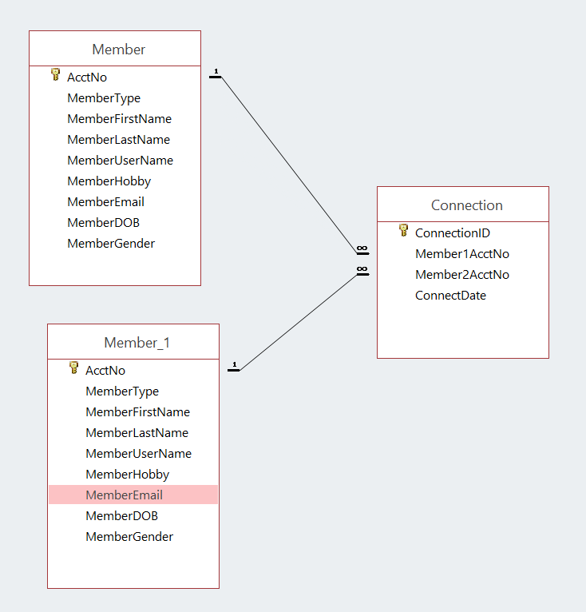

1. **Question2:**

**Business Rules:**

An employee is either paid hourly with hourly rate, or paid by fixed annual salary amount.

