Name: _______Pan Chen___________
Lab 6 Exercise due on Sunday, 12:00 NOON
Problem Description (the same as lab 4)
- Alter table “AircraftSpecs” to add one more columns for number of cabins. Name the column as “cabinNumber”. The column data type is INT, and it can be null.
ALTER TABLE AircraftSpecs
ADD cabinNumber INT NOT NULL;
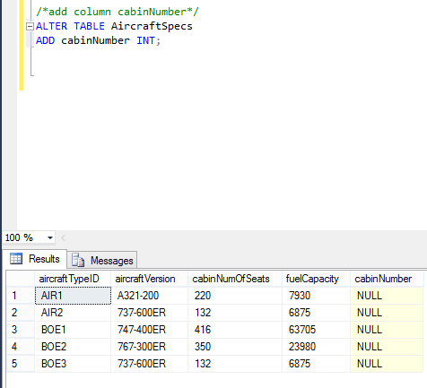
- Update information in table “AircraftSpecs”. For planes whose “fuelCapacity” is 63705, change their “fuelCapacity” to be 73705.
UPDATE AircraftSpecs
SET fuelCapacity =73705
WHERE fuelCapacity =63705;
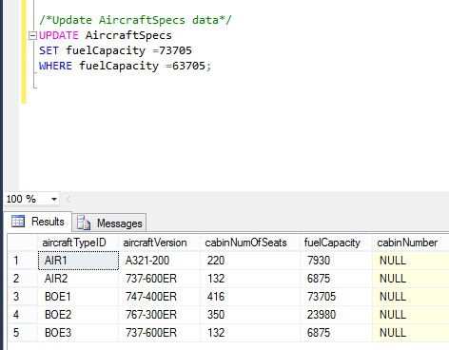
- Simple data questions
- Find out all flight schedule information of flight “3310”. Make sure to show all the fields.
SELECT * FROM flightSchedule
WHERE flightNumber = 3310;
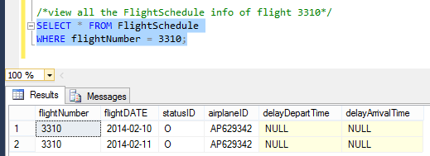
- Find all flights departing from LAX airport. Show flight number, arrival airport, and depart time.
SELECT flightNumber, arriveAirport, scheduledDepartTime
FROM flightRoute
WHERE departAirport LIKE 'LAX';
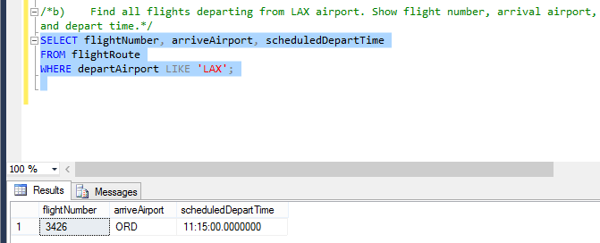
- Find all planes purchased in March 2013. Show airplane ID and purchase date only.
SELECT airplaneID, purchaseDate
FROM Airplane
WHERE purchaseDate LIKE '2013-03%';
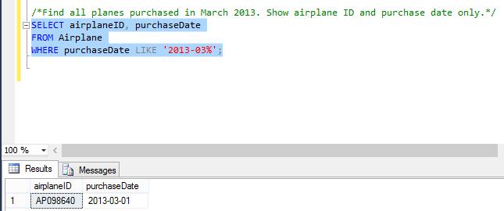
- Find all flights that are of status “Delay”. Show flight number, flight date, and delay arrive time only.
SELECT flightNumber, flightDATE, delayArrivalTime
FROM FlightSchedule
WHERE statusID='D';
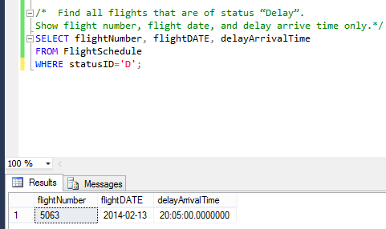
- Find all aircraft types whose number of seats is less than 250. Show aircraft version only.
SELECT aircraftVersion
FROM AircraftSpecs
WHERE cabinNumOfSeats < 250;
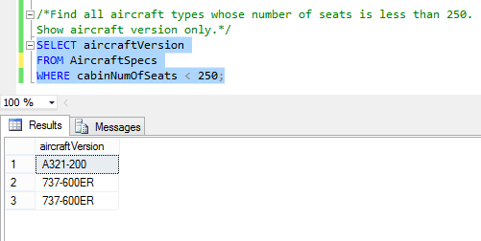

- Use aggregate functions to answer data questions
- Count the number of flights departing each day. Show the date and the number of flights.
SELECT flightDate, COUNT(flightDate) as totalFlights
FROM FlightSchedule
GROUP BY flightDate;
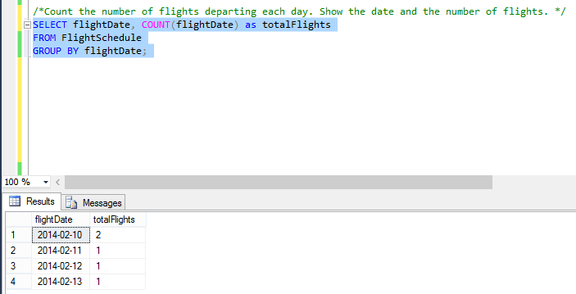
- Sort AircraftSpecs table by fuel capacity in ascending order. Show the result with aircraft version and fuel capacity.
SELECT aircraftVersion, fuelCapacity
FROM AircraftSpecs
ORDER BY fuelCapacity ASC;
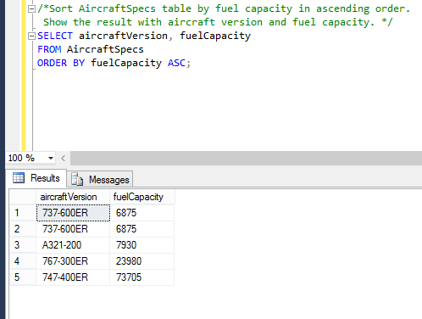
- Calculate the average, min, and max value of cabin seats numbers for aircraft spec. Show average seat numbers, min seat numbers, and max seat numbers.
SELECT AVG (cabinNumOfSeats) as AvgNumOfSeats, MIN(cabinNumOfSeats) as MinNumOfSeats,
Max (cabinNumOfSeats) as MaxNumOfSeats
FROM AircraftSpecs;
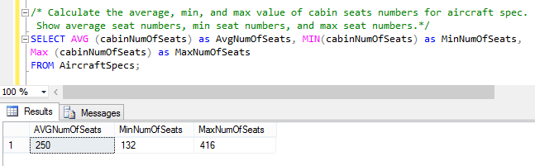
d) Show the average fuel capacity of airplanes from Boeing and Airbus separately.
SELECT AVG (fuelCapacity) as BOEAvgFuelCapacity
FROM AircraftSpecs
WHERE aircraftTypeID LIKE 'BOE%'
SELECT AVG (fuelCapacity) as AIRAvgFuelCapacity
FROM AircraftSpecs
WHERE aircraftTypeID LIKE 'AIR%'
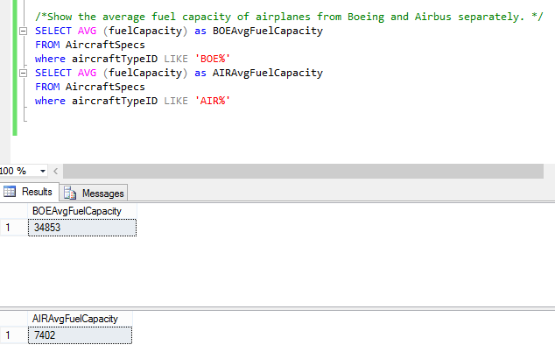
- Open ended Questions:

- From the Flight Schedule Table, show how many flight are delayed and how many flights are on time
SELECT statusID, COUNT(statusID) as NoFlights
FROM FlightSchedule
GROUP BY statusID;
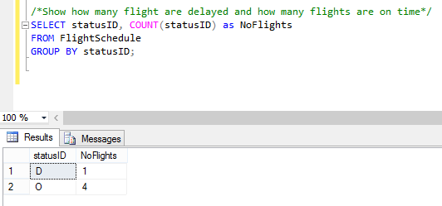
- From the Flight Schedule Table, show how many flight are on time from different flights
SELECT flightNumber, COUNT(statusID) as NoFlightsOnTime
FROM FlightSchedule
WHERE statusID = 'O'
GROUP BY flightNumber;
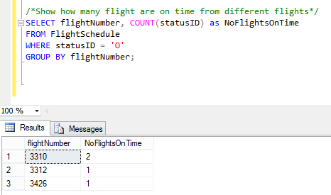
Submission instruction
Please submit your lab report in one PDF file to BlackBoard. Name your file in this format “IST659-Lab6-Lastname-Firstname.pdf”.
After each question, copy and paste your SQL statement, followed by the screenshot to show that your SQL statement has been successfully executed. Remember to add comments to your SQL statements to explain the purpose of the code blocks.

