Name: __________________
Lab 7 Exercise DUE ON SUNDAY NOON
Problem Description (the same as lab 4 and 5 & 6)
In lab 2, we have modeled a database for SUAirways to track planes and flights. In this lab, assume we created the following ERD model for the Airways database (see below).

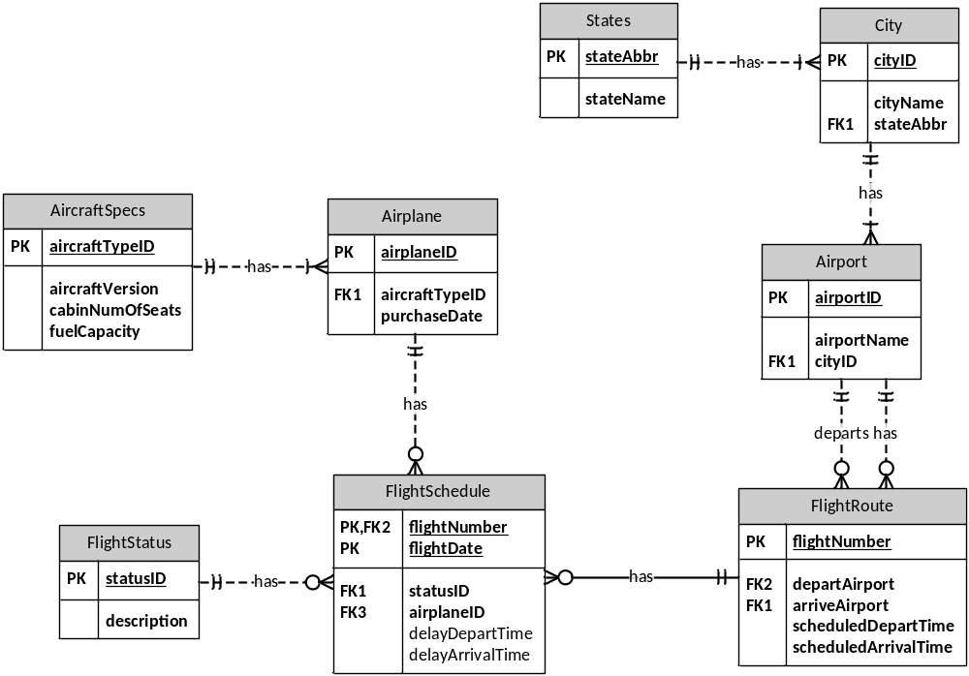
As the model shows: the company has many airplanes which are of different specifications (e.g. Boeing 777, Airbus A320, and so on). Each aircraft specification has the same attributes, such as aircraftVersion, cabin number of seats and fuel capacity. The airplanes are assigned to diverse flight routes. Each flight route has a unique flight number, departs and arrives at particular airports at different cities in scheduled time. Every day the airplanes work according to their flight routes, but the flight schedule may be affected by flight statuses (on time, delay, or cancelled).

Instruction
Imagine you are hired to design a new database to support this platform. In lab 4 you have created and populated the tables. In lab 5 you have revised the tables and written queries to answer easy data questions. In this lab you are going to write complex queries which pull data out of multiple tables. Please write SQL statements to finish the following tasks.
Before starting the lab, please use the following SQL commands to add new data to your tables.
INSERT INTO Airplane VALUES ('AP324423','AIR1','2012-02-21'),('AP422379','AIR1','2012-03-22'),
('AP240173','BOE3','2012-04-20'),('AP139783','AIR1','2012-04-20'),('AP103752','AIR2','2012-06-07'),('AP130221','AIR2','2012-07-04'),('AP108297','BOE1','2012-07-29'),('AP461923','BOE1','2012-07-31'),('AP913857','BOE2','2012-08-12'),('AP123471','BOE2','2012-09-22'),('AP813701','AIR1','2013-01-03'),('AP429421','BOE3','2013-01-13'),('AP132984','AIR2','2013-11-28');

INSERT INTO FlightRoute VALUES ('4376','JFK','IAD','06:00','07:03'),
('1397','SFO','LGA','00:20','07:40'),('3019','LAX','ORD','14:40','18:15'),
('0436','DCA','MIA','10:05','15:33'),('7192','SYR','BOS','11:30','12:45'), ('2531','JFK','LAX','07:20','13:30');

INSERT INTO FlightSchedule VALUES ('4376','2014-02-14','D','AP132984','06:30','07:40'),
('1397','2014-02-15','O','AP123471',NULL,NULL),('1397','2014-02-16','O','AP139783',NULL,NULL),
('3019','2014-02-16','O','AP422379',NULL,NULL),('0436','2014-02-16','O','AP123471',NULL,NULL),
('4376','2014-02-16','D','AP130221','06:30','07:40'),('7192','2014-02-17','O','AP103752',NULL,NULL),
('7192','2014-02-18','C','AP108297',NULL,NULL);

Submission instruction
Please submit your lab report in one PDF file to Blackboard. Name your file in this format “IST659-Lab7-Lastname-Firstname.pdf”.
After each question, copy and paste your SQL statement, followed by the screenshot to show that your SQL statement has been successfully executed. Remember to add comments to your SQL statements to explain the purpose of the code blocks.

