Lab 4 Exercise
Business Rules
- Each customer must have one and only one account.
- Each account must have at least one of the connections, e.g., electric, gas, and water.
- Electricity meter number is not the same as gas meter number, water meter number, or electric meter number.
- Each electric meter number is associated with one and only one account number.
- Each gas meter number is associated with one and only one account number.
- Each water meter number is associated with one and only one account number.
- Current charge is the summation of electric, gas and water billed amounts for the billing period. There are no adjustments from previous cycles.
- The Unit charge for each meter is never going to change.
- Every customer is billed on the 1st day of each month

- an Access table that is in 1NF (using Account No and Start Date as a composite PK)
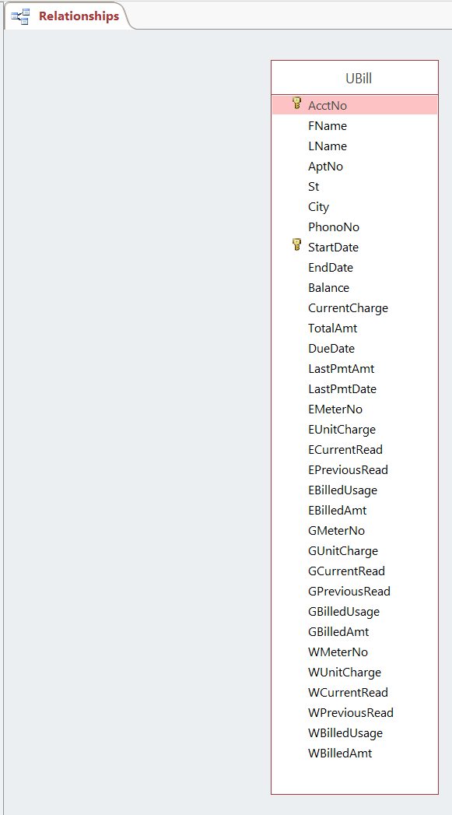
2) the Access tables that conform to 2NF, and explanation of what partial dependencies you have found and how you removed them
Partial Dependencies: find out if a part of a composite PK could determine other non-key attributes
AcctNo -> FName, LName, AptNo, St, City, PhoneNo, EMeterNo, EUnitCharge, GMeterNo, GUnitCharge, WMeterNo, WUnitCharge: these attributes are all determined by Account number alone and they have nothing to do with Bill Start Date
StartDate -> EndDate, DueDate: these attributes are all determined by Bill Start Date alone and they have nothing to do with Account Number
AcctNo, StartDate -> Balance, CurrentCharge, TotalAmt, LastPmtAmt, LastPmtDate, ECurrentRead, EPreviousRead, EBilledUsage, EBilledAmt, GCurrentRead, GPreviousRead, GBilledUsage, GBilledAmt, WCurrentRead, WPreviousRead, WBilledUsage, WBilledAmt: Both of the Primary Keys determine the following attributes.
So we separate the table into 3 parts based on the previous dependencies
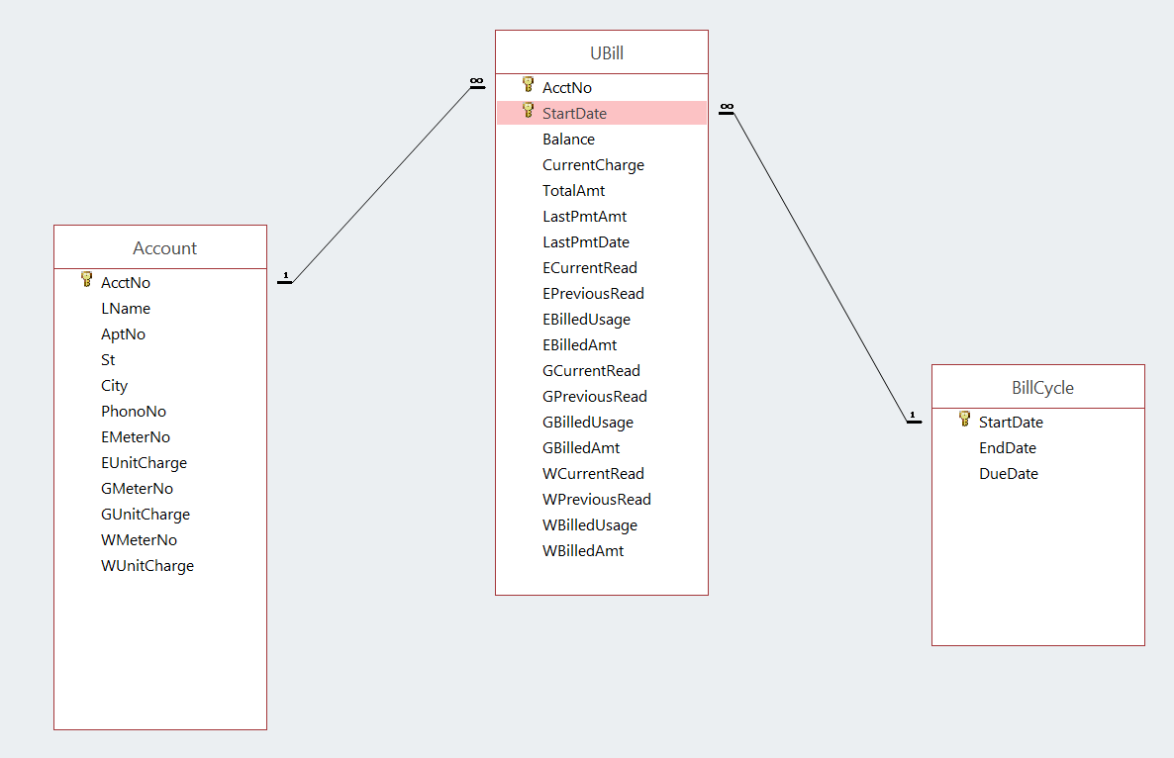

4) The data model that conforms to 3NF, and explanation of what transitive dependencies you have found and how you removed them
Transitive dependencies:
Find out if some non-key attributes could determine other non-key attributes, I found out:
EMeterNo-> EUnitCharge
GMeterNo-> GUnitCharge
WMeterNo-> WUnitCharge
EMeterNo, StartDate-> ECurrentRead, EPreviousRead, EBilledUsage, EBilledAmt
GMeterNo, StartDate-> GCurrentRead, GPreviousRead, GBilledUsage, GBilledAmt
WMeterNo, StartDate-> WCurrentRead, WPreviousRead, WBilledUsage, WBilledAmt
So we separate the table into more parts based on the previous dependencies
