**AppEEARS CASE STUDY I – Wildlife Management: Combining Species Abundance data with Remote Sensing Data-derived Environmental Descriptors**

Material Written by Cole Krehbiel1

1 Innovate Inc., contractor to the USGS EROS Center Sioux Falls, South Dakota

**Research Question:**

How can the AppEEARS point sampler be used to generate remote sensing-derived environmental descriptors?

**Goal:**

Access remotely sensed data that can be used to derive environmental descriptors for use in wildlife management without ever (1) downloading the source data for the remote sensing datasets or (2) needing to open remote sensing software.

**Data Needed:**

|  |  |  |
| --- | --- | --- |
| **Sensor** | **Product** | **Layer** |
| Terra Moderate Resolution Imaging Spectroradiometer (MODIS) | Snowcover ([MOD10A1.006](https://doi.org/10.5067/MODIS/MOD10A1.006)) | 500 m daily Normalized Difference Snow Index (NDSI) |
| Terra Moderate Resolution Imaging Spectroradiometer (MODIS) | Land Surface Temperature ([MOD11A1.006](https://doi.org/10.5067/MODIS/MOD11A1.006)) | 1 km Daily Daytime Land Surface Temperature |
| Terra and Aqua Combined Moderate Resolution Imaging Spectroradiometer (MODIS) | Nadir BRDF Adjusted Reflectance ([MCD43A4.006](https://doi.org/10.5067/MODIS/MCD43A4.006)) | 500 m daily Nadir Bidirectional reflectance distribution function Adjusted Reflectance for bands 1-2 (red, NIR) |

**Software/Tools Needed:**

AppEEARS: <https://lpdaacsvc.cr.usgs.gov/appeears/>

Microsoft Excel

R/Rstudio (optional)

**Estimated Time: 25 minutes**

**Instructions**

**Step 1: Download Data**

Go to <https://github.com/cpkrehbiel/SCGIS_2019> and download the SSWI_2015CPUE.csv file. The file is a list of point locations from the Snapshot Wisconsin project. The lat/lon locations describe trail cams that are part of the Snapshot Wisconsin program that we have species richness data for from 2015 based on citizen science identification of the trail cam images.

**Source Data:** 2015 Total Catch Per Unit Effort (CPUE) for 26 trail cam locations in Wisconsin.

**Step 2: Extract Point Sample in AppEEARS**

* Go to the AppEEARS homepage <https://lpdaacsvc.cr.usgs.gov/appeears/> and sign-in using your NASA Earthdata Login.
* From the top panel, select “Extract” 🡪 “Point Sample”
* Start a new request
* Provide a name for your sample (SCGIS Use Case #1)
* Upload SSWI_2015CPUE.csv
* Set Start Date to 01-01-2015 and End Date to 12-31-2015
* “Is Date Recurring” is unchecked.
* Under “Select the layers to include in the sample,” choose the following layers from these products (find products by typing in the product name in the search and selecting the appropriate data product. Click on the layer to select.)

|  |  |
| --- | --- |
| **Data Product** | **Layer** |
| Snow cover ([MOD10A1.006](https://doi.org/10.5067/MODIS/MOD10A1.006)) | NDSI_Snow_Cover |
| Land Surface Temperature ([MOD11A1.006](https://doi.org/10.5067/MODIS/MOD11A1.006)) | LST_Day_1km |
| NBAR Surface Reflectance ([MCD43A4.006](https://doi.org/10.5067/MODIS/MCD43A4.006)) | Nadir_Reflectance_Band1  Nadir_Reflectance_Band2 |

* Review the data product layers in the “Selected Layers” box that you have chosen and use the “**−**“ symbol to remove any unwanted layers.
* Submit the request. Click on the “Explore” tab to view submission progress.

**Step 3: Reviewing Results in AppEEARS Test Location**

* The length of time for an AppEEARS request to process is dependent upon a number of factors including size of the request and server traffic. In the meantime, you can log-on to an AppEEARS Demo account to view the outputs for the above request:
* Go to <https://urs.earthdata.nasa.gov> and sign out of your personal account. Next, sign in using the username and password provided. From there, return to AppEEARS.
  + **Username: AppEEARSTesting**
  + **Password: NASApixels2017**
* Sign out of AppEEARS and sign back in. Once you are logged in, from the top panel, select “Explore” 🡪 “SCGIS Use Case #1”

**Step 4: Exploring Results of a Point Sample Request**

**Layer Stats**

* Temporal Comparison Tab
* Select ELKBR069 from the Site dropdown
* Select MOD11A1_006_LST_Day_1km from the Layer dropdown
* Select ‘Show Good Quality’ from the Quality dropdown
* Check the Add Line box on the upper right side of the graph
* Figure 1 shows the daily LST data plotted for 2015 showing seasonality as temperatures are warmer in the summer and cooler in the winter.

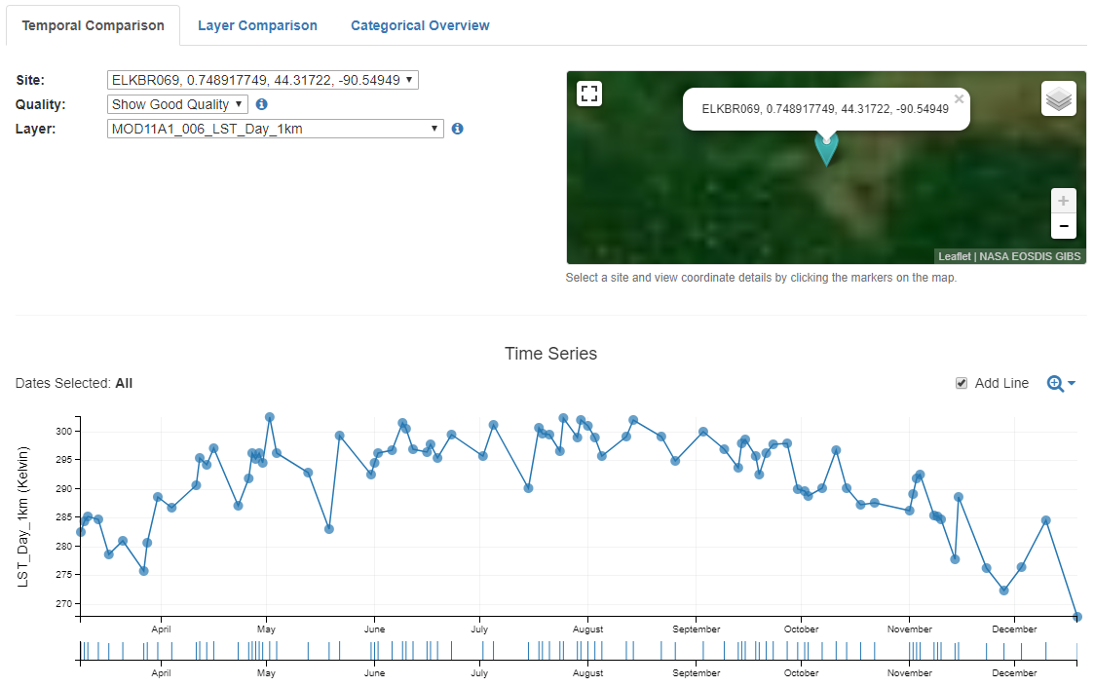

* Click on the Layer Comparison Tab
* Select ELKBR069 from the Site dropdown
* Change the Quality dropdown to Show Good Quality
* Check the Add Lines box next to the plot
  + Figure 2 shows the NBAR surface reflectance plotted for bands 1 (red) and 2 (NIR). Since plants strongly absorb visible wavelengths while reflecting NIR wavelengths, not surprisingly as the growing season gets underway we see NIR increasing while visible reflectance decreases.

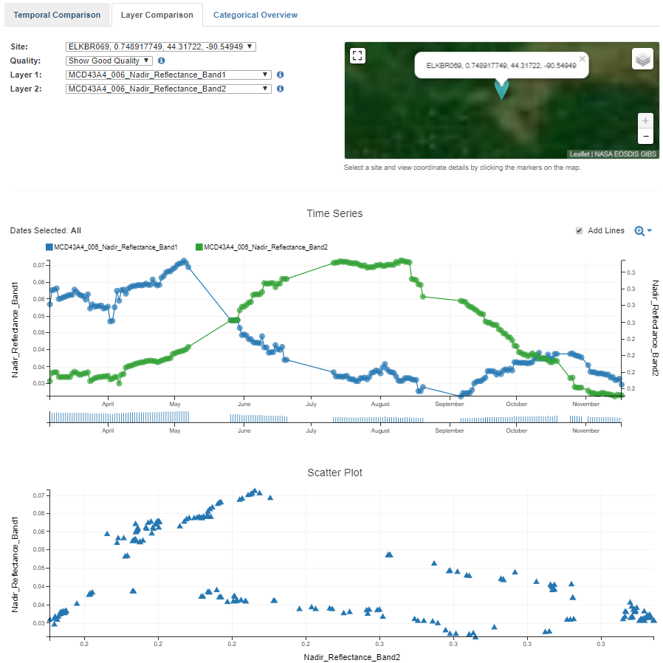

* Click on the Categorical Overview Tab
* Select MOD11A1_006_LST_Day_1km from the Layer dropdown
* Click the ‘i’ icon next to Quality
* Click on the boxplot over ‘0’, this will filter the boxplots below to only include observations of the highest quality
* notice the differences in annual LST by CPUE & trail cam location, shown in Figure 3.

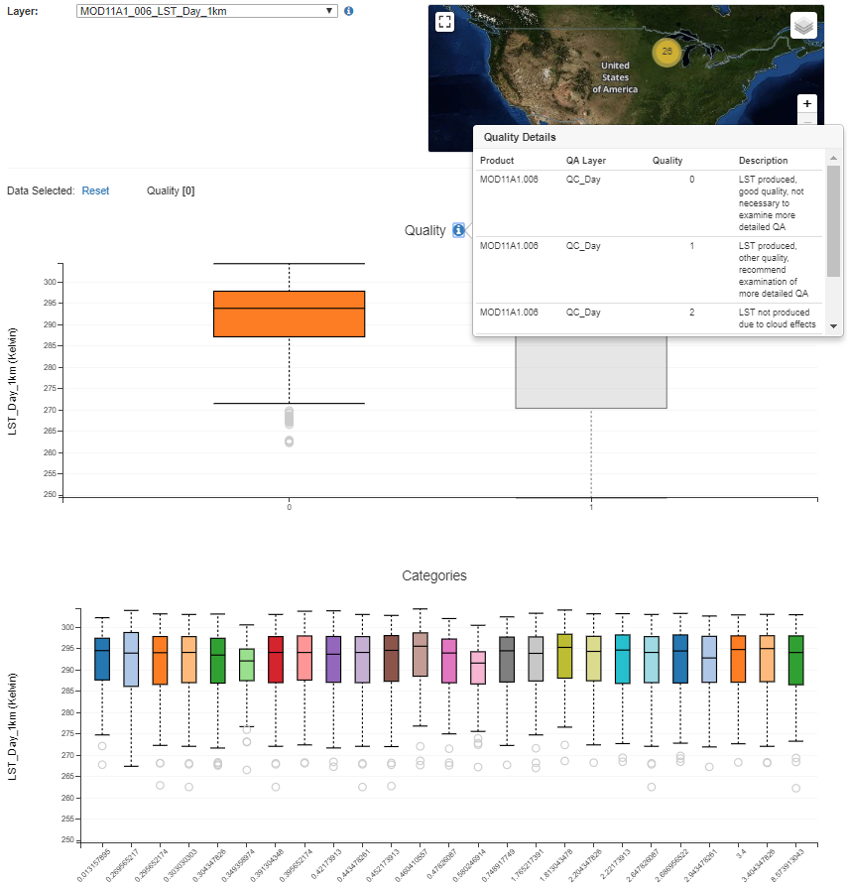

**Step 5: Downloading the Contents of an AppEEARS Request**

* Under the Explore Tab, select “Download the contents of the request” (Figure 4).

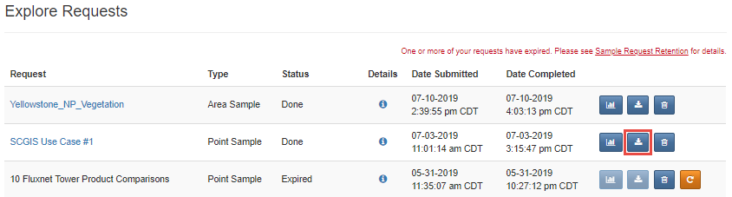

For point requests, you can download a .zip file containing all of the output files, or pick and choose the files you are looking to download. You should see the following files:

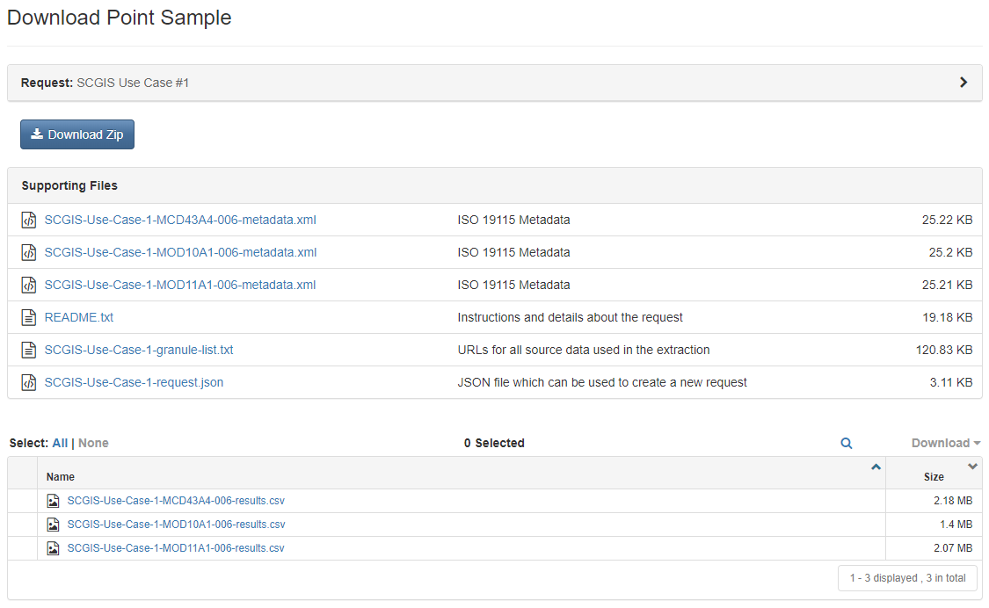

* Begin by downloading and exploring the following output files:
  + SCGIS-Use-Case-1-MOD11A1-006-results.csv
  + SCGIS-Use-Case-1-MOD10A1-006-results.csv
  + SCGIS-Use-Case-1-MCD43A4-006-results.csv
* The files above contain the values for each point in the request by variable and for each observation available.
  + The csv files also contain the bit-word descriptions for the quality value associated with each data point. In the next section, we will look at how to quickly filter your results based on quality.

**Step 6: Quality Filtering AppEEARS Outputs in Excel**

* **Land Surface Temperature**
  + Open the SCGIS-Use-Case-1-MOD11A1-006-results.csv file
  + Select all rows/columns, go to the Data Tab, and select Filter
  + Find cell M1 (MOD11A1_006_QC_Day_MODLAND_Description)
    - click on the dropdown, and uncheck the box for ‘LST not produced due to cloud effects’
  + Find Cell O1 (MOD11A1_006_QC_Day_Data_Quality_flag_Description)
    - unselect ‘TBD’
  + Find Cell B1, and select one of the trail cams to filter by
  + Highlight Columns E and I, go to the Insert Tab > Charts > Scatter Plot (w lines):

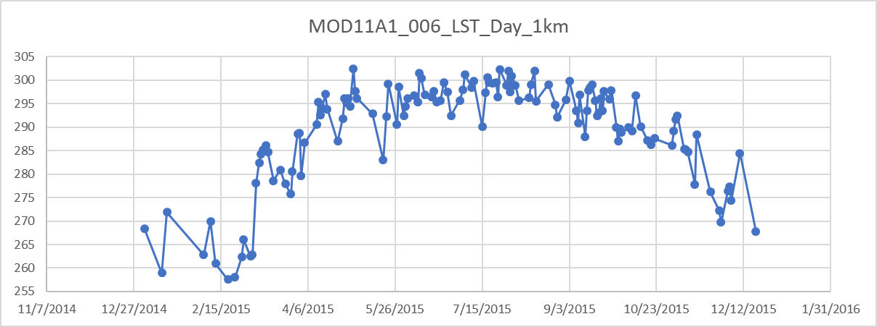

**OPTIONAL: If you wish to continue quality filtering and analysis in excel, continue below. For those interested in quality filtering and analysis in R, skip to section 8.**

* + Press ctrl+a and ctrl+c
  + Open a new excel workbook, and paste the quality filtered data into it. Save the workbook as ‘Results.xlsx’
* **Snow Cover**
  + Open the SCGIS-Use-Case-1-MOD10A1-006-results.csv file
  + Select all rows/columns, go to the Data Tab, and select Filter
  + Find cell N1 (MOD10A1_006_NDSI_Snow_Cover_Basic_QA_Quality_Mask_Description)
    - click on the dropdown, and uncheck the box for ‘unusable input or no data’
  + Find Cell Q1 (MOD10A1_006_NDSI_Snow_Cover_Algorithm_Flags_QA_Inland_Water_Description)
    - unselect ‘Yes’
  + Find Cell S1 (MOD10A1_006_NDSI_Snow_Cover_Algorithm_Flags_QA_Low_Visible_Screen_Description)
    - unselect ‘Yes’
  + Find Cell U1 (MOD10A1_006_NDSI_Snow_Cover_Algorithm_Flags_QA_Low_NDSI_Screen_Description)
    - unselect ‘Yes’
  + Find Cell W1 (MOD10A1_006_NDSI_Snow_Cover_Algorithm_Flags_QA_Combined_temperature/height_screen_Description)
    - unselect ‘Yes’
  + Find Cell AA1 (MOD10A1_006_NDSI_Snow_Cover_Algorithm_Flags_QA_Solar_zenith_screen_failed_Description)
    - unselect ‘Yes’
  + Find Cell I1 (MOD10A1_006_NDSI_Snow_Cover)
    - Only select values between 0-100
  + Find Cell B1, and select one of the trail cams to filter by (Be sure to use the same one as you used above) and press ctrl+a and ctrl+c
  + Open a new sheet in your Results workbook, and paste the quality filtered NDSI data into it
* **Surface Reflectance**
  + Open the SCGIS-Use-Case-1-MCD43A4-006-results.csv file
  + Select all rows/columns, go to the Data Tab, and select Filter
  + Find cell O1 (MCD43A4_006_BRDF_Albedo_Band_Mandatory_Quality_Band1_MODLAND_Description)
    - click on the dropdown, and uncheck the box for ‘Processed, see other QA (Magnitude BRDF Inversions)’
  + Find Cell T1 (MCD43A4_006_BRDF_Albedo_Band_Mandatory_Quality_Band2_MODLAND_Description)
    - Check ‘Processed, see other QA (Magnitude BRDF Inversions)’
  + Find Cell B1, and select one of the trail cams to filter by (use the same as above), and press ctrl+a and ctrl+c
  + Open a new sheet in your results workbook, and paste the quality filtered Surface Reflectance data into it

**Step 7: Deriving Environmental Descriptors from Remote Sensing Data in Excel**

* From the Results excel workbook:
  + Rename the sheets to ‘LST’, ‘NDSI’, and ‘SR’
  + Feel free to delete any unnecessary columns at this point, we will only be using the Category, ID, Date, and data columns from now on.
* Calculate Normalized Difference Vegetation Index (NDVI)
  + On the SR Tab, add a column titled ‘NDVI’ to the right of the Date column
  + in cell D2, type the formula: =((F2-E2)/(F2+E2))
    - fill the formula down to the end of the list
* Plot each variable by selecting the header and contents for columns C (Date) and D (data). Next go to Insert -> Scatterplot with straight lines and points
* To see how these environmental descriptors can be used to look at patterns of animal activity, be sure to check out the Snapshot Wisconsin Project:
  + <https://dnr.wi.gov/topic/research/projects/snapshot/>
  + <https://science.nasa.gov/earth-science/applied-sciences/making-space-for-earth/wisconsin-wildlife-says-cheese>
  + <https://earthobservatory.nasa.gov/IOTD/view.php?id=92178&src=eoa-iotd>
  + <https://blog.snapshotwisconsin.org/2017/07/26/how-does-nasa-play-into-snapshot-wisconsin/>

**Step 8: Looking to take it a step further? Check out the R tutorial provided:**

* Want to plot the environmental descriptors vs. Deer presence data for multiple locations? Check out the SCGIS_UseCase.R R script
  + Open a new R or RStudio instance
  + Load SCGIS_UseCase.R into your workspace (available at <https://github.com/cpkrehbiel/SCGIS_2019>), and follow the instructions in the script.