TACT Phase 1 Deliverable Report
RWE Purchase order No. 4300043916-S1-D33
This document outlines the completion of Phase 1 of the TACT (Turbulence Adjustment Computation Tool) modernization effort. The primary objectives of Phase 1 are outlined in the TACT Software Work Package document (Tasks 1-2), however additional tasks from Phase 2 have been included insofar as they relate to the Phase 1 tasks (repository design and UX development).

Phase 1 Detailed Objectives
- Define an updated, professional, and modern repository structure that follows best practices for open-source software development.
- Design intuitive user experiences for both types of “users”, e.g., TACT end-users and development/contributing users.
- Clean up codebase and remove unused/redundant code/functions (Phase 2).
- Create documentation for TACT Public API and contribution guidelines (Phase 2).
- Commit updates to CFARS/TACT GitHub as a development branch (Phase 2).

Repository Design Achievements
- Core Architecture
  - Designed a modular, extensible architecture with clear separation of concerns that follow SOLID principles wherever possible.
  - Defined core abstractions and base classes for adjustment methods
  - Created a robust registry system for adjustment methods that includes methods for defining requirements, validating data, and defining outputs.
  - Defined static-typings where possible to improve developer experience
  - Rewrote and/or updated relevant TACT functions/parameters while maintain legacy code.
- Project Structure

The repository structure was updated to separate core functionality into intuitive files and directories that are easier to read, maintain, and add to. The new directory structure is as follows:

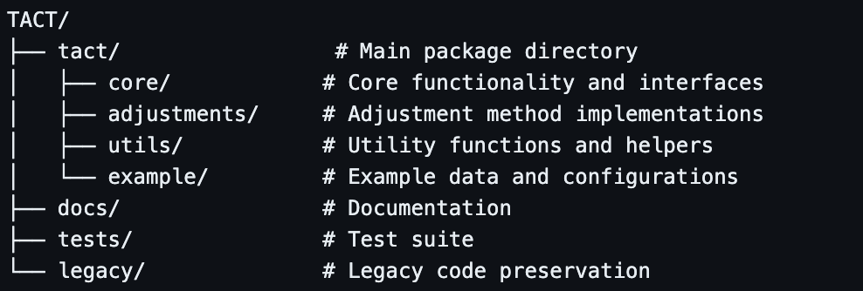
Note that the entire previous TACT codebase has been moved to /legacy.
- Development Infrastructure

The repositories development infrastructure was enhanced to improve developer and contributors experience. Key additions include:
- Doc strings on all core functions and classes
- GitHub Action-based deployment pipeline for automated documentation publishing.
- Contribution guidelines and templates to standardize contributions.

UX Design Achievements
- Improved User Interface and Program Entry Point
- Refactored program entry point (main.py) to simply program operation and integration.
- Developed clean, consistent core-API design with defined process for adding adjustment models.
- Created type-safe interfaces for all public methods
- Implemented error and validation messages to assist user with debugging.

- Created Robust Configuration System
- Designed flexible JSON-based configuration to map arbitrarily named data into the TACT system
- Added support for custom model parameters

- Add Auto-Generating Documentation System
- Implemented MkDocs for modern, responsive documentation that auto-builds from doc-strings.
- Created comprehensive API documentation structure
- Designed intuitive navigation system
- Added search functionality and code highlighting

Simplified Developer Experience
- Established clear contribution guidelines
- Created comprehensive quick start guide
- Implemented custom model creation documentation
- Added example implementations and use cases

Futureproofing + Extensibility Features Built-in
- Designed extensible plugin architecture for adding binning, statistics, and adjustment models.
- Created clear upgrade path from legacy system
- Implemented version management

Impact and Next Steps
The completion of Phase 1 has established a solid foundation for Phase 2. The new repository design and UX improvements have:
- Reduced the learning curve for new users + promote use and onboarding.
- Streamlined the development process for contributors
- Enabled faster implementation of new features
- Improved code maintainability, readability, and testing
- Improved codebase documentation

Phase 2 will focus on further refining these features and implementing Tasks 3-6 from the Work Package Breakdown, specifically:
- Adding additional adjustment models
- Creating several unit tests to ensure core functionality is maintained through future feature additions
- Further-improved documentation
- Upload to PyPi

