FIELD ENUMERATOR'S MANUAL
Universal Health Care (UHC) Survey - Year 2
Field Reference for Field Enumerators
Asian Social Project Services, Inc. (ASPSI)
Department of Health (DOH)
2026

Table of Contents
Introduction 5
Purpose of the Enumerator's Manual 5
How to Use this Manual During Fieldwork 5
Overview of the UHC Year 2 Study 6
Background of the Study 6
Study Objectives 6
Overview of the 4 Survey Tools 6
Field Team Structure and Enumerator Responsibilities 7
Composition of Field Teams 7
Responsibilities of the Field Enumerator 7
Daily Reporting to the Field Supervisor 8
Professional Conduct in the Field 8
General Fieldwork Procedures 10
Receiving Daily Assignments 10
Reviewing Assigned Respondents or Sites 10
Preparing Materials Before Fieldwork 10
Locating Assigned Facilities, Departments, or Households 10
Recording Field Notes and Comments 10
Returning Completed Work Assignments 11
End-of-Day Submission Procedures 11
Respondent Recruitment and Eligibility 12
General Recruitment Rules 12
Eligibility Screening 12
Recruiting Facility Head Respondents 12
Recruiting Healthcare Worker Respondents 13
Recruiting Inpatient Respondents 13
Recruiting Outpatient Respondents in Hospitals 14
Recruiting Outpatient Respondents in RHUs 14
Recruiting Household Respondents 14
Non-Substitution of Respondents 14
Handling Ineligible Respondents 15
Handling Respondents Who Decline Participation 15
Informed Consent Process 16
Informed Consent 16
Voluntary Participation 16
Confidentiality of Responses 16
Handling Sensitive Information 16
When to Obtain Consent 16
How to Read the Consent Statement 16
Confirming Understanding 17
Recording Consent in CAPI 17
Handling Refusal to Participate 17
Handling Interrupted Consent or Interview 18
Special Considerations for Patient and Household Respondents 18
Building Rapport with Respondents 19
Making a Good First Impression 19
Introducing Yourself and the Survey 19
Explaining the Purpose of the Survey 19
Answering Questions from Respondents 19
Assuring Confidentiality 20
Conducting the Interview Privately 20
Handling Disengaged Respondents 20
Ending the Interaction Respectfully 20
General Interviewing Techniques 22
Asking Questions as Written 22
Maintaining Neutrality 22
Language of the Interview 22
Avoiding Leading Questions 22
Probing Without Suggesting Answers 22
Not Changing the Meaning of Questions 23
Managing Respondent Fatigue 23
Handling Difficult Situations 23
Use of CAPI During Interviews 25
Basic CAPI Responsibilities of Enumerators 25
Opening Assigned Cases 25
Starting the Correct Questionnaire 25
Entering Responses 25
Required Questions 25
Entering Comments 26
Saving and Completing Interviews 26
Confidentiality and Data Security in the Field 26
Uploading Completed Questionnaires 27
Reporting CAPI Problems to the Supervisor 27
Handling Nonresponse and Callbacks 28
Types of Nonresponses 28
Callback Procedures 28
Checking Completed Questionnaires 29
Enumerator Review Before Submission 29
Responding to CAPI Prompts 29
Checking Completeness 29
Reviewing Comments 29
Correcting Allowed Errors 29
Reporting Issues to the Supervisor 29
Uploading Completed Questionnaires 30
Field Communication and Reporting Protocol 31
Communication Protocol with the Field Supervisor 31
Team Briefing Activities 31
Daily Field Reporting 31
Use of Mobile Phones and Digital Devices 31
Safety And Security Protocols 32
Enumerator Safety in the Field 32
Unfavorable Field Conditions 32
Safey Measures when Travelling 32
Adverse Event Types 33
Serious Offences 33
Managing Unsafe Situations 34
Reporting an Incident 34
Professional Conduct and Anti-Harassment Policy 35
Annexes 37
Annex A. Enumerator Daily Checklist 38
Annex B. Informed Consent Script 39
Annex C. Glossary of Survey Terms 40
Annex H. Frequently Asked Questions from Respondents 41

Introduction

Purpose of the Enumerator's Manual
This manual is your primary field reference for the Universal Health Care (UHC) Survey Year 2. It tells you how to introduce the survey, obtain consent, interview respondents, handle field problems, and submit completed work across all four survey tools: the Facility Head, Health Care Worker, Patient, and Household questionnaires.

I need to know... | Use this document
How to introduce the survey | Field Enumerator's Manual
How to obtain consent | Field Enumerator's Manual + the relevant Tool Guide
How to recruit a patient respondent | Patient Tool Guide
How to fill out the household roster | Household Tool Guide
How to resolve a CAPI login or sync problem | CAPI Manual
How to report a refusal | Field Enumerator's Manual and Field Supervisor Instruction

How to Use this Manual During Fieldwork
- Study this manual carefully before each training session, alongside the questionnaire, and write down any questions you have.
- Bring this manual to every training day and to fieldwork.
- Ask questions at any time to avoid mistakes during actual interviews. Enumerators learn a great deal from each other by discussing situations they encounter in practice.
Your training does not end when the formal training period is completed. Every time your Field Supervisor meets with you to discuss your work, your training continues, particularly during the first few days of fieldwork.

Overview of the UHC Year 2 Study

Background of the Study
Republic Act No. 11223, the Universal Health Care (UHC) Act, was signed into law on February 20, 2019. It guarantees equitable access to quality, affordable health care for every Filipino while protecting against financial hardship from health care costs. Under Section 40 of the UHC Act, the Department of Health (DOH) established the Performance Monitoring and Strategy Management Division (PMSMD) to monitor and evaluate UHC implementation.
PMSMD launched the first UHC Survey in 2023, gathering evidence from 1,135 facility heads, 11,582 health care workers, 7,824 patients, and 31,674 household members across 70 UHC Integration Sites. The UHC Survey Year 2 deepens this evidence base to assess the effectiveness, equity, and sustainability of UHC reforms.

Study Objectives
General Objective: Generate evidence on the general public's overall experience to support continuous monitoring, evaluation, and learning of the implementation of the UHC Act and its Implementing Rules and Regulations (IRR).
Specific Objectives:
- Ensure comprehensive data collection, including representation from national, regional, and local levels (provincial, highly urbanized cities, and independent component cities).
- Establish a data analysis framework through enhanced data utilization across DOH units.
- Disseminate survey findings to all concerned health stakeholders.

Overview of the 4 Survey Tools
The UHC Survey Year 2 uses four (4) instruments. Each has its own Tool Guide with detailed, tool-specific instructions.

Tool | Respondent | Mode | Duration
Facility Head Questionnaire (F1) | Facility head or authorized representative | CAPI face-to-face interview | Approximately 1 hour
Healthcare Worker Questionnaire (F2) | All health care workers at the sampled facility | Self-administered (online or offline)  Offline copies will be distributed to some areas that do not have a stable internet connection | Online or offline; approximately 30 minutes
Patient Questionnaire (F3) | Inpatient or outpatient; | CAPI face-to-face interview | Approximately 1 to 1.5 hours
Household Questionnaire (F4) | One respondent per household | CAPI face-to-face interview | Approximately 1 to 1.5 hours

Field Team Structure and Enumerator Responsibilities

Composition of Field Teams
Six (6) regional clusters will be mobilized to collect field data, each covering two to four regions. Each cluster is composed of a supervising Research Associate (RA), several Field Supervisors (FS), and Field Enumerators (FEs). Cluster sizes range from 15 to 26 FEs, depending on the number of health facilities and households to be covered. The organizational structure is shown below.

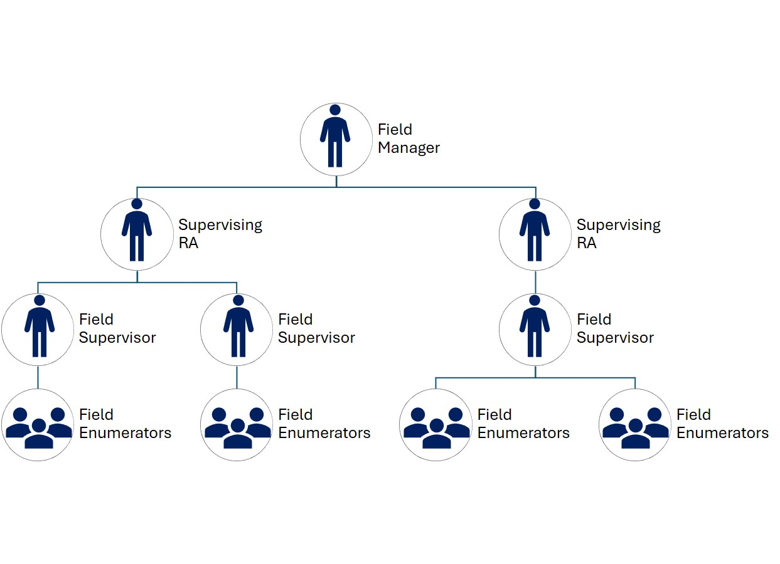
Organizational structure of the Field Team

The Field Supervisor provides guidance, monitors the quality and progress of fieldwork, verifies completed interviews, and ensures that survey procedures are followed correctly. Field Enumerators work under the direct supervision of Field Supervisors. Throughout the data collection, enumerators are expected to (1) maintain regular communication with their Field Supervisor, (2) follow instructions, and (3) report any issues encountered in the field.

Responsibilities of the Field Enumerator
As a Field Enumerator (FE), you are expected to:
- Participate in training on using the survey instrument and manual  - Coordinate with the respondents to set the schedule before administering the survey, when needed;  - Locating the structures, facilities, or households in your assignment.  - Identify and recruit all eligible respondents at those sites.  - Interviewing eligible respondents using the correct questionnaire.  - Checking completed interviews to be sure all required questions were asked and answers recorded correctly. |  | - Returning to facilities or households to interview respondents who could not be interviewed on the first visit.  - Ensure completeness and accuracy of the survey before submission to the FS  - Sync the data once there is a stable internet connection during the end of each field day.  - Submit to the FS the list of respondents, diary, and other ASPSI-required forms, such as cash vouchers for the liquidation of cash advances.

✔  DOs | - Share field experiences and problem-solving with fellow enumerators during field debriefings  - All answers to the survey questionnaire are private and confidential.

✖  DON’Ts | - Do not show a completed questionnaire to your supervisor, or discuss a specific respondent's answers, in front of any other person, including fellow enumerators.

Daily Reporting to the Field Supervisor
Purpose | - Keeps your Field Supervisor and the central office aware of your location, progress, and any problems encountered.
When to do this | - The daily reporting to the field supervisor would be at the end of every working day.  - If you cannot check in with your Field Supervisor by the agreed end-of-day time, your team will be treated as a potential incident until contact is confirmed.  - Make every effort to check in on time.
What to record (Daily Field Diary) | - Sites visited  - Interviews completed  - Any unusual events  - Your whereabouts for the day

Professional Conduct in the Field
To maintain professionalism in the field, and for the safety of all parties, and to facilitate a smooth coordination with the respondents, the Survey enumerators are expected to observe the following guidelines:

✔  DOs | - Wear your official ID badge at all times during field work.  - Carry the DOH/ASPSI endorsement letter whenever conducting interviews or coordinating with the facilities.  - Wear face mask at all times while inside any health facility.  - Travel and work in groups at all times.  - If you are assigned to interview a respondent, household, or facility staff member you know personally, notify your Field Supervisor immediately so the case can be reassigned.

✖  DON’Ts | - Do not accept unsolicited food or drink from unknown persons at the site.  - Do not discuss internal survey logistics with persons outside the team.  - Do not accept gifts or money from respondents, facility staff, or LGU officials.  - Do not use personal phones for calls or social media while conducting an interview.

General Fieldwork Procedures

Receiving Daily Assignments
Your Field Supervisor will brief you each morning on the day's work and explains how to locate your assigned facilities or households.

Reviewing Assigned Respondents or Sites
Review your assignment as soon as you receive it and ask any questions you might have. Your field supervisor will not always be available once fieldwork begins. Confirm you know the location of your assigned facilities or households and have sufficient materials (maps, written directions) to find them, and that you understand any special instructions.
Before departing each morning, confirm with your Field Supervisor that you are reachable and share your day's itinerary. In areas with poor mobile signal, your supervisor will designate a check-in point where connectivity is available and set the time by which you must report.

Preparing Materials Before Fieldwork
Before starting fieldwork each morning, verify that you have everything you need.
Task / Item
- Fully charged tablet
- Enumerator's Manual (downloaded in tablet)
- Identification badge
- Blue ink pens
- A bag to carry your tablet and other materials
- A blank paper questionnaire

Locating Assigned Facilities, Departments, or Households
Use the maps or written directions provided with your assignment. For households, use the listed address and confirm any special access instructions from your supervisor.

Recording Field Notes and Comments
Record anything out of the ordinary that occurred during the interview in the comments section at the end of the questionnaire. These comments help your supervisor check questionnaires and are used in the office to resolve problems during secondary editing.

Returning Completed Work Assignments
At the end of the day, send your completed questionnaires to your Field Supervisor. Be ready to report any problems you experienced locating a household or completing an interview.

End-of-Day Submission Procedures
Upload completed interviews to the central server by 10:00 PM the same day. For household interviews specifically, upload before leaving the barangay, or by 10:00 PM at the latest.

CALL | - A team that does not check in by the agreed end-of-day time is treated as a potential incident until contact is confirmed.

Respondent Recruitment and Eligibility

General Recruitment Rules
All four respondent groups are adults — 18 years or older, or adults by virtue of their professional role in the case of facility heads and health care workers. No minors should be included in this study.

Eligibility Screening
The inclusion criteria for the different respondents is tabulated below.
Respondent Group | Description
Facility Heads (FH) | Respondents are:  - Head of facility or authorized representative;  - With a minimum 6 months in position;  - 1 FH per selected facility
Healthcare Workers (HCW) | Respondents are:  - All health workers (e.g. Physicians/Doctors, Nurses, Midwives, Dentists, Pharmacist, etc.)  Barangay Health Workers (BHWs) are excluded.
Patients | Respondents are:  - Inpatients at point of discharge  - Outpatients who have completed consultation
Household Members* | Respondents are:  - Household head or  - Member of the household who is health decision-maker
* The household survey is conducted in 8 sites (4 UHC IS, 4 non-UHC IS), one per island group per site type. The household survey targets a minimum of 2,670 households nationwide.

Patient respondents are 18 years or older. Where an admitted patient is a minor, the accompanying adult caregiver serves as respondent on the patient's behalf (not the minor). The caregiver signs the ICF.

When approaching a prospective respondent, briefly observe whether they appear to be in pain, confused, emotionally distressed, or otherwise unfit to participate. If so, do not begin the interview. Record the situation and move on to the next eligible respondent.

Recruiting Facility Head Respondents
The respondent is the facility head (such as a municipal or city health officer, rural health physician, or chief of hospital) who has held the position for at least six months. Ideally, the interview happens the same day as the facility visit. When facility head is unavailable, ask them for the authorized/ designated representative. When both the facility head or representative are unavailable, make at least 3 contact attempts on 3 separate days and at different times before classifying the facility as non-responsive.

✎ RECORD | - Fill in the Facility Contact Log with the following information: date, time, method, and outcome of every attempt.

CALL | - If the minimum contact protocol is exhausted, the case is submitted for replacement from the same stratum (UHC IS or non-UHC IS, facility type, geographic area), with your Field Supervisor's approval.

Recruiting Healthcare Worker Respondents
All health care workers at a sampled facility during the data collection window are eligible to participate in the survey. The survey is self-administered online or offline (for facilities with poor internet connectivity). The survey will be administered/ made available for up to 3 days.

CHECK | - A minimum facility-level response threshold of 60% of the master list is required.  - If responses are 40% or below at the midpoint of the 3-day window, your Field Supervisor will initiate a follow-up reminder to the facility focal person.

Recruiting Inpatient Respondents
The respondent must be an admitted patient at the point of discharge from a selected hospital. There is no minimum age requirement — an adult household member may sign the consent form if the respondent cannot, also the companion should answer in behalf of the patient. The companion must be 18 years old and above. You will be stationed at the discharge or billing area(s) and use a randomized waiting-interval procedure generated in CSPro.

✖  DON’Ts | - Do not enter hospital wards for any data collection activity, in order to reduce infection risk and protect patient privacy.

✎ RECORD | - Patient Listing Form (Annex H): contact number and, optionally, family name of each patient who agrees to be listed.

Recruiting Outpatient Respondents in Hospitals
Outpatients present in the OPD ward become eligible only after completing their OPD consultation, not while waiting or mid-consultation. You will be stationed in the OPD area and use a convenience-intercept approach within a prescribed per-facility interview quota. Since it is likely that hospitals would have different OPD arrangements and schedules, your FS will provide you more specific instructions on how to do this.

Recruiting Outpatient Respondents in RHUs
Patients present at the facility or pre-listed on the day's consultation roster are eligible, including both walk-ins and scheduled patients. Apply a systematic random selection with a random start to the daily consultation list. The sampling interval is computed using the following equation:

Recruiting Household Respondents
Only one respondent should be interviewed per household. The respondent must be 18 or older, have resided in the barangay for at least 6 months. The respondent should be head of household or the person mainly responsible for health-related decisions. Individuals who are too ill or have cognitive limitations affecting their understanding are excluded from participating.

Apply a systematic random selection. The sampling interval is computed using the following equation

Your FS will be providing you with the pre-determined route from the barangay hall or barangay health center to be taken to identify and select eligible households. This is to ensure that the barangay can be covered by the Fes.

Non-Substitution of Respondents
Once a household is selected, only the eligible respondent should be interviewed (see table above). For both inpatient and outpatient respondents, replacement follows a strict systematic-interval procedure, not your own discretion.

✖  DON’Ts | - Do not substitute a different, more convenient household member or patient for the one selected by the sampling procedure.  - Do not deviate from the eligibility criteria for the survey. v

Handling Ineligible Respondents
Move to the next patient or household in sequence, following the systematic selection rule. Document the ineligible encounter — including the reason and its position in the sequence — on the relevant listing form.

Handling Respondents Who Decline Participation
Document every refusal without pressure. It is important to remember that no interview proceeds without prior signed consent.
Tool | Where to document the refusal
Facility Head | Facility Contact Log
Health Care Worker | No individual-level log (self-administered census)
Patient | CSPro, with a newly generated random interval before continuing (Code '4' REFUSED)
Household | Supervisor App
Recommendation: Request the complete CAPI disposition/result code list from the CAPI Manual or CSPro programming team so this chapter and Annex F ("Common CAPI Errors") cite the authoritative, complete set rather than the partial list found in the SOPs.

Informed Consent Process

Informed Consent
Informed Consent means that respondent voluntarily agrees to participate after receiving sufficient information about the study. The respondent must consent to participate in the study before administering the survey. They need to sign/ complete the ICF. No data may be collected from any respondent before valid, signed consent is obtained.

Voluntary Participation
Participation in the UHC Survey Year 2 is entirely voluntary for all four respondent groups. Respondents may decline to participate, or stop at any point, without penalty and without any effect on their care or employment.

✔  DOs | - Explain to the prospective respondent that they can choose to participate or not in the study  - Encourage them ask questions about the study, expectations about their participation and details about their participation  - State clearly and sincerely that the respondent may stop at any time and that this will not affect their care or standing at the facility.

Confidentiality of Responses
All personally-identifiable data collected during the survey never shared outside the study team or included in any report. Survey responses should be kept confidential as well. Names and other personally identifiable responses will be stored separately from responses in a secure location.

Handling Sensitive Information
Some survey questions cover topics such as out-of-pocket health expenses and the financial impact of seeking health care. These topics may be sensitive for some respondents, particularly those who have recently experienced illness or hospitalization.

When to Obtain Consent
Consent must be obtained before the administration of the survey questionnaire.

How to Read the Consent Statement
Read the full Informed Consent Form (ICF) aloud, exactly as written. The ICF has is in English and has been translated to the major Filipino dialects. The ICF is included in the Facility Head, Patient and Household forms. Every form covers:
- The study's purpose,
- Approximate duration of the engagement
- Confidentiality and privacy commitments
- The residual risk of data exposure and the commitment to notify the respondent if it occurs,
- Expected risks and benefits,
- Full voluntariness, and
- SJREB/DOH/ASPSI contact information for concerns.

✖  DON’Ts | - Do not summarize or skip any part of the consent form, even if the respondent seems impatient.

Confirming Understanding
Pause after reading the form and ask if the respondent has any questions. Answer their questions truthfully. Give more time to respondents who seem unsure. If any doubt remains, do not proceed.

Recording Consent in CAPI
Respondent | How consent is captured | If unable to sign
Facility Head | Signature on paper ICF (Annex K); | Complete the witness-signature option
Health Care Worker | Completing the digital page or paper form (Annex L) is consenting to participate
Patient | Signature on paper ICF (Annex M) | If minor, the adult caregiver may witness-sign
Household | Signature on paper ICF (Annex N) | Complete the witness-signature option

Patient respondents are ordinarily 18 years or older. Where an admitted patient is a minor, the accompanying adult caregiver serves as respondent on the patient's behalf (not the minor); the caregiver signs the ICF.

Handling Refusal to Participate
If the respondent declines after the informed consent process, the interview does not proceed. Document the refusal in the tool-appropriate log (facility contact log, CSPro, or Supervisor App).

Handling Interrupted Consent or Interview
If a patient wishes to finish the interview at a separate time, collect their contact details and re-administer the full consent process before resuming. If a respondent is called away mid-interview, the session suspends and the partial CAPI record is preserved automatically.

Special Considerations for Patient and Household Respondents
A physically incapacitated patient may have an adult household member sign as a witness. This attests that the consent process was properly conducted with the patient present, not that the household member is a proxy respondent.

Building Rapport with Respondents

Making a Good First Impression
A positive first impression helps establish trust and encourages respondent participation. When you arrive, do your best to make the respondent feel at ease. Open with a smile and a greeting such as "good morning" or "good afternoon," then proceed with your introduction.

✔  DOs | - Be friendly, courteous, and respectful when interacting with respondents.  - Dress professionally and maintain a neat appearance.  - Practice introducing yourself to ensure you can communicate confidently and clearly.

Introducing Yourself and the Survey
State your name and your affiliation with Asian Social Project Services, Inc. (ASPSI) and mention that the Department of Health funded the study. Then deliver the introduction spiel that is built into the relevant consent form for the respondent type you are interviewing. You can just make slight adjustments to the spiel to make it more comfortable and conversational.

✖  DON’Ts | - Do not adopt an apologetic manner or use questions like "Are you too busy?". These invite refusal before you even start.

SPIEL | "Hello, my name is (data collector name). I work for Asian Social Project Services, Inc. (ASPSI). I am here to invite you to participate in a survey on the Universal Health Care (UHC) and packages of programs like YAKAP, ZBB, BUCAS, and GAMOT. The Department of Health funded this study. Please let me tell you more about the study."  [sample spiel]

Explaining the Purpose of the Survey
As a Field Enumerator, it is your task to explain that the study aims to generate evidence on the public's experience of UHC Act implementation to support monitoring, evaluation, and learning, and mention the specific PhilHealth programs (YAKAP, ZBB, BUCAS, GAMOT) relevant to the respondent.

Answering Questions from Respondents
Be direct and pleasant when answering respondents’ question.
Question | Respond
How long the interview will take | State the estimated duration for that tool
The respondent asks about being inconvenienced | Offer to return at another time that is convenient to them
The respondent wants to discuss a topic in more depth mid-interview | Offer to to talk further after the interview so as not to interrupt its flow
The respondent asks questions on specific services and/or PhilHealth benefits that are beyond the scope of the survey | Refer them to the appropriate office (Health Office, Hospital Administration or PhilHealth Office)

Assuring Confidentiality
If a respondent asks what the data will be used for, explain that the information collected remains confidential, no individual names will be used for any purpose, and all information is grouped together for reporting.

Conducting the Interview Privately
Select a private location within the facility or home before you begin. If you notice that others nearby can overhear, reposition the interview (see also Chapter IV.C).

Handling Disengaged Respondents
If the respondent is shy, afraid, bored, or gives an irrelevant answer, spend a few moments on small talk unrelated to the survey, such as their town, the weather, their daily activities, before returning gently to the question.

✎ RECORD | - If the respondent is reluctant to answer a specific question, explain once more that the information will be strictly confidential.  - If they are still reluctant, write "REFUSED" as a comment to that question in CAPI and continue as if nothing had happened. The respondent cannot be forced to answer.

Ending the Interaction Respectfully
After confirming that all applicable questions have been completed, thank the respondent for their time and participation. Provide the designated token of appreciation as a gesture of gratitude for their cooperation in the survey.
Respondent | Token
Facility Head | No token
Healthcare Workers | Raffle entry (Raffle Price: 1,000)
Patient | PHP 100.00
Household Head | PHP 100.00

General Interviewing Techniques
Successful interviewing is an art, not a mechanical process, but certain basic principles are followed by every successful enumerator. This chapter establishes the core neutral-interviewing discipline you must follow, regardless of which tool you are administering.

Asking Questions as Written
Read each question exactly as displayed or written. Avoid summarizing or paraphrasing. You may reword a question only if the respondent does not understand it, and only without changing its meaning.

Maintaining Neutrality
Never signal through your facial expression, body language or tone of voice that an answer is "right" or "wrong." The questions are carefully worded to be neutral.

Language of the Interview
Questionnaires are translated into major Philippine dialects (Tagalog, Ilocano, Bicolano, Hiligaynon, Bisaya, Waray and Cebuano). Local enumerators are assigned to areas where their dialect is spoken. Where possible, avoid using an interpreter, since this can affect interview quality and length.

✖  DON’Ts | - Never use a respondent's husband, or a child of any age, as an interpreter.

Avoiding Leading Questions
Avoid asking questions or making statements that may influence the respondent’s answer. Read each question exactly as written and allow the respondent to answer in their own words. Do not suggest, imply, or encourage a particular response through your wording, tone of voice, facial expression, or body language.

Probing Without Suggesting Answers
Probing is the technique of asking neutral follow-up questions to obtain complete, accurate, and relevant responses without influencing the respondent’s answer. Do not suggest answers based on what you understood. Do not finish the respondent’s sentences. Allow them to think through their answer and express themselves completely. Minimize asking probing questions as much as possible.

✔  DOs | - Use neutral probes  - Pwede niyo po bang ipaliwanag ang ibig ninyong sabihin?  - Pwede niyo po bang i-klaro pa nang kaunti ang sagot niyo?  - Mayroon pa po ba kayong ibang rason?

✖  DON’Ts | - Probe when:  - The respondent is visibly annoyed or irritated  - The respondent already gave a clear and comprehensive answer

Not Changing the Meaning of Questions
The wording and sequence of questions must be maintained. If a respondent does not understand a question, repeat it slowly and clearly first; only reword it if the problem persists, and never in a way that alters its original meaning.

Managing Respondent Fatigue
Ask questions slowly and pause after each one to give the respondent time to think. If the respondent pauses, appears fatigued, or looks confused, slow down, offer a brief break, or ask if they would like to continue. If the respondent becomes distressed or fatigued, pause immediately and offer to stop. If they wish to finish at a separate time, collect their contact details and re-administer the full consent process before resuming. A shorter completed interview is always preferable to a full interview conducted under distress.

Handling Difficult Situations
Situations covered here include a respondent saying "I don't know," giving irrelevant or elaborate answers, or refusing mid-question, as well as recognizing signs of distress.

Difficult responses. When respondents provide difficult or incomplete responses, survey enumerators should respond appropriately while respecting the respondent's autonomy.
Respondent response | Possible reason | Appropriate response
“I don’t know” | Respondent does not understand the question | Repeat the question. If necessary, explain it using simpler language without changing its meaning.
 | Respondent needs time to think | Allow time for the respondent to determine their response.
 | The question is too personal or the respondent fears being judged. | Reassure the respondent that all responses are kept strictly confidential and that personally identifiable information will not be associated with survey responses.
 | The respondent genuinely does not know the answer. | Select the "Don't know" response option in the questionnaire.

The respondent refuses to answer.
- Remind the respondent that answers are kept strictly confidential and will not be shared with anyone else.
- Maybe the respondent refuses because they fear that someone else might be listening. Make sure that the interview is not attended by any other person.
- Choose the “Refuse to answer” option

When recording “Others, please specify” responses
- Check carefully whether answers fit existing categories first; probe if you’re unsure – never just guess!
- Strive to correctly encode responses, avoid misspelling words
- Encode the response as you hear it, before submitting the form, translate the original answer into English

When the respondent experiencing distress.
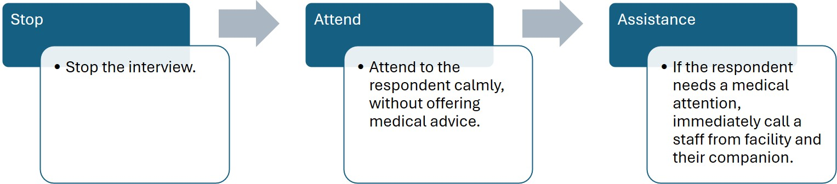

CALL | - Notify your Field Supervisor immediately

Use of CAPI During Interviews
This chapter covers what you need to know operationally about CAPI in the field. It does not duplicate the standalone CAPI Manual, which covers the application's mechanics in full detail.

Basic CAPI Responsibilities of Enumerators
All interviews, except the self-administered Health Care Worker survey, are conducted using the CAPI application on Android tablets. Confirm all required fields are complete before closing each record.

Opening Assigned Cases
Opening your assigned case using the procedures describes in the CAPI Manual (see Chapter __). Follow the instructions for logging in, synchronizing data, downloading assignments, and opening the appropriate case before beginning an interview. If you encounter any technical issues while accessing assigned cases, refer to the trouble shooting section (see Chapter _) of the CAPI Manual.

CALL | - When the issue cannot be resolved at your level, contact your Field Supervisor.

Starting the Correct Questionnaire
CHECK | - Select and confirm the correct module (Facility Head, Patient inpatient/outpatient, or Household).  - For patients, confirm the box (outpatient/inpatient) matches the Patient Listing Form.

Entering Responses
Read each question as displayed on the tablet and record the response. When a respondent cannot recall a specific figure, use the designated "don't know" option rather than pressing for an estimate. Secondary data items that require facility records are flagged for follow-up.

Required Questions
The CAPI includes built-in validation checks to help ensure that the questionnaire is completed accurately and consistently.
CAPI built-in validation | Definition
Required Questions | - Questions marked as required must be answered before the enumerator can proceed to the next question.  - This helps ensure that all mandatory information is collected during the interview.
Soft Warning | - The CAPI system displays a Soft Warning when a response appears inconsistent with a previous answer or falls outside the expected range.  - Enumerators should review the response with the respondent and make corrections if necessary. If the response is confirmed to be correct, the enumerator may proceed without changing the answer.
Hard Warning | - The CAPI system displays a Hard Warning when an error must be corrected before the interview can continue.  - Enumerators must review and correct the response in accordance with the respondent’s answer before proceeding to the next question.

NOTE | - CAPI validates entries at the point of collection, flagging missing required items, inconsistent or out-of-range responses, and mis keyed patient types (for example, the wrong outpatient/inpatient box).  - Most discrepancies are caught and resolved the same day during your Field Supervisor's daily review.

Entering Comments
Record anything out of the ordinary and other observations in the comments section, the survey enumerators can comment in each question of the questionnaire. Your Field Supervisor uses this for quality control, and the office uses it for secondary-editing troubleshooting.

Saving and Completing Interviews
If a respondent is called away mid-interview, the session suspends and the partial CAPI record is preserved automatically for resumption at the respondent's convenience. At the conclusion of the interview, confirm all required fields are complete before closing the record.

Confidentiality and Data Security in the Field
Data collected in the field is stored only on authorized devices, carried by or under the direct supervision of authorized personnel at all times. CAPI encrypts data in transit to a secure central server. Data at rest on the tablet is likewise encrypted and accessible only through the enumerator's authorized login

Uploading Completed Questionnaires
NOTE | - Upload or sync completed interviews to CSWeb/the central server daily by 10:00 PM.  - Upload household records before leaving the barangay or by 10:00 PM the same day at the latest.

Reporting CAPI Problems to the Supervisor
The data programmer is tasked to resolve application errors and sync failures. S/he can manually recover unsynced interview cases directly from a tablet.

NOTE | - Escalate problems up the reporting chain (Field Enumerator Field Supervisor Supervising RA Data Programmer)

Handling Nonresponse and Callbacks

Types of Nonresponses
- Respondent not available
- Incomplete or interrupted interview
- Incapacitated respondent

Situation | Action/s to take | Note
Respondent Unavailable | - Ask a neighbor or household member when the respondent will return. Make at least 3 contact attempts at different times of day.  - Enter Code '2' (NOT AT HOME) in CAPI | Do not make all 3 visits in a single day and then stop.
Partial or Interrupted Interview | - Arrange to see the respondent again as soon as possible.  - collect contact details  - Re-administer consent before resuming the interview at a later time.  - Enter Code '5' (PARTLY COMPLETED) in CAPI. | A partial interview resulting from an adverse event or safety incident may not be submitted unless the respondent explicitly agreed to continue.

Callback Procedures
Type of callback | Callback process
Household callbacks | - Prioritize evening or weekend visits
Patient callbacks | - Attempt to complete within the same day whenever possible, since inpatients may be discharged
Facility Head callbacks | - Schedule around the facility head's stated availability

✔  DOs | - A minimum of 3 attempts across different days and times applies to households, inpatient cases, and facility-head cases alike.  - Make callbacks at a different time of day than earlier visits — for example, a morning callback after an afternoon visit — to reduce nonresponse.  - Review your notes each morning for scheduled appointments before taking on other assignments.

✎ RECORD | - Cases that exhaust the minimum contact protocol are submitted for replacement per Annex O of the Survey Protocol.  - Document every contact attempt with date, time, method, and outcome in the tool-appropriate log: facility contact log, CSPro, Visit Sheet, or Supervisor App.

Checking Completed Questionnaires

Enumerator Review Before Submission
Review each questionnaire before leaving the household or facility to confirm every appropriate question was asked and that all answers are clear and reasonable. If you find a keying error affecting skip patterns, re-ask the affected question(s), explaining the error to the respondent.

Responding to CAPI Prompts
Resolve flagged missing, inconsistent, or mis-keyed items at the point of entry before moving on

Checking Completeness
Confirm all required fields are complete before closing the CAPI record (echoes Chapter X.H). CAPI's built-in validation flags missing required items automatically.

As part of routine quality control, your Field Supervisor may conduct a brief follow-up verification visit or call with a respondent you interviewed. This is a standard part of every enumerator's work, not a sign that an error is suspected.”

Reviewing Comments
Confirm that anything unusual during the interview is captured in the comments section. Your Field Supervisor uses comments for quality control, and the office uses them during secondary editing.

Correcting Allowed Errors
If you discover an error before leaving the respondent, correct it immediately in CAPI. If discovered after leaving and the respondent is still reachable, return the same day or early the next morning and correct the record in CSEntry — never on paper. Do not fabricate or guess a correct answer. If the respondent cannot be reached, leave the field blank or use the 'Not collected' code, per protocol.

Reporting Issues to the Supervisor
Your Field Supervisor reviews questionnaires at the end of each working day and returns records with issues for correction.

CALL | - Report any completeness, comment, or CAPI-prompt issue that cannot be resolved in the field to your Field Supervisor before leaving.

Uploading Completed Questionnaires
✔  DOs | - Upload to CSWeb daily by 10:00 PM (see Chapter X.I for the full procedure).

Field Communication and Reporting Protocol

Communication Protocol with the Field Supervisor
CALL | - Confirm reachability and itinerary with your supervisor each morning. Schedule regularly check-in with your Field Supervisor.  - Contact your Field Supervisor immediately by phone or message when a threat or incident arises, or the supervising Research Associate if your Field Supervisor is unreachable.  - In areas with poor mobile signal, use the check-in point and time your Field Supervisor designates.

Team Briefing Activities
Your Field Supervisor will be holding daily Start-Of-Day briefings to go through your assignments for the day. At the end of each data collection day, your Field Supervisor will hold another debriefing meeting to discuss issues. Before leaving an area, a Lessons Learned Session (LLS) will be conducted together with the Field Supervisor.

Daily Field Reporting
✎ RECORD | - Submit your Daily Field Diary — sites visited, interviews completed, unusual events, and whereabouts — to your Field Supervisor.

Use of Mobile Phones and Digital Devices
✔  DOs | - Keep a fully charged mobile phone with you at all times during field deployment.  - Always secure your tablet in a storage/area where the gadget as well as the data is safe and secure, away from other people who are not involve in the project.

✖  DON’Ts | - Never leave a tablet unattended.  - Do not display or announce tablets or data storage devices in a way that could invite theft.

Safety And Security Protocols

Enumerator Safety in the Field
✔  DOs | - Remain within proximity of a teammate, or within communication reach of your Field Supervisor, at all times.  - No enumerator works alone.

✖  DON’Ts | - Do not enter an unfamiliar or isolated location without your Field Supervisor's explicit clearance.

Unfavorable Field Conditions
Fieldwork shall be suspended when weather or environmental conditions pose a risk to the safety of field staff. Fieldwork shall not be conducted in areas where:
NOTE | - PAGASA has issued Tropical Cyclone Wind Signal (TCWS) No. 2, 3, 4, or 5.  - PAGASA has issued a Red Rainfall Warning for the area.  - PHIVOLCS has reported an earthquake with an intensity of V (5) or higher in the area.

The conditions listed above are not the only circumstances under which fieldwork may be suspended. If field conditions remain unsafe despite the absence of active advisories (e.g., flooded roads, impassable routes, or other hazards following a typhoon or other disaster), survey enumerators shall immediately inform their Field Supervisor (FS). The FS will assess the situation and determine whether fieldwork should be postponed or suspended.

Safey Measures when Travelling
✔  DOs | - Always use registered public utility vehicles (PUVs) when travelling. Avoid using unregistered or "colorum" vehicles.  - Familiarize yourself with public transportation routes and schedules, especially in rural areas where transport services may be limited or unavailable outside certain hours.  - Consider travel time between the data collection area and your home or accommodation when planning daily schedules and assigning interview targets.  - Always comply with traffic rules and regulations while travelling.  - Field staff using their own vehicles shall carry all required documents, including a valid driver's license, vehicle registration, and insurance.  - Field staff using motorcycles or bicycles shall wear appropriate safety gear, including a helmet, and regularly inspect their vehicle to ensure that tires, brakes, lights, and other essential components are in good working condition.

Adverse Event Types
Adverse events are any unexpected or undesirable incidents that occur during or immediately after the interview and may negatively affect the respondent’s emotional well-being, physical condition, privacy, confidentiality, safety, or willingness to participate.
Type | Signs
Emotional distress | The respondent becomes visibly upset, tearful, anxious, or refuses to continue.
Physical discomfort or deterioration | The respondent shows signs of pain, dizziness, difficulty breathing, or worsening physical condition.
Privacy or confidentiality breach | The interview is overheard, or the respondent believes that their identity or responses may have been exposed.

When you notice that your respondent is distressed, do the following:
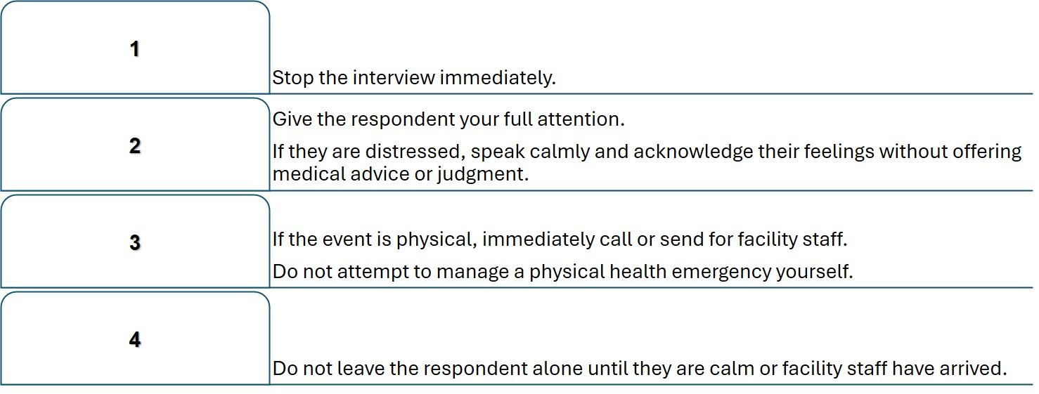

CALL | - Notify your Field Supervisor immediately by phone or message.  - Describe what happened, the respondent's current condition, and the actions you have taken.

Serious Offences
Field staff are expected to uphold the highest standards of professionalism, integrity, and ethical conduct throughout the duration of the project. The following acts are considered serious offences and may result in disciplinary action, including removal from the project, depending on the nature and severity of the violation. The following are grounds for disciplinary action, which may include removal from the project:
- Reporting for work while intoxicated or becoming intoxicated during work, resulting in the inability or impairment to perform assigned duties.
- Using abusive or insulting language, or behaving in a manner that is disrespectful toward respondents, colleagues, or other stakeholders.
- Proven cases of data fabrication or falsification.
- Multiple and/or repeated absences without just cause or without prior notice.
- Collusion or cheating during training assessments
- Accepting gifts or money from respondents or facility staff
- Use of personal devices during an interview.

Managing Unsafe Situations
If the threat involves active violence, armed confrontation, or immediate risk to life, do not wait for instructions. Leave immediately by the safest route and contact your Field Supervisor and 911 as soon as it is safe. Do not attempt to recover tablets, bags, or materials if doing so would put you in further danger.
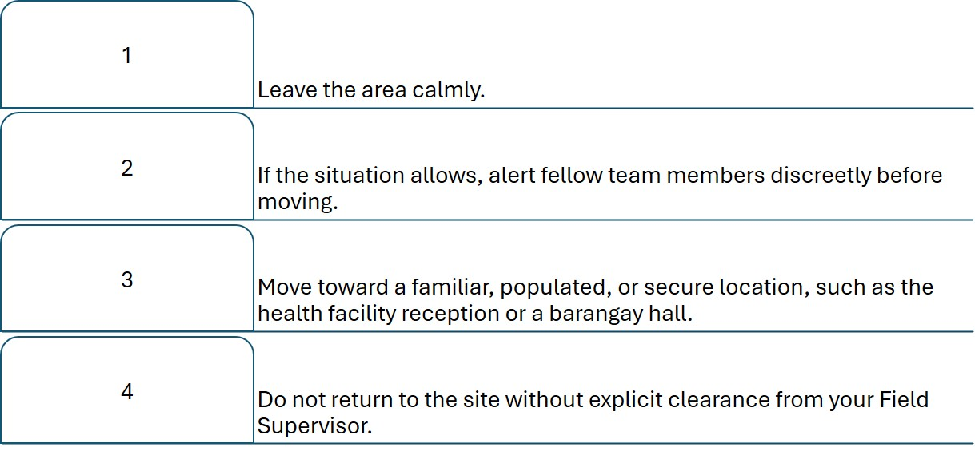

Reporting an Incident
If an adverse incident, threat, unfavorable field conditions occur, your safety and your team's safety come first. Documentation always comes second.
Situation | Immediate Action
You or a teammate is seriously ill or injured | Seek medical attention first. Contact your Field Supervisor as soon as it is safe.
Vehicle accident | Check that everyone is safe. Contact local emergency services if needed, then your Field Supervisor.
Natural disaster or severe weather (flood, earthquake, typhoon) | Withdraw to a safe location. Do not resume fieldwork until your Field Supervisor confirms it is safe.
Security threat or violence | Leave immediately by the safest route. Do not confront anyone. Contact your Field Supervisor and, if there is immediate danger, 911.
Theft or loss of a tablet or equipment | Move to safety first. Do not attempt to recover the item if doing so puts you at risk.

CALL | - Notify your Field Supervisor immediately by phone or message.  - Describe what happened, the respondent's current condition, and the actions you have taken.

✎ RECORD | - As soon as it is safe to do so, and ideally before you leave the location, write down:  - Date and time the incident occurred  - Location (facility / barangay / municipality)  - Who was involved (yourself, a teammate, a respondent, or a third party)  - What happened, in your own words, as completely and factually as you can

These are your raw field notes, not the official report. Your Field Supervisor uses them, together with your verbal account, to complete the Incident Report Form (Annex J) and to notify the RA/FM — who require a written report within 24 hours. Keep your notes even after you've reported verbally; the FS may need to check them again when writing that report.

✖  DON’Ts | - Do not delay reporting to "handle it yourself" first. Do not attempt to resolve a security threat before withdrawing to safety.

Professional Conduct and Anti-Harassment Policy
” subsection: definition of harassment, a statement that it will not be tolerated from or toward any party in the field, and the reporting channel (immediate report to FS, or to the RA/FM if the FS is implicated).

Annexes

Annex A. Enumerator Daily Checklist
Complete this checklist every morning before leaving for fieldwork, and again before leaving each site.

OK | Task / Item
[ ] | Fully charged tablet
[ ] | Enumerator's Manual (downloaded in the tablet)
[ ] | Identification badge
[ ] | Blue ink pens packed
[ ] | Bag for tablet and materials packed
[ ] | A few blank paper questionnaires packed
[ ] | Reachability and itinerary confirmed with Field Supervisor
[ ] | Assignment reviewed; location and any special instructions understood
[ ] | Notes checked for scheduled callback appointments

Annex B. Informed Consent Script
Read the applicable consent form aloud, in full, exactly as written. The core opening is reproduced below from the Facility Head Informed Consent Form as a representative example; the Patient, Household, and Health Care Worker forms follow the same structure with the variations noted in the table beneath.

"Hello, my name is (data collector name). I work for Asian Social Project Services, Inc. (ASPSI). I am here to invite you to participate in a study about the Universal Health Care (UHC) and packages of programs like Yaman ng Kalusugan Program (YAKAP), No Balance Billing (NBB), Zero Balance Billing (ZBB), Bagong Urgent Care and Ambulatory Services (BUCAS), and Guaranteed and Accessible Medications for Outpatient Treatment (GAMOT). This is a Department of Health funded this study.
Please let me tell you more about the study. This study aims to generate evidence on the overall experience of the general public to support continuous monitoring, evaluation, and learning of the implementation of the UHC Act and its Implementing Rules and Regulations (IRR).
We are committed to protecting your privacy. If you choose to participate, we will never include your name in information shared with the government or in any reports. Aside from this, there are no other risks to you if you take part in this study. You are free to decline participation or to stop at any time. Choosing not to participate will not result in any penalty, and you will not have to pay anything to take part in this study. Do you have any questions about the study or about what I have told you?"

Tool | Key variation from the core script
Facility Head (Annex K) | No token of appreciation mentioned; approximate duration "more or less than an hour"
Health Care Worker (Annex L) | Mentions entry into a PhP 1,000 raffle; consent given by proceeding past the digital consent screen or emailing the signed form
Patient — Inpatient/Outpatient (Annex M) | Mentions PhP 100 token of appreciation; duration "1.5 hours"; witness-signature line for incapacitated respondents
Household (Annex N) | Mentions PhP 100 token of appreciation; adds address fields (barangay, municipality/city); witness-signature line

✔  DOs | - Deliver the script at a natural pace, in the respondent's language, making eye contact where culturally appropriate.

Annex C. Glossary of Survey Terms

Term | Meaning
ASPSI | Asian Social Project Services, Inc. (implementing consultant)
BARMM | Bangsamoro Autonomous Region in Muslim Mindanao
BUCAS | Bagong Urgent Care and Ambulatory Services
CAPI | Computer-Assisted Personal Interviewing
CHE | Catastrophic Health Expenditure
CSPro / CSEntry / CSWeb | Census and Survey Processing System / its tablet entry app / its web monitoring dashboard
DOH | Department of Health
FE | Field Enumerator
FS | Field Supervisor
GAMOT | Guaranteed and Accessible Medications for Outpatient Treatment
GIDA | Geographically Isolated and Disadvantaged Area
HUC / ICC | Highly Urbanized City / Independent Component City
NHFR | National Health Facility Registry
OOP | Out-of-pocket (health payments)
OPD | Outpatient Department
PK | PuroKalusugan, community-level primary care program
PMSMD | Performance Monitoring and Strategy Management Division (DOH)
PSA | Philippine Statistics Authority
RA | Research Associate (also the abbreviation used for "Republic Act" elsewhere in this glossary — see gap note below)
RA 11223 | Republic Act No. 11223, the Universal Health Care Act (2019)
RHU | Rural Health Unit
SJREB | Single Joint Research Ethics Board
UHC | Universal Health Care
UHC IS / non-UHC IS | UHC Integration Site / non-UHC Integration Site
YAKAP / Konsulta | Enhanced PhilHealth primary care benefit package
ZBB / NBB | Zero Balance Billing / No Balance Billing

Annex H. Frequently Asked Questions from Respondents

Question | Suggested answer basis
How long will this take? | State the estimated duration for the tool being administered (30 min to 1.5 hours; see Chapter II.E).
Why was I selected? | Explain the sampling method briefly (e.g., systematic selection) without technical jargon.
Will my name be shared? | No — names are kept separate from answers in a secure location and never appear in reports (Chapter IV.D).
What if I don't want to answer a question? | The respondent may decline any question or stop the interview at any time without penalty (Chapter IV.A).
Will this cost me anything? | No — participation is free, and some respondent groups receive a small token of appreciation (Chapter II.E).

Populate this FAQ with the training team's input from pilot testing, and model further formatting on the GATS Field Interviewer's Manual's FAQ annex.

