FIELD SUPERVISOR'S MANUAL
Universal Health Care (UHC) Survey – Year 2
Asian Social Project Services, Inc. (ASPSI)
Department of Health (DOH)
2026

Table of Contents
INTRODUCTION 5
Purpose of the Field Supervisor's Manual 5
Relationship of This Manual to Other Survey Documents 5
Supervisor's Accountability for Fieldwork Quality 6
OVERVIEW OF THE UHC YEAR 2 SURVEY 7
Study Background 7
Study Objectives 7
Survey Sites and Respondent Groups 7
Overview of the Four Survey Instruments 8
FIELD TEAM STRUCTURE & RESPONSIBILITIES 9
Composition of Field Teams 9
Role of the Field Supervisor in the UHC Year 2 Survey 9
Reporting and Escalation Lines 10
FIELD COORDINATION & ENTRY PROTOCOLS 11
Coordination with CHD 11
Coordination with LGUs 11
Coordination with Health Facilities 12
Courtesy Calls to Facility Heads 13
Handling Facility Refusals or Non-Endorsement 13
Documentation of Coordination Activities 14
TO DOs BEFORE FIELDWORK 15
Review and Update Field Implementation Plan 15
Prepare Original and Photocopies of LGU packet 15
Review the CAPI Assignments 15
Checking Tablets, Chargers, Power Banks, and Connectivity 16
Double Check Transportation and Accommodation arrangements 16
Confirmation of Allowances and Communication Arrangements 16
Risk Review and Security Considerations 17
ORGANIZING DAILY FIELDWORK 18
Start-of-Day Field Briefing 18
Assignment Distribution to Enumerators 18
Review of Daily Targets 18
Managing Field Work 19
End-of-Day Debriefing 20
SUPERVISING RECRUITMENT OF RESPONDENTS 21
Identifying Prospective Respondents 21
Monitoring Eligibility Screening 21
Preventing Substitution of Respondents 21
Managing Respondent Flow in Facilities 22
SUPERVISING INFORMED CONSENT AND INTERVIEW CONDUCT 23
Ensuring Proper Administration of the Informed Consent 23
Guaranteeing Proper Administration of the Survey 23
Documentation of Pending Interviews 23
MONITORING ENUMERATOR PERFORMANCE 25
Observation of Interviews 25
Use of an Enumerator Observation Checklist 25
Providing Feedback to Enumerators 25
Correcting Interviewing Errors Early 26
Coaching on Difficult Respondent Situations 26
Monitoring Professional Conduct 26
Maintaining Team Morale 27
DAILY REVIEW OF COMPLETED QUESTIONNAIRES 28
Returning Questionnaires for Correction 29
Recording Field Quality Issues 29
CAPI SUPERVISION TASKS 30
Monitoring Downloaded Assignments 30
Coordinating with CAPI / IT Support 30
Documenting CAPI-Related Field Issues 30
PROGRESS MONITORING AND REPORTING 31
Daily Accomplishment Tracking 31
Facility-Level Progress Monitoring 31
Household Survey Progress Monitoring 31
Tool Completion 32
Monitoring Progress by Site 32
Weekly Coordination Meetings 32
Escalating Issues 32
FIELD LOGISTICS, SAFETY & INCIDENT MANAGEMENT 33
Team Safety and Security 33
Device and Equipment Security 33
Health and Emergency Concerns 33
Crisis Management and Escalation 33
CLOSING FIELDWORK SITE 35
Resolve Pending Cases 35
Confirmation of Uploads 35
Submission of Final-Day Report 35
Turnover of Field Notes and Documentation 35
Completion Review Before Leaving a Facility or Area 36
Lessons Learned and Debriefing 36
CHAPTER XVI. ANNEXES 37
Annex A. Supervisor Daily Checklist 38
Annex B. Field Materials Checklist 39
Annex C. Coordination Log Template 40
Annex D. Enumerator Assignment Sheet 41
Annex E. Interview Observation Checklist 42
Annex F. Callback and Pending Interview Log 44
Annex G. Refusal Documentation Form 45
Annex H. Daily Accomplishment Report Template 46
Annex I. CAPI Sync Monitoring Checklist 48
Annex J. Incident Report Form 49
Annex K. End-of-Site Completion Checklist 50

INTRODUCTION
You have been selected to be a team supervisor for the Universal Health Care (UHC) Survey – Year 2. You will serve as the main link between data collection in the field and the central office. As such, supervisors are responsible for ensuring the quality and success of the fieldwork.
Each supervisor will oversee a team consisting of field enumerators. To be an effective supervisor, you must understand the content of the survey questionnaires and the tasks and responsibilities of your team members and the challenges they face. You should have successfully completed the Trainors Training in Los Banos as well as participated in the Field Enumerators Training. It is expected that have read and understood the Field Enumerators Manual, the Interviewer’s CAPI Manual, and the 4 Tools Manual.

Purpose of the Field Supervisor's Manual
This Field Supervisors Manual is the primary reference for Field Supervisors (FSs) during the conduct of the Universal Health Care (UHC) Survey – Year 2. It provides practical, step-by-step guidance for managing daily fieldwork, supervising Field Enumerators (FEs), ensuring data quality, and coordinating with the wider survey team.
The manual is designed to be used in the field. Keep a copy on your phone, tablet for easy access at all times. Every procedure described here is drawn directly from the UHC Year 2 Survey Protocol and the Survey Operations Manual. Do not invent or improvise procedures not found in these sources.

» NOTE | - This manual is for Field Supervisors. It covers supervisor-specific tasks including coordinating with facilities, assigning work to enumerators, reviewing completed questionnaires, and monitoring data uploads.  - Enumerator-level interview procedures are detailed in the Enumerator's Manual.

Relationship of This Manual to Other Survey Documents
This manual works alongside the following manuals.
Document | What it covers
Survey Operations Manual | Full technical protocol, sampling design, ethical clearances, QC standards
Enumerator's Manual | Interview procedures, question-by-question guidance, respondent recruitment rules
CAPI / CSEntry Manual | CSPro/ CSEntry application navigation, sync, troubleshooting
4 Survey Tools Manuals | Complete details on the survey questionnaire and answers.

When this manual and the Survey Protocol conflict, the Survey Protocol takes precedence. Refer unresolved conflicts to the Field Manager (FM) or supervising RA.

Supervisor's Accountability for Fieldwork Quality
You are personally accountable for the data quality of your cluster. Poor data quality such as including incomplete records and skipped data quality checks, reflects directly on your performance as FS.

✔  DOs | - Set the example: arrive on time, observe interviews, give daily feedback.  - Escalate any problem you cannot resolve at your level to your Supervising RA immediately.  - Document everything (contacts, refusals, delays, replacements) in the correct forms.

✖  DON’Ts | - Do not allow FEs to sign consent forms on behalf of respondents.  - Do not allow FEs to exceed the quota of respondents assigned per facility.  - Do not allow FEs to delete records from CSEntry even if upload fails.

OVERVIEW OF THE UHC YEAR 2 SURVEY

Study Background
The Universal Health Care (UHC) Survey – Year 2 is conducted by Asian Social Project Services, Inc. (ASPSI) for the Department of Health (DOH) under REI No. 2025-001. It is implemented by the DOH Performance Monitoring and Strategy Management Division (PMSMD) to generate evidence on UHC Act (RA 11223) implementation.
Year 2 expands on the 2023 UHC Survey Year 1 (which covered 70 UHC Integration Sites) by including 107 UHC IS and 13 non-UHC IS — a total of 120 study sites — across all regions of the Philippines. A household survey component has been added to assess the general population's UHC experience.

Study Objectives
The general objective is to generate evidence on the overall UHC experience of the general public to support continuous monitoring, evaluation, and learning of UHC Act implementation. Specific objectives include:
- Ensure comprehensive data collection with national, regional, and local representation
- Establish a data analysis framework through enhanced data utilization across DOH units
- Disseminate survey findings to all concerned health stakeholders

Survey Sites and Respondent Groups
The survey covers 1,521 health facilities (911 RHUs/health centers and 610 hospitals) in 120 study sites. Within these, four types of respondents will be recruited and surveyed.

Respondent Group | Description
Facility Heads (FH) | This questionnaire covers facility profile, PhilHealth program participation, service availability, health workforce data, governance arrangements, and UHC implementation experience.  Respondents are:  - Head of facility or authorized representative;  - With a minimum 6 months in position;  - 1 FH per selected facility
Healthcare Workers (HCW) | Covers awareness of UHC programs, satisfaction with compensation and professional development, and experience with PhilHealth benefit implementation.  Respondents are:  - All health workers (e.g. Physicians/Doctors, Nurses, Midwives, Dentists, Pharmacist, etc.)  - Barangay Health Workers (BHWs) are excluded.
Patients | Covers UHC awareness, PhilHealth registration and benefit use, health-seeking behavior, satisfaction with care, and out-of-pocket expenditure.  Respondents are:  - Inpatients at point of discharge  - Outpatients who have completed consultation
Household Members* | Covers household composition, health status of members, health-seeking behavior, awareness and use of PhilHealth benefits, and out-of-pocket health expenditures.  Respondents are:  - Household head or  - Member of the household who is health decision-maker
* The household survey is conducted in 8 sites (4 UHC IS, 4 non-UHC IS), one per island group per site type. The household survey targets a minimum of 2,670 households nationwide.

Overview of the Four Survey Instruments
Survey Instrument | Mode of Administration | Estimated Duration | Key Notes
Facility Head Questionnaire (F1) | Face-to-face CAPI interview conducted using CAPI | ~ 1 hour | Administered to the designated facility head or authorized representative.
Healthcare Worker Questionnaire (F2) | Self-administered through an online QR code or paper-based questionnaire | ~ 30 minutes | Disseminated through the facility focal person. Responses are monitored through CSWeb.
Patient Questionnaire (F3) | Face-to-face interview conducted using CAPI  Inpatient and Outpatient respondents | ~ 1 hour | Separate questionnaires are administered to eligible inpatient and outpatient respondents.
Household Questionnaire (F4) | Face-to-face CAPI interview conducted by a Survey Enumerator (FE) | ~ 1 - 1.5 hours | Applicable only in the 8 selected survey sites.

FIELD TEAM STRUCTURE & RESPONSIBILITIES

Composition of Field Teams
The UHC Year 2 Survey is organized into 6 field clusters. Each cluster is led by a Field Manager (FM) supported by Supervising Research Associates (RAs), Field Supervisors (FSs), and Survey Enumerators (FEs).

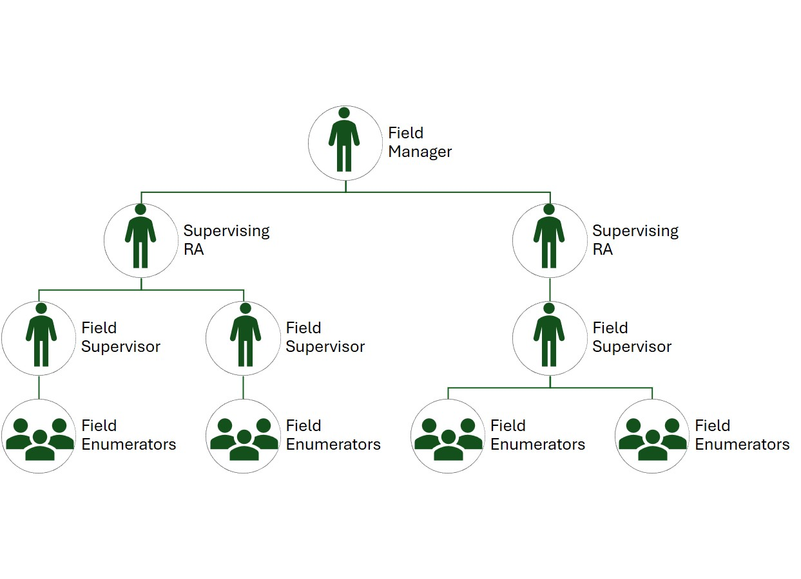
Field Team Structure

Role of the Field Supervisor in the UHC Year 2 Survey
The Field Supervisor (FS) oversees field operations and serves as the primary link between the Survey Enumerators (FEs) and the central survey management team. The Field Supervisor is responsible for:

- Preparing the survey team and materials before field deployment;  - Conducting daily briefings, assigning work, and monitoring the progress of Survey Enumerators;  - Coordinating courtesy calls and field activities with facility focal persons and LGUs, as applicable;  - Observing FE interviews and providing timely feedback to improve performance; |  | - Reviewing completed questionnaires and monitoring CAPI uploads to ensure timely synchronization of data  - Managing nonresponse cases, callbacks, and respondent replacements in accordance with survey procedures;  - Documenting daily accomplishments, field incidents, and operational issues; and  - Reporting field progress, issues, and concerns to the supervising Research Associate (RA).

The table below summarizes the Field Supervisor's reporting, supervision, and coordination relationships with key personnel involved in the UHC Year 2 Survey.

Role | Relationship with the Field Supervisor
Field Manager (FM) | Provides overall oversight of field operations. The FS does not report directly to the FM; unresolved issues are escalated to the FM through the supervising RA.
Supervising Research Associate (RA) | Serves as the immediate supervisor of the FS. The FS reports operational concerns, submits reports, and seeks guidance from the assigned RA.
Survey Enumerators (FEs) | Report directly to the FS. The FS assigns work, supervises field activities, reviews outputs, and provides guidance and feedback.
Data Manager and CAPI/IT Support | Provide technical support to field operations. The FS coordinates with them through the supervising RA for issues requiring technical assistance.

Reporting and Escalation Lines
The reporting hierarchy is shown below. FSs should resolve issues at their level where possible and escalate promptly when they cannot.

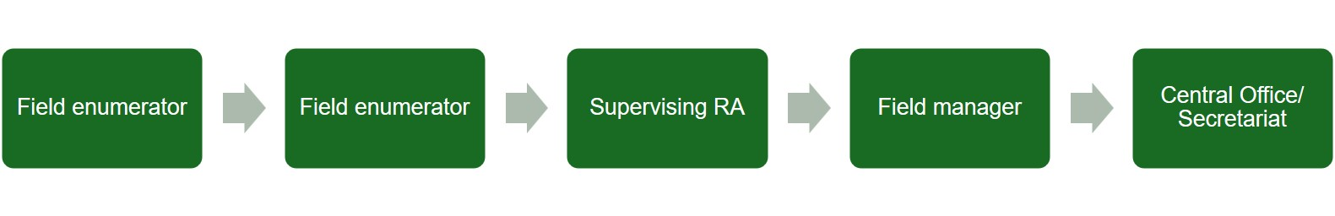

FIELD COORDINATION & ENTRY PROTOCOLS

Coordination with CHD
Prior to fieldwork in a region, the DOH will issue a memo to the regional Centers for Health Development (CHDs) informing them of the survey. The Supervising RA coordinates this communication with the central office. Confirm with the ASPSI Central Office that the CHD endorsement is in place before conducting courtesy calls at facilities in your region.

✖  DON’Ts | - Do not attempt facility entry without the appropriate endorsements.  - If a CHD endorsement has not been secured, inform the Supervising RA.

Coordination with LGUs
The FS must deliver the official survey introduction letter to the Office of the Mayor or City Health Officer before visiting any health facility or community. This letter explains the study's objectives, planned activities, and schedule. LGU coordination is a 5-step process.

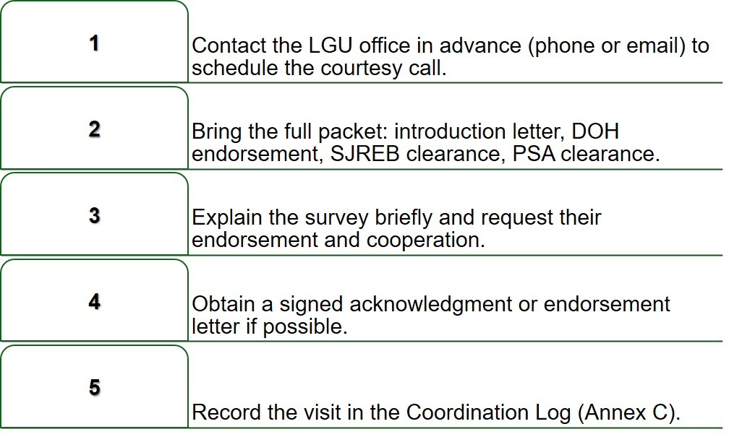

In some areas, a courtesy call to the Local Chief Executive (Mayor, Governor) may be required or requested by the facility or CHD. The FS should be prepared to make this call if needed. Follow the same protocol as LGU coordination. Escalate to the RA if the LCE requests changes to the survey plan.

✎ RECORD | - Record every LGU coordination visit in the Coordination Log (Annex C): date, office, name of official met, outcome, and any follow-up actions required.

Coordination with Health Facilities
Upon arriving at each selected health facility, the FS makes a courtesy call to the facility head. Although coordination with health facilities have the same process, arrangements in the hospitals should cover both inpatient and outpatient respondents while RHUs arrangements should focus only on outpatient respondents.

In Hospitals
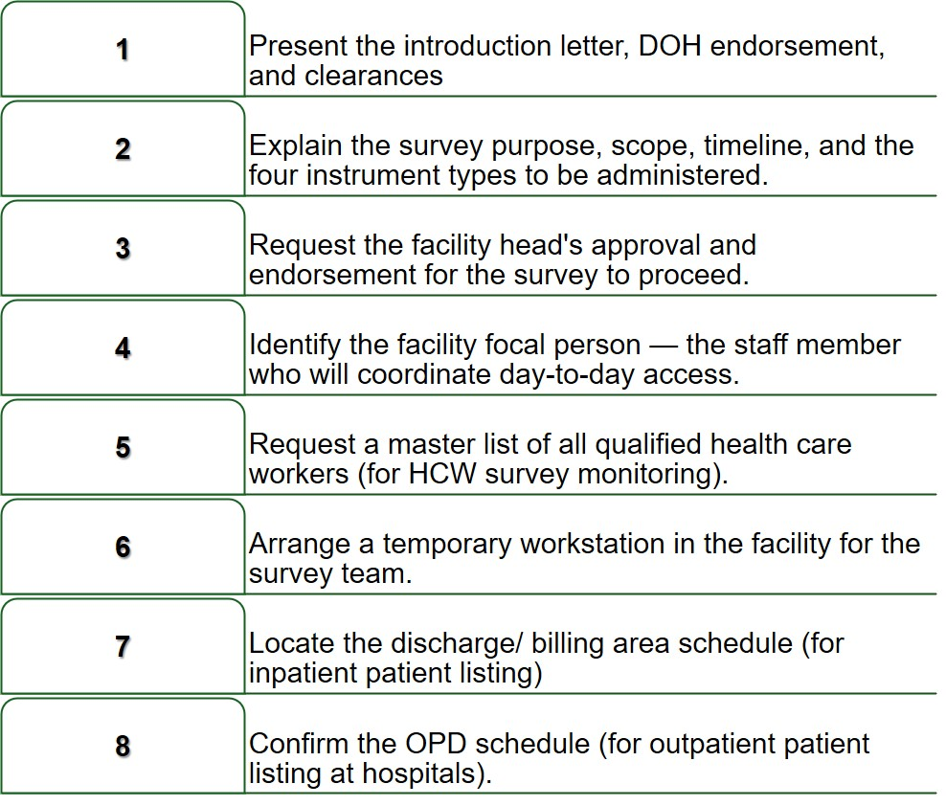

In Rural Health Units
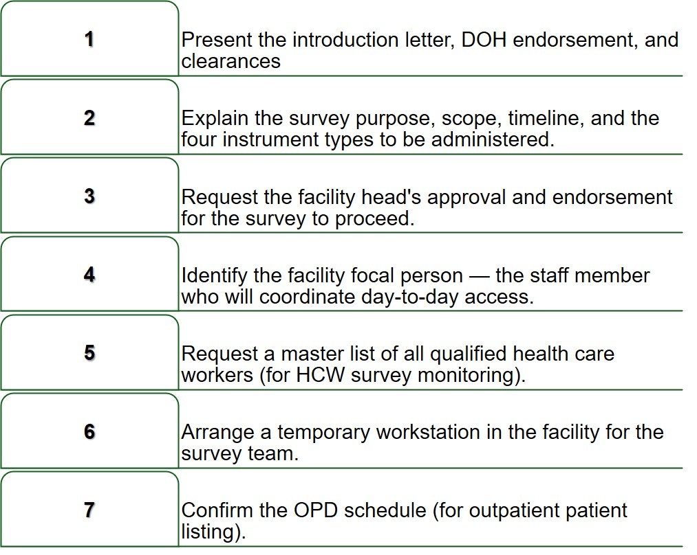

✎ RECORD | - Record the facility courtesy call in the Coordination Log: date, time, facility name, name of facility head met, endorsement outcome, focal person name and contact, workstation location.

Courtesy Calls to Facility Heads
The courtesy call to the facility head is not just a formality. It establishes the working relationship for the entire facility visit. Approach the facility head with respect and professionalism.

Handling Facility Refusals or Non-Endorsement
When a facility head declines to endorse the survey or a local authority refuses cooperation:
- Remain polite and professional. Do not argue or pressure.
- Listen to the specific concern or objection. Offer to provide additional documentation or clarification if available.
- Inform the official that you will document and report the situation to your Supervising RA and FM.
- Document the refusal in the Coordination Log and Refusal Documentation Form (Annex G).
- Escalate to the Supervising RA immediately. At this stage, the Supervising RA will coordinate FM and DOH focal person on next steps.
- Wait for further instructions.

✖  DON’Ts | - Do not proceed with data collection in a facility or area without proper endorsement. Any data collected without proper endorsement is invalid.

When a facility is classified as non-responsive after the minimum contact protocol is exhausted, or formally refuses, submit for replacement. The replacement facility must come from the pre-approved reserve list, the same stratum (UHC IS / non-UHC IS, facility type, geographic area). All replacements require RA approval. Replacement rate is limited to 5–10%.
The FS is responsible for making at least three contact attempts on three separate days and at different times before classifying a facility as non-responsive. All attempts must be documented in the facility contact log.

Documentation of Coordination Activities
ALL coordination activities must be documented in the Coordination Log (Annex C). This log is reviewed by the RA during the weekly coordination meeting and forms part of the final field report. Minimum documentation per entry:
- Date and time of contact
- Name and position of person contacted
- Facility or LGU name
- Purpose of contact
- Outcome (endorsement obtained, pending, refused)
- Follow-up actions required

✔  DOs | - Arrive on time for scheduled courtesy calls.  - Bring a complete document packet for every facility visit.  - Leave a copy of the introduction letter and clearances with the facility.  - Introduce all team members present at the courtesy call.

✖  DON’Ts | - Do not begin any data collection before the courtesy call is complete and approval is obtained.  - Do not agree to modification in survey procedures or respondent selection.  - Do not leave original clearance documents with the facility

TO DOs BEFORE FIELDWORK

Review and Update Field Implementation Plan
Before leaving for the field, obtain your complete field assignment package from the supervising RA. You should have:
- Directory of all facilities and barangay assigned to your team
- Directory of facility focal persons in each facility
- Target respondent quotas per facility and per instrument
- Reserve facility and household replacement lists
- When applicable, selected barangays and target respondent quota for the Household survey

CHECK | - Cross-check your cluster map against the official facility list.  - Any discrepancy must be communicated and verified with your Supervising RA before fieldwork begins.

Update the following parameters:
- Target respondent quotas per respondent type
- Fieldwork schedule with dates per facility
- In areas where the Household Survey will be conducted, plot out the route of the different Fes to ensure the systematic data collection in the community. You can either request for the community map of the selected barangay or check Google Map.

Prepare Original and Photocopies of LGU packet
Prepare the LGU and health facility packets before deployment. Each packet includes
- Official letter addressed to the facility head (or LGU Mayor, where needed)
- DOH national endorsement memo
- SJREB clearance certificate
- PSA clearance certificate
- Contact number for the RA and FM

Prepare all field materials as well. Use Annex B (Field Materials Checklist) to confirm completeness.

Review the CAPI Assignments
Log in to CSEntry on your supervisor tablet and verify that all FE assignments are loaded and accessible. Confirm that:
- Each FE has been assigned the correct facilities and cases in CSEntry
- The CSWeb sync connection is working on all tablets
- Your supervisor dashboard in CSWeb shows all FEs under your cluster

CHECK | - Monitor and review the supervisor's CSWeb dashboard at the end of the day.  - It shows real-time upload status, interview counts, and any alerts for missing or delayed data.

Checking Tablets, Chargers, Power Banks, and Connectivity
Each FE must have a fully charged Android tablet with CSEntry installed and all assigned cases loaded before leaving for the field. As FS, you are responsible for confirming that.
- All tablets should start each day above 80%
- Updated CSEntry is installed
- Can sync with CSWeb by performing one test upload to CSWeb before the first day of data collection
- Presence of at least 1 Power banks
- Can connect to the Internet via Wi-Fi or mobile data

✖  DON’Ts | - Never allow an FE to go to the field with an uncharged tablet or without confirming their CSEntry assignment is loaded.

Double Check Transportation and Accommodation arrangements
- Ensure transportation (vehicle, motorcycle, boat, or other means as applicable to your area) and accommodation arrangements with the Supervising RA.
- The survey vehicle should be used exclusively for survey-related travel. When not in use, tablets and equipment must be removed from the vehicle or placed out of sight.

Confirmation of Allowances and Communication Arrangements
- Verify that all FEs have received their daily allowances and mobile data allowances for the cluster period.
- Establish a communication protocol: at minimum, FEs should send you a message each evening confirming their upload status, and you should confirm receipt.

CHECK | - A separate finance/ admin manual will be provided to all FEs and FSs.  - Check with the Supervising RA and/ or the Field Manager the daily allowance and the disbursement schedule prior to deployment

Risk Review and Security Considerations
Before entering a new area, review available information on local conditions. This is particularly important when entering remote sites, areas with ongoing conflicts, or facilities with known access restrictions. Discuss any risk areas with the Supervising RA before deployment. Ensure all FEs know the emergency contact number for the FM and the nearest health facility in their work area.

NOTE | - In case of any security emergency, contact the FM immediately.  - Activate the emergency and security protocol (Section XX)  - Do not attempt to resolve security threats. Withdraw the team to a safe location and await guidance from the FM.

ORGANIZING DAILY FIELDWORK

Start-of-Day Field Briefing
Begin every working day with a brief team meeting (10 to 15 minutes maximum). The daily briefing is the opportunity to set expectations, share updates, and address questions and concerns. Agenda for the daily briefing:
- Confirm attendance. All FEs present and accounted for
- Review the day's facility assignments and respondent targets for each FE
- Confirm that all tablets are charged and CSEntry assignments are loaded
- Share any updates from the RA (protocol clarifications, facility changes)
- Address any unresolved issues from the previous day's debriefing
- Remind FEs of the 10:00 PM upload deadline

Assignment Distribution to Enumerators
Assign work to FEs using the Enumerator Assignment Sheet (Annex D). Consider the following when distributing assignments:
- Assign enough work for a full day but not more than can realistically be completed — account for travel, informed consent administration, and interview duration
- For the first few days of a new cluster, assign lighter loads to allow time for close supervision and error correction
- Distribute work fairly among Fes. Account for response rate especially in the household survey
- Do not assign an FE to interview anyone they know personally — reassign immediately if this situation arises
- Ensure each FE has the correct Patient Listing Form and Visit Sheet for their assigned facility/barangay

Review of Daily Targets
Before the team disperses each morning, confirm that each FE knows their specific numeric targets for the day:
Instrument | Key target to confirm
Facility Head | - Which facility  - Whether facility head or authorized rep will participate  - Contact attempts remaining if pending
HCW Survey | - Current response count vs. master list total  - Any follow-up needed with focal person
Patient (Hospital Inpatients) | - What is the number of inpatients that are expected to be discharged today?
Patient (Hospital Outpatient) | - Target number of outpatient respondents  - What is the OPD set-up? Is there a schedule to the OPD on the data collection day?
Patient (RHU Outpatient) | - Target number of outpatient respondents  - What is the consultation set-up/ process? How are patients for consultation listed?
Household | - Target number of household interviews for the day  - Where is the starting point (barangay hall, health center)?  - Sampling interval (kth household)  - Enumerators’ route in the barangay

CHECK | - Check if each FE is able to state exactly who they are looking for, where they will find eligible respondents, and what they will do if a respondent is unavailable or refuses.  - Review this during the morning briefing for any assignment that involves a new procedure or site.

Managing Field Work
Work through the facility list systematically. For facility-based surveys (FH, HCW, Patient), complete one facility before moving to the next whenever possible. For household surveys, work within one barangay cluster at a time. Adjust daily schedules as needed.

✔  DOs | - Finish one facility first before moving on the next  - Complete one barangay at a time  - Adjust daily schedules as needed  - Establish regular check-in times throughout the day. FEs.

Situation | Adjustment to take
The facility is closed | - Schedule another attempt (on a different date).
The facility head or identified representative is absent/ unavailable/ busy | - Have the FE wait and reattempt later the same day (if the respondent will return)  - Document the pending case and schedule another attempt  - Escalate to the Supervising RA if a facility is refusing access or the situation cannot be resolved

End-of-Day Debriefing
Gather all FEs at the end of each working day. The end-of-day debriefing should cover:
- Upload confirmation: every FE confirms their records are uploaded to CSWeb
- Questionnaire review: collect all tablets for end-of-day FS review (see Chapter XI)
- Progress update: how many interviews completed vs. targets
- Pending cases: any respondents not reached today; plan callbacks
- Problems encountered: any interviewing errors, access issues, respondent difficulties
- Plan for the next day: confirm tomorrow's assignments

CHECK | - Before ending the debriefing, verify on CSWeb that all expected uploads from your team have arrived.  - If any are missing, resolve with the FE immediately  - Do not leave for the night with unresolved upload failures.

SUPERVISING RECRUITMENT OF RESPONDENTS

Identifying Prospective Respondents
Eligibility criteria for the four (4) survey tools are described in their respective tool manuals. The recruitment and informed consent administration procedure are described in the Field Enumerators manual.

CHECK | - All contact attempts by the FE must be recorded in the Visit Sheet: date, time, outcome, and reason for non-contact.  - Replacement cases must be reported at the next weekly coordination meeting.

Monitoring Eligibility Screening
The FS should periodically check that FEs are applying eligibility criteria correctly. During interview observations and questionnaire review.

Respondent type | Key target to confirm
Facility Head | - Respondent is not just a receptionist or clinic aide  - S/he must have held a management position for ≥ 6 months
Patient (Hospital Inpatients) | - Respondent is actually at the point of discharge, not still admitted or merely a visitor
Patient (Hospital/ RHU Outpatient) | - Respondent was selected from the consultation list, not self-referred by the FE  - Respondent has time to complete the survey
Household | - Respondent is the household head or health decision-maker, not just a convenient adult at home

Preventing Substitution of Respondents
Substitution occurs when an FE interviews a person other than the selected, eligible respondent to make their work easier. This is a serious data quality violation.

✖  DON’Ts | - An FE must never interview a neighbor "instead of" a selected household because the household head was absent.  - An FE must never interview a relative or caregiver instead of an inpatient without proper eligibility verification.  - An FE must never "select" an outpatient who is sitting near them rather than following the prescribed sampling procedure.

Managing Respondent Flow in Facilities
In busy facilities, managing the flow of eligible respondents requires coordination with the facility focal person.

✔  DOs | - Closely work with the focal person to ensure the survey team has a designated working station  - Understand the processes in the area to avoid disrupting the normal facility operations  - Do the pre-work to avoid unnecessary delays during the data collection schedule.

SUPERVISING INFORMED CONSENT AND INTERVIEW CONDUCT

Ensuring Proper Administration of the Informed Consent
Every tool begins with the introduction spiel from Annex J of the Survey Protocol. The informed consent process follows.

CHECK | - The introduction spiel must be delivered in full and in the dialect of the respondent before the informed consent form.  - The informed consent form should be signed before beginning the survey.

Guaranteeing Proper Administration of the Survey
Survey questions must be read exactly as written and record answers without interpreting, paraphrasing, or suggesting responses. If a respondent does not understand a question, the re-read the question slowly and clearly. If the respondent asks what a term means, the FE should give the standardized definition provided in the Tools Manual.

✖  DON’Ts | - Paraphrasing questions rather than reading them verbatim  - Nodding, frowning, or showing agreement/disagreement with answers  - Filling in "don't know" or a guess without probing the respondent  - Rushing through questions to finish faster  - Entering responses that were not actually given by the respondent

Documentation of Pending Interviews
Track refusals, pending interviews and callbacks. Remind FEs that every pending case must be recorded in the Callback and Pending Interview Log (Annex F).

Case | Key target to confirm
Refusals | - The FS may make one additional attempt if the refusal seemed to stem from a misunderstanding about the survey. But only if the respondent has not given a final and definitive "no."  - If the refusal appears to stem from a language or cultural barrier, consider assigning a different FE who may have better rapport.
Interrupted/ incomplete survey | - Monitor the FE to ensure that the survey is completed.
Callbacks | - Assign callbacks to the same FE who initiated the contact (consistency reduces respondent confusion)  - Schedule FH callback based on their availability  - Attempt to schedule household callback in the evening or on weekends  - Continue patient callback within the same day if possible

MONITORING ENUMERATOR PERFORMANCE

Observation of Interviews
Observing interviews is the most important quality control activity you will perform. You must observe at least one interview for each FE under your supervision, with more frequent observations during the first few days of fieldwork and again toward the end of the cluster. Ideally, it is best to observe the FEs performance daily but strive to observe each FE at least once per week. The purpose of this observation exercise is to:
  - Detect errors that cannot be seen in a completed questionnaire (e.g., paraphrasing questions, skipping probes, assuming answers)
  - Verify that the FE follows proper consent and introduction procedures
  - Confirm that the FE selects the correct respondent and follows the sampling procedure
  - Assess the FE's rapport with respondents and their handling of sensitive questions

When observing the FE, do the following:
  - Sit close enough to see what the FE is entering on the tablet, without crowding the respondent.
  - Complete the Interview Observation Checklist (Annex E) for every observed interview.
  - Note all observations for discussion after the interview. Do not intervene unless a serious error is in progress.
  - After the interview, discuss performance with the FE privately. Mention both strengths and areas for improvement.

Use of an Enumerator Observation Checklist
Interview Observation Checklist (Annex E) systematically evaluates each observed interview. The checklist covers:
- Correct respondent identified and eligibility confirmed
- Full introduction spiel delivered before ICF reading
- ICF read aloud in full; respondent given opportunity to ask questions
- Respondent signature obtained before interview began
- Questions read verbatim in correct sequence
- "Don't know" option used correctly — not forced on uncertain respondents
- Neutral tone maintained throughout
- Private setting maintained
- Upload completed at end of interview

Providing Feedback to Enumerators
Feedback must be after each observation cycle. During the end-of-day debriefing, address performance issues raised during the day's observations.

✔  DOs | - Give feedback promptly. Address errors on the same day they are observed.  - Acknowledge good performance.  - Discuss errors at the team level without singling out individuals by name — frame errors as things the team should all watch out for.  - When addressing an error with a specific FE, do so privately and constructively.  - Frame corrective feedback as helping the FE, not as punishment.

Correcting Interviewing Errors Early
The first week of fieldwork is the most critical period for error correction. Observe FEs frequently at the start. If an FE is making consistent errors (e.g., consistently paraphrasing the same question, consistently skipping the same prompt), re-read that section of the Enumerator's Manual together with the FE and conduct a mock interview to practice the correction before the next day. If an FE repeatedly fails to improve after coaching, do the following:

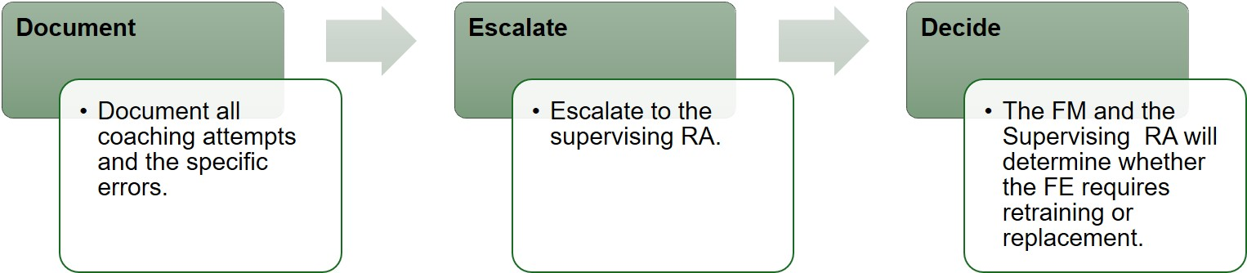

Coaching on Difficult Respondent Situations
During team debriefings, encourage FEs to share difficult field situations, such as a hostile respondent, a question they couldn't explain clearly, a facility staff member who interfered. Discuss as a team how the situation was handled and what the correct approach is. This builds team knowledge and prevents similar errors in future.

Monitoring Professional Conduct
FSs are responsible for ensuring that all FEs maintain professional conduct at all times. This includes:
- Wearing survey identification at all facility visits
- Treating respondents, facility staff, and LGU officials with respect
- Arriving on time to facilities and household areas
- Maintaining confidentiality of all survey data
- Not using personal devices (phone calls, social media) during interviews
- Not accepting gifts or money from respondents or facilities

Maintaining Team Morale
Fieldwork is physically and emotionally demanding. As FS, you have a direct impact on how your team feels about the work.

✔  DOs | - Foster team spirit: work alongside FEs when needed, not just observe from a distance.  - Recognize good work explicitly and publicly in team debriefings.  - Distribute difficult assignments fairly.  - Be punctual and prepared — your example sets the standard.

DAILY REVIEW OF COMPLETED QUESTIONNAIRES
At the end of every working day, the FS reviews all completed questionnaires submitted by FEs in CSEntry (via the supervisor's CSWeb dashboard) and on the tablets before upload confirmation. This is a non-negotiable daily task. The purpose is to identify and correct errors while the FE can still return to the respondent or facility for clarification.

Task | Check
Check for completeness | - All required fields are filled — no blanks where an answer is mandatory  - The respondent type is correctly coded (inpatient vs. outpatient; FH vs. authorized representative)  - The facility code and barangay code match the assigned location  - The interview date and time are correctly recorded  - The FE's ID is correctly recorded on the record
Check for internal consistency | - Response pattern appears mechanical (e.g., all questions answered the same value — a sign of data fabrication)  - Interview duration is implausibly short (e.g., a 1.5-hour household interview completed in 12 minutes)  - Age, sex, or household composition responses do not match what the FE noted in field notes  - Date of discharge (inpatient) is before the date of the interview  - Check the CSWeb dashboard alert tab every evening.  - Investigate all alerts before marking the day's work as complete.
Check responses to “Comments” and “Other Specify” | - Look out for responses that are:  - Gibberish or placeholder text (e.g., "N/A", "none", "xxx") that should have a real answer  - Entries that suggest the FE misunderstood the question  - Entries that actually match a coded response option and should be recoded
Identifying Missing Data | If a required field is empty, determine whether:  - The respondent genuinely did not know the answer (use the designated "Don't know" code)  - The skip pattern should have routed past this question but did not (report to CAPI/IT via RA)  - The FE forgot to ask the question (the FE must contact the respondent for clarification if still possible)

Returning Questionnaires for Correction
If an error can be corrected by re-asking the respondent (i.e., the respondent is still accessible and willing), instruct the FE to return to the respondent the same day or early the next morning. The correction must be made in CSEntry — not on paper. The corrected record must be re-synced to CSWeb.

✖  DON’Ts | - Do not ask an FE to fabricate or guess the correct answer to a missing or erroneous field.  - If the respondent cannot be reached for correction, the field must remain blank or coded as "Not collected" per protocol.

Recording Field Quality Issues
Record all data quality issues identified during the daily review — even those that were corrected — in the Daily Accomplishment Report (Annex H). This documentation supports the weekly coordination meeting and the final field quality report. Include: the case ID, the nature of the error, the correction applied, and whether the correction was possible.

CAPI SUPERVISION TASKS

Monitoring Downloaded Assignments
Each FE's assignments are loaded into CSEntry via the supervisor's dashboard in CSWeb. At the start of each day, verify in CSWeb that all assigned cases are correctly downloaded and accessible on each FE's tablet. If a case is missing, coordinate with the CAPI/IT team through the RA to re-push the assignment before the FE leaves for the field.

Task | Check
Monitoring FE assignments | - Verify in CSWeb that all assigned cases are correctly downloaded and accessible on each FE's tablet.  - If a case is missing, coordinate with the CAPI/IT team through the RA to re-push the assignment before the FE leaves for the field.  - Reassign the case if an FE is unable to complete an assignment (illness, conflict, error)  - Document the reassignment with the reason in the Daily Accomplishment Report. Notify the RA of any reassignment.
Monitoring Completed and Pending Cases | - Review the case status dashboard at the end of each day. Every "Upload failed" case must be resolved before 10:00 PM.  - Check:  - Completed: interview recorded and uploaded  - Pending: assigned but not yet completed  - In progress: interview started but not closed  - Upload failed: record complete but not yet on the server

Coordinating with CAPI / IT Support
Refer to the CAPI manual for CAPI-related issues. All CAPI issues that cannot be resolved at the FE or FS level are reported to the RA, who escalates to the CAPI/IT team with the case ID, device ID, and error description. CAPI/IT support is provided by the Central Office data team through the Supervising RA. Do not contact the CAPI/IT team directly.

Documenting CAPI-Related Field Issues
Record all CAPI issues in the CAPI Sync Monitoring Checklist (Annex I) and the Daily Accomplishment Report (Annex H). This documentation supports the CAPI team in identifying systematic issues with the application.

PROGRESS MONITORING AND REPORTING

Daily Accomplishment Tracking
At the end of each working day, complete the Daily Accomplishment Report (Annex H) covering:
- Number of interviews completed today vs. target, by instrument
- Number of uploads confirmed vs. number of interviews completed
- Number of pending cases, with reasons
- Number of refusals documented today
- Any data quality issues identified and resolved
- Any CAPI or equipment issues
- Any access or coordination issues
- Cases escalated to the RA, and why

Submit the Daily Accomplishment Report to the supervising RA every evening by 10:30 PM (after upload confirmation).

Facility-Level Progress Monitoring
TRACK | - FH interview: completed, pending (number of contact attempts made), or non-responsive  - HCW survey: current aggregate response count vs. master list; response rate (%)  - Patient inpatient: number listed and interviewed vs. quota  - Patient outpatient: number listed and interviewed vs. quota

CHECK | - If HCW response rate at any facility is ≤ 40% at the midpoint of the 3-day window, initiate the follow-up protocol (coordinate with focal person for a neutral reminder) and document the follow-up.  - If HCW response rate remains below 60% at the end of the window, notify the Supervising RA immediately.

Household Survey Progress Monitoring
TRACK | - Number of households interviewed vs. the assigned target for the cluster  - Number of non-contact cases and replacements drawn  - Number of refusals  - replacements have been drawn within the same barangay cluster

Tool Completion
CHECK | - All completed records are uploaded  - No records are stuck in a failed sync state.

Monitoring Progress by Site
TRACK | - Proportion of survey target met  - Prescribed interviews have been completed or accounted for (pending, refused, non-responsive with documentation)  - Replacements have been authorized and completed  - Uploads from that site are confirmed in CSWeb

Weekly Coordination Meetings
A weekly coordination meeting is held every Friday among the Field Manager, Data Manager, Assistant Data Managers, Supervising RAs and FSs. This meeting will discuss the accomplishments, flagged cases and quality concerns, performance feedback as well as emerging challenges and adjustments needed.

Escalating Issues
Escalate any of the following to the RA immediately.
- A facility is approaching or has exceeded the maximum contact attempts with no interview conducted
- HCW response rate at a facility has dropped to critically low levels with no improvement
- A barangay or facility is refusing all access
- Any FE is showing a pattern of errors that suggest data fabrication or serious protocol violations
- Any security incident, injury, or emergency
- Equipment (tablet) loss or theft

FIELD LOGISTICS, SAFETY & INCIDENT MANAGEMENT

Team Safety and Security
Team safety is a non-negotiable priority. Before entering any new area:
- Review local security conditions with the RA or FM
- Ensure all FEs know the emergency contact number for the FM
- Ensure all FEs know the location of the nearest health facility in their work area
- Confirm there are no active incidents (flooding, unrest, road closures) that would make the area unsafe

✖  DON’Ts | - Do not enter an area that the FM or RA has flagged as unsafe. The safety of team members is more important than any data collection target.

Device and Equipment Security
CHECK | - Confirm all tablets have been collected from FEs and are stored in a locked room or bag  - Charge all tablets overnight so they start the next day above 80%  - Never leave tablets unattended in the vehicle  - Report any lost, stolen, or damaged tablet to the RA and FM immediately

Health and Emergency Concerns
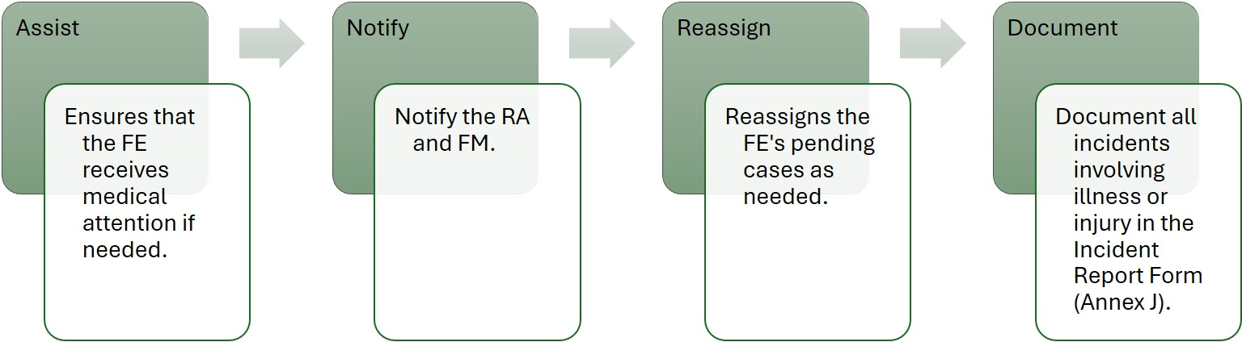

Crisis Management and Escalation
An "incident" is any unplanned event that disrupts fieldwork or poses a risk to team members, respondents, or data quality. Should an incident occur, ensure the safety of all team members first. Contact the FM immediately. Do not attempt to resolve security crises at the team level. Document the incident as soon as the situation is safe to do so.

Crisis Type | Immediate Action
FE serious illness or injury | - Seek medical attention
Vehicle accident | - Ensure safety of all persons  - Contact local emergency services
Natural disaster (flood, earthquake) | - Withdraw team to safety  - Wait for further instructions
Security threat or violence | - Withdraw immediately  - Do not confront
Theft of tablets or equipment | - Document items stolen  - Report to local police

All incidents must be reported to the RA and FM as soon as possible and documented in the Incident Report Form (Annex J).

CONTACT | - Gather local emergency numbers, including police, hospitals and DRRM, for each cluster area.

CLOSING FIELDWORK SITE

Resolve Pending Cases
Before finalizing departure from a site, assess every pending case:
- Identify which pending cases still have callback attempts remaining.
- For cases with remaining attempts: schedule callbacks before leaving or confirm that an FE will return.
- For cases where the minimum contact protocol has been exhausted: document as non-contact or non-responsive, and initiate the replacement process if applicable.
- Submit the list of pending and non-responsive cases to the RA for review before departing the cluster.

Confirmation of Uploads
CHECK | - All completed interview records are showing "Uploaded" status in CSWeb  - No records are in "Upload failed" or "Sync pending" status  - The record count in CSWeb matches the number of completed interviews in your Daily Accomplishment Report

Submission of Final-Day Report
The final-day report should include a summary of overall achievement at that site: total interviews completed per instrument vs. target, total refusals, total pending/non-responsive cases, and any outstanding quality issues.

Turnover of Field Notes and Documentation
CHECK | - All completed Coordination Logs (Annex C)  - All Enumerator Assignment Sheets (Annex D)  - All completed Interview Observation Checklists (Annex E)  - All Callback and Pending Interview Logs (Annex F)  - All Refusal Documentation Forms (Annex G)  - All Daily Accomplishment Reports (Annex H)  - All Incident Report Forms (Annex J), if any  - All End-of-Site Completion Checklists (Annex K)  - Any printed patient listing forms or visit sheets collected during the site

Completion Review Before Leaving a Facility or Area
Before your team leaves any facility or barangay area, conduct a completion review. Do not leave until you are confident that the work at that site is as complete as possible given the time and circumstances.

CONFIRM | - All prescribed FH interviews completed or all contact attempts exhausted and documented  - HCW response monitoring confirmed; follow-up actions completed if response rate is below threshold  - All inpatient and outpatient patient interviews completed to quota, or shortfalls documented  - All household interviews for this barangay completed to target, or pending cases documented with callback plan  - All patient listing forms verified: two streams (inpatient and outpatient) tracked separately  - All refusal documentation forms completed  - Coordination log updated with all facility and LGU contacts made at this site  - All completed records uploaded to CSWeb and sync confirmed

Lessons Learned and Debriefing
After completing a cluster, hold a lessons-learned session with your FE team. This does not need to be long. Discuss and process:
- What worked well at this cluster that should be repeated
- What problems arose and how they were handled
- What could be done better at the next cluster
- Any protocol questions or ambiguities that need to be clarified before the next deployment

Submit a brief written summary of lessons learned to the Supervising RA. These summaries inform the weekly coordination meeting and improve fieldwork across all clusters.

CHAPTER XVI. ANNEXES

Annex A. Supervisor Daily Checklist
Use this checklist every morning and evening to ensure all supervisor tasks are on track.
MORNING CHECKLIST
✓ | Task / Item
□ | All FEs present and accounted for
□ | All tablets charged (above 80%) and CSEntry assignments loaded
□ | Today's facility assignments confirmed with each FE
□ | Patient quotas and sampling instructions confirmed with relevant FEs
□ | Tokens of appreciation (PhP 100 each) ready for patient/household interviews
□ | Field documents packet confirmed for each facility visit today
□ | Transport confirmed
□ | CSWeb dashboard reviewed — no outstanding alerts from last night

EVENING CHECKLIST
✓ | Task / Item
□ | All completed interviews uploaded to CSWeb by 10:00 PM
□ | CSWeb dashboard reviewed — all uploads confirmed, no failed syncs
□ | Daily Accomplishment Report (Annex H) completed and submitted to RA
□ | All questionnaires reviewed for completeness and internal consistency
□ | Errors returned to FEs for correction where possible
□ | Pending cases documented in Callback Log (Annex F)
□ | Refusals documented in Refusal Forms (Annex G)
□ | All tablets collected, charged, and stored securely
□ | Tomorrow's assignments confirmed for all FEs

Annex B. Field Materials Checklist
Verify all materials are packed before leaving for each cluster deployment.

✓ | Task / Item
□ | Field Supervisor's Manual
□ | Enumerator's Manual (1 per FE)
□ | CAPI Manual (1 per FE)
□ | Introduction letter addressed to facilities/LGUs (1 per site)
□ | DOH national endorsement document (1 per cluster)
□ | SJREB clearance certificate (copies, 1 per facility)
□ | PSA clearance certificate (copies, 1 per facility)
□ | Contact list: RA, FM, CAPI/IT support, facility focal persons
□ | Coordination Log forms (Annex C) — sufficient for all sites
□ | Enumerator Assignment Sheets (Annex D)
□ | Interview Observation Checklists (Annex E)
□ | Callback and Pending Interview Logs (Annex F)
□ | Refusal Documentation Forms (Annex G)
□ | Daily Accomplishment Report Templates (Annex H)
□ | CAPI Sync Monitoring Checklists (Annex I)
□ | Incident Report Forms (Annex J)
□ | End-of-Site Completion Checklists (Annex K)
□ | Patient Listing Forms (inpatient and outpatient)
□ | Visit Sheets (for Household Survey)
□ | PhP 100 tokens (sufficient for estimated interviews)
□ | Tablets (1 per FE + 1 supervisor tablet)
□ | Tablet chargers and power banks
□ | First aid kit
□ | Face masks (sufficient for all team members)

Annex C. Coordination Log Template

Record all coordination activities: LGU visits, courtesy calls, facility focal person contacts, and all follow-up actions.

Date | Facility / LGU | Person Contacted / Position | Purpose | Outcome | Follow-up Needed

Annex D. Enumerator Assignment Sheet

Complete one row per FE per day. Use to track assigned facilities/barangays, instruments, quotas, and completion status.

Date | FE Name / ID | Facility / Barangay | Instrument | Target Count | Completed | Pending | Notes

Annex E. Interview Observation Checklist
Complete one checklist per observed interview. Discuss findings with the FE immediately after the observation.
Field | Details
Date of Observation
FE Name / ID
Instrument Observed | FH / HCW / Patient / Household (circle one)
Facility / Barangay

✓ | Task / Item
□ | Correct respondent identified and eligibility confirmed before starting
□ | Introduction spiel delivered fully before ICF reading
□ | ICF read aloud in full; respondent given opportunity to ask questions before signing
□ | Respondent signature obtained before the first survey question was asked
□ | Interview conducted in a reasonably private setting
□ | Questions read verbatim — no paraphrasing or skipping
□ | "Don't know" option used appropriately — not forced when respondent hesitates briefly
□ | Neutral tone and manner maintained throughout
□ | FE did not suggest or hint at answers
□ | Probes used correctly when required by the questionnaire
□ | All required fields completed before closing the record
□ | Record uploaded to CSWeb before leaving the site

Observations and Feedback Notes:
Question / Section | Issue Observed | Feedback Given to FE

Annex F. Callback and Pending Interview Log

Record all pending cases and callback attempts. Update the "Final Outcome" column as cases are resolved.

Case ID / Respondent Code | Instrument | Attempt 1 (Date / Time / Outcome) | Attempt 2 | Attempt 3 | Final Outcome

Annex G. Refusal Documentation Form
Complete one form for each confirmed refusal. Submit to RA at end-of-cluster.
Date | Facility / Barangay | Respondent Type | FE Who Attempted | Reason Given (if any) | FS Follow-up Attempt? (Y/N) | Final Status

Annex H. Daily Accomplishment Report Template
Complete and submit to RA by 10:30 PM every field day.
Field | Details
Date
Cluster / Site
FS Name
Number of FEs working today

Instrument | Target Today | Completed Today | Cumulative Completed | Pending | Refused | Notes

Data Quality Issues Identified and Resolved Today:
Case ID | Issue | Action Taken | Resolved? (Y/N)

Upload Status:
FE Name / ID | Interviews Uploaded | Upload Confirmation Time | Any Failed Syncs?

Issues Escalated to RA Today:
Issue Description | Time Reported to RA | RA Response

Annex I. CAPI Sync Monitoring Checklist
Use to track sync status for all FEs at the end of each day.
FE Name / ID | Tablet ID | Cases Completed Today | Sync Attempted (Y/N) | Sync Confirmed (Y/N) | Error Message (if failed) | Resolution

⊞ CAPI NOTE
If any FE's sync shows "failed" in this log at end of day: attempt to resolve immediately.
If still unresolved after troubleshooting: escalate to RA before 10:00 PM.
Do not mark the day as complete while upload failures remain unresolved.

Annex J. Incident Report Form
Complete one form for each incident — any unplanned event affecting team safety, equipment, data, or survey access. Submit to RA immediately upon incident and again as a written report within 24 hours.
Field | Details
Date and Time of Incident
Location (Facility / Barangay / Municipality)
Type of Incident | Accident / Theft / Refusal / Medical / Security / CAPI / Other
Persons Involved (FE, respondent, third party)
Description of Incident
Immediate Actions Taken
Time RA/FM Notified
RA/FM Guidance Received
Follow-up Actions Required
FS Signature

Annex K. End-of-Site Completion Checklist
Complete before departing each facility site or barangay cluster. Submit to RA.
Field | Details
Site Name (Facility / Barangay)
Date(s) of Visit
FS Name

✓ | Task / Item
□ | FH interview: completed, OR all 3 contact attempts documented, OR replacement submitted to RA
□ | HCW response rate ≥ 60%, OR follow-up completed, OR shortfall reported to RA
□ | Inpatient patient quota met, OR shortfall documented
□ | Outpatient patient quota met, OR shortfall documented
□ | Household interview target met, OR pending cases documented with RA approval
□ | All Patient Listing Forms completed and reviewed
□ | All refusal documentation forms completed
□ | Coordination Log updated for this site
□ | All records uploaded to CSWeb and confirmed (no failed syncs)
□ | Record count in CSWeb matches Daily Accomplishment Report count
□ | All paper forms collected and organized for turnover to RA
□ | RA notified of any unresolved issues before departure

Summary of Achievement at this Site:
Instrument | Target | Completed | Pending / Non-Responsive | Refused | Replacements Drawn

Outstanding Issues (if any):
Issue | Status | Action Required

FS Signature: ____________________________ Date: _______________
RA Signature: ____________________________ Date: _______________

