**CMPE 272 ENTERPRISE SOFTWARE PLATFORMS**

**HOMEWORK – 2**

**KARAF/TWITTER**

**TEAM MEMBERS**

PARAMDEEP SAINI

MUKESH RANJAN SAHAY

MUTHU KUMAR SUKUMARAN

**ABSTRACT**

The objective is to create a client web application which uses Apache Karaf container to implement Twitter APIs.

The application is built around the twitter account of the developer. The developer works on the twitter APIs through OAuth protocol by request for the authentication key and token for the twitter account. Using these tokens and keys, the developer gets to choose from the list of twitter APIs from the twitter website and call these APIs locally. This UI contains the list of the APIs that were implemented by the team. Each of these APIs have a unique function to perform. When the client clicks on any of these APIs, the response to the API Request is displayed. Whenever the user clicks on these APIs, the tokens and keys get authenticated before displaying the result of these API calls.

**DESIGN PATTERN**

MVC design pattern is used to implement this Web Application.

1. Model – Java POJO classes representing the data to be presented to the users.

2. View – JSP pages representing visualization of data that the model contains.

3. Controller – Java Servlets that handle both the model and view managing data flow between them.

**USE CASE DIAGRAM**

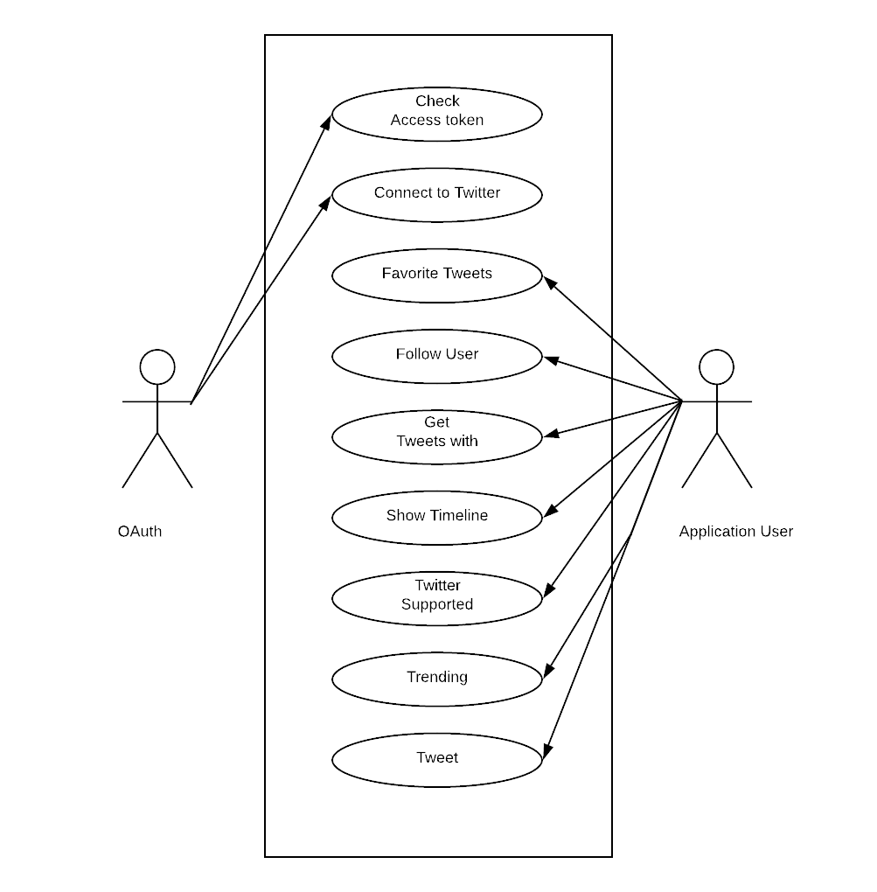

**SEQUENCE DIAGRAM**

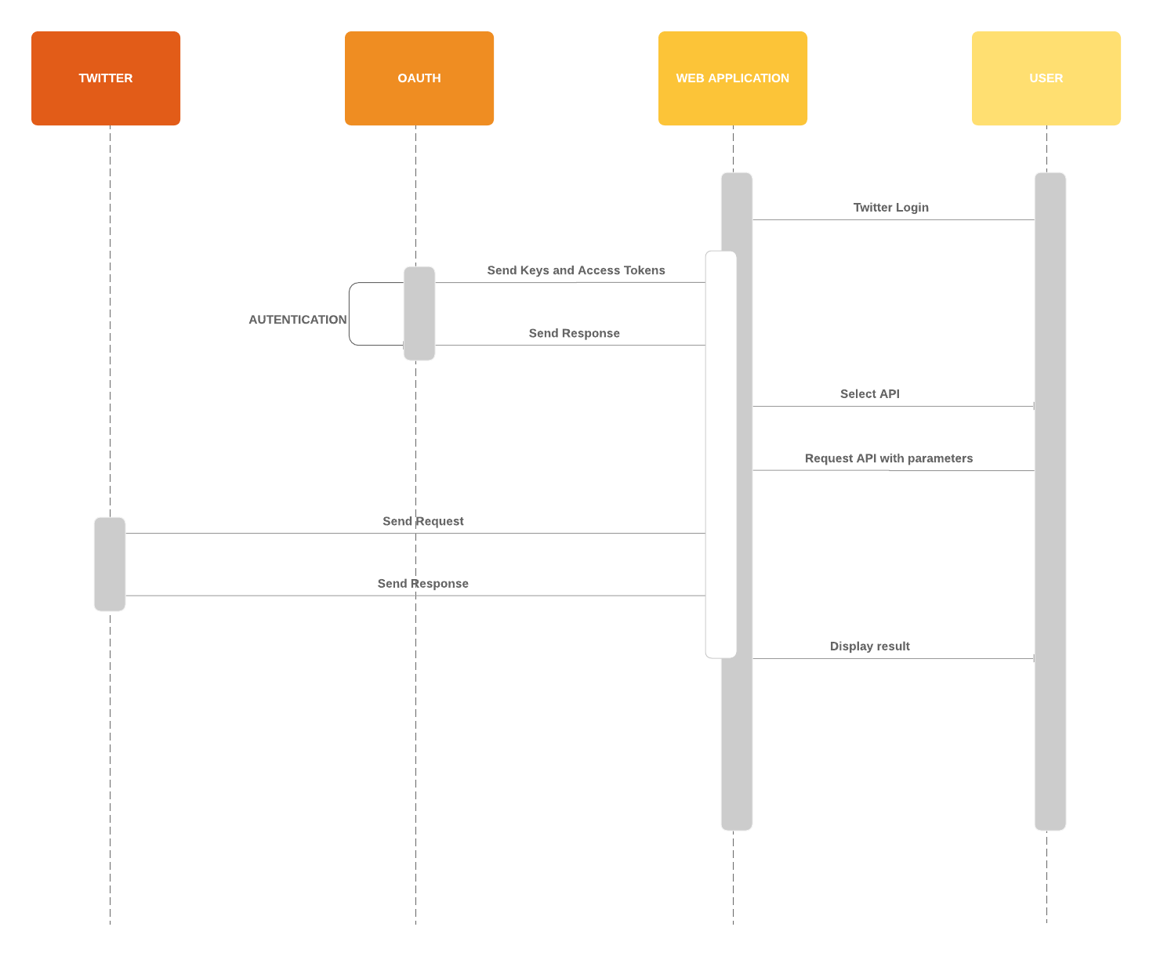

**TOOLS**

• Apache Karaf

• Maven

• JSP

• Eclipse Technologies

• JavaScript

• Java Http Servlet

**APIs USED**

1. Favorite Tweets   
   (<https://developer.twitter.com/en/docs/tweets/post-and-engage/api-reference/get-favorites-list>)
2. Follow User   
   (<https://developer.twitter.com/en/docs/accounts-and-users/follow-search-get-users/api-reference/post-friendships-create>)
3. Followers List  
   (<https://developer.twitter.com/en/docs/accounts-and-users/follow-search-get-users/api-reference/get-followers-list>)
4. Get Tweets with Hashtag (<https://developer.twitter.com/en/docs/tweets/search/api-reference/get-search-tweets.html>)
5. Show Timeline (<https://developer.twitter.com/en/docs/tweets/timelines/api-reference/get-statuses-home_timeline.html>)
6. Twitter supported Languages (<https://developer.twitter.com/en/docs/developer-utilities/supported-languages/api-reference/get-help-languages>)
7. Trending   
   (<https://developer.twitter.com/en/docs/trends/locations-with-trending-topics/api-reference/get-trends-available>)
8. Tweet   
   (<https://developer.twitter.com/en/docs/tweets/post-and-engage/api-reference/post-statuses-update>)

**DEPLOYMENT INSTRUCTIONS**

1. Download apache-karaf-4.2.1 and extract the file using the commands

• gunzip apache-karaf-4.2.1.tar.gz

• tar xvf apache-karaf-4.2.1.tar

1. Change the directory to the extracted folder and launch the Karaf container using the following command

• sudo bin/karaf

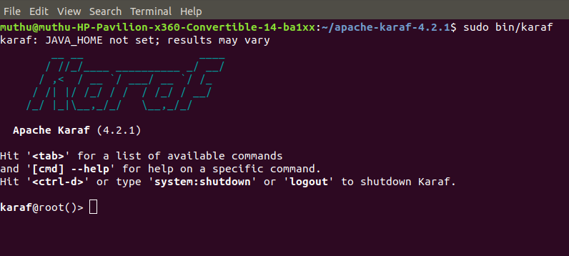

1. Build a WAR file for twitterwithdrifters using the following command

• mvn clean install

1. Copy the WAR file to apache-karaf-4.2.1 -> deploy folder.
2. Run the command LIST to deploy twitterwithdrifters in Karaf

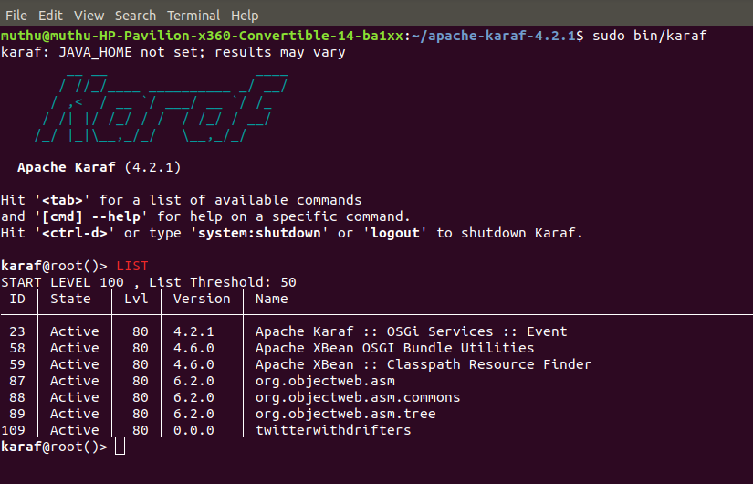

1. Create App in Twitter Developer Account

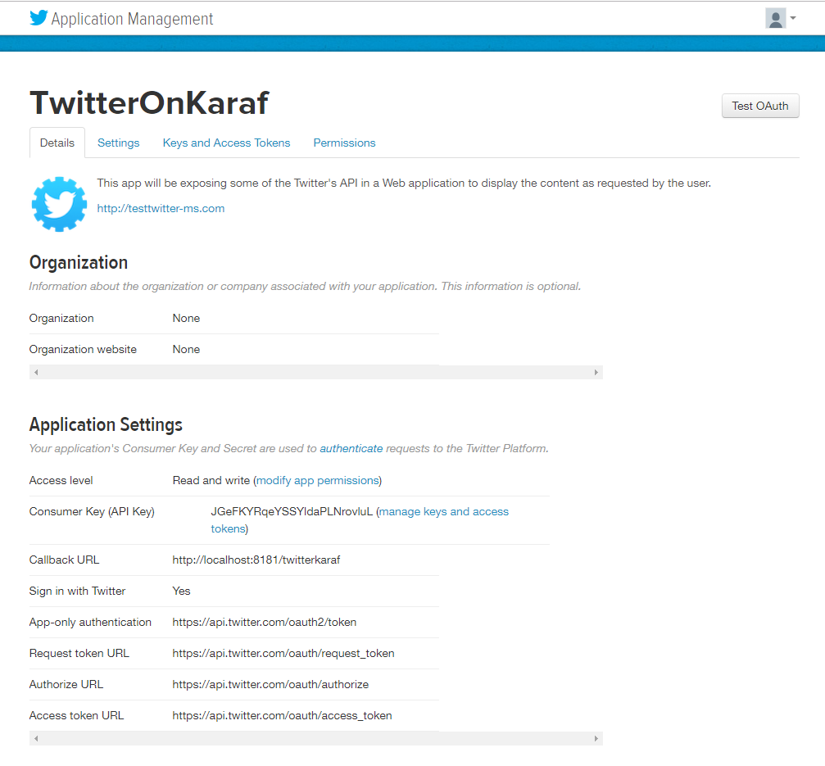

1. Generate Access tokens and API keys

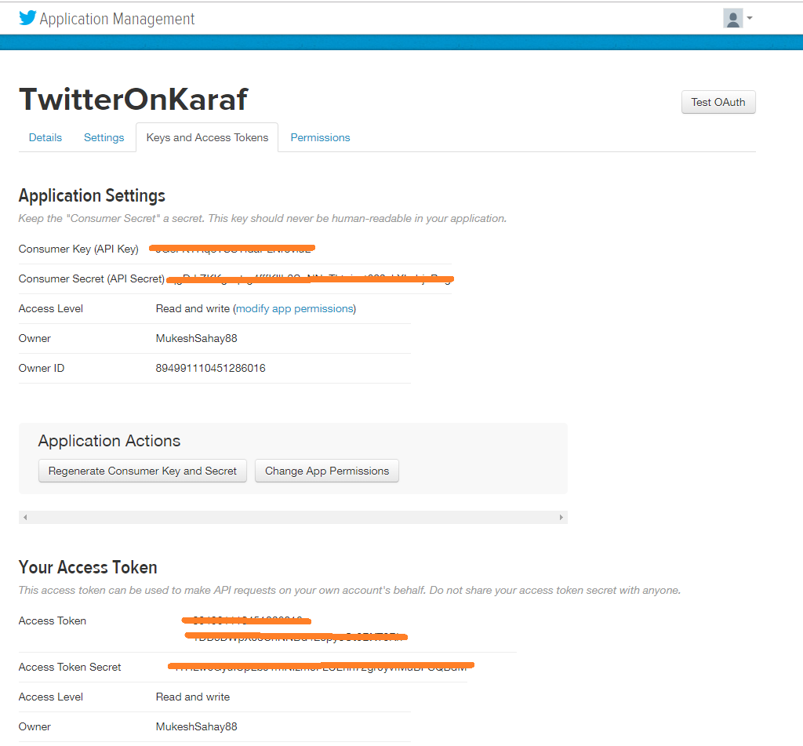

1. Run the application on the browser at <http://localhost:8181/twitterwithdrifters>

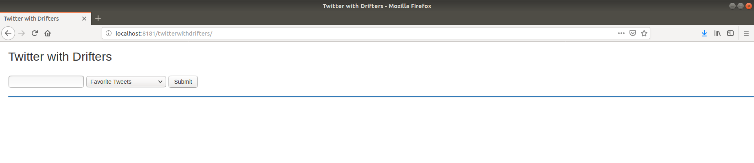

**SCREENSHOTS OF APIs IMPLEMENTATION**

1. Favorite Tweets

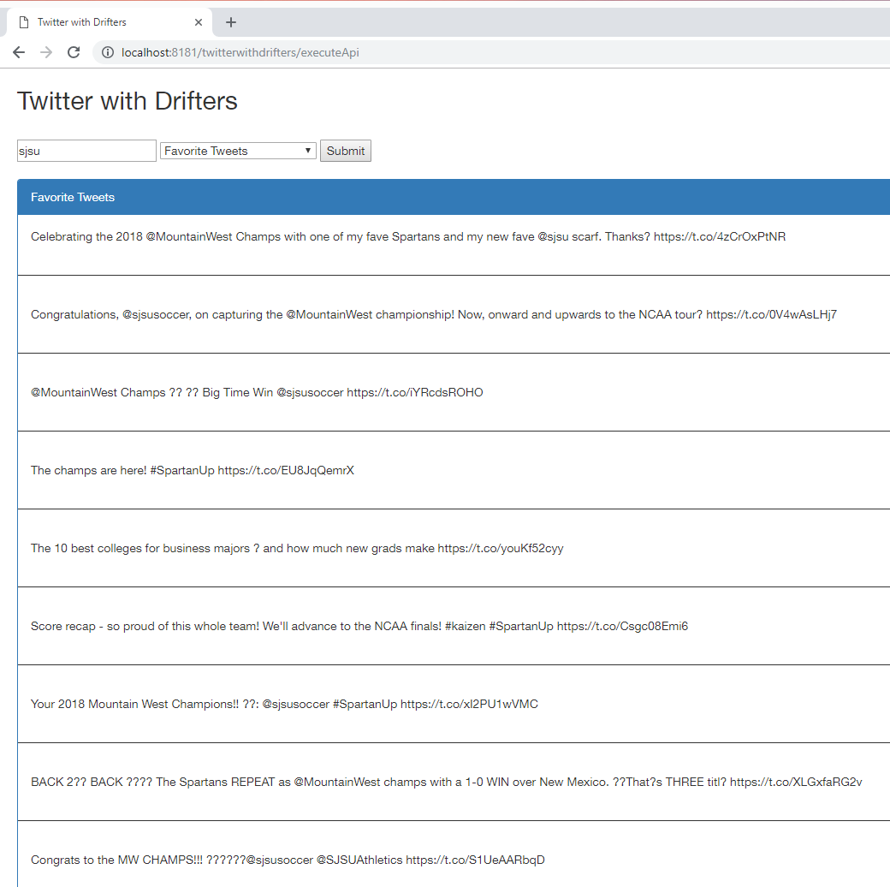

1. Follow User

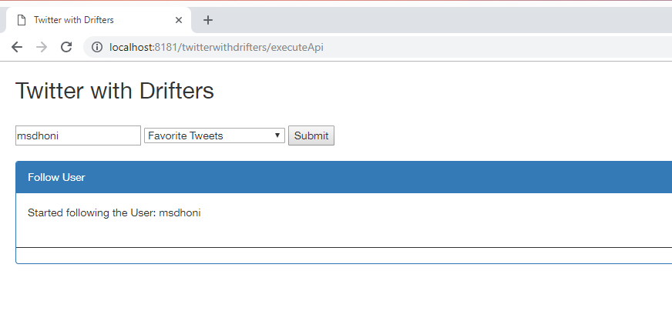

1. Followers List

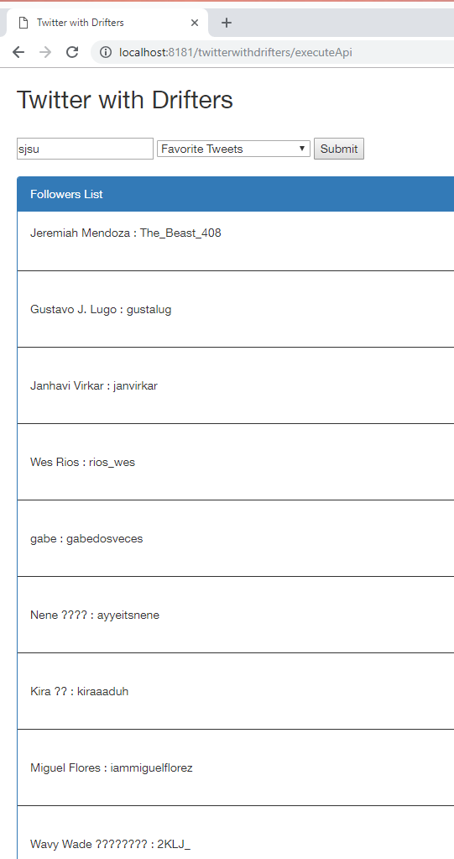

1. Get Tweets with Hashtag

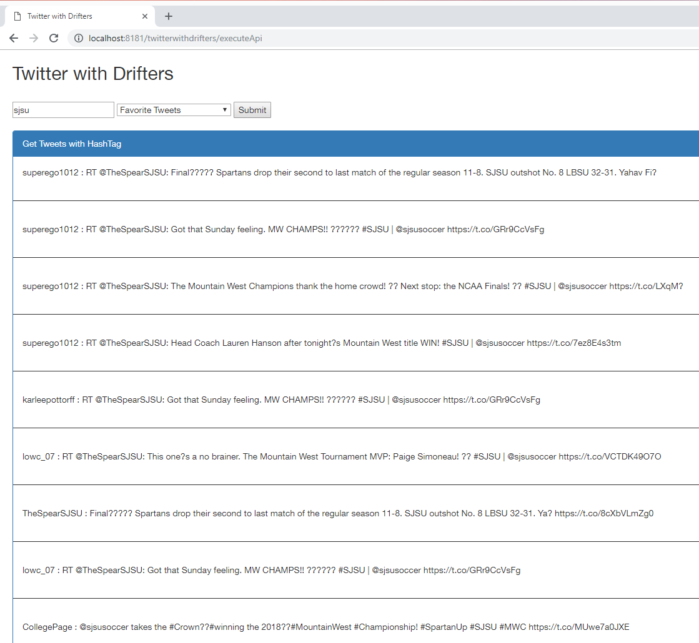

1. Show Timeline

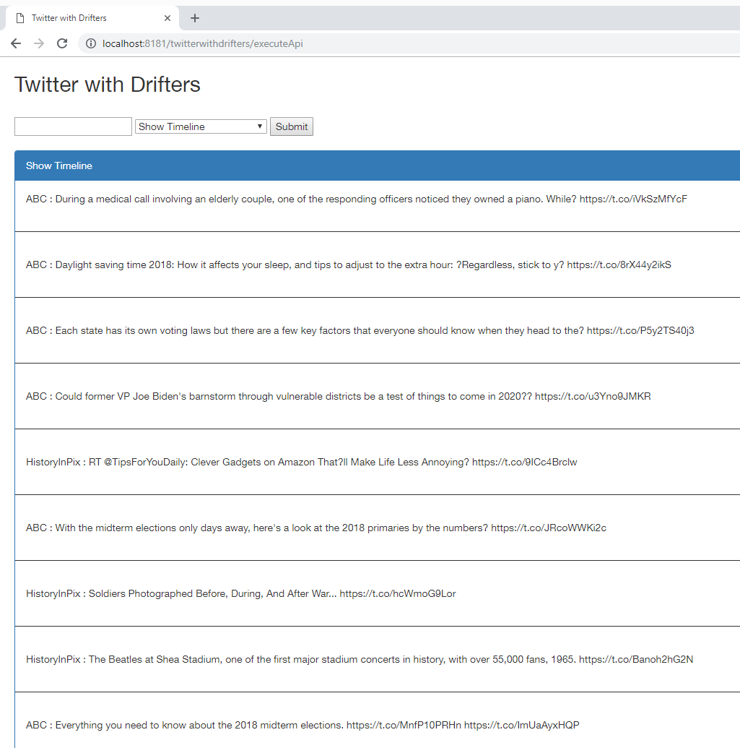

1. Supported Languages

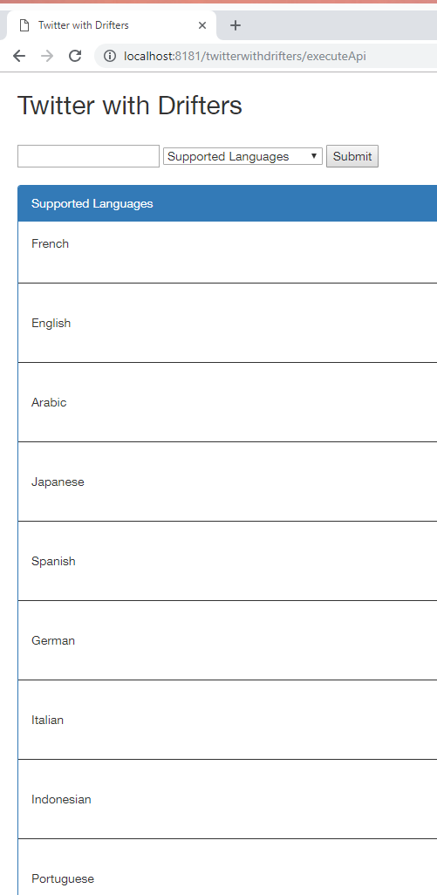

1. Trending From

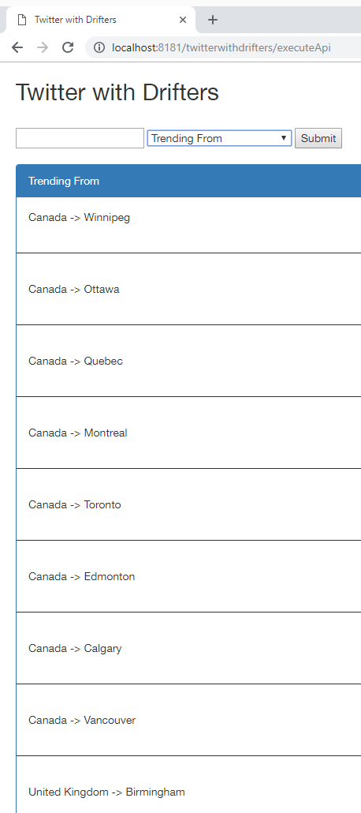

1. Tweet

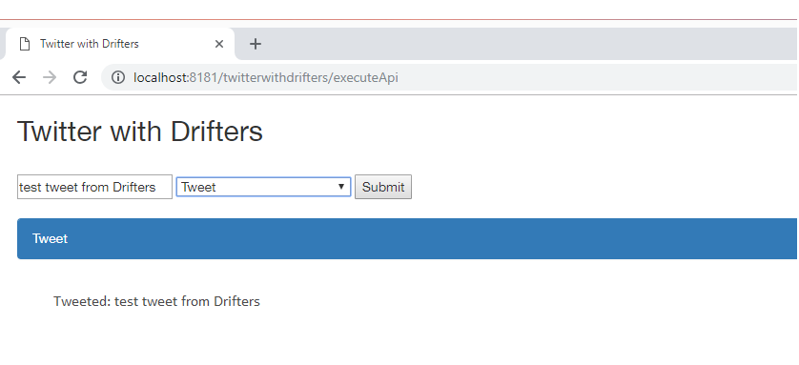

**JUnit TESTING**

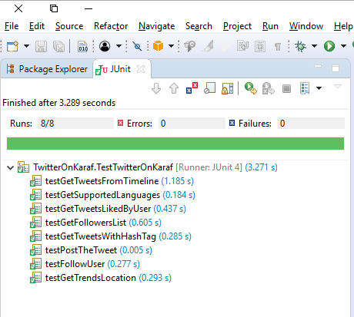

**Source Code**:  
<https://github.com/cpme272/HW2-TwitterOnKaraf>