
SERVICE CLUB S.L.
DELIVERY-SECTOR COMPLIANCE OPERATIONS
PROPOSAL
Outsourcing of Compliance Controls — Delivery Partners

Prepared for
Amazon EU S.à r.l. (Amazon Logistics)
RFP: Outsourcing Compliance DSPs 2026
Submitted by | Date | Validity
Service Club S.L. | [dd.mm.yyyy] | 180 days from submission
COMMERCIAL IN CONFIDENCE

Table of Contents

To refresh page numbers: right-click the table above and choose “Update Field”.

1 Executive Summary

1.1 The Challenge in One Line
Amazon already knows what Service Club can do inside a live logistics network. Amazon has described us as “far more than a software vendor; a strategic extension of our logistics ecosystem for driver acquisition and training.” The mandate now is to bring that same delivery-sector discipline to one of Amazon’s highest-risk control points: proving, within 24 hours, that every DSP, DA, subcontractor, SMP, Mobility Affiliate and vehicle is compliant before it enters the network.
That is the challenge in a single line. Amazon does not need another document repository. It needs a live compliance operating system — one that can absorb country-by-country legal variation, multilingual document evidence, peak-period volume and GDPR-sensitive personal data without slowing onboarding, weakening audit defensibility, or pushing risk back onto Amazon’s operations teams.
The risk is concrete, not theoretical. One expired insurance certificate, one incomplete right-to-work record, one vehicle document accepted without the correct local validation, or one untraceable reviewer decision produces the same operational consequence: Amazon carries exposure with no clean evidence trail. In a 20+ jurisdiction DSP environment, compliance rarely fails because nobody checked. It fails because the check was late, fragmented, undocumented, or impossible to defend after the fact.
Service Club was built to close exactly that gap — operationally, not hypothetically.
“far more than a software vendor; a strategic extension of our logistics ecosystem for driver acquisition and training”
— Amazon, on Service Club

1.2 Our Answer & the Transformation
Service Club will give Amazon a single managed compliance platform and operating model for document vetting, expiry control, renewal management, exception handling, SLA reporting and audit evidence across 20+ jurisdictions and 17+ languages. Every entity type in scope — DSPs, DAs, non-DAs, subcontractors, SMPs, Mobility Affiliates and vehicles — enters a timestamped workflow the moment documentation is submitted. Every outcome is logged, every exception is visible, and every decision is retrievable as evidence.
The transformation is immediate. Vetting stops being a sequence of manual checks scattered across countries and becomes a single, controlled compliance chain. Amazon sees what has been submitted, approved, rejected, what is approaching expiry, what is at SLA risk and what needs escalation — with no batch delay, no spreadsheet dependency and no end-of-month discovery of a gap that should have closed in the first 24 hours.
Our core commitment is contractual: ≤24-hour vetting outcomes, seven days a week, for every check type and entity type in scope. The measure is not subjective. The platform records submission timestamp, reviewer action, outcome timestamp, rejection reason, renewal trigger and audit history against each record, giving Amazon live breach-risk visibility before a breach can occur. Where generic HR providers report compliance gaps after the audit, Service Club closes them before the auditor arrives.
This is not a human-resources screening workflow rebranded for logistics. Amazon’s environment is different. A DA record is not just a candidate file; it is a live operational permission. A vehicle document is not just an uploaded PDF; it determines whether capacity can be deployed lawfully. A DSP renewal is not an administrative reminder; it protects continuity of service, contractual eligibility and customer promise during the periods when Amazon has the least tolerance for friction.
The platform is built around that reality. It supports SSO, API integration, configurable workflows, role-based access, MFA, audit logs, automated expiry alerts and real-time dashboards. Access is segregated by role, geography, entity type and operational function, so DSP managers, Amazon country teams, regional leads, auditors and SC compliance operators each see exactly the records they are authorised to see — nothing more, nothing less. Every login, upload, document view, validation action, rejection, approval, override and permission change is timestamped.
The managed service adds the judgement technology cannot replace. Country-specific documentation varies enormously: local registrations, driving-licence formats, vehicle insurance evidence, work-permit requirements, tax/VAT proofs and contractor eligibility rules do not behave like one European template copied twenty times. Service Club combines central visibility with jurisdiction-sensitive review, so Amazon receives one operating standard without flattening the local legal detail that determines whether a document is genuinely valid.
Through the October–November peak, the same standard holds. Surge capacity is not an exception clause. By 1 September each year, Service Club submits a costed, resourced peak-capacity plan covering forecast volume, staffing, workflow distribution, escalation coverage and SLA protection. Amazon gains the operational confidence that vetting will not become the bottleneck precisely when DSP capacity matters most.
After twelve months with Service Club, Amazon’s compliance environment looks different. Onboarding is faster because missing or rejected documents are identified immediately. Renewal cycles are cleaner because expiry alerts begin at T-60, T-30 and T-7 days before risk materialises. Audits are easier because each record carries its own evidence chain. Operations teams spend less time chasing documents and more time managing performance. And Procurement holds a contract with a partner whose value is visible every week — in SLA data, exception reduction and audit readiness.

1.3 Why Service Club — Three Proof Points
First — Amazon already knows Service Club performs inside the logistics ecosystem. The Amazon reference matters because this RFP is not a neutral software purchase; it is a delivery-sector compliance mandate. Amazon has described Service Club as “far more than a software vendor; a strategic extension of our logistics ecosystem for driver acquisition and training.” That statement speaks directly to this contract. We understand the rhythm of last-mile delivery, the pressure of onboarding windows, the operational cost of delayed eligibility decisions, and the difference between a compliant file and a driver or vehicle that can actually be deployed.
That existing relationship reduces procurement risk. A generic background-checking provider can explain its platform; Service Club can explain Amazon’s operating reality. We already work in the world of DSPs, couriers, fleet operators, delivery associates, driver documentation, certification status, identity verification and multi-country onboarding. The regulatory knowledge that wins this bid does not need to be assembled after award — it is operational before mobilisation begins.
Second — compliance is Service Club’s infrastructure, not paperwork. Service Club Compliance automates the tracking, verification and management of driver and vehicle compliance evidence: licence validity, right-to-work and work-permit checks, insurance certificates, certification records, KYC identity validation, automated expiry alerts and tamper-proof audit trails. That is the difference between document storage and compliance control. A file repository can show that something was uploaded; Service Club shows who reviewed it, when, why it passed or failed, what expiry risk exists, and what Amazon must know next.
Every record follows a defensible evidence chain: submission, validation, outcome, reviewer action, expiry status, renewal trigger and retrieval history. Audit-trail completeness is designed so that 100% of vetting outcomes are timestamped and retrievable within 4 hours of an authorised audit request. GDPR handling is embedded through role-based access, retention controls, secure storage, identity management and purpose-limited processing. If a regulator, internal auditor or Amazon governance team asks why a person, company or vehicle was compliant on a specific date, Service Club can produce the answer from the record itself.
Third — Service Club operates across countries and languages without losing the standard. We run driver-workforce capability across 30+ countries, with active European delivery and compliance experience in markets including France, Spain, Germany, Italy, the UK, Belgium and the Netherlands. This matters because Amazon’s requirement is not “Europe” as an abstract region. It is a country matrix of local document types, local eligibility rules, local privacy expectations, local vehicle evidence and local operational urgency.
Generic HR providers often centralise process by stripping away local nuance. Service Club does the opposite: we maintain one compliance standard while configuring workflows by country, document category, entity type and Amazon operating requirement. A French vehicle-insurance document, a German licence record, a Spanish work authorisation and a UK right-to-work check can all sit inside one governance model without pretending they are the same compliance event. Amazon receives central control with local legal intelligence.
The no-subcontracting constraint is treated as a delivery-design requirement, not a footnote. Service Club does not subcontract the core vetting operation. The country eligibility model, local registrations, business licences and insurance evidence required for the contract will be confirmed before award through Service Club’s own eligible structure and any permitted, pre-approved consortium arrangements where Amazon’s procurement rules require them. No post-award scrambling. No hidden handoffs. No compliance surprises at inspection.
These proof points converge on a single procurement conclusion: Service Club is not asking Amazon to bet on a generic provider learning last-mile compliance at European scale. We are offering a delivery-specific compliance system, an existing Amazon relationship, multilingual country coverage and a governed operating model built for the exact risk profile of this RFP. The team that selects Service Club signs a contract with a partner whose value is visible before the first audit asks for evidence.

1.4 Headline Value & Commitment
Service Club’s commercial value is not measured only in platform access or processing fees. It is measured in avoided operational friction: fewer onboarding delays, fewer expired documents, fewer manual escalations, fewer audit-remediation cycles, fewer data-handling risks, and fewer moments where Amazon operations must decide whether a missing document is a compliance issue or a capacity issue. In last-mile delivery, it is usually both.
One missed certificate equals one unchecked operational risk. One late renewal can delay a driver, vehicle or partner entity exactly when capacity is needed. One weak audit trail creates a defensibility problem long after the delivery window has closed. Service Club’s value is that these risks are surfaced early, documented clearly, and resolved inside a managed workflow Amazon can see.
Service Club commits to the following headline service position for Amazon:
- ≤24-hour vetting outcomes for every in-scope entity and check type
- 7-day operational coverage, with 24/7 escalation for critical incidents
- 20+ jurisdiction delivery, supported by multilingual processing across 17+ languages
- Real-time compliance dashboards, with live status, exception and SLA visibility
- Automated expiry alerts at T-60, T-30 and T-7 days
- SSO and API readiness, with role-based access and full audit logging
- GDPR-aligned data handling, including access control, retention configuration and breach-notification escalation
- October–November surge planning, submitted annually by 1 September
- Weekly SLA summaries, monthly performance reporting and quarterly governance reviews
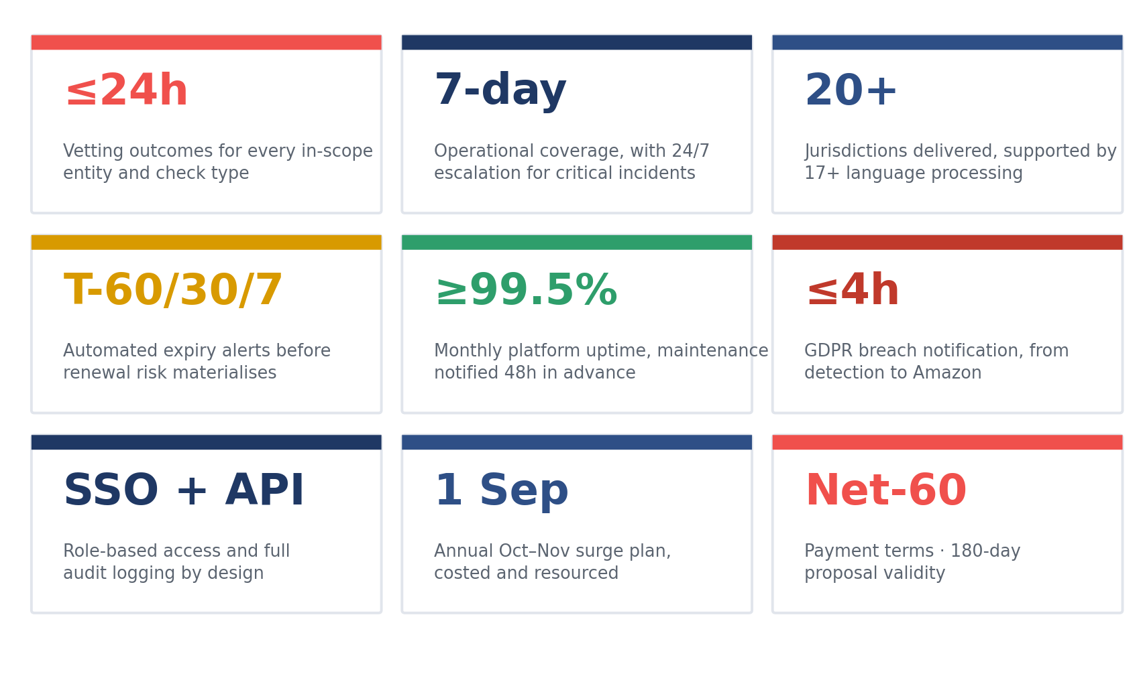
Service Club’s headline commitments to Amazon — at a glance
Our commercial terms are structured to support Amazon’s procurement and finance governance: Net-60 payment terms and 180-day proposal validity from submission. The detailed commercial model is aligned to Amazon’s final volume assumptions, country scope, entity mix and service configuration — so Amazon pays for a delivery model sized to the network, not for an inflated assumption built to protect the supplier.
Service Club commits to making Amazon’s compliance operation faster, clearer and more defensible from day one. The outcome is not simply that documents are checked. The outcome is that Amazon can see, prove and govern compliance across its DSP ecosystem in real time — during normal operations, during peak, during audit, and under executive scrutiny.
That is the decision this Executive Summary asks Amazon to make: select the partner that already understands the delivery environment, already operates driver compliance at multi-country scale, already holds Amazon credibility, and will contract the operating standard Amazon needs — compliant, fast, transparent, multilingual and built for European last-mile reality.

2 Understanding Your Challenge

2.1 Scale & Volume Volatility
Amazon’s Appendix 4 volume curve — from approximately 226,000 vetting transactions in 2026 to approximately 484,000 in 2027 — is not growth; it is a 2.14× operational shock to any provider whose model depends on manual queues, country-by-country inboxes or after-the-fact reporting. That increase represents around 258,000 additional checks in a single year, before seasonal peaks, rework, rejected documents, renewals, expired evidence and exception handling are even counted.
This is where ordinary compliance providers break. They price the average month, staff the average week and report the average SLA. Amazon does not operate on averages. A DSP onboarding surge in one market, a document-rule change in another, a peak-period vehicle upload batch, or a sudden renewal cycle across multiple entities can turn a stable compliance queue into an operational constraint within hours.
Service Club reads the volume profile differently. We treat every submission as a live compliance event: timestamped at intake, routed by entity type, prioritised by SLA risk, reviewed against country-specific rules, and visible to Amazon in real time. The point is not simply to process 484,000 records. The point is to prevent Amazon from discovering, too late, that volume has quietly converted into hidden non-compliance.

2.2 Geographic & Language Complexity
Amazon’s requirement spans 20+ countries across EU, APAC, MEATR and LATAM operating environments, with multilingual processing across at least 17 languages and document sets that change by jurisdiction, entity type and local legal obligation. A driving licence, work permit, insurance certificate, vehicle registration, tax/VAT document or contractor evidence pack does not carry the same compliance meaning in France, Germany, Spain, the UK, the UAE, Brazil or India.
Generic HR providers often impose one workflow across all markets and call it standardisation. Amazon needs something stricter: one governance standard, configured to local document reality. Service Club structures compliance by role, geography, entity type and operational function, so DSPs, DAs, non-DAs, subcontractors, SMPs, Mobility Affiliates and vehicles each move through workflows that reflect the actual evidence required in each country.
That distinction matters. Central visibility without local accuracy creates false confidence. Local review without central control creates audit fragmentation. Amazon needs both at once: country-sensitive validation, governed through one platform, one evidence chain and one SLA model.

2.3 Speed, SLA & Seasonal Peaks
The 24-hour vetting SLA is the operational test that separates a compliance platform from a document-storage system. Amazon is not asking for an acknowledgement within 24 hours. It is asking for an outcome — approved, rejected, or exceptioned with a defensible reason — across every in-scope entity and check type.
October and November expose weak providers. Peak does not only increase volume; it compresses tolerance. A delayed DA approval affects route readiness. A late vehicle-document decision constrains capacity. A DSP renewal stuck in review creates escalation pressure exactly when Amazon operations have the least time to absorb friction.
Service Club treats surge as a designed state, not an emergency. Every submission is timestamped, every workflow is breach-tracked, and every outcome is visible to Amazon before delay becomes operational damage. For the Oct/Nov peak, capacity is pre-modelled, staffing is pre-deployed, and the service standard remains ≤24-hour outcomes, seven days a week. No SLA holiday. No peak-period ambiguity.

2.4 Risk: Fraud, Non-Compliance & the Cost of Error
A single wrong vetting decision can cost Amazon more than the processing of thousands of correct ones. One fraudulent identity, expired licence, invalid insurance certificate, incorrect work authorisation, non-compliant vehicle record or undocumented reviewer override can trigger safety exposure, legal challenge, DSP disruption, regulatory scrutiny, GDPR escalation and reputational harm.
The danger is not only that a bad document passes. The deeper danger is that Amazon cannot prove, months later, why it passed. In a multi-region environment handling sensitive personal, commercial and vehicle data, compliance defensibility depends on the evidence chain: who uploaded the document, who reviewed it, what rule was applied, what decision was made, when expiry was triggered, and how the record was retained.
Service Club’s compliance architecture is built for that question. Every approval, rejection, escalation, renewal trigger, access event and audit retrieval is timestamped and traceable. Amazon receives more than vetting throughput; it receives operational protection — a defensible compliance record for every DSP, DA, subcontractor, SMP, Mobility Affiliate and vehicle before risk reaches the road.

3 The Transformation We Deliver

3.1 From Today’s Pain to the Future State
Amazon’s current risk is not that documents are missing; it is that compliance certainty arrives too late for a network moving at last-mile speed. Today’s pain is familiar: a DSP uploads evidence in one country, a DA licence renewal sits in a queue in another, a subcontractor record waits on a local tax document, a vehicle insurance certificate approaches expiry during a peak planning cycle — and Amazon operations only see the true compliance position once somebody asks, escalates or audits. That is not control. That is delayed visibility under operational pressure.
The problem compounds because Amazon’s vetting universe is not a single document type or a single population. It spans DSPs, DAs, non-DAs, subcontractors, Mobility Affiliates, Speed Mobility Partners and vehicles — each with different eligibility triggers, country rules, renewal cycles and failure consequences. A generic provider can process a file; Amazon needs to know whether that file grants lawful, auditable permission for a person, company or vehicle to operate in a specific market on a specific date. That distinction is where delivery-sector compliance is won or lost.
With Service Club, vetting becomes a live operating rhythm. Every record enters one managed workflow from submission to outcome, with status visible in real time by country, entity type, document category and SLA position. Amazon no longer waits for a provider to explain the queue. Amazon sees the queue, the risk, the action and the timestamp — before a late decision becomes a route-readiness issue or a governance escalation.
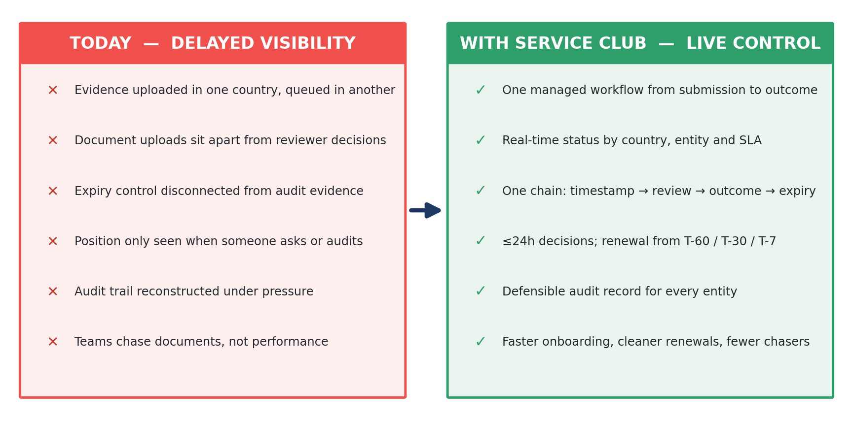
From fragmented, delayed visibility to one live, defensible evidence chain
The before-state is fragmented: document uploads sit apart from reviewer decisions; reviewer decisions sit apart from expiry control; expiry control sits apart from audit evidence; and audit evidence is reconstructed under pressure when Amazon least wants uncertainty. The after-state is one evidence chain: submission timestamp, validation route, reviewer action, approval or rejection, rejection reason, expiry status, renewal trigger and retrieval history. No invisible handoffs. No compliance record that depends on a spreadsheet being current.
A document submitted at 09:14 carries a platform timestamp. The reviewer action is logged; the decision is issued within ≤24 hours; the record is retained with its full audit trail; and renewal control begins automatically through expiry monitoring at T-60, T-30 and T-7 days. The compliance question changes from “Where is this document?” to “What decision has been made, what evidence supports it, what expiry risk remains, and who can see it?” That is the operating state Amazon needs across 20+ countries and 17+ languages.
This is not a tool sitting beside Amazon’s process. It is the compliance layer beneath it: faster onboarding, cleaner renewals, fewer manual chasers, earlier exception resolution, and a defensible audit record for every in-scope entity. Amazon receives not only document vetting, but the confidence that every decision can withstand operational challenge, internal review and regulatory scrutiny.

3.2 The Measurable Outcomes
Service Club commits to outcomes Amazon can measure, challenge and govern. The headline commitment is ≤24-hour vetting outcomes, seven days a week, across every required check category: DA, non-DA, DSP, subcontractor, Mobility Affiliate, Speed Mobility Partner and vehicle documentation. The SLA is measured from platform submission timestamp to outcome timestamp — not from when a reviewer first opens the file. That matters, because Amazon’s operating risk begins when the document enters the process, not when a supplier decides the clock should start.
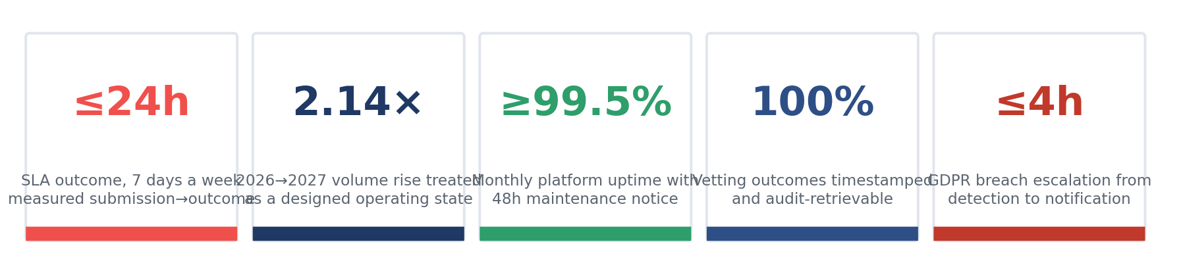
Amazon’s projected volume movement — approximately 226,000 checks in 2026 rising to approximately 484,000 in 2027 — requires more than extra reviewers. It requires queue intelligence. Service Club routes records by jurisdiction, document type, entity risk and SLA exposure, so growth does not become hidden backlog. A 2.14× increase in annual vetting activity is treated as a designed operating condition, not a surprise for year two.
Through the October–November peak, the model holds. Surge is not an exception clause. Service Club pre-models demand, pre-deploys staffing and confirms the peak-capacity plan to Amazon by 1 September each year — covering expected volume, workflow distribution, escalation coverage and SLA protection. Amazon receives a clear view of how peak will be absorbed before peak begins, rather than an explanation after service levels degrade.
Fraud and error are addressed where they become expensive: before approval. Service Club’s compliance architecture includes KYC identity verification, licence and insurance tracking, reviewer audit logs, role-based access, rejection-reason capture, document-validation workflows, automated expiry alerts and tamper-proof evidence records. Suspicious, expired, inconsistent, incomplete or jurisdictionally invalid documentation is exceptioned with a recorded reason — giving Amazon a defensible decision trail rather than a silent pass/fail result.
The fraud benefit is not only detection; it is deterrence. When every upload, access event, reviewer action, override, approval, rejection and renewal trigger is timestamped, the compliance environment becomes harder to manipulate and easier to defend. Amazon receives a record that can answer the critical audit question months later: why was this DA, DSP, subcontractor or vehicle considered compliant on that date?
Platform performance is also measurable. Service Club commits to ≥99.5% monthly uptime, with scheduled maintenance notified at least 48 hours in advance, and real-time dashboard visibility across submission status, approval status, rejection reasons, renewal exposure and SLA position. Audit-trail completeness is designed so that 100% of vetting outcomes are timestamped and retrievable within defined governance windows, and GDPR breach escalation is governed through a ≤4-hour notification commitment from detection to Amazon notification.
Cost control follows from removing avoidable work. Automated expiry alerts reduce emergency renewals; real-time dashboards reduce manual status chasing; SSO and API readiness reduce duplicate handling; role-based access reduces internal routing noise; and audit records reduce remediation effort because Amazon never has to rebuild the evidence chain after the fact. Lower cost per check comes from fewer rechecks, fewer escalations, fewer manual interventions and fewer late-stage exceptions — not from cutting compliance depth.
The measurable outcome is a vetting operation that scales without becoming opaque. Amazon can track throughput, SLA adherence, breach risk, rejected-document patterns, fraud indicators, country workload, peak pressure and renewal exposure in one operating view. That is how 484,000 annual checks remain a governed compliance environment rather than an administrative burden.

3.3 What This Means for Amazon
Amazon receives a compliance model that protects the brand before the brand is exposed. A non-compliant driver, vehicle or partner entity is not just an administrative defect; it is a safety, legal, reputational and customer-promise risk. Service Club reduces that exposure by making eligibility visible, evidenced and governed before work reaches the road.
Onboarding becomes faster because Amazon no longer loses time to unclear document status: a DA, DSP or vehicle record is approved, rejected or exceptioned with a reason within ≤24 hours, giving operations teams the certainty to act. Capacity planning becomes more predictable because renewals and exceptions are visible before peak pressure arrives. Governance becomes cleaner because every approval, rejection, escalation, access event and expiry trigger is timestamped in one audit trail.
The brand protection is practical, not abstract. If an incident, audit or internal review asks whether an entity was eligible to operate, Amazon can retrieve the record, the decision, the timestamp and the evidence path. If a document was rejected, Amazon can see why. If a renewal is approaching, Amazon can see when the alert was issued and what action followed. If a reviewer decision is challenged, Amazon can trace the user, action and rule path attached to that decision.
The procurement value is equally direct. Amazon selects a partner already recognised as “far more than a software vendor; a strategic extension of our logistics ecosystem for driver acquisition and training” and extends that delivery-sector credibility into DSP compliance operations. That existing Amazon context reduces the learning curve, shortens mobilisation risk and strengthens confidence that the service model reflects how last-mile operations actually work.
Amazon’s world after Service Club is not a larger document database; it is a more controlled network. Faster onboarding without blind approvals. More languages without fragmented standards. More countries without country-by-country chaos. More checks without hidden backlog. More transparency without adding administrative burden to Amazon’s teams.
That is the outcome Service Club contracts: speed without losing control, scale without losing local accuracy, cost predictability without weakening compliance. Amazon receives a partner that manages the compliance consequence of every vetting decision — and gives Amazon the evidence to prove it.

4 Why Service Club

4.1 Who We Are
Amazon has already described Service Club as “far more than a software vendor; a strategic extension of our logistics ecosystem for driver acquisition and training.” That sentence is the shortest way to explain why we are different in this RFP. We are not arriving as a generic compliance platform hoping to learn last-mile delivery after award; we already operate inside the delivery environment Amazon is asking suppliers to understand — with the discipline required to turn driver, partner and vehicle eligibility into a governed operational system.
Service Club is a specialist compliance, workforce and driver-operations technology partner, built for logistics networks where people, vehicles, documents and regulatory obligations move faster than traditional back-office controls. Our operating footprint spans 30+ countries, with multilingual delivery, compliance workflows, identity verification, licence validation, insurance tracking, certification monitoring, audit trails and dashboard reporting already embedded in our platform model. The relevance to Amazon is immediate: the populations in this RFP — DSPs, DAs, non-DAs, subcontractors, Mobility Affiliates, Speed Mobility Partners and vehicles — are not peripheral use cases for us. They are the core operating world we were built to serve.
This matters because Amazon is not buying company heritage; Amazon is buying risk reduction at scale. The question is not whether a supplier has existed for many years or processed documents in other sectors. The question is whether it can prove, within ≤24 hours, that a person, company or vehicle is eligible to operate in a specific country, under a specific document requirement, with evidence Amazon can retrieve when challenged. Our answer is not a manual promise; it is a compliance architecture: document submission, validation route, reviewer action, decision outcome, rejection reason, expiry control and audit history captured in one chain.
Our work sits at the intersection Amazon cares about most — speed, compliance and operational continuity. A slow vetting decision blocks onboarding. A weak vetting decision exposes Amazon to legal, safety and reputational risk. An undocumented vetting decision leaves procurement, operations and governance teams defending a record they cannot reconstruct. Service Club reduces that exposure by managing the compliance consequence of every record, not merely the administrative act of checking it.
Service Club is focused rather than generalist, and that focus is commercially useful to Amazon: this mandate is not an HR screening exercise repeated at volume; it is a delivery-sector control function across 20+ countries, 17+ languages and a volume curve moving from approximately 226,000 checks in 2026 to approximately 484,000 in 2027. We know what breaks under that pressure — inbox-based review, static document repositories, month-end reporting, country teams working from different rules, and dashboards that show status without showing risk. Service Club is built to prevent exactly those failures.

4.2 Our Edge — Agility, AI & Multilingual Delivery
Service Club’s first advantage is agility with governance. Large incumbents often confuse standardisation with control: one workflow, one queue, one operating manual, imposed across markets that do not share the same document reality. Amazon needs the opposite — one central compliance standard configured by country, entity type, document class and SLA exposure, so a Spanish vehicle-insurance renewal, a German licence validation, a French contractor record, a UK right-to-work file and a Brazilian identity document are not forced through the same blunt template.
That is where our model gives Amazon speed without sacrificing accuracy. Workflows are configured around the actual evidence Amazon needs to accept or reject: licences, work permits, right-to-work records, insurance certificates, vehicle registrations, certifications, tax/VAT documents, business licences and local eligibility proofs. Each workflow carries its own routing logic, reviewer permissions, exception rules and expiry triggers. Amazon receives central visibility across the network, while the validation decision still respects the local rule that determines whether the record is valid.
Agility also matters during volume shock. The forecast increase from 226,000 to 484,000 annual vetting transactions is not a linear growth line; it is a stress test of operating design. Service Club does not wait for queues to age before acting. Submissions are timestamped at intake, routed by jurisdiction and document category, prioritised by SLA risk, and surfaced through live dashboards — so Amazon sees bottlenecks before they become operational constraints. In the Oct/Nov peak, surge is not a supplier excuse; it is pre-modelled, pre-resourced and governed against the same ≤24-hour outcome SLA.
The second advantage is AI-enabled compliance control. Service Club uses automation and AI where it strengthens evidence, speed and consistency: KYC biometric check-in, identity-verification logic, automated expiry alerts, real-time progress monitoring, document-status dashboards, tamper-proof audit trails, API-ready architecture and exception flagging for incomplete, expired or inconsistent evidence. AI does not replace the compliance judgement Amazon needs; it removes the blind spots that make human review slow, uneven and hard to defend under audit.
For Amazon, this means fewer silent failures. A suspicious identity match is not buried in a queue. An expired document is not discovered after a route is planned. A rejected record does not disappear into an email thread. A reviewer action is not an undocumented opinion. Every login, upload, document view, validation action, approval, rejection, override, renewal trigger and access change is timestamped and retained as evidence. Where ordinary portals store documents, Service Club creates the decision trail that proves why a document was accepted or refused.
The third advantage is multilingual delivery with operational context. Amazon’s requirement for 17+ languages is not a translation requirement; it is a compliance-accuracy requirement. A reviewer must understand the language on the document, the local format, the jurisdictional expectation and the operational consequence of approving or rejecting it. A mistranslated insurance certificate, a misunderstood work authorisation, or a local registration accepted without the required field can create the same risk as no check at all.
Service Club operates across 30+ markets because delivery networks do not behave in one language. DSP managers, drivers, subcontractors, operations teams and auditors work across local systems, local documents and local escalation paths. Our multilingual capability gives Amazon a practical advantage: fewer rejected records caused by poor instruction, fewer escalations caused by unclear evidence requests, and faster resolution because the supplier can communicate with the person or entity holding the missing document. That is not language support as a service feature — it is language capability as SLA protection.
This combination — agility, AI and multilingual delivery — is what lets Service Club compete differently against large, slow incumbents. We do not ask Amazon to accept a global template and wait for customisation later. We configure the operating model around Amazon’s DSP compliance reality from the start: SSO, API integration, role-based access, configurable workflows, GDPR-aligned processing, automated expiry alerts, real-time dashboards, audit logs and managed 7-day operations. Amazon receives a partner that can move quickly because the domain is already familiar, and govern tightly because the evidence chain is already designed.
The result is not a more attractive interface; it is a safer operating position. Faster onboarding without blind approvals. More countries without diluted standards. More automation without losing human accountability. More volume without hidden backlog. More languages without compliance ambiguity. That is the structural edge Service Club brings to this mandate.

4.3 Built for This Mandate
This RFP sits inside Service Club’s operating DNA: last-mile delivery, high-volume onboarding, driver and vehicle compliance, multilingual document review, GDPR-sensitive processing, API integration and audit defensibility. Amazon’s mandate is not adjacent to our business; it is a direct expression of the problem we already solve. Every in-scope population — DSPs, DAs, non-DAs, subcontractors, SMPs, Mobility Affiliates and vehicles — requires exactly the controls we have built: identity, eligibility, documentation, renewal, evidence and governance.
Service Club Compliance automates the tracking, verification and management of driver and vehicle compliance documentation — licence validity, insurance certificates, right-to-work/work-permit evidence, KYC identity verification, certification status and expiry alerts. Each record carries the evidence Amazon needs to defend a decision: submission timestamp, reviewer action, outcome timestamp, rejection reason, expiry status, renewal trigger, access history and audit-retrieval trail. That gives Amazon a live compliance chain, not a static document store.
The ≤24-hour SLA is therefore not a service aspiration; it is an operating-design principle. Intake timestamps start the clock, routing rules move the record, dashboards expose risk, escalation paths protect ageing items, and reviewer actions create the evidence Amazon needs. Seven-day coverage is structured around Amazon’s operating reality, not office-hour convenience. Peak periods are planned before they arrive, with capacity modelling aligned to forecast volumes and Oct/Nov surge pressure.
The no-subcontracting requirement reinforces why our focus matters. Service Club does not subcontract the core compliance operation; we govern the platform, workflows, reviewers, SLA reporting, data handling and audit evidence directly. Where country registrations, business licences or insurance evidence are required, we treat them as mobilisation controls to be confirmed before launch through eligible Service Club structures and any Amazon-approved pre-award arrangements. No post-award scrambling. No hidden operational handoffs. No inspection surprise.
GDPR and local legal adherence are built into the mandate, not appended to it. Sensitive personal, commercial and vehicle data must be processed with role-based access, defined retention, secure storage, audit logging and clear escalation. Our model gives Amazon permission control by role, geography, entity type and operational function, so users see what they are authorised to see and every access event is traceable. In a multi-region compliance environment, that traceability is not administrative hygiene — it is Amazon’s defence.
The procurement decision this section supports is simple. Amazon can select a generalist supplier that will translate a background-check process into delivery language, or it can select the partner already recognised by Amazon as an extension of its logistics ecosystem. Service Club brings 30+ country operating experience, delivery-sector focus, multilingual compliance delivery, AI-enabled evidence control and a platform model built around live auditability. Amazon receives the outcome procurement needs to defend: a supplier that is fast enough for the network, precise enough for local rules, and disciplined enough to prove every decision.

5 Proven Experience & References

5.1 Relevant Track Record
Amazon has already judged Service Club in the only environment that matters for this mandate: live logistics operations, where driver readiness, compliance evidence and delivery performance meet under time pressure. Amazon described us as “far more than a software vendor; a strategic extension of our logistics ecosystem for driver acquisition and training.” That reference is directly relevant, because this RFP is not an abstract document-vetting exercise — it is a last-mile compliance control function across people, partner entities and vehicles.
Service Club’s experience is concentrated in driver-led, delivery-led and fleet-led environments across 30+ countries. We support qualified, verified and ready-to-work driver populations through identity verification, initial licence validation, background-check workflows, multilingual recruitment support, training-completion records, certification tracking, insurance monitoring, automated expiry alerts and audit-ready evidence trails. The same operating logic applies to Amazon’s in-scope populations: DSPs, DAs, non-DAs, subcontractors, Mobility Affiliates, Speed Mobility Partners and vehicles.
This focus is the proof point. A generalist screening provider can show Amazon a large client list; Service Club can show Amazon the specific compliance mechanics that make a delivery network safe to operate — KYC, licence validity, work eligibility, vehicle evidence, insurance status, renewal triggers, reviewer accountability and real-time dashboards. For a mandate moving from approximately 226,000 checks in 2026 to 484,000 in 2027, that specialism is not cosmetic. It is the difference between processing documents and governing operational permission.

5.2 Case Study 1 — Amazon Logistics Ecosystem Support
CHALLENGE
Amazon’s challenge was not simply to find more drivers. It needed a partner capable of supporting driver acquisition and training in a delivery environment where speed, suitability and operational readiness matter from the first interaction.
A candidate who cannot be verified, trained or moved through the next stage quickly is not a lead; they are friction in the DSP capacity chain. Amazon needed a partner that understood that distinction.
Action — Service Club brought together driver acquisition, verification and readiness support through a logistics-specific model. SC Jobs operates as a dedicated driver-acquisition platform across 30+ countries, sourcing qualified, verified and ready-to-work delivery and logistics drivers rather than relying on passive job-board response. Candidate workflows include KYC identity verification, initial licence validation, multi-channel sourcing, multilingual support and pipeline visibility, with integration options such as SmartRecruiters ATS alignment where required.
Result — Amazon’s own endorsement of our role: “far more than a software vendor; a strategic extension of our logistics ecosystem for driver acquisition and training.” That sentence is more than a testimonial. It confirms the operating relationship Amazon needs in this RFP — a partner that understands last-mile pressure, does not treat drivers as generic HR records, and can connect compliance evidence to operational readiness.
The relevance to document vetting is direct. The same failure modes exist here: unverified identity, unclear licence status, missing documentation, delayed action, weak evidence and poor visibility. Service Club has already worked in the Amazon logistics context where those failures matter. For this RFP, we extend that delivery-sector credibility into a governed vetting service with ≤24-hour outcomes, audit trails and renewal controls across Amazon’s wider DSP ecosystem.

5.3 Case Study 2 — Multi-Country Driver Compliance & Audit Evidence
A European fleet and delivery operating environment faces a different version of Amazon’s problem: multiple jurisdictions, different document rules, different driver categories, local training and certification obligations, and the need for one central view that holds under audit. The operational risk is familiar — one missed licence renewal, one expired insurance certificate, one unverified training completion or one inconsistent country process creates exposure that is only discovered when the record is challenged.
Action — Service Club built compliance around the driver record, not around a spreadsheet. Service Club Compliance automates the tracking, verification and management of driver documentation, including driver-licence validity, insurance-certificate tracking, compliance status, KYC biometric check-in, expiry alerts, real-time dashboards and tamper-proof audit trails. Through Service Club Academy, training completions update compliance status directly, so a driver’s readiness record reflects identity, eligibility, training and certification evidence in one controlled chain.
The measurable outcome is operational control across complexity. Our driver compliance and training infrastructure supports activity across 30+ countries, with jurisdiction-specific assignment for EU/UK professional-driver frameworks including Driver CPC, FIMO/FCO, tachograph compliance and Working Time Directive requirements where applicable. In practical delivery terms, our wider training network includes 10,000+ certified instructors, 7,000+ partner schools and 500+ training locations, putting driver readiness and compliance support close to where fleets operate.
The relevance for Amazon is the audit trail. Service Club does not only confirm that a document or certificate exists; it records the event, identity check, completion or validation action, expiry status and access history behind the record. That gives Amazon the answer an auditor, regulator or internal governance lead will ask months later: who was compliant, against what evidence, on what date, and who made the decision?

5.4 Partner / Joint-Bid Strength
Service Club presents this mandate as a direct compliance-delivery model, not a hidden subcontracting structure. That is deliberate. Amazon’s RFP prohibits subcontracting, and our position is clear: the core vetting operation — platform, workflows, reviewer governance, SLA reporting, data handling, audit evidence and Amazon-facing service management — remains under Service Club control.
Where the RFP requires country-specific registrations, business licences, insurance certificates or local authorisations, Service Club will treat those items as pre-award mobilisation controls. Any permitted consortium or formal partner arrangement will be disclosed, approved through Amazon’s procurement process, and limited to the specific local eligibility requirement it supports. No post-award improvisation. No undocumented operational handoff.
This is how Amazon’s risk is protected. Service Club gives Amazon one accountable compliance owner, one SLA model, one governance structure and one audit trail — while ensuring any country-specific eligibility requirement is resolved transparently before service launch. The partner model, if used, strengthens coverage without diluting accountability.

6 Our Solution — Platform & AI Engine

6.1 Solution Overview
Amazon’s vetting operation fails if the platform only stores documents after risk has already entered the queue. Service Club’s model starts earlier: every Amazon event becomes a timestamped compliance trigger, every trigger starts the ≤24-hour SLA clock, and every outcome returns to Amazon with the evidence needed to approve, reject, monitor or audit the entity.
The solution is built around one controlled pathway. Amazon generates an onboarding, renewal or periodic vetting event; the event is received through API, SSO-enabled portal upload or approved batch workflow; the platform classifies the entity and document type; AI Document Intelligence extracts and tests the evidence; trained compliance reviewers validate the decision; and the outcome returns to Amazon with a reason code, timestamp, expiry status and audit trail. This is not a document portal. It is a compliance-decision engine with human accountability at the point where Amazon needs defensibility.
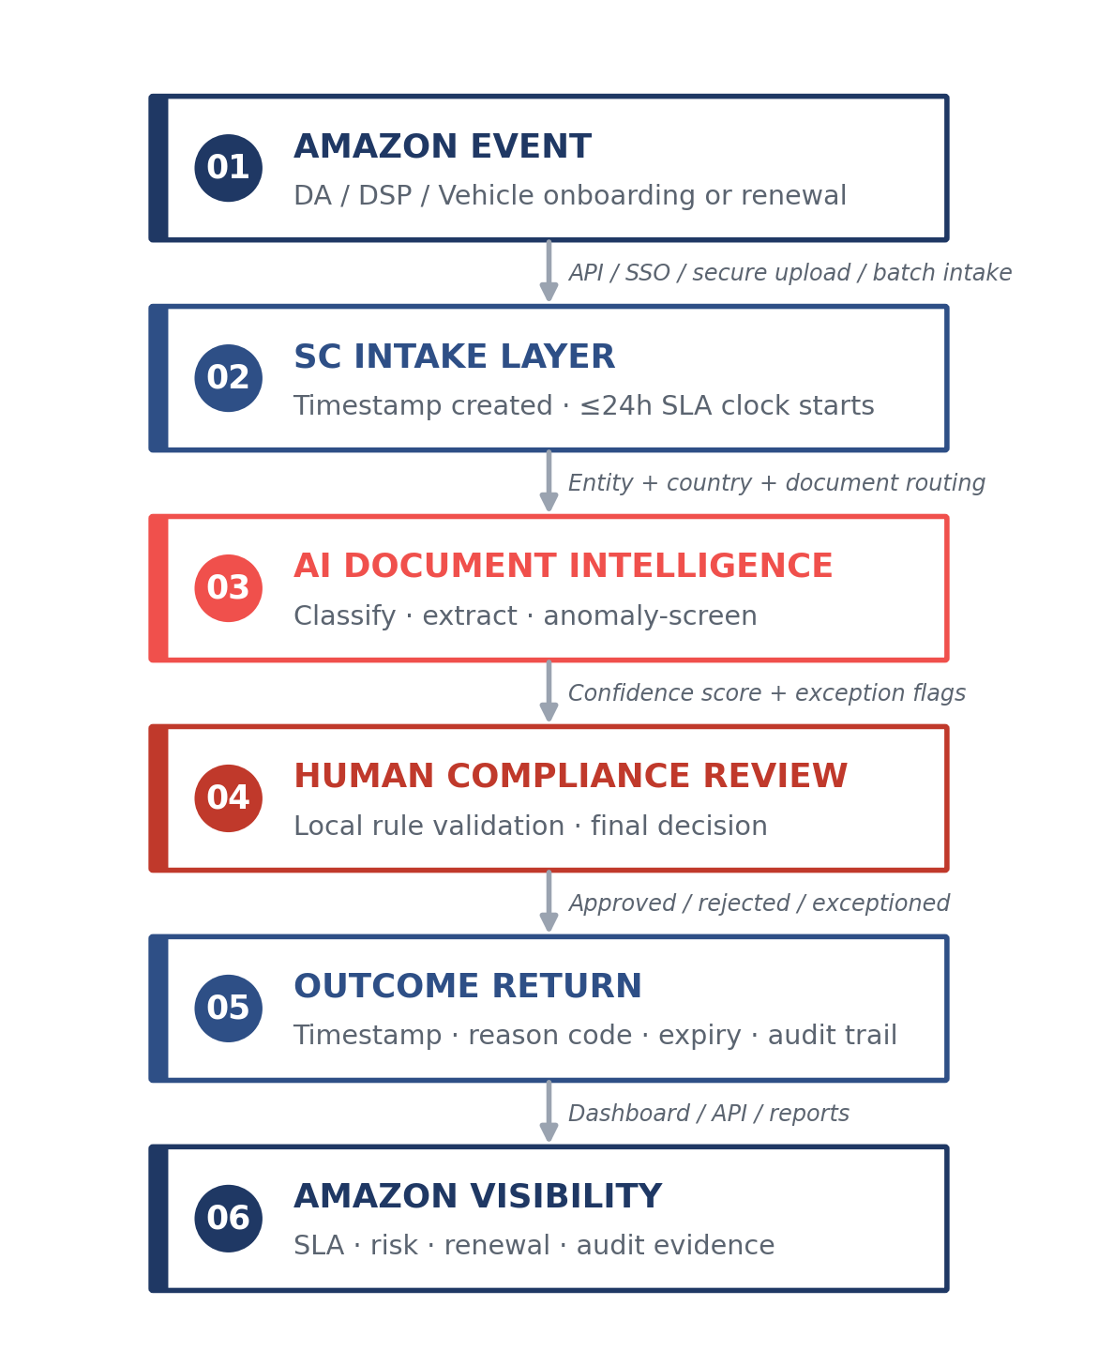
Diagram 1 — From an Amazon event to a defensible compliance outcome
The mechanism matters because Amazon’s volume profile moves from approximately 226,000 checks in 2026 to 484,000 in 2027. Manual review alone will not hold that curve; AI without compliance judgement will not defend the decision. Service Club combines both, so Amazon receives speed with evidence rather than automation without accountability.

6.2 The Managed Platform
Amazon’s users should not have to learn a supplier’s access model; the supplier’s platform should fit Amazon’s control environment. Service Club supports enterprise SSO, role-based access, MFA-aligned authentication, user-lifecycle management and permission segregation by role, geography, entity type and operational function. Amazon global administrators, regional operations leads, country teams, DSP managers, auditors, read-only reporting users and SC compliance operators all access the same compliance environment with different evidence rights.
Secure upload is available for document submission where API-triggered intake is not the correct route. Bulk upload and bulk download support high-volume cycles, while structured metadata prevents Amazon from inheriting a folder of unlabelled PDFs. Every upload, view, approval, rejection, override, permission change and download is captured in the audit log — giving Amazon a record that can answer the audit question months later: who accessed what, what decision was made, when, and on what evidence.
The managed platform includes automated expiry alerts, tailored dashboards, document-status reporting, SLA tracking, rejection-reason analytics, renewal-exposure views and country-level workload visibility. Modularity is included in the in-scope service design at no additional platform-configuration charge: Amazon can activate workflows for DAs, non-DAs, DSPs, subcontractors, Mobility Affiliates, Speed Mobility Partners and vehicles without buying a separate system for each population. The platform is one control layer, configured by use case.
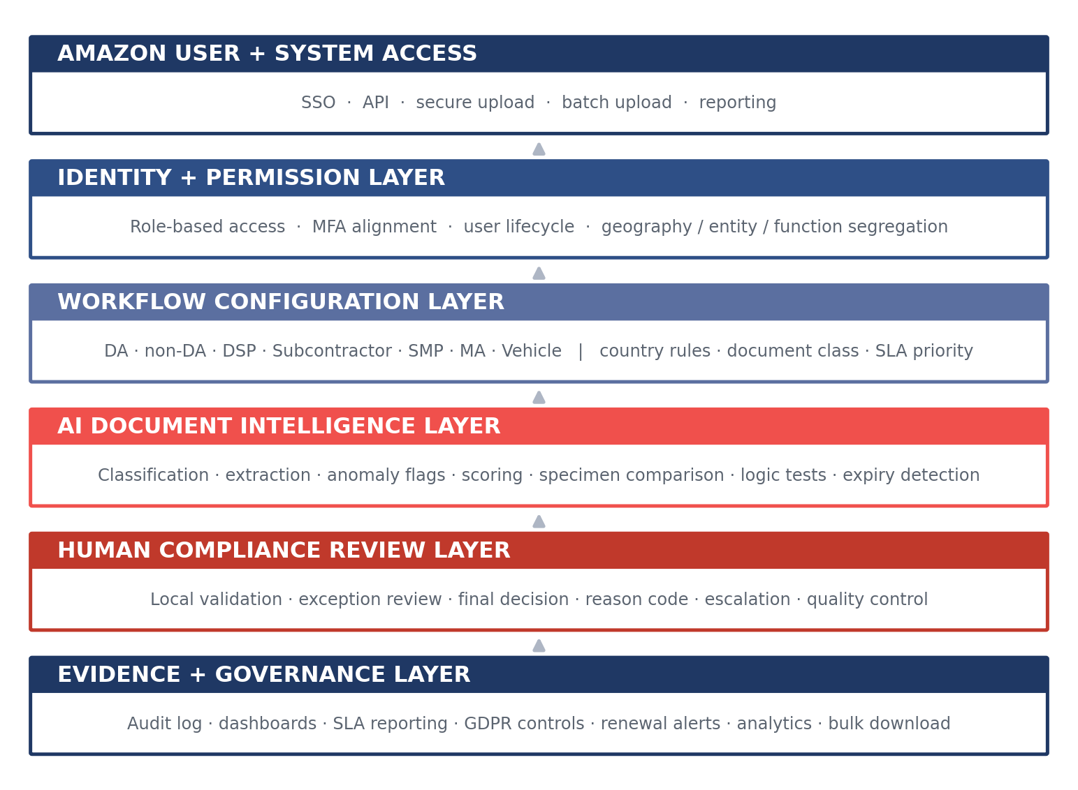
Diagram 2 — Layered platform architecture, from Amazon access to evidence and governance
Platform availability is governed through ≥99.5% monthly uptime, scheduled maintenance notice at least 48 hours in advance, and operational reporting through live dashboards. Amazon does not wait for a weekly file to know whether compliance is drifting; the control position is visible as the work happens.

6.3 AI Document Intelligence & Falsified-Document Detection
Fraud rarely announces itself as fraud. It appears as a licence format that looks almost right, an insurance certificate with inconsistent dates, a work permit with mismatched metadata, a vehicle record where registration logic does not fit the country, or a specimen that resembles the official version closely enough to pass a tired manual reviewer. This is exactly where AI must be present — not as decoration, but as the first line of structured evidence testing.
Service Club’s AI Document Intelligence begins with document classification, identifying whether the upload is a driving licence, identity document, work authorisation, insurance certificate, vehicle registration, business licence, tax/VAT evidence, certification record or other country-specific document class. It then extracts metadata: names, dates of birth, licence numbers, expiry dates, issue dates, registration identifiers, issuing authority, country markers, vehicle registration details, policy numbers and document-version signals.
The next layer is cross-referencing. Where registers, public-authority sources, approved specimen libraries, Amazon-approved country rules or structured validation sources are available, the AI-assisted workflow compares the extracted fields against the expected format and validation logic. The test is not “does the document look plausible?” It is “does this document behave like a valid record for this country, this entity type, this document class and this operating purpose?”
Service Club applies four AI-assisted falsification screens before final approval:
- Specimen comparison — layout, field order, issuing marks and document structure checked against approved patterns
- Anomaly detection — inconsistent fonts, date patterns, metadata gaps, image artefacts and suspicious edits flagged
- Logic validation — issue date, expiry date, age, vehicle registration, licence category and jurisdiction rules tested for coherence
- Cross-record consistency — identity, entity, vehicle and policy data compared against the wider Amazon record set
The AI does not issue the final compliance decision in isolation. It produces confidence scores, extracted fields, anomaly markers and recommended routing. A trained compliance reviewer then confirms, rejects or exceptions the record, applying local document knowledge and Amazon’s agreed rulebook. That human-in-the-loop model is deliberate: Amazon receives the speed of automation and the defensibility of accountable review.
Every AI signal and reviewer action is retained in the evidence trail. If a document is rejected, Amazon sees the reason. If it is escalated, Amazon sees the flag. If it is approved after review, Amazon can trace the classification, extraction, validation path, reviewer action and outcome timestamp. That is how AI becomes procurement-safe: visible, governed and auditable.

6.4 Predictive Expiry & Continuous Monitoring
Amazon’s compliance risk does not end when a document is approved — it often begins there, because every approved licence, insurance certificate, work authorisation, vehicle document, registration or business licence immediately starts moving toward expiry. A supplier that only checks documents at onboarding leaves Amazon exposed to renewal failure, especially during peak volume and country-level policy change.
Service Club’s platform uses predictive expiry monitoring to convert expiry dates into action windows. Documents are tracked through automated alerts at T-60, T-30 and T-7 days, with escalation logic for unresolved items and dashboard visibility by country, DSP, entity type and document class. Amazon sees upcoming risk before the record becomes non-compliant, and DSPs receive the instruction early enough to correct it without emergency intervention.
This is where the PDV — Periodic Document Verification — lifecycle becomes critical. PDV means a record is not treated as static evidence; it is monitored through its active compliance life. A vehicle insurance certificate approved today is not simply archived. It is tracked until renewal, revalidated at the next trigger, and retained with the previous evidence chain intact. The same principle applies to DA eligibility, subcontractor documents, SMP evidence, Mobility Affiliate records and DSP documentation.
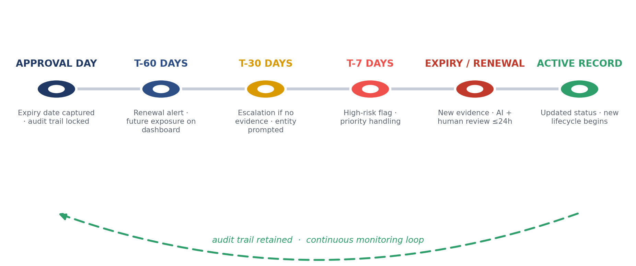
Diagram 3 — Periodic Document Verification: managing compliance by forecast, not by surprise
The client outcome is simple: Amazon does not manage compliance by surprise — it manages it by forecast.

6.5 API-First Integration
Amazon’s operating environment needs event-driven compliance, not manual supplier chasing. Service Club’s integration model is API-first: an Amazon event triggers the vetting workflow, the platform creates the timestamp, the ≤24-hour SLA timer starts, and the final outcome returns to Amazon with structured status, reason code, expiry data and audit reference. The integration is designed around operational signals, not static file transfer.
The standard event flow is direct. Amazon creates or updates an entity record; the event is passed to Service Club through the agreed API; we confirm receipt; the document package is attached or requested; the workflow routes by country, entity type and document class; AI classification and extraction are completed; human review confirms the decision; and the outcome is returned to Amazon’s system of record. If the file is incomplete, the exception is returned as an actionable outcome rather than an invisible queue delay.
Implementation is controlled through a defined test phase. Service Club and Amazon agree the entity taxonomy, document matrix, country rules, API payloads, status codes, rejection-reason codes, security requirements, retention parameters, error handling and reporting fields. Test cases include standard approvals, document rejection, missing evidence, expired evidence, duplicate upload, country-specific exception, bulk submission, renewal trigger and SLA breach-risk escalation. No production launch occurs until Amazon can see the full path from event to outcome.
This approach gives Amazon three protections from day one: integration clarity, SLA accountability and audit-ready evidence. The platform does not merely receive documents; it converts Amazon events into compliance decisions Amazon can see, govern and prove.

7 Compliance Methodology & Operating Model

7.1 End-to-End Control Workflow
Amazon’s compliance exposure starts the moment a document is submitted, so Service Club starts the control clock there — not when a reviewer opens the file, not when a batch is processed, not when a weekly report is produced. Every DA, non-DA, DSP, subcontractor, Mobility Affiliate, Speed Mobility Partner and vehicle record is timestamped at intake, assigned a unique workflow ID, mapped to country, entity type, document class and SLA priority, and placed under the ≤24-hour outcome clock immediately. That first timestamp becomes the anchor for Amazon’s SLA evidence, breach-risk monitoring and audit trail.
The record then enters our AI-assisted control layer, which classifies the document type, extracts key metadata, detects expiry dates, tests field logic, flags missing information, compares document patterns where approved references exist, and identifies anomaly indicators before human review begins. This AI layer is not a shortcut around compliance judgement; it is the mechanism that gives Amazon speed and consistency across a vetting volume rising from approximately 226,000 transactions in 2026 to 484,000 in 2027.
Human review remains the compliance decision point. SC compliance operators validate the AI output against the Amazon Compliance Rulebook, the relevant country rule, the entity type, the document class and the agreed acceptance criteria. Each record receives one controlled outcome — approved, rejected, or exceptioned / cure required — including reviewer action, timestamp, reason code, metadata update, expiry status and audit-log entry.
The cure process prevents failed records from disappearing into operational fog. If a document is incomplete, expired, illegible, inconsistent, suspected fraudulent, incorrectly classified or jurisdictionally invalid, Service Club issues a structured cure notice with the rejection reason, corrective action required, responsible party, ageing status and escalation threshold. Where Amazon, the DSP or the entity must provide new evidence, the dashboard shows the record as pending external action; where Service Club can resolve the issue through clarification or secondary validation, the case remains under active compliance handling.
Quality control sits around the workflow, not outside it. Higher-risk files, anomaly flags, disputed cures and country-specific exceptions receive senior review before final outcome where required. Post-outcome QC sampling is conducted by country, reviewer, document class, rejection reason and exception pattern, then fed back into reviewer guidance, AI routing rules and SOP clarification. Amazon receives a workflow where every record has a status, every delay has a reason, every cure has an owner, and every decision can be reconstructed.
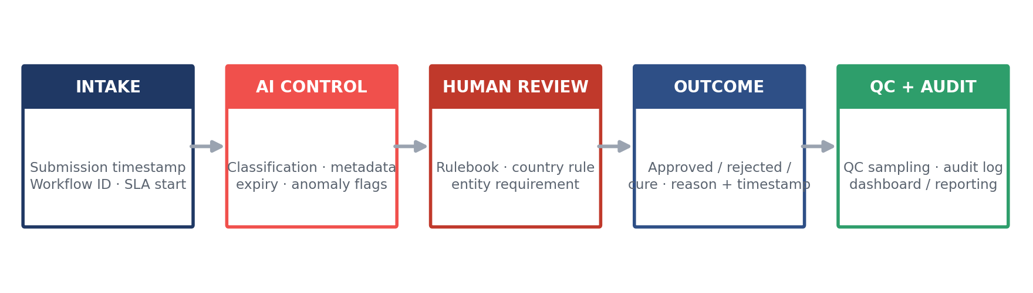
The end-to-end control workflow — intake to quality and audit

7.2 SOP Ownership & Governance
Service Club will own the compliance standard for this programme. Amazon will provide the required source standards — country matrices, entity-eligibility rules, document requirements, operational policies, rejection principles, reporting needs, retention expectations and escalation priorities — and Service Club will convert those inputs into the controlled compliance standard that governs daily vetting. Amazon should not have to manage the mechanics of compliance execution: Amazon provides the mandate, and Service Club owns the operating standard that makes the mandate enforceable.
At mobilisation, Service Club builds the Amazon Compliance Rulebook — the approved operating reference for every country, entity type, document class, validation rule, cure route, expiry trigger and outcome code. This Rulebook becomes the single source of truth used by SC reviewers, AI routing logic, QA sampling, dashboard reporting and audit-evidence production. No reviewer improvises. No country team works from an email thread. No document is accepted because it “looks acceptable” outside the approved standard.
Service Club owns the SOP lifecycle from that point forward. Every SOP carries a version number, effective date, country scope, entity scope, evidence requirement, reviewer instruction, AI-rule dependency, rejection-reason taxonomy and audit history. When Amazon updates a requirement, local law changes, or a document rule needs clarification, Service Club issues a controlled standard update, tests it against workflow logic, briefs the review team, updates AI classification or validation rules where required, and records the change for Amazon governance.
Governance is structured to make ownership visible:
- Weekly — SLA digest, volume trends, open cures, ageing exceptions, breach-risk items, urgent SOP clarifications
- Monthly — performance pack, rejection analysis, QC findings, country-level patterns, root-cause actions, rule-change log
- Quarterly — strategic governance review, regulatory-horizon scan, SOP version review, forecast volumes, peak readiness, platform-roadmap alignment
Service Club provides a named Amazon Account Lead with single-point accountability, supported by compliance-operations, quality-control, technical-integration and data-protection leads. If one country shows elevated rejection rates, Amazon sees it. If an SOP ambiguity creates inconsistent outcomes, Service Club resolves it through controlled rule clarification. If a local legal requirement changes, Service Club updates the compliance standard and evidences the change path.
Amazon sets the mandate; Service Club owns the standard that operationalises it. The result is a vetting operation where every decision is made against a controlled rule, every rule has an owner, every change is traceable, and every audit can follow the line from Amazon requirement to SC decision.

7.3 Multilingual Coverage & Local Expertise
Amazon’s requirement for 17+ languages is a compliance control, not a service-desk feature. A reviewer who cannot understand the document language, local terminology, issuing-authority format and country-specific evidence requirement cannot reliably determine whether a record is valid. Service Club’s multilingual model is therefore built around operational accuracy: documents are routed by language, geography, entity type and document class before review, so the person validating the record understands both the document and its compliance consequence.
A French vehicle-insurance certificate, German driving licence, Spanish work authorisation, UK right-to-work record, Italian company registration, UAE permit or LATAM identity document cannot be treated as the same compliance event. Each enters a workflow configured to Amazon’s approved standard and the relevant local evidence requirement. The reviewer applies the Amazon Compliance Rulebook, supported by AI-extracted metadata, document-class guidance, country rules, specimen references where available and escalation routes for uncertain cases.
This model avoids the two failures that damage multi-country programmes. Centralised providers create false consistency by ignoring local nuance; local-only providers create fragmentation by losing central governance. Service Club gives Amazon one compliance standard with local validation intelligence underneath it: the same SLA, the same audit trail, the same reporting model and the same outcome taxonomy across 20+ countries, with country-specific logic applied where the document reality requires it.
Language coverage also protects speed. Clear cure notices reduce rework. Local-language evidence requests reduce back-and-forth with DSPs and entity contacts. Reviewer familiarity with document formats reduces unnecessary escalation. Amazon receives faster decisions because the operating model understands the document before it becomes a problem.

7.4 Elastic Staffing & Escalation
Amazon’s volume profile punishes providers who staff for the average day. The move from approximately 226,000 vetting transactions in 2026 to 484,000 in 2027 is a 2.14× growth curve before rejected documents, cures, renewals, rechecks and October/November peak pressure are included. Service Club’s staffing model is elastic by design: baseline teams manage normal flow, cross-trained reviewer pools absorb country and document surges, and peak capacity is modelled before it is needed.
The operating structure includes a named Amazon Account Lead, a Compliance Operations Manager, country and language review teams, quality-control reviewers, technical-integration support, data-protection escalation and critical-incident coverage. The Compliance Operations Desk operates 7 days, 07:00–22:00 CET, with 24/7 escalation for P1 incidents — platform outage, data-risk event, critical SLA exposure or Amazon-designated operational emergency. Critical incidents receive ≤1-hour acknowledgement and a defined resolution path within ≤4 hours.
October and November are treated as a designed operating state. By 1 September annually, Service Club provides Amazon with a costed, resourced surge-capacity plan covering forecast volumes, staffing ratios, language coverage, workflow distribution, escalation coverage, QC sampling and breach-risk controls. Surge staffing is pre-deployed, not requested after queues grow, and the ≤24-hour outcome SLA remains the standard during peak.
Escalation is tiered and visible:
- Level 1 — standard reviewer resolution within workflow
- Level 2 — senior compliance review for anomalies, high-risk rejects or cure disputes
- Level 3 — country/legal escalation for local-rule ambiguity or Amazon-standard interpretation
- Level 4 — executive incident route for P1 service, data, SLA or reputational risk
Every escalation has an owner, timestamp, reason, action log and closure record. Amazon receives capacity that flexes before volume becomes backlog, escalation that moves before risk becomes damage, and a compliance operation governed tightly enough to protect the network at last-mile speed.

8 Service Levels, Scalability & Peak Resilience

8.1 SLA Framework
Amazon’s real fear is not whether a supplier can process the average day; it is whether the supplier quietly redefines the clock when volume becomes uncomfortable. Service Club removes that ambiguity by separating intake accountability from vetting-SLA measurement. Every submission is timestamped immediately at intake, while the formal vetting SLA starts when the required documentation package is complete, legible and assigned to the correct entity, country and control type.
That distinction protects Amazon operationally. If a DSP uploads an expired insurance certificate, an unreadable licence scan, a missing work-authorisation page or a document attached to the wrong vehicle, Service Club does not pretend a final approval is possible. We issue a structured cure / exception outcome with a reason code, corrective action and owner. Amazon sees the cause of delay in real time, rather than receiving a false SLA breach created by incomplete evidence.
Service Club proposes a tiered SLA framework that reflects operational reality without weakening Amazon’s control:
Control Type | SLA Commitment | Measurement Point
Standard DA / non-DA onboarding document vetting | ≤24 hours | From complete documentation package to outcome
DSP / subcontractor / SMP / Mobility Affiliate entity checks | ≤24 hours | From complete required entity pack to outcome
Vehicle documentation checks | ≤24 hours | From complete vehicle pack to outcome
Renewal / periodic document verification | ≤24 hours | From complete renewal evidence or expiry-triggered submission
Cure notice for incomplete / illegible / mismatched files | ≤4 hours | From intake timestamp to structured cure request
Suspected falsification / high-risk anomaly escalation | ≤4 hours | From AI or reviewer flag to senior compliance escalation
P1 platform or data-risk incident acknowledgement | ≤1 hour | From detection or Amazon notification

The core promise stays sharp: complete files receive a compliance outcome within 24 hours, seven days a week. Incomplete files receive a fast cure outcome, not silence. Amazon gets the operational truth early enough to act.

8.2 Seasonal Surge Model
Amazon’s Appendix 4 volume profile moves from approximately 226,000 vetting transactions in 2026 to approximately 484,000 in 2027 — a 2.14× annual increase that lifts the average from approximately 18,800 checks per month in 2026 to approximately 40,300 per month in 2027, before rechecks, cures, rejected files and periodic renewals are included. October and November are the real examination point: peak does not only lift demand; it compresses the time Amazon has to absorb any supplier weakness.
Service Club sizes the service against the peak envelope, not the annual average. By 1 September annually, we provide Amazon with a costed surge plan covering forecast volume, country distribution, language coverage, queue routing, QC coverage, escalation coverage, weekend operations, automation throughput and breach-risk controls. Capacity is prepared before October begins, with Amazon’s Compliance Rulebook already embedded into reviewer guidance and AI routing logic.
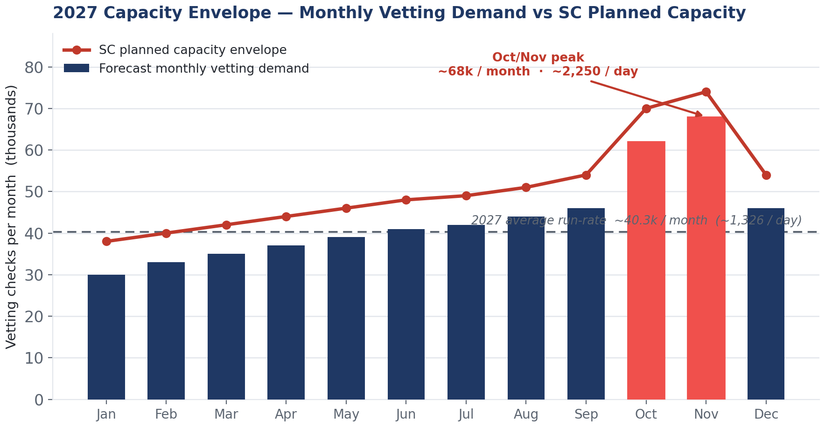
2027 capacity envelope — average run-rate ~40.3k/month; SC peak planning envelope up to ~68k/month (~2,250/day)
This is not a decorative forecast; it is the operating principle. Amazon’s SLA is protected by capacity held above the average month, with the highest coverage assigned to the Oct/Nov surge. No peak-period SLA holiday. No queue ageing hidden behind weekly reporting.

8.3 Capacity, Automation & Throughput Control
Manual-only vetting does not survive 484,000 annual transactions without becoming expensive, slow or inconsistent. Service Club’s capacity model uses AI Document Intelligence to remove avoidable human drag, not to remove human accountability. The platform classifies documents, extracts metadata, identifies expiry dates, flags missing fields, screens anomaly indicators and routes each record to the correct country-language workflow before compliance review begins.
That changes the throughput equation. Reviewers do not waste critical minutes identifying whether a file is a licence, insurance certificate, vehicle registration, right-to-work record or entity document; the platform presents the record with extracted fields, expiry signals, document class, entity match, country rule and any anomaly flags already surfaced. Human review is then focused where Amazon needs judgement — validating the evidence against the Amazon Compliance Rulebook and issuing a defensible outcome.
Capacity is governed through live controls rather than static staffing promises. Service Club monitors submission inflow, ageing records, cure volumes, rejection patterns, country bottlenecks, language demand, anomaly rates and SLA exposure in real time. When one market accelerates, routing adjusts. When one document class drives elevated cure rates, QC reviews the pattern. When peak demand rises, automation and pre-planned surge coverage absorb the load before backlog becomes breach risk.
Amazon receives the assurance that matters: AI speed, human accountability, 24-hour outcomes for complete files, and throughput controls sized before peak failure can occur. The model proves capacity through operational mechanics — timestamped intake, automated classification, routed review, cure discipline, live dashboards and surge planning — rather than through a headcount number that says little about whether the SLA will hold.

9 Reporting & Transparency

9.1 Reporting Suite & Cadence
Amazon should never need to ask Service Club whether the compliance position is safe; the dashboard will already show it. Our reporting is designed around live operational control: every DA, non-DA, DSP, subcontractor, Mobility Affiliate, Speed Mobility Partner and vehicle record is visible by country, entity type, document class, SLA status, cure status, expiry exposure and audit readiness. That is the difference between reporting activity and governing risk.
Amazon receives continuous dashboard access, supported by a structured reporting cadence that turns data into action. The weekly report is operational: volumes processed, ≤24-hour SLA adherence, ageing items, cure reasons, open exceptions, suspected-falsification escalations and country-level bottlenecks. The monthly report is managerial: trend analysis, rejection patterns, root causes, QC findings, throughput performance, renewal exposure and improvement actions. The quarterly review is strategic: regulatory-change horizon, SOP updates, platform roadmap, peak readiness, country-performance comparison and forecast alignment.
The reporting suite is built for Amazon’s growth curve from approximately 226,000 checks in 2026 to 484,000 in 2027. At that volume, static PDF reporting is too late. Amazon needs to see compliance drift before it becomes backlog, audit risk or operational friction. Service Club gives Amazon self-serve visibility for daily control and formal governance packs for procurement, operations, compliance and executive review.

9.2 Near-Real-Time QC & Trend Analytics
Right-first-time performance is the metric that protects Amazon from hidden cost. A supplier can hit throughput numbers while creating rework, unclear rejections and repeated cure cycles; Service Club reports the quality behind the speed. Each record carries its outcome reason, reviewer action, AI-flag status, cure trigger, resolution route and QC result, letting Amazon see whether the process is improving or simply moving volume.
Service Club operates a 360° feedback loop between the platform, AI rules, human review, QC sampling and Amazon’s Compliance Rulebook. If one document class produces elevated rejection rates, we identify whether the cause is poor DSP instruction, a local format change, a rule ambiguity, a recurring fraud pattern or reviewer calibration. The finding becomes an action: improved upload guidance, SOP clarification, AI routing adjustment, country-specific reviewer note, or Amazon escalation where the standard requires confirmation.
The analytics are practical. Amazon can see right-first-time submission rate, cure frequency by country, rejection-reason distribution, suspected-falsification trends, ageing exceptions, renewal exposure at T-60 / T-30 / T-7 days, SLA breach-risk items and QC accuracy patterns. That turns reporting into prevention. Amazon receives not a report that explains last month’s problem, but a control system that reduces next month’s problem before it reaches the network.

9.3 Sample Reports
Service Club’s dashboards are built for the Amazon user who has 90 seconds to know whether the network is safe. The first screen shows the compliance position; the second shows the exception; the third shows the evidence. Every view can be filtered by region, country, entity type, DSP, document class, SLA band and expiry window, with exportable evidence for audit and governance.
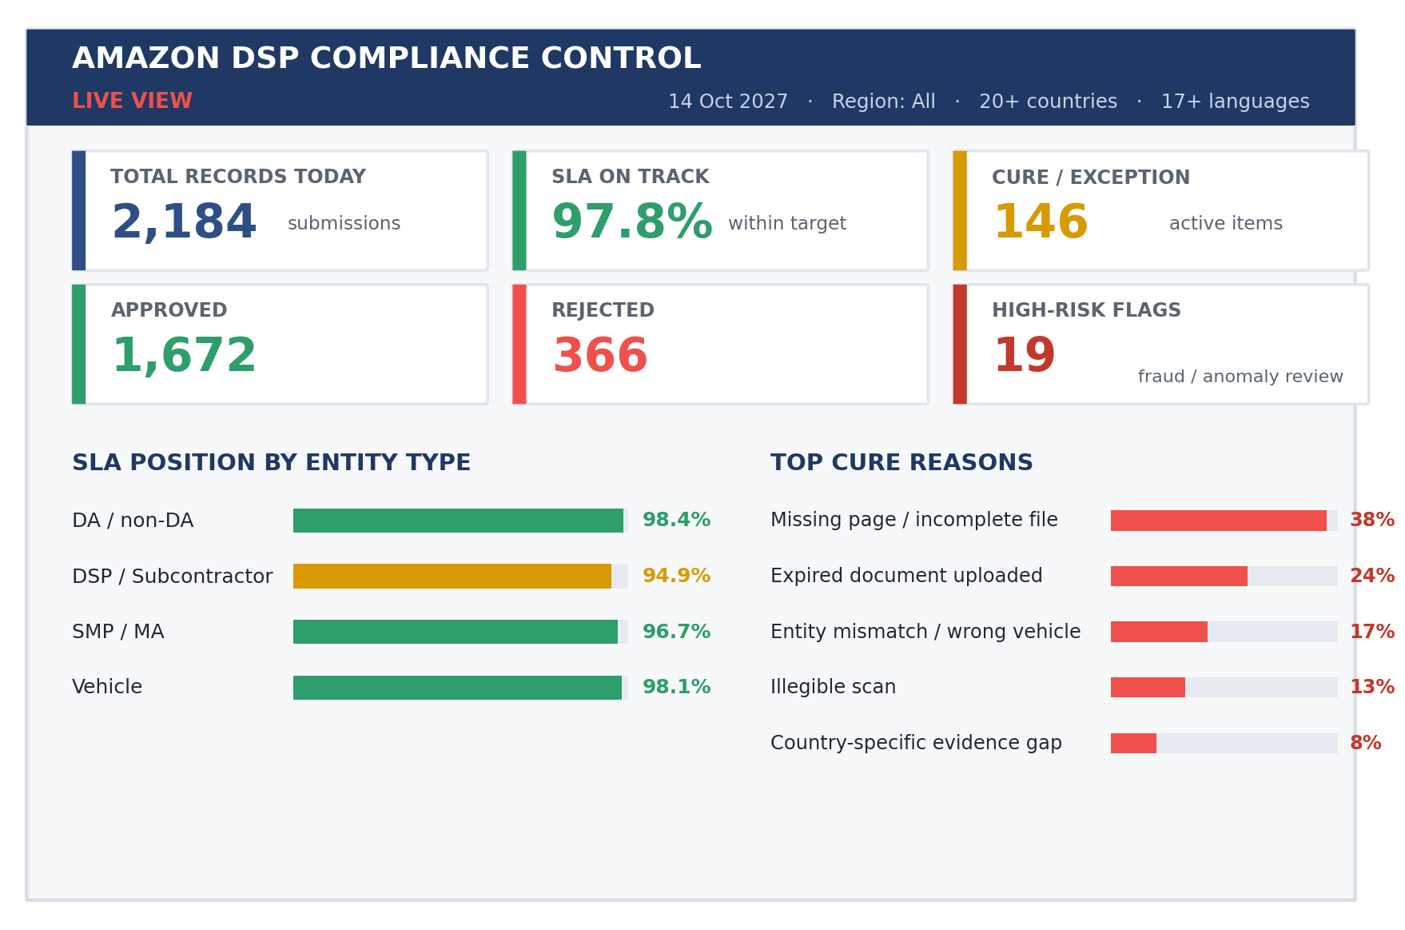
Sample Visual 1 — Live compliance control dashboard
Sample Visual 2 — Expiry & renewal exposure. Filtered to vehicles and DA work-eligibility across the next 60-day window, the Periodic Document Verification view shows where renewal pressure is building, country by country:
Country | T-60 | T-30 | T-7 | Expired
Germany | 412 | 189 | 31 | 0
France | 386 | 144 | 22 | 1 cure open
Spain | 275 | 118 | 17 | 0
UK | 233 | 96 | 14 | 0
Italy | 201 | 88 | 11 | 0

Action required this week:
- 95 records require DSP upload follow-up
- 18 records require senior compliance review
- 1 expired item blocked pending corrected evidence
Sample Visual 3 — Monthly governance pack. The monthly executive summary turns operational data into governance evidence — SLA adherence, outcome speed, QC accuracy, audit-retrieval performance and the improvement actions agreed for the next cycle:
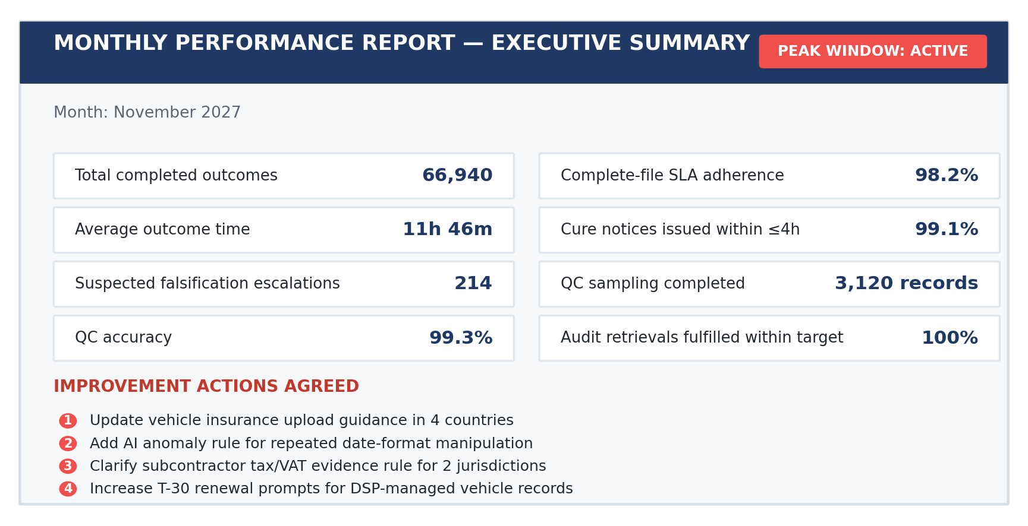
Sample Visual 3 — Monthly performance report, executive summary (November 2027, peak active)
Amazon receives transparency as control: live status for operations, evidence for audit, trend intelligence for prevention, and governance reporting strong enough for executive scrutiny.

10 Data Protection, Security, AI Governance & Continuity

10.1 Data Protection & Residency
Amazon’s vetting data is not ordinary supplier data. It includes identity documents, work-eligibility evidence, licences, vehicle records, insurance certificates, company documents, timestamps, rejection reasons and audit history across 20+ countries. Service Club treats that dataset as regulated compliance evidence from the first upload: purpose-limited, access-controlled, retained only against agreed policy, and processed under Amazon’s approved data-protection framework.
Our baseline operating model is GDPR-aligned by design, with documented processing purposes, role-based access, audit logging, retention configuration, deletion workflows, data-subject-request support and controlled transfer mechanisms. For EU and UK processing, Service Club applies GDPR / UK GDPR principles and supports Amazon with the processing records, access logs and retention evidence needed for audit. Sensitive personal data does not sit in informal inboxes, local spreadsheets or unmanaged country folders.
For non-EU jurisdictions — including KSA, UAE, Brazil and Japan — Service Club applies a local-law overlay during mobilisation. Each country workflow is checked against the relevant privacy and data-transfer regime, including Saudi PDPL, UAE PDPL / DIFC or ADGM requirements where applicable, Brazil’s LGPD, and Japan’s APPI. Where a jurisdiction imposes specific residency, transfer, consent, localisation or onward-processing controls, we configure the workflow, storage route and access model accordingly before go-live.
Our residency stance is controlled, not improvised. The default architecture uses approved secure hosting and Amazon-agreed processing locations; any offshore access is limited to defined operational roles and protected through contractual safeguards, transfer-impact assessment where required, encryption, least-privilege permissions and audit logging. No country team receives uncontrolled access because it is convenient. Amazon receives a data model where every access event is traceable, every transfer route is governed, and every processing purpose is defensible.

10.2 Information Security
Amazon’s compliance platform must prove who accessed a record, what they changed, when they changed it, and why the decision was made. Service Club’s security model is built around that evidence chain. Platform access is controlled through SSO-ready authentication, role-based permissions, least-privilege access, MFA-aligned controls, user-lifecycle management and immediate revocation for leavers, role changes or suspended users.
Data is protected in transit and at rest using enterprise security controls, including encrypted transmission, encrypted storage, segregated permissions and controlled administrative access. Every login, document upload, document view, metadata edit, reviewer action, approval, rejection, override, cure notice, download and permission change is timestamped in the audit log. Amazon receives more than a secure repository; it receives a defensible record of the human and system activity behind each compliance decision.
Service Club will provide Amazon with the required security evidence during due diligence, including technical architecture, access-control design, audit-log structure, data-flow mapping, incident-escalation process and policy artefacts. We will not ask Amazon to rely on unsupported certification language. Where formal certifications, third-party reports or security attestations are required, we will provide current evidence available at submission, or agree the control evidence Amazon requires before production launch.
The operating commitment is clear: ≥99.5% monthly platform uptime, scheduled maintenance notice at least 48 hours in advance, and critical-incident acknowledgement within ≤1 hour. For data-risk incidents, Service Club notifies Amazon within ≤4 hours of detection and provides the containment path, impact assessment, remediation owner and evidence trail.

10.3 AI Governance
AI is powerful in this mandate because Amazon’s volume profile — approximately 226,000 checks in 2026 rising to 484,000 in 2027 — cannot be governed safely through manual review alone. And yet AI cannot be allowed to become an unchallengeable black box deciding who can work, operate or remain compliant. Service Club’s AI-governance model is built around that line: automation accelerates evidence testing; humans own adverse decisions.
Our AI Document Intelligence classifies documents, extracts metadata, detects expiry dates, flags missing fields, identifies anomaly indicators, compares document logic and routes cases to the right country-language workflow. It supports falsified-document detection through specimen comparison, anomaly screening, internal logic checks and cross-record consistency testing. The AI produces signals, confidence indicators and escalation flags; it does not silently reject an Amazon entity without accountable review.
Human oversight is mandatory for adverse or high-impact decisions. Where a document is rejected, exceptioned, escalated for suspected fraud or placed into cure, a trained SC compliance reviewer confirms the basis against the Amazon Compliance Rulebook and records the reason code. Amazon can see the decision path: document class, extracted fields, AI flags, reviewer action, outcome timestamp and audit history.
Service Club aligns the model with the principles of the EU AI Act and comparable governance expectations: transparency, human oversight, proportionality, traceability, bias-risk awareness, data minimisation and explainability for affected operational decisions. Amazon receives AI that is visible, governed and auditable — fast enough for peak volume, controlled enough for procurement confidence.

10.4 Business Continuity & Disaster Recovery
Amazon’s compliance operation cannot stop because a supplier platform, reviewer location or integration path has a bad day. Service Club’s BCP and disaster-recovery model protects the vetting service through redundant operating procedures, access-controlled continuity routes, defined escalation ownership and recovery targets aligned to Amazon’s operational risk.
The platform service is governed against ≥99.5% monthly uptime, with disaster recovery designed around RTO ≤1 hour and RPO ≤15 minutes for core compliance data. Scheduled maintenance is notified at least 48 hours in advance and planned outside critical processing windows wherever possible. P1 incidents — platform outage, data-risk event, critical SLA exposure or Amazon-designated emergency — receive ≤1-hour acknowledgement and a documented resolution path within ≤4 hours.
Continuity is tested through scenario planning covering platform unavailability, integration failure, reviewer-access disruption, data-risk event, peak-volume surge and country-specific operational interruption. Amazon receives the outcome that matters: vetting continuity, evidence preservation, fast incident visibility, and a recovery process that protects the ≤24-hour outcome SLA rather than explaining its failure after the fact.

11 Implementation & Transition

11.1 Phased Rollout Plan
Amazon should not have to accept a “big-bang” migration across 20+ countries, 17+ languages and multiple entity types on trust. Service Club de-risks go-live by phasing the rollout through controlled proof points: mobilisation, pilot country, EU expansion, then APAC / MEATR / LATAM activation once workflows, integrations, reporting and governance are proven in production conditions. The sequence is deliberate — it protects Amazon’s network while accelerating the path to scale.
Phase 1 — Mobilisation. Service Club converts Amazon’s source standards into the Amazon Compliance Rulebook, confirms country-eligibility requirements, validates data-protection and residency constraints, maps entity types, configures initial workflows, prepares SSO/API integration and agrees reporting fields. This phase also confirms the no-subcontracting control: core vetting, platform operation, SLA reporting, data handling and audit evidence remain under Service Club ownership, while any required country-specific registration, licence or insurance evidence is closed before launch.
Phase 2 — Pilot country. One priority market is selected with Amazon to test the complete operating model: intake, API or secure upload, AI classification, human review, cure process, outcome return, dashboard reporting, audit retrieval and governance cadence. The purpose is not to “trial” our capability; it is to calibrate the Amazon-specific standard before scale — rejection reasons, cure wording, language routing, entity matching, escalation triggers and data exports.
Phases 3–4 — EU then APAC / MEATR / LATAM. Phase 3 expands across the EU country set, where GDPR, local labour evidence, vehicle documentation, licence rules and right-to-work requirements demand strong central control with local validation. Phase 4 activates APAC, MEATR and LATAM in waves, applying the same compliance architecture with local privacy and document-rule overlays for jurisdictions including KSA, UAE, Brazil and Japan where relevant. Amazon receives scale without uncontrolled launch risk.

11.2 Milestones & Timeline
Service Club proposes a 12-week controlled implementation path, with acceleration available where Amazon’s integration readiness, source standards and country matrices are complete at award. Each milestone ends with a readiness gate, so Amazon sees what has been completed, what remains open and what risk has been retired before the next wave begins.
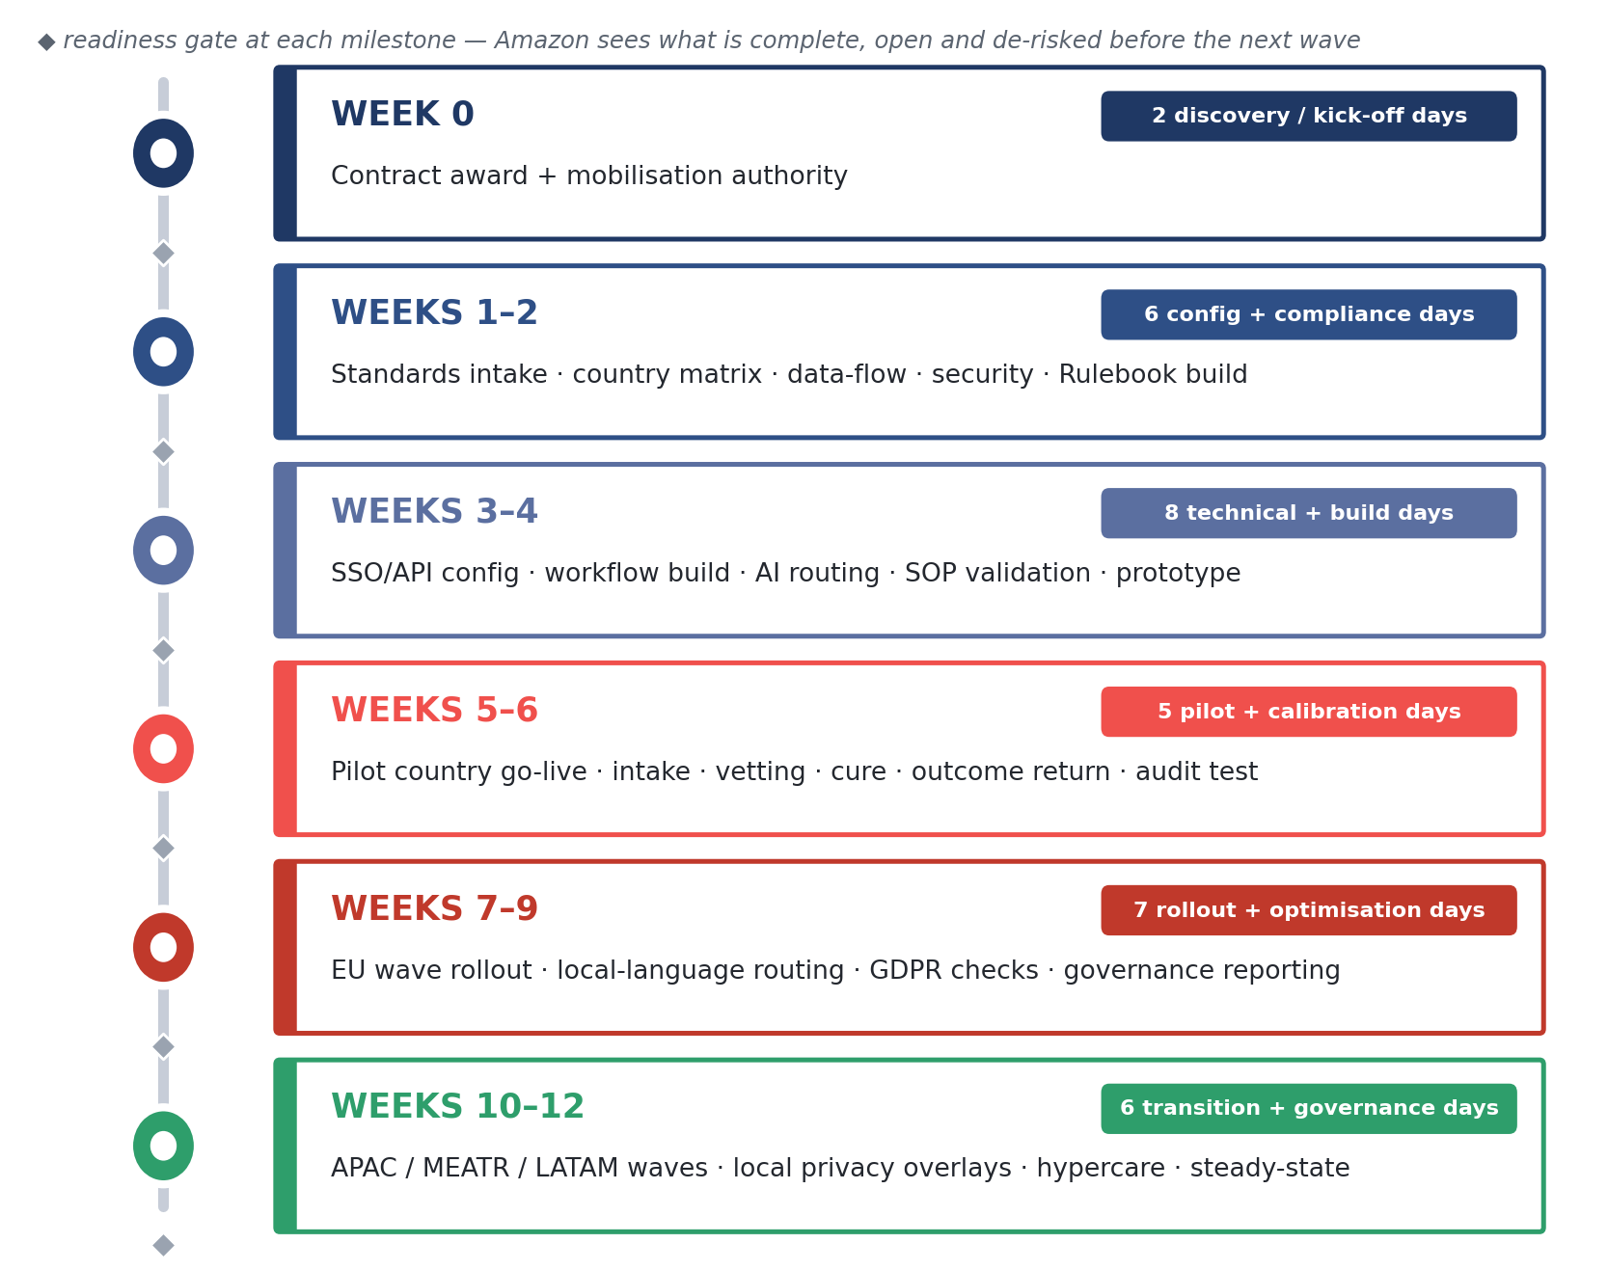
Controlled Amazon rollout — 12-week implementation model with a readiness gate at each milestone
The timeline gives Amazon a practical path to go-live without losing control. By the end of Week 6, the full mechanism is proven in one pilot market. By Week 9, EU expansion is operating through the same rulebook and dashboard model. By Week 12, the wider regional rollout is transitioned into steady-state governance.

11.3 Data Migration & Training
Historical data is only useful if it explains the compliance position on a specific date. Service Club’s migration approach therefore treats existing records as evidence, not as files to be dumped into a new repository. Amazon provides the available datasets — entity identifiers, document types, expiry dates, current statuses, country mappings, DSP relationships, vehicle references, decision history where available and retention requirements — and Service Club maps them into the platform’s compliance structure.
The migration process has five controls: data inventory, field mapping, cleansing and deduplication, sample validation, and controlled import. Records are matched to the correct entity, country, document class and expiry profile. Where documents are missing, expired, ambiguous or unsupported by metadata, Service Club does not hide them inside a “migrated” status. They are flagged as cure, review or verification required — giving Amazon a truthful opening position rather than a clean-looking but unsafe database.
Training is practical and role-based. Amazon administrators learn dashboard control, reporting, audit retrieval and escalation workflows. Country and operations users learn entity status, cure visibility, rejection reasons and renewal exposure. DSP-facing users receive clear upload guidance, document-quality standards and response routes for cure notices. SC reviewers are trained on the Amazon Compliance Rulebook, AI-assisted review screens, document taxonomy, country rules, adverse-decision handling and QC expectations.
This training is not a one-off webinar. During pilot and EU rollout, Service Club runs live calibration sessions using real cases, rejected documents, cure examples and audit-retrieval tests. Amazon receives users who understand the platform, reviewers who apply the standard consistently, and a migrated dataset that exposes risk instead of masking it.

11.4 Governance During Transition
Transition governance starts on Day 0. Service Club establishes a joint mobilisation board with Amazon covering compliance, operations, technology, data protection, reporting and commercial readiness. The board meets twice weekly during mobilisation, weekly during pilot and wave rollout, then moves into the agreed steady-state cadence once the service is stable.
Each transition meeting is evidence-led: open actions, country readiness, integration status, data-migration defects, SOP approvals, unresolved legal or privacy items, pilot performance, cure volumes, SLA position and launch risks. Red-status items have an owner, due date and decision route. No issue waits for a monthly review.
Amazon receives a low-friction go-live because Service Club makes readiness visible before launch. The procurement team can approve the transition knowing the standard is built, the pilot has proven the workflow, the data is mapped, the users are trained, and every country wave enters service through a controlled readiness gate.

12 Commercial Approach

12.1 Pricing Philosophy
Amazon should not pay for supplier inefficiency disguised as compliance effort. Service Club’s pricing model is built on a simple principle: Amazon pays for controlled vetting outcomes, governed infrastructure and audit-ready evidence — not for duplicated manual handling, avoidable rework or opaque back-office activity. The commercial structure in Appendix 5 is therefore transparent, fully loaded and aligned to the actual service Amazon receives: platform access, managed vetting, AI-assisted document intelligence, human compliance review, cure handling, reporting, governance and operational support.
The value is in removing hidden cost from Amazon’s network. A delayed DA approval affects onboarding. A weak vehicle record creates operational exposure. An expired insurance certificate becomes an avoidable escalation. A poor audit trail forces Amazon teams to reconstruct evidence after the fact. Service Club reduces those costs through automation, predictive expiry monitoring, structured cure workflows, real-time dashboards and AI-supported metadata extraction — so each check moves faster and with fewer unnecessary touches.
Automation lowers the cost per check as volume grows, because the platform absorbs work that manual teams normally repeat: document classification, field extraction, expiry detection, entity matching, anomaly flagging and routing to the right country-language workflow. Human reviewers then focus on the compliance decision Amazon actually needs defended. Amazon receives a pricing model where efficiency is engineered into the process rather than added as a future optimisation promise.

12.2 Commercial Levers
The commercial model recognises Amazon’s volume profile and protects value as the programme expands. As usage grows across countries, entity types and recurring verification cycles, the unit economics improve, because the same platform, AI logic, rulebook, reporting structure and governance model support greater throughput. Those scale benefits are reflected in the pricing template in Appendix 5, including volume-linked commercial levers.
Peak is handled with the same discipline. October and November require additional operational coverage, language routing, QC attention and escalation readiness, but peak support should not become an uncapped commercial risk for Amazon. Service Club’s model therefore uses a defined peak mechanism, with the surcharge approach capped and described in the pricing template. Amazon gets surge protection without giving the supplier a blank cheque for seasonal pressure.
The model also avoids configuration traps. The in-scope modular workflows — DA, non-DA, DSP, subcontractor, SMP, Mobility Affiliate and vehicle controls — are priced as part of the agreed service structure rather than treated as separate mini-platforms. Amazon receives commercial clarity as scope expands, not a new negotiation every time a workflow is activated.

12.3 Payment Terms & Reference to Appendix 5
Service Club confirms Net-60 payment terms for this proposal. All pricing figures, rate logic, volume bands, peak mechanisms, assumptions, inclusions and exclusions are provided in Appendix 5 — Pricing Template, which should be read as the sole commercial schedule for evaluated pricing.
This chapter deliberately frames value rather than repeating the grid. The decision for Amazon is not whether a check can be bought cheaply; it is whether the selected partner reduces onboarding friction, compliance exposure, audit burden and peak-season risk at scale. Appendix 5 provides the figures. This section explains why the model protects Amazon’s operational and commercial position.

13 Why We Win — Our Differentiators

13.1 Our Differentiators vs. the Field
Amazon’s risk is not choosing a supplier that cannot describe compliance; it is choosing one that cannot operate it at last-mile speed. Service Club is different because the delivery environment is already our operating ground. Amazon has described us as “far more than a software vendor; a strategic extension of our logistics ecosystem for driver acquisition and training.” That is not a generic reference — it proves we already understand the pressure behind DSP readiness, DA eligibility, vehicle documentation, onboarding velocity and operational consequence.
First — delivery-specific, not HR-generalist. Generic screening providers treat DA, DSP, subcontractor and vehicle files as background-check objects. Service Club treats them as live operating permissions. That distinction protects Amazon, because a delayed licence decision, invalid insurance certificate or weak vehicle record does not stay inside a portal; it affects capacity, safety, compliance and customer promise. Our proof is a driver and compliance infrastructure across 30+ countries, built around KYC, licence validation, insurance tracking, expiry alerts, audit trails and real-time compliance dashboards.
Second — AI in the control path where Amazon needs it most. At approximately 226,000 vetting transactions in 2026 rising to 484,000 in 2027, manual-only vetting becomes slow, inconsistent and expensive. Our AI Document Intelligence classifies documents, extracts metadata, identifies expiry dates, flags missing fields, screens anomaly indicators and routes records by country-language workflow before human review. Amazon receives AI speed without black-box decision-making: adverse outcomes remain human-reviewed, reason-coded and auditable.
Third — we own the compliance standard, not just the workflow. Amazon provides the source requirements; Service Club converts them into the Amazon Compliance Rulebook and owns the SOP lifecycle, version control, reviewer guidance, AI-rule dependency, cure process and audit evidence. This removes the administrative burden from Amazon while preserving control. Every decision follows a governed rule; every rule has an owner; every change is traceable.
Fourth — built for multilingual, multi-jurisdiction reality. Amazon’s scope spans 20+ countries across EU, APAC, MEATR and LATAM, with 17+ languages and local document sets that cannot be flattened into one template. Service Club gives Amazon one governance model with local validation intelligence underneath it: the same SLA, the same audit trail and the same reporting taxonomy, configured to the document reality of each market.
Fifth — we protect peak before peak arrives. Ordinary providers staff for average demand and explain failure in October. Service Club sizes capacity against the surge envelope, provides the annual peak plan by 1 September, runs 7-day operations, and measures the formal vetting SLA from complete documentation to outcome. Complete files receive ≤24-hour decisions; incomplete files receive cure notices within ≤4 hours. Amazon gets operational truth early enough to act.
Sixth — visibility that becomes control. Real-time dashboards show status by country, entity type, document class, SLA risk, cure status, expiry exposure and audit readiness. Every upload, review, approval, rejection, override, access event and renewal trigger is timestamped. Amazon does not receive a report after risk has formed; Amazon sees the risk while it is still preventable.

13.2 Closing Statement
This contract will be remembered inside Amazon for one of two reasons: either the selected partner made DSP compliance quieter, faster and safer — or the selected partner turned volume, language and peak season into another operational burden. Service Club is the safer decision because our model is built for the exact failure modes this RFP was written to prevent.
We bring Amazon credibility, delivery-sector focus, AI-enabled document intelligence, multilingual compliance operations, governed SOP ownership, transparent reporting, and a realistic 24-hour SLA framework that does not bluff incomplete files. We do not promise regulatory compliance; we engineer it — through workflow, evidence, accountability and live visibility.
The next step is straightforward: confirm the source standards, validate the country matrix, activate the pilot, prove the operating model, then scale with control. Amazon receives the partner that makes the procurement decision defensible from day one — and stronger at every audit, peak and governance review thereafter.

