Methodology for Modelling the Road Transportation Sector
A “technoeconomic” model is used to forecast vehicle and driving demand, road transportation energy use, and emissions under various policies. The model performs separate projections for two-three wheelers (motorcycles), light-duty vehicles (LDVs, cars and commercial vehicles with weight below 3.5 tons), heavy-duty vehicles (HDVs, medium- and heavy-duty freight), and public transportation (buses) since the vehicle types have different existing fuel pricing policies, economics, and/or abatement pathways—for example, HDVs have higher depreciation rates, lower fuel efficiency, more VKT distance travelled, and are more costly to electrify—as well as distinguishing between new and used vehicles for LDVs given differences in purchase prices and fuel economy and varying reliance on used vehicle markets across countries. A simplified approach is taken for public transportation. The model covers energy use from gasoline, diesel, natural gas, LPG, biofuels, and electricity. Other energy sources (e.g., coal) are calculated using the elasticity approach.

Data sources for historical data
Historical data on fuel demand, fuel economy, vehicle ownership, and battery electric vehicle (BEV) and plug-in EV (PHEV) shares comes from several sources. Where data is not available, it is estimated based on related data (e.g., vehicle ownership to estimate disaggregated fuel consumption) and regional and income averages. A significant amount of data is estimated, especially for developing countries, so it is important to request data on key variables (see sheet TransportDataRequest in CPAT and share the collected data with the IMF team for integrating into the live dataset). In any case, all results are benchmarked to the most recent energy balances which limits the size of errors. This is the best global data source (Global EV Data Explorer – Data Tools - IEA).
- Fuel use by vehicle type: the IEA, Enerdata, UN, and US EIA provides on fuel use for road transportation as a whole (i.e., energy balances)—this is then disaggregated to vehicle type (e.g., how much diesel is consumed by LDVs vs HDVs vs buses) based on observed data from the IEA for about 40 countries and vehicle ownership and fuel economy for others.
- Vehicle ownership by vehicle type: the IEA and IRF provides this for around 100 countries (it is supplemented with additional data sources like CEIC). In other cases, ownership data either comes from OICA and manual online data collection or is estimated using the Gompertz function (see below).
- Fuel economy by vehicle type: the IEA provides this for around 40 countries and has a couple one off studies. More has been completed manually and through ICCT total cost of ownership studies (good to do a quick search online to see if one of these is available before going on mission).
- Distance driven by vehicle type: VKT per vehicle is estimated so that the product of fuel economy, vehicle ownership, and VKT per vehicle matches the observed fuel consumption from road transport (sourced from the IEA or Enerdata).
- Share of EV stock and sales: The IEA, Statista, and the EEA provide BEV and PHEV purchases for around 100 countries, which is supplemented with manual collection from online sources for another 10-20 countries.
- Share of vehicles that are new vs used:, the share of vehicles sales that are used vs. new vehicles are calculated using shares of new and used vehicle imports from the IRF and country-specific sources.
- Purchase price of EVs and ICEVs: various country specific studies (e.g., ICCT studies on China, Europe, United States, its meta-analysis) and then extrapolating to other countries based on income levels.

Projections
Once historical data for up to 2025 is defined based on the above methodology, projections of vehicle demand, emissions, and externalities use the following steps. Road transportation demand, split between the size and stock of the vehicle fleet and distance per vehicle, adjusts to changing income, population, and fuel costs and depreciation of existing vehicles. New vehicles are split between BEVs and ICEVs according to their relative costs. The fuel economy for new ICEVs responds to changing policies, such as fuel taxes and fuel economy standards. Externality calculations follow Black and others 2025. The combination of aggregate and the composition of vehicle and driving demand, and various policies allows for estimation of emissions, fiscal impacts, and externalities. Each step in the calculation is detailed below.

Vehicle demand
Total passenger vehicle demand is estimated using the Gompertz function (e.g., see Dargay and others 2006). The Gompertz function estimates (i) the saturation point of vehicle ownership (i.e., vehicle ownership if the country was as wealthy as the United States) based on urbanization and population density rates and (ii) the income elasticity of vehicle ownership, with the main feature being a large increase in ownership as country’s transition from lower middle to upper middle income. In any year, vehicle purchases are equal to the difference between current vehicle ownership after depreciation and desired vehicle ownership estimated using the Gompertz function and applying short and long-run elasticities. Changes in demand for heavy goods and 2-3 wheelers are calculated as a percentage of passenger vehicles using a simple regression for heavy goods and a study for 2-3 wheelers (the share of both goods vehicles relative to passenger vehicles declines as income grows and 2-3 wheelers show an upside down U-shape).

Total cost of ownership
The share of BEV in vehicle purchases is estimated using a total cost of ownership (TCO) calculation for each vehicle type (see Table 1 for detailed assumptions). TCO is calculated as a net present value (NPV) cost of using a vehicle over its lifetime and expressed as a cost per kilometer driven. The TCO is separated into the purchase price (adjusted for depreciation), insurance, maintenance, fuel costs, and taxes on driving.
- The purchase price of a new vehicle is a function of the following:
  - Retail prices—for ICEVs these are projected to remain constant in the baseline for a given income level but increase as income rises (elasticity of income to prices based on a survey of countries). Retail prices for BEVs fall steeply with declining battery costs for both light- and heavy-duty EVs but increase as income rises (same income elasticity as ICEVs).
  - Depreciation—faster for freight vehicles due to their much higher annual mileage and faster in the first year of vehicle ownership, reflecting the sharp decline in resale value after vehicle purchase (Argonne 2021). Depreciation rates are assumed to be the same for BEVs and ICEVs.
  - Salvage or resale value—this reduces the TCO and is the vehicle’s estimated market value at the end of the ownership period. This is equal to the depreciated value of the vehicle.
  - Discount rates—discount rates are needed to value costs across the vehicle’s lifecycle. Generally, BEVs have higher upfront costs (e.g., retail prices) but lower future costs (e.g., fuel and maintenance) than do ICEVs so a higher discount rate, which reduces the value of future cost savings, increases the relative costs for BEVs. The discount rate for LDVs/motorcycles and HDVs reflect financing costs, rather than a social discounting rate, to better reflect consumer purchasing decisions. Discount rates vary by a country’s income level, with higher rates for lower income countries: they are assumed to be 10% in high income countries, increasing to 30% in low income countries based off a quick AI search (needs to be reviewed).
  - Policies impacting vehicle purchase prices—these include any modelled subsidies, feebates and existing country-specific VAT and customs for passenger vehicles. Fuel efficiency standards are modelled as a shadow carbon price.
  - Range anxiety—an additional cost for BEVs that declines over time reflecting anxiety over charging availability and range limitations. Range anxiety is calibrated so that new sales in the latest available year calculated in the model match actual values. For this, sales are new vehicles on the road (i.e., new vehicles and imported, used vehicles but not including second-hand vehicle sales that were already owned domestically).
- Maintenance costs vary with labor costs (measured by wage rates) and are lower for BEVs than ICEVs due to fewer moving parts for the former.
- Insurance is assumed to be the same for BEVs and ICE.
- Fuel costs (from gasoline, diesel, or electricity) are a function of VKT, fuel economy, and fuel prices. Each calculation is performed separately for gasoline and diesel LDVs and then a weighted average is taken, based on ownership shares.
  - Fuel prices—these are updating following Black and others (2025). Electricity prices include mark-ups to cover charging infrastructure costs, which decline with technological improvements and EV deployment expansion (the latter increasing charging station utilization and, thus, reducing the fixed cost of charging infrastructure).
  - Fuel economy—this increases exogenously with technological improvement in the baseline for all vehicles and, additionally, with learning-by-doing and economies of scale for BEVs. For light- and heavy-duty ICEVs and light BEVs, the fuel economy improves one percent a year from gradual autonomous improvement, while heavy-duty EVs improve from 0.7 km per kWh in 2020 to 1.5 km per kWh in 2050 (ICCT 2021). In addition, fuel economy of new BEVs and ICEVs increases with higher fuel prices as manufactures make technological modifications and vehicle buyers shift to more fuel efficient models—elasticities of around -0.4 and -0.3 are assumed for light- and heavy-duty ICEVs but with some country variation (see Black and others 2023). The fuel economy of BEVs is assumed to be unresponsive to changes in electricity prices given the high energy efficiency of BEVs and relatively low share of costs related to fuel.
  - VKT—the VKT per new vehicle adjusts to fuel prices according to driving elasticities (-0.3 and -0.2 for LDVs/2-3 wheelers and HDVs respectively) and to income levels (elasticity of 0.05). It is assumed that VKT per vehicle is identical between BEVs and ICEVs for TCO estimates given that evidence on driving differences are mixed.
- For used vehicles, the same calculation is performed but with the purchase price equal to the salvage value of a new vehicle and fuel economy from the year in which the vehicle was produced/sold for the first time.

Table 1: Total Cost of Ownership Parameters
 | ICEV LDV | BEV LDV | ICEV heavy duty | BEV heavy duty | ICEV motorcycle |  | BEV motorcycle
New vehicle purchase price | IEA and Argonne, see chart below |  | ICCT, see chart below |  | IEA, see chart below
Depreciation | 30% in first year and then linearly depreciated over 19 years, new cars sold at 10 years |  | 30% in first year and then linearly depreciated over 7 years, sold at year 5 |  | Linearly over 5 years (ICCT)
Energy cost | Country-specific (see Black et al 2023 for sources), with additional charge that declines with EV penetration to recover EV charging infrastructure costs (ICCT)
Fuel/energy efficiency | Country-specific for around 30 countries (IEA), extrapolation for others, 1% annual improvement |  | 32-63 liters per 100 km (various); 2.5% annual decline (ICCT) | 150-100 kWh per 100 km from 2020-2030 (ICCT); continued decline | 1-3 liters per 100 km | 4 kWh per 100 km
Maintenance | $0.03-$0.012 per km (Argonne, ICCT) | 1/3 of ICE (Argonne) | $0.045-$0.135 per km (Argonne, ICCT) | 1/3 of ICE (Argonne) | $0.01-0.04 per km (ICCT) |  | 1/3 of ICE (ICCT)
Insurance | 1.5% of vehicle value (~Argonne)
VKT per year | Country-specific, around 10,000 km |  | Country-specific, around 80,000 km |  | Country-specific, around X
Sources: ICCT refers to the average of ICCT studies for China, Europe, United States, its meta-analysis on ZEV purchase costs, or a study on Vietnam for 2-3 wheelers. Argonne refers to its 2021 TCO review and AFLEET 2024. Notes: all prices are presented in 2023 real terms. VKT is calculated using vehicle ownership, fuel consumption, and fuel economy for ICE vehicles and is scaled based on differences in cost per km for ICE and EVs and an assumed driving elasticity for EVs. The charging cost could be a function of EV ownership. For freight vehicles purchase costs, the average of straight trucks and tractor trailers is used.

Figure . Vehicle purchase price from 2020 to 2040
Passenger  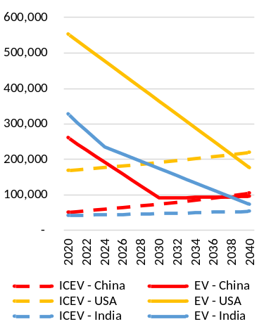 | Freight  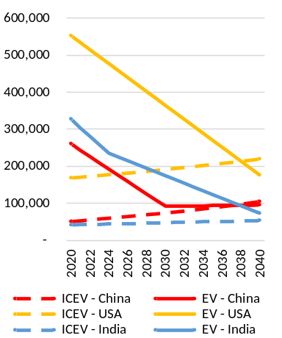 | 2-3 wheeler
Source: IMF staff estimates using Argonne and ICCT.
Share of ICEVs by fuel type
Once total ICEV purchases are estimated, the share of vehicle purchases for each fuel type (gasoline, diesel, LPG, CNG, and PHEVs for passenger vehicles and diesel, LPG, and CNG for freight) is calculated. This is done using cross and own-price elasticities from a study on how the Norwegian vehicle fleet responds to changes in total cost of ownership (Fridstrøm and Østli 2021).
Distance driven per vehicle and fuel economy
Next, the distance driven per vehicle are estimated according to the driving elasticities and considering any fiscal instruments that impact the marginal cost per kilometer driven (e.g., distance-based taxes and fuel or carbon taxes) and allowing for differences between ICEVs and EVs. Combining assumptions on distance driven, number of vehicles, and the fuel economy allows for estimates of emissions and fuel use, as well as fiscal implications of various road decarbonization policies.
Public transportation
A simplified approach to modelling energy use from buses, but excluding rail and air, are included in the calculations. Fuel and electricity use from buses change at the same rate as passenger vehicles (to be updated in the future), meaning that they approximately electrify at the same rate as passenger vehicles.
Biofuels
The biofuel blending ratio is calculated using the IEA energy balances. The blending ratio is assumed to stay constant so biofuel use changes proportionally to diesel and gasoline. Biofuel blending is incorporated into the emissions-intensities of gasoline and diesel for estimating the impact of policies that are based on CO2 such as feebates and carbon taxes.
Modelled policies
A range of policies are modelled and work through separate channels.
- Policies that impact fuel prices, such as carbon taxes and fuel excises, impact emissions through three channels: improvements in fuel efficiency of newly purchased ICEVs based on the efficiency elasticity (-0.3 for freight and -0.4 for passenger and 2-3 wheelers), distance driven of all ICEVs based on the intensive margin elasticity (-0.2 for freight and -0.3 for passenger and 2-3 wheelers), and a greater share of new vehicle purchases being EVs due to a higher relative price of ICEVs.
- Feebates result in improvements in fuel efficiency of newly purchased ICEVs (in a similar way to policies impacting fuel prices) and a greater share of EV purchases due to higher ICEV purchase taxes and EV subsidies, assuming the pivot point is set above zero. The impact on the purchase prices of an average ICEV is product of (i) the net present value of kilometers driven over a vehicle’s lifetime, (ii) the difference between the ICEV fuel efficiency and fuel efficiency of all new vehicle purchases expressed in tons of CO2 per kilometer, and (iii) the shadow carbon price. The EV subsidy is calculated using the same equation but assuming a fuel economy of zero, making component (ii) negative.
- Distance based taxes reduce distance driven, similar to the driving portion of carbon taxes.
- Ad-valorem taxes on vehicle purchases impact the share of vehicles that are ICEVs vs EVs based on changes in TCOs.
- Charging station subsidies impact range anxiety through the elasticity of charging station deployment to costs (see footnote above on elasticity assumption). This reduces the TCO of EVs.

Cross-checking against other projections
BEV shares
A logit function based on the relative TCO of ICEV and BEV determines the share of vehicle demand met by ICEV vs. BEVs, separately for new vs. used vehicle purchases. The logit function is fitted to minimize the difference between modelled and actual EV sales between 2015 and 2024 for select economies.,
The resulting shares of vehicles that are BEVs are similar to other forecasts at the global and country level (Figure 11, Figure 12).
Figure 11. EV sale shares, global
Passenger  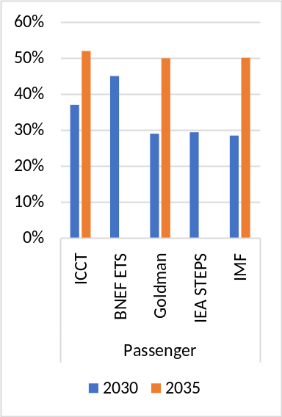 | Freight  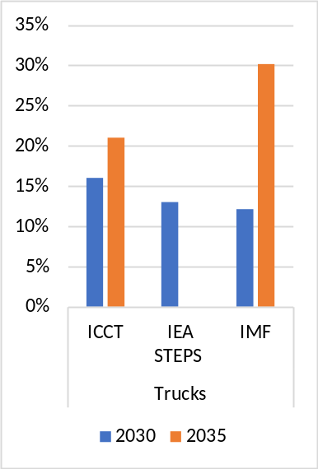 | 2-3 wheeler  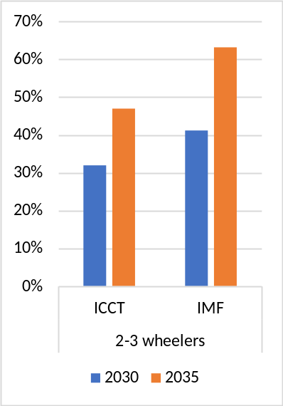
Source: IMF staff estimates using IEA Electric Vehicle Outlook 2025, BNEF Electric Vehicle Outlook 2024, ICCT Vision 2050 and Goldman Sachs Research.

Figure 12. EV sales share, select markets
Passenger  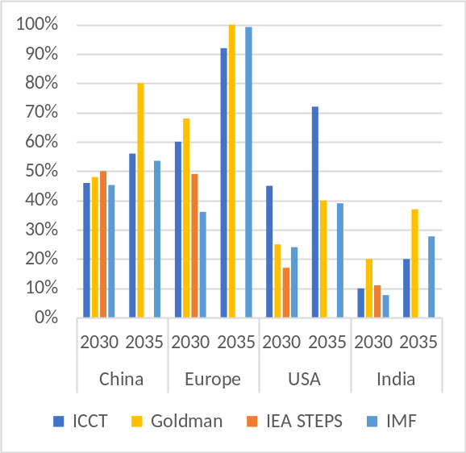 | Freight
Source: IMF staff estimates using IEA Electric Vehicle Outlook 2025, BNEF Electric Vehicle Outlook 2024, ICCT Vision 2050 and Goldman Sachs Research.

The data sources are the OECD’s International Transport Forum (ITF), the IRF’s World Road Statistics (WRS), IEA’s Electric Vehicles Initiative (EVI) and Energy Efficiency database, Statista, European Environmental Agency (EEA), and International Organization of Motor Vehicle Manufacturers (IOCA).
Key variables are details of the vehicle stock and share of EV sales and more.
There are various definitions for freight or commercial vehicles across datasets: IEA Energy Efficiency Indicators and OICA includes all vehicles carrying goods in freight (including light-duty commercial vehicles), while the IEA EVI and IRS WRS definition only captures vehicles with weight above 3.5 tons in freight. Light- and heavy-duty vehicle fuel economy and VKT is used to calculate the share of commercial diesel fuel use for each vehicle type. All commercial gasoline fuel use is allocated to LDVs. Commercial vehicle fuel use is split between light and medium/heavy-duty vehicles based on ownership (from the IRF WRS), fuel economy, and VKT.
The average fuel economy of new ICEV purchases is not available in cross-country datasets, other than that of the EU. It is calculated assuming that the annual change in the average fuel economy is caused by new vehicles on the market and that the LDVs and HDVs vehicle fleets turnover every 15 and eight years, respectively. The value of LDVs is also used for motorcycles.
The share of new vehicles that are HDV vs LDV and new vs used vehicles gradually converges with the share seen in high income countries (low income countries tend to have a greater share of HDVs and used vehicles). 2-3 wheelers increase until a country reaches GDP per capita of 7,000 and then begins to decline. The portion of used vehicles that were previously new, domestically owned vehicle is held constant.
The six digit HS codes from 8703 and 8704 are used to determine customs duties for LDV and HDV EVs and ICEVs. For non-tariff policies, data has been collected manually for a subset of large countries.
Projected range anxiety is impacted by the availability of charging stations to mimic elasticities in Cole et al 2021. A 10 percent increase in charging availability increases EV uptake by 3.7 percent at relatively low levels of charging availability. The elasticity of charging station supply to charging station costs is assumed to be 0.67 (Cole et al 2021). Charging station availability naturally increases with EV penetration (and vice versa), representing an important network effect.
A charging utilization increases from low levels to levels achieved in Europe by 2030 (around 50 percent BEV penetration), costs to cover the fixed cost of charging infrastructure falls from USD 0.10 per kWh to 0.02 per kWh (following ICCT 2021).
The evidence on whether EV are driven more than ICEVs is largely mixed for studies focusing on the US (e.g., Zhao et al. 2023, Burlig et al. 2021, Chakraborty et al. 2021, EPA. 2023, Metcalf and Doshi. 2023). A Norwegian study finds EVs are driven about 10 percent more then ICEVs (Bloomberg 2022, Rystad 2023). Results for the Norwegian study may have more validity for a country with higher EV uptake and availability of charging stations.
The k-parameter for the logic function is 3 for passenger vehicles, 2 for freight, and 4 for 2-3 wheelers.
Used vehicles are split between imported used vehicles and used vehicles that were previously owned domestically. There is assumed to be a limited supply of both imported and second-hand domestic used vehicles, which is determined based on the global and domestic number of EV purchases from 10 years ago (i.e., the assumed vehicle ownership period) for passenger vehicles and 4 years ago for freight.

